aCTION ENHANCEMENT GUIDE

April 2016 Training Guide



April 22, 2016

CDAC

CDACweb.com

**Table of Contents**

1. Action .NET security update …………………………………………………………………….. 3
2. Work flow enhancements ……………………………..………......................................... 4- 5
3. Victim Witness Tab enhancements ………………………………………………….……………. 6-7
4. Victim Witness Notification enhancement …………………………………………………… 8
5. Prosecutor Tools- Google Email display….……………………………………………………… 9
6. Updated Display of Action Header ………………….………………………………………..…… 10
7. Miscellaneous …………………………………………………………………………………………….. 11-12
8. Action Scan V 3.1.1 ………………………………………………………………………………………… 13

Action .NET 4.6 Security Upgrade

Action will now require both Microsoft .NET 3.5 and .NET 4.6 framework installed on your computer to run.  Previous Version of Action only required .NET 3.5.  This upgrade is needed to comply with the new security standard implemented by the Judicial Court System.

* We have notified all district Admins ahead of time of this new requirement.  If your admin has configured your computer with both .NET 3.5 & .4.6, you can start Action normally and it will upgrade itself normally without any further requirement.
* If you run into problem when you start Action:
  + Make sure you have admin rights on your computer.  If the account you are using does not have admin rights, you may have to contact your local network admin to have them log on and perform the next step for you.  You will only need to do this once.
  + Please browse to <http://action.cdac.state.co.us/action2/> and follow the instruction under “Important Note”

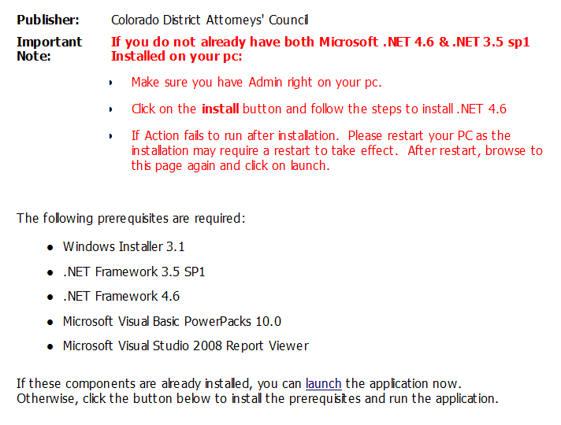

User Task List- Work Flow

Work Flow enhancement has been added to the User Task List to Show if the case is VRA. This VRA flag is picked up if any of the Victim/Witnesses have the VRA flag selected on their record. Same functionality that exists for Prosecutor Tools- Dockets displaying of the VRA flag.

1. Open User Task List, new column named VRA **Y**es or **N**o indicated for user. This column like the others is sortable if clicked on the column heading.

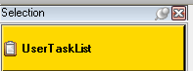

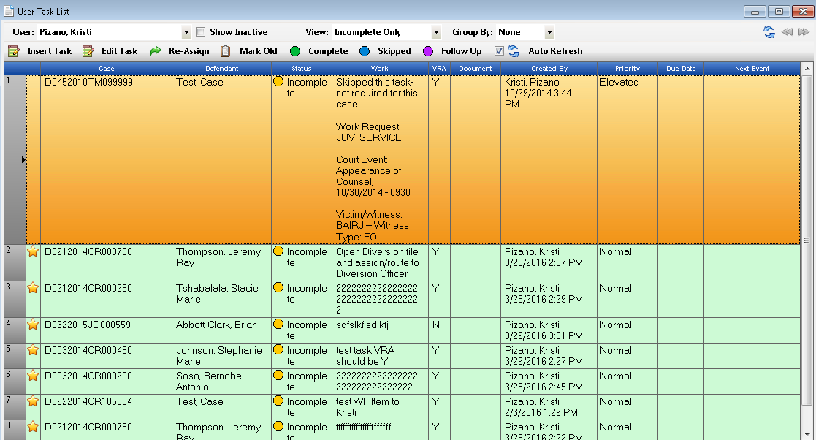

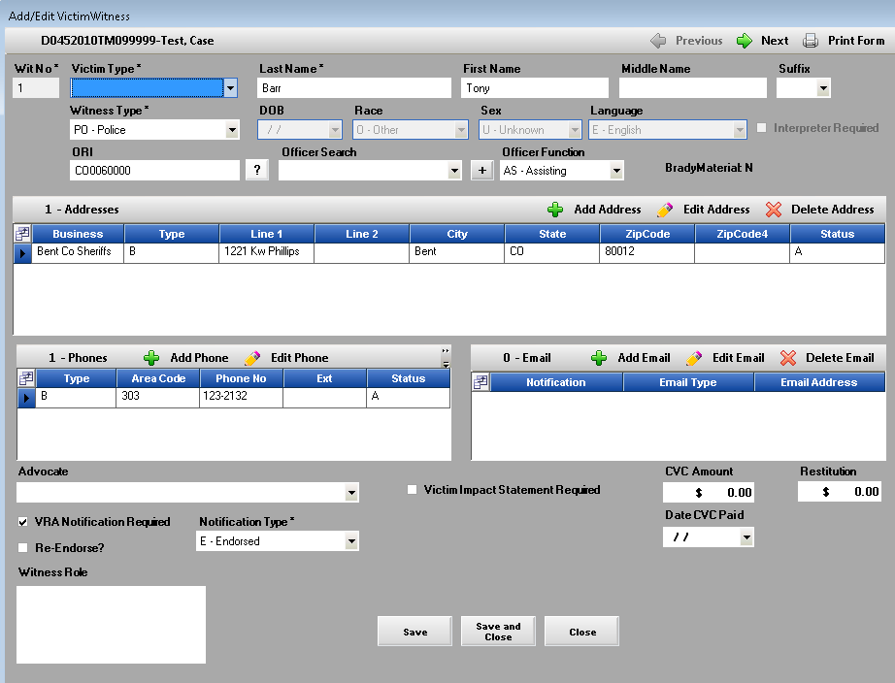

Screen shot of Victim Witness Tab- if the VRA Notification Required box is checked on one or more witnesses this will change this column to Y.

Work Flow - Insert Task

Work flow enhancement to the Insert Tasks window from the Work Flow Tab, User Task List and Pros Tools.

1. Short cut keys have now been added to the Insert Task window allowing for quicker entry from the keyboard while typing. Hold down the Alt on your keyboard to show the underlined shortcut keys.

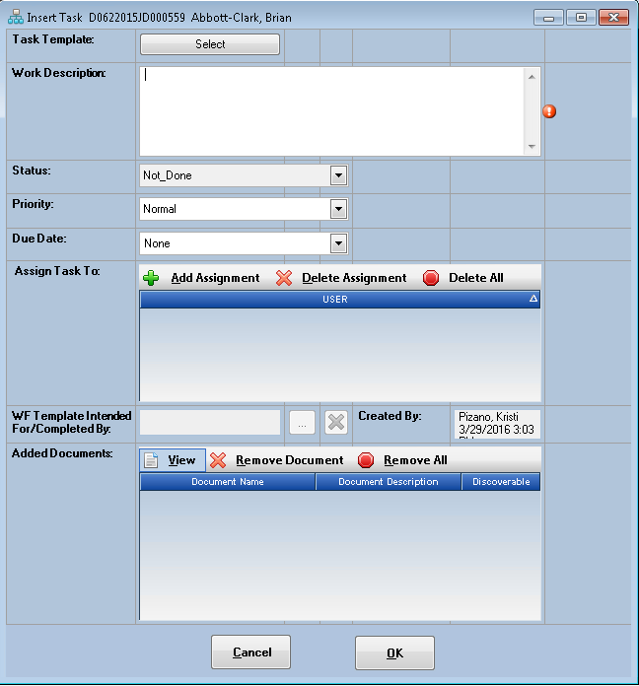

Victim Witness Form

The Victim Witness Tab has been enhanced so that when a Non-LEA witness type is added identifying a witness the District Specific Agencies entered from the “Other Agency” Tab within Maintenance are displayed with their code and also the full name for easier selection.

1. Power Users within a District can create and maintain addresses that are often used in daily VW entry that are non-law enforcement related.
   1. Maintenance
   2. Agency
   3. Other Tab
      1. Add/Edit/Inactive these agency selections.

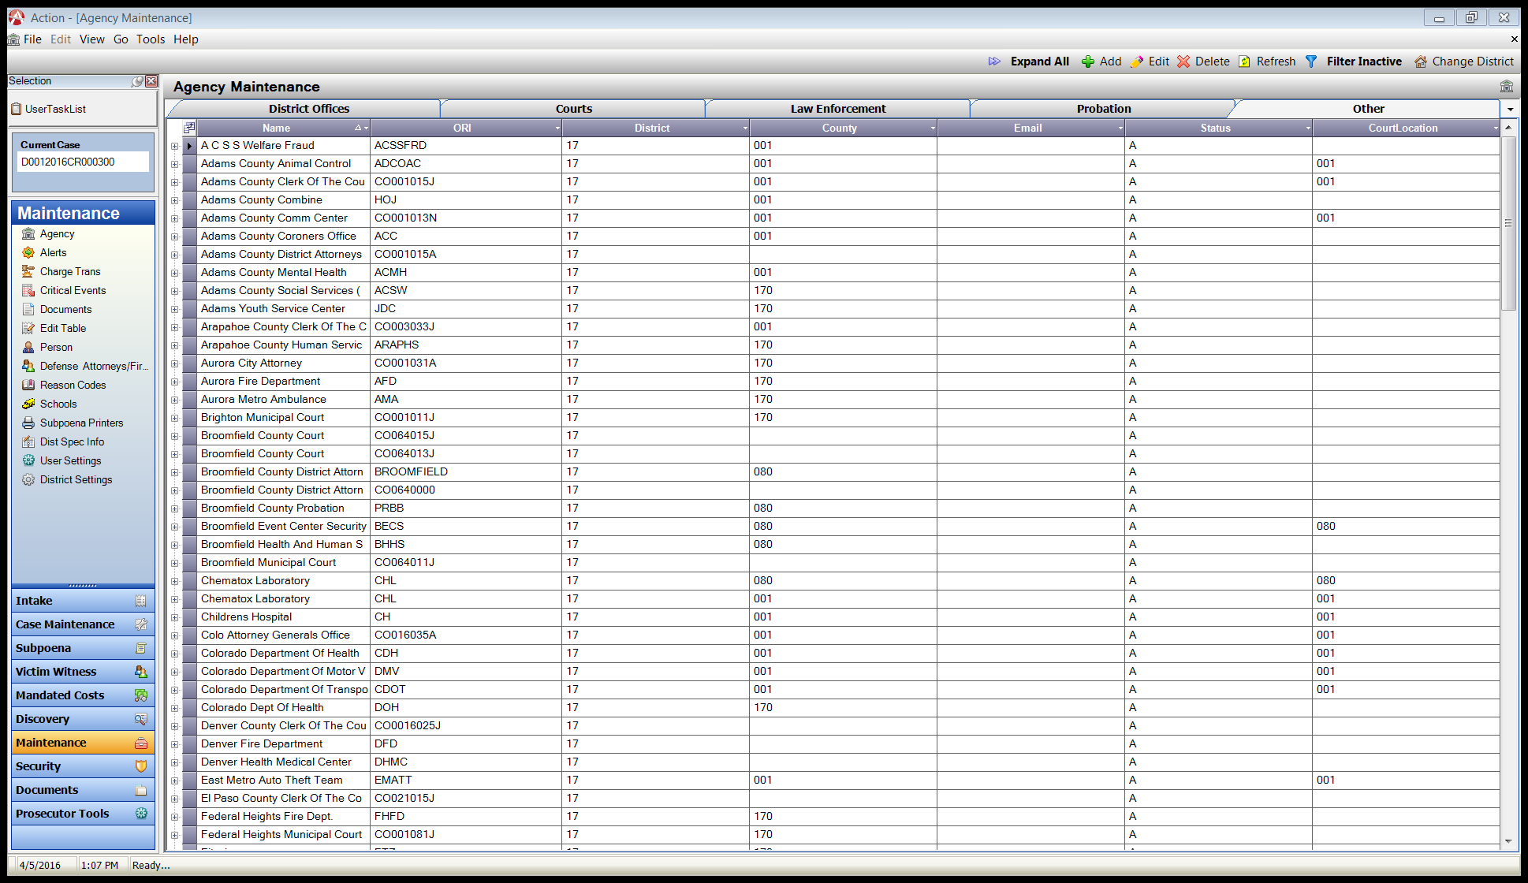

1. 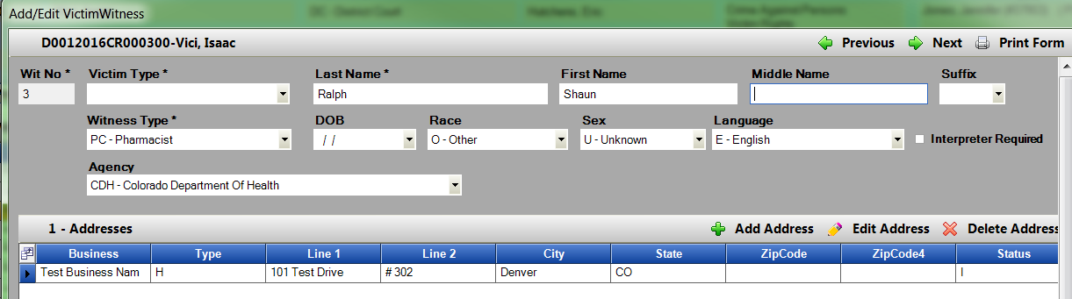In the VW tab select a Non-LEA witness type such as LA = Lay Witness; PC = Pharmacist etc. the Agency field is now displayed with the code and full name/description of the Agency for easier user identification and selection.
2. In the VW tab: Addresses section, if an address is now user marked as Inactive this will un-check all of the notification type selection boxes previously associated to it.

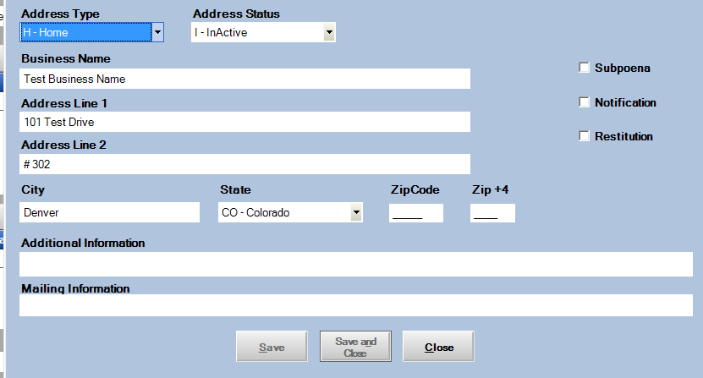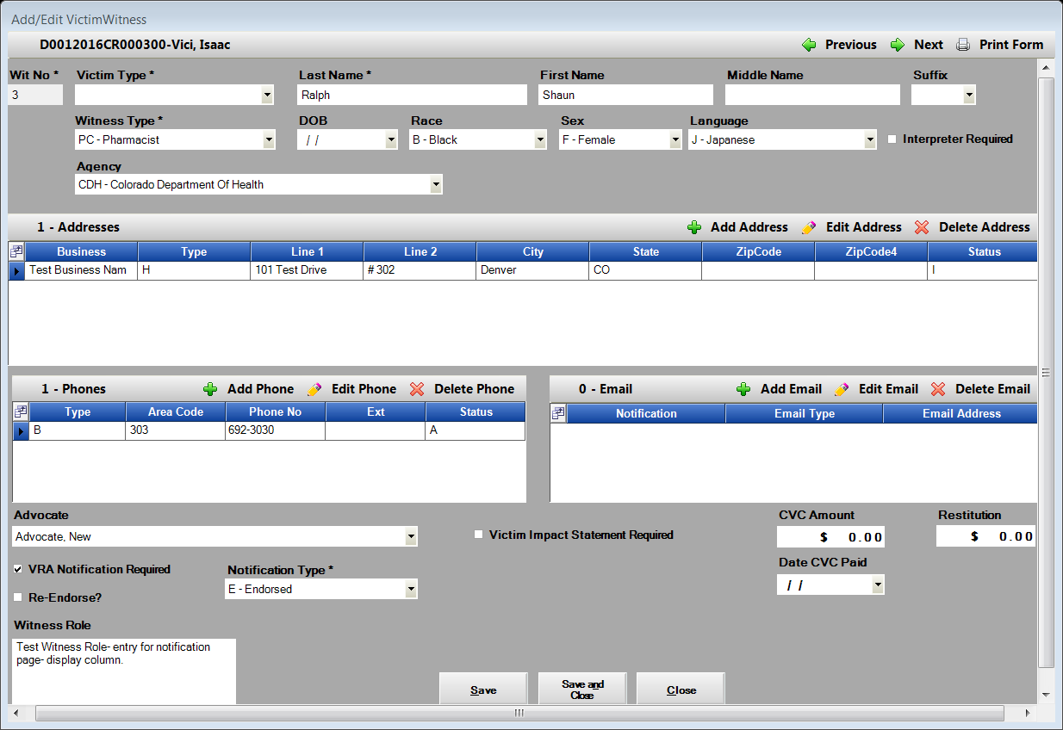As a review these notification type selections are Subpoena’s, Notification (VW Notification Letters), Restitution. Users may enter multiple active addresses so that each notification type selection can be connected to a specific address. These notification type selections can only be flagged independently once. (Example 2 Active addresses only one of these address can be marked as Subpoenas). Setting the check box on once record will remove the check from the previously marked record.

Victim Witness Notification Screen

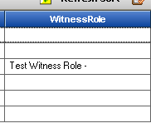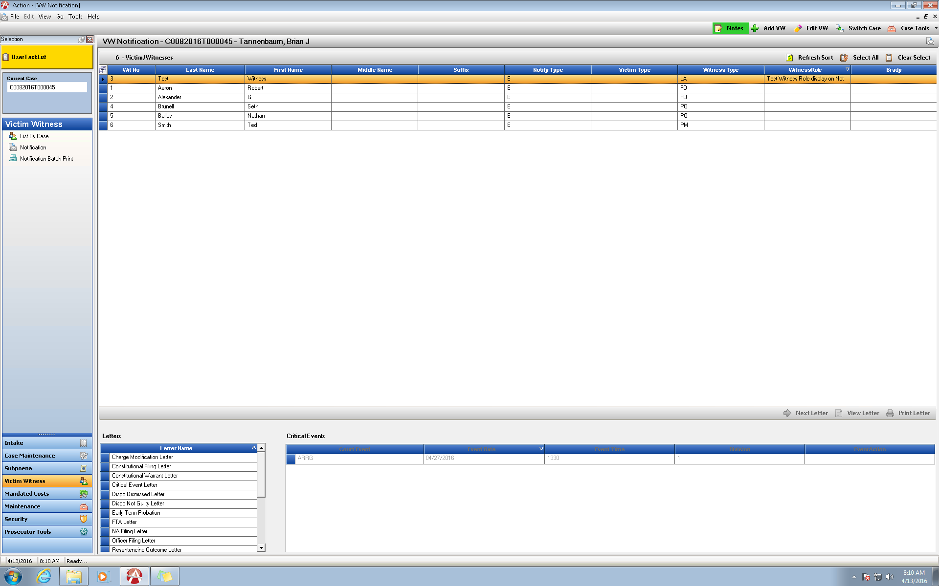 The Victim Notification screen used for producing Notification Letters is now also displaying a column for the Witness Role. The witness role field is a free form field where a note about that witness can be entered on the VW Tab in your case in Action. This will help users see more information quickly about the witnesses as they are preparing to send out Notification Letters.

Prosecutor Dockets

Add to Calendar- Google Calendar’s Display

Districts set up with Google Calendars, adding court events to your Google calendar from Prosecutor Tools- Dockets will now be displayed with the Defendants Name, Case Number and then the 4 Code Court Event. All other functionality has remained unchanged.

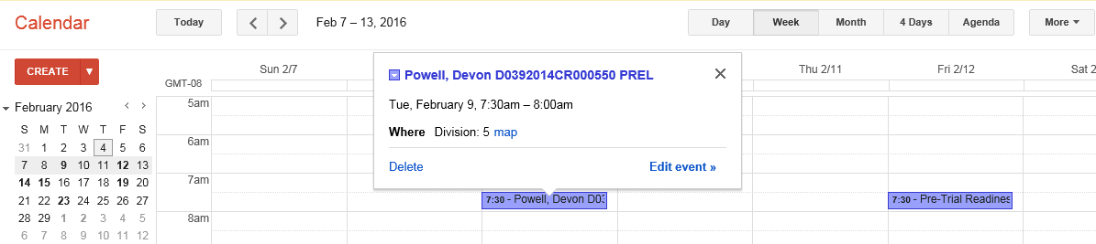

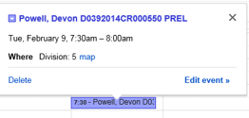

Action Header Enhancement

Action Header will now display the Defense Attorney’s that the users have entered on the Case Tab within Action. This was added so that from every tab a user is accessing they can see quickly who the listed/entered defense council is.

Power users maintain the defense attorney information from Maintenance, Defense Attorney/Firm table within Action.

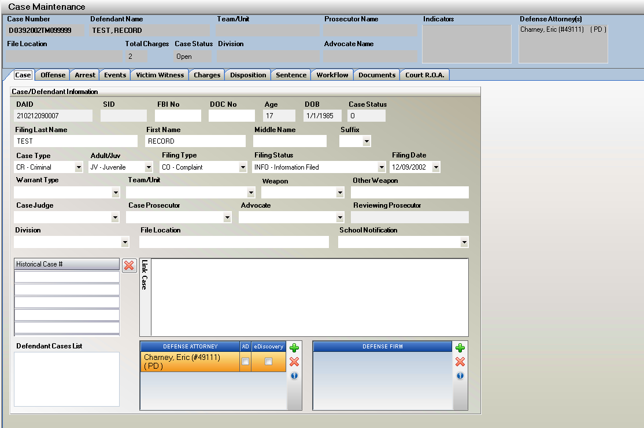

View from Documents/ Action File Cabinet of Defense Attorney’s

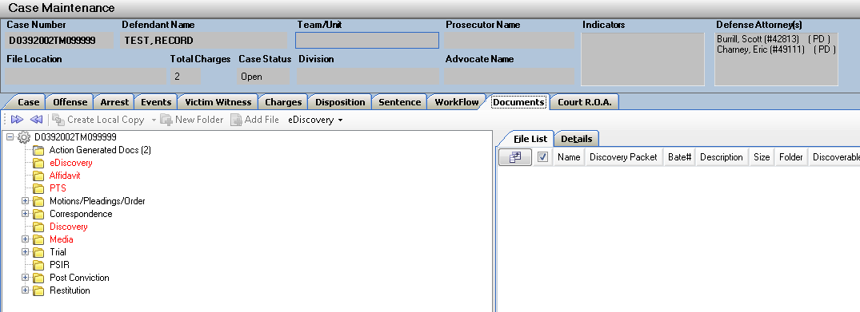

**Miscellaneous**

1. Noting within Action. Tab order has been corrected so that when a user is adding a new note the tab sequence follows the fields for easier entry.

Note Sub Type, Subject, Note Text, OK, Clear, Cancel.

Private selection box is excluded from the tab sequence.

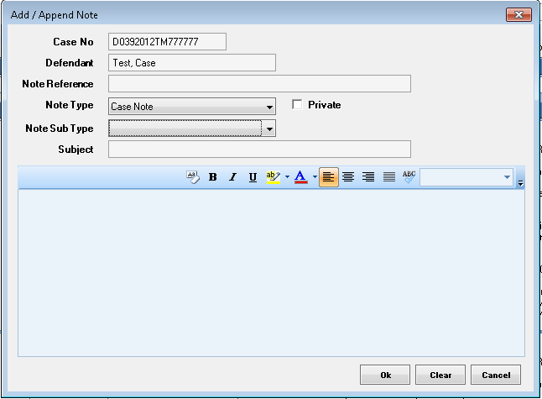

1. Sealing a case in Intake, after the case was No-filed was producing an error message. This has now been resolved. The case seals without issue.

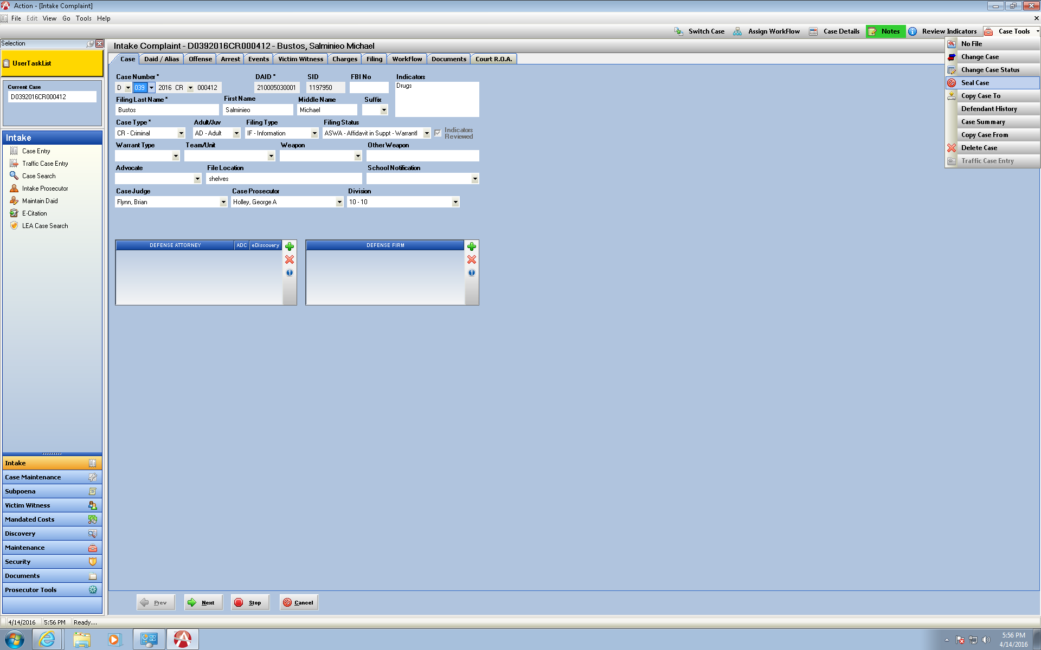

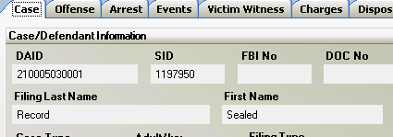

1. Edit of Court Events in the Events Tab in Case Maintenance has been enhanced so that if a user selects an associated reason code in error, they can now Edit the Event and select a blank Reason instead of being locked into selecting another code.

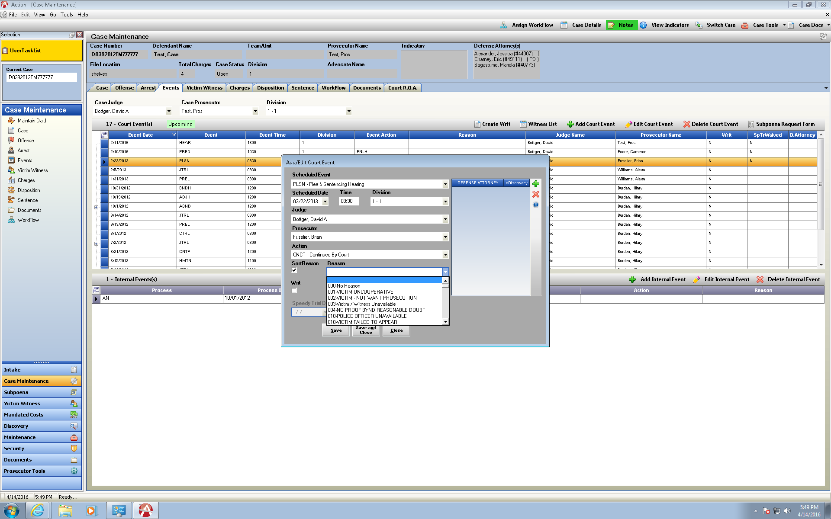

1. Edit of Officer Maintenance fields Rank and Suffix now also have a blank selection under the drop down so that a user is not locked into selecting a value that was entered incorrectly.

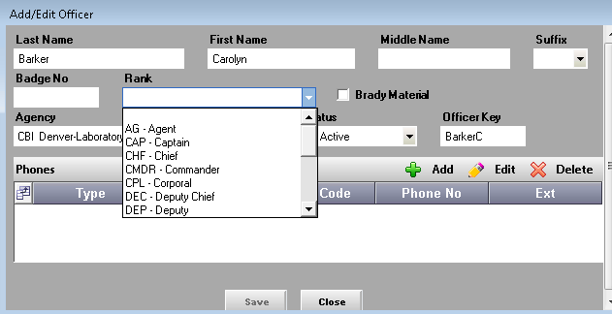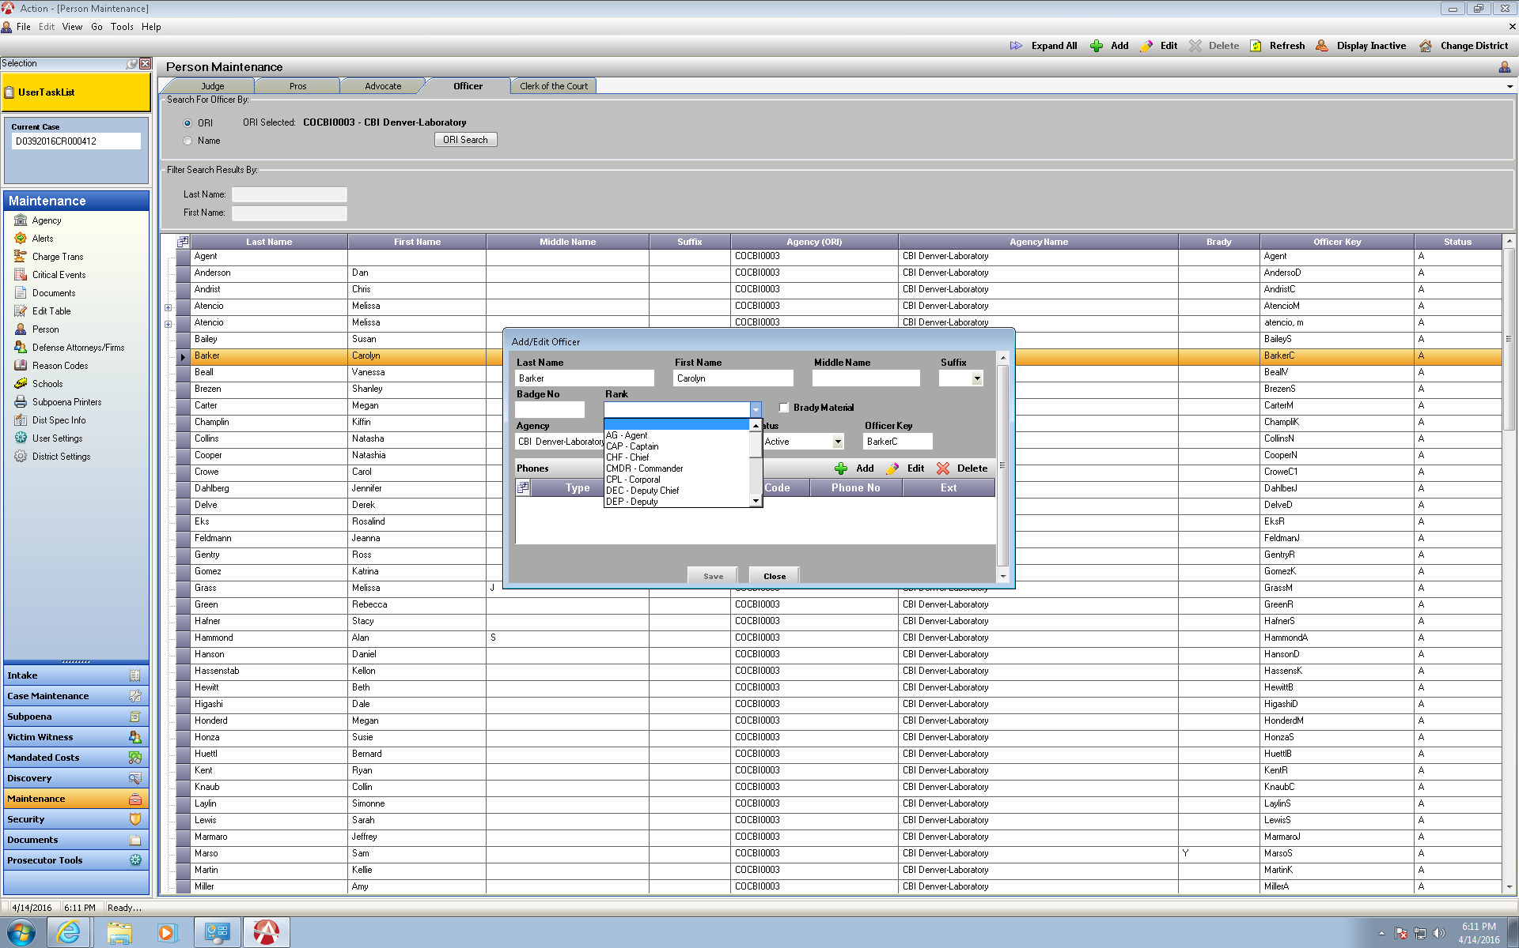

**Action Scan V 3.1.1**

1. **Action Scan**-V 3.1.1 is now available. Enhancements include adding Work Flow- Route Document, and creating a new Click Once deployment method.

Please contact [Kristi@cdac.state.co.us](mailto:Kristi@cdac.state.co.us) for more information on this.

1. I also want to reiterate that Action Scan uses 3rd party software to obtain the images from scanners that requires a license to be purchased.  The cost of these licenses is $600 per computer where Action Scan is installed.  CDAC has purchased 3 licenses for each district, so you can install Action Scan on 3 computers for free, but will need to pay for additional computers.  Please contact CDAC before purchasing these additional licenses.