Mini-Release December 15, 2016

Action File Cabinet:

A. Produce PDF that contains all Bate Stamped Discovery for Prosecutors

1. District Setting

Off- (default value)

Manual Mode

Automatic Mode

1. Select Mode and have CDAC turn on this setting for the District.

Manual Mode: Users will select when they want to create the PDF document after a discovery packet is produced.

Automatic Mode: When discovery packets are created process will automatically create/append the PDF document on the case.

1. Create Discovery Packets as normal internal process- packet must be bate-stamped.
2. If in Automatic Mode- After the Discovery Packet has been created the Prosecutor PDF will then be generated under eDiscovery folder.

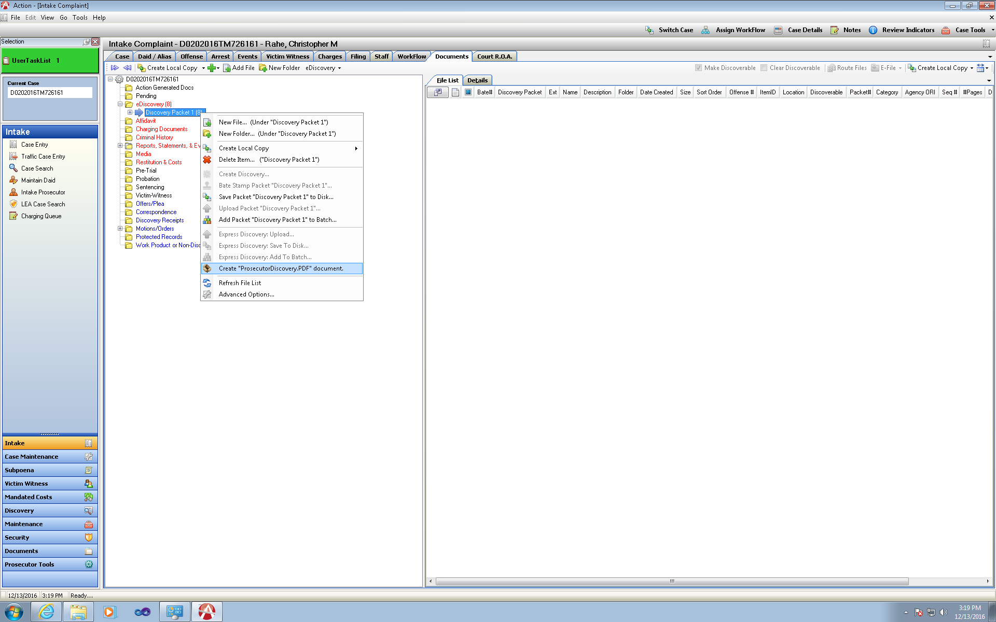If in Manual Mode- Right Click your discovery packet or from eDiscovery select new option: Generate Prosecutor Discovery PDF to be produced in the eDiscovery folder.

1. Process Runs and Saves Directly into the eDiscovery Folder

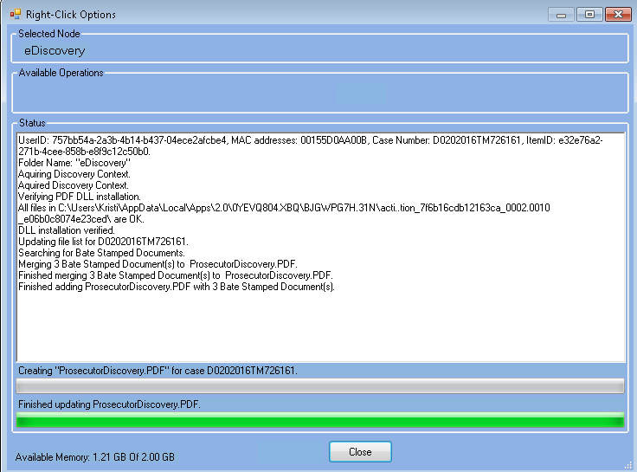

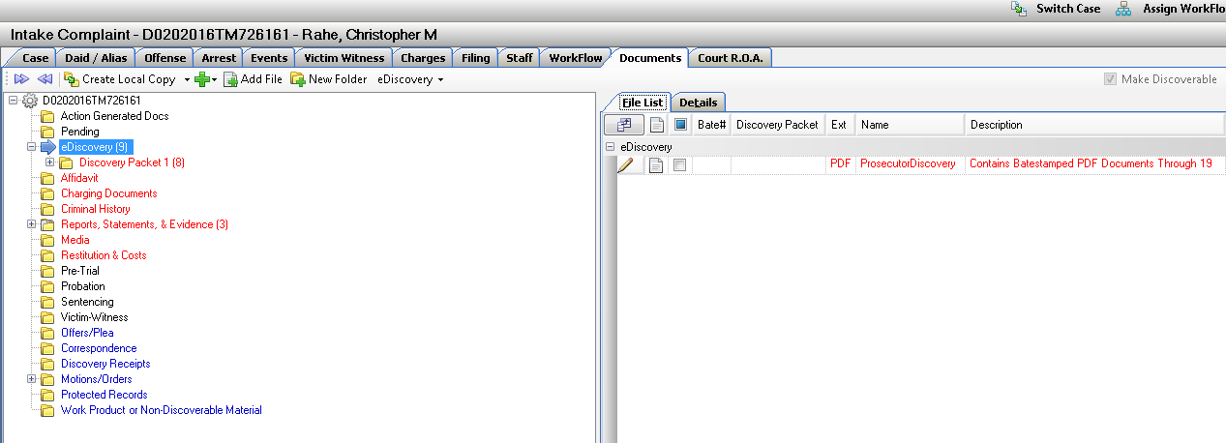

1. When Supplemental Discovery is added to the case and Subsequent discovery packet has been generated- again if will either be automatically appended, or when if on manual – will be appended once it is user selected.

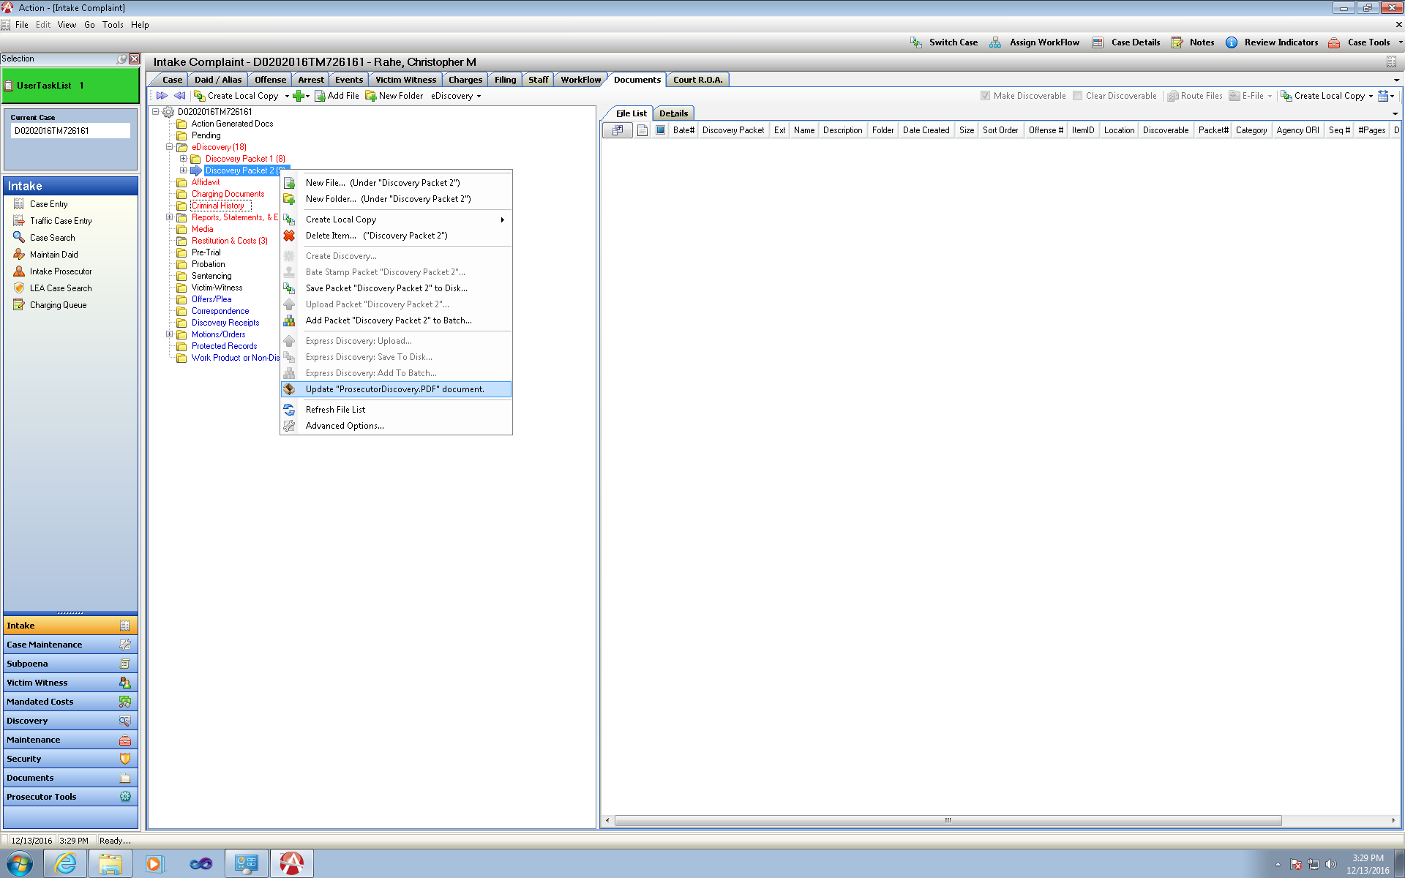

1. User can create a local copy of this PDF-

Save File Only Option under Create Local Copy from the File (Right) side view.

Defaults to as Prosecutor Discovery name.

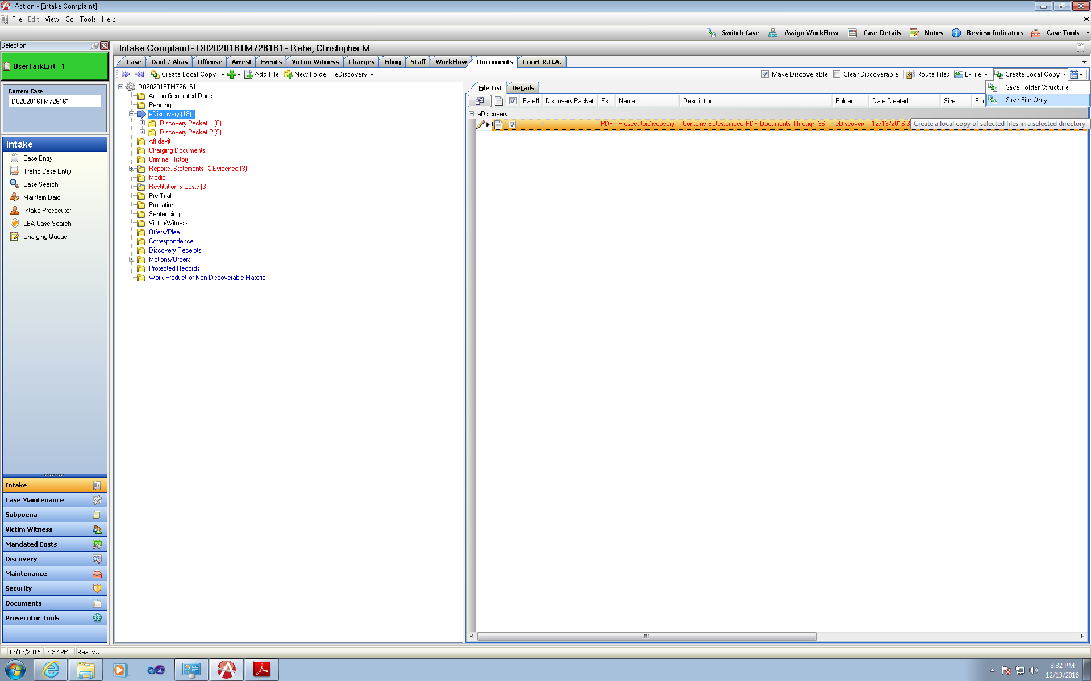

1. Note- if there are NON-PDF files included in your discovery packet- their bate stamp will be referenced on the Non-PDF File List that is bate-stamped.