ACTION ENHANCEMENT GUIDE

February 2016 Release Training Guide



February 3, 2016

CDAC

CDACweb.com

**Table of Contents**

1. Charge Look Up enhancement……………………………………......................................... 3
2. Note enhancement …………………………………………………………………………………………… 4
3. User Task List enhancement ………………………………………………………………………….. 5
4. Victim Witness Tab enhancement …………….……………………………………………………… 6
5. Case Summary option to print when Case Closed ………………………………………..…… 7-8
6. Review of Closing Cases in Action …………………………………………………………………….. 9
7. Bug Corrections ………………………………………………………………………………………………… 10
8. Miscellaneous ……..…………………………………………………………………………………………… 11

Charge Look-Up

Charge Look-Up was created in our December release. We have now added an enhancement to view the selected charge language when the user selects a charge. This makes viewing the actual charge language easier and allows the user to copy and paste the language to documents outside of Action.

1. Select Charge Look up from Tools dropdown selection
2. Search for Charge and Highlight.
3. Charge Test is now displayed in the form.
4. Charge Look up window can be minimized, for continued work in Action.

*Note if there is no charge text associated to the selected charge a note is displayed to the user: There is no charge text currently available for this charge *

5. This charge language has also been added to the **Add/Amend Felony Charge Tab** for easier

reviewing of language before selected as an Added or Amended Charge on your case.

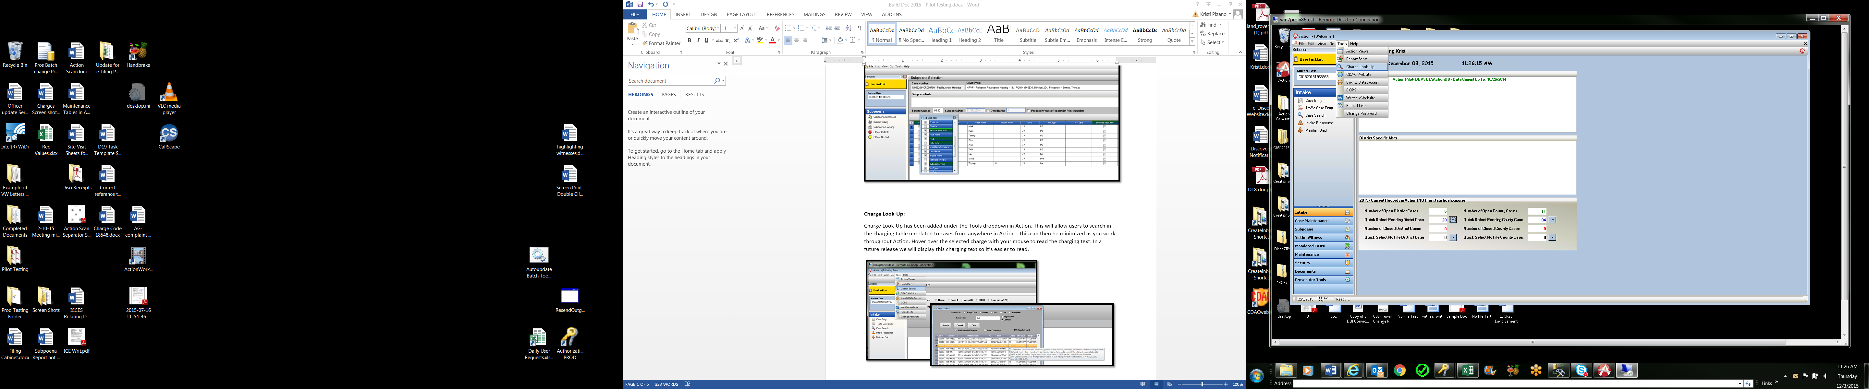

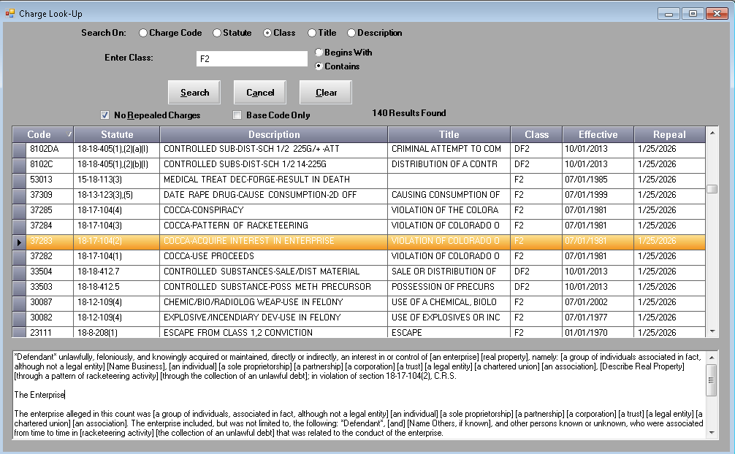

Noting

The noting function in Action has been enhanced to indicate to the user when the maximum note length has been exceeded and the current note cannot be saved. The user note is retained so that they can cut/copy part of their extended note into a subsequent note. Previously notes would return an error that the Note could not be saved at this time and the user would lose their information.

1. Open Notes in Action. Add notes, if exceed character limit is reached this message will appear advising user to shorten the note.
2. Click OK- shorten the note or copy/cut portion of extended note to paste into a new note

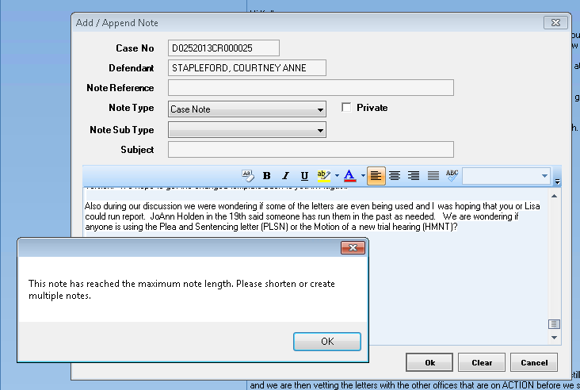

Work Flow- User Task List

User task list has been enhanced to show the Defendant name in a new column next to the case number, when tasks are viewed with the default of Group By: None.

This new column can also be sorted on, as with current functionality of all columns in the task list.

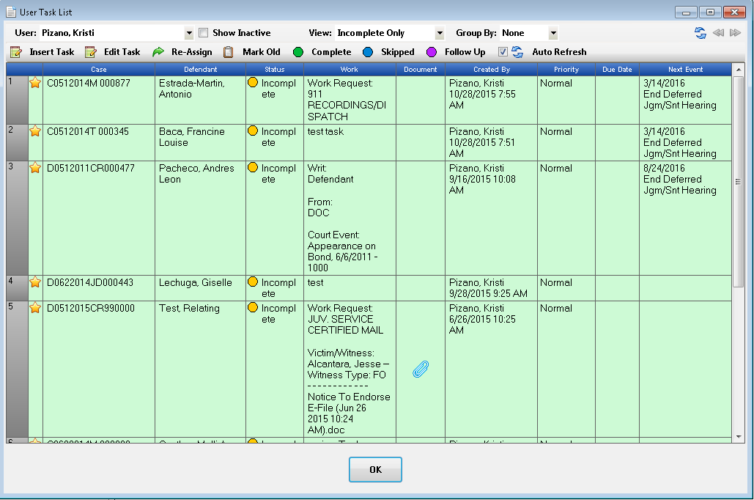

Victim Witness Form

The Victim Witness Tab has been enhanced with the ability now to update a newly selected ORI if the record is being edited. Previously if users were editing an existing record and new ORI was selected the Address and Phone number were not updating correctly and was a manual entry. This is the first enhancement in a series CDAC is working on involving this screen.

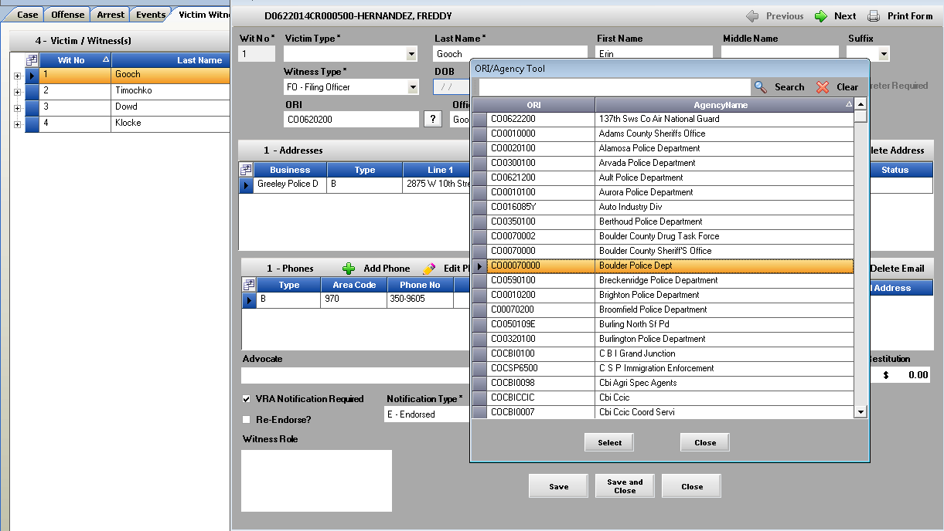

Case Summary View/Print Option on Closing Case

Enhancement to closing out cases in Action has been added to allow users to click a check box titled: View Case Summary that will open the case summary and allow users to view/print all this report saving time from accessing this report from Case Documents.

1. Select Case Tools- Close Case
2. Close Case Window is displayed
3. **Click** on New option: View Case Summary
4. Verification of complete data fields will check case first, if no errors returned the case will close successfully.
5. Case Summary will then open for user to view/print.

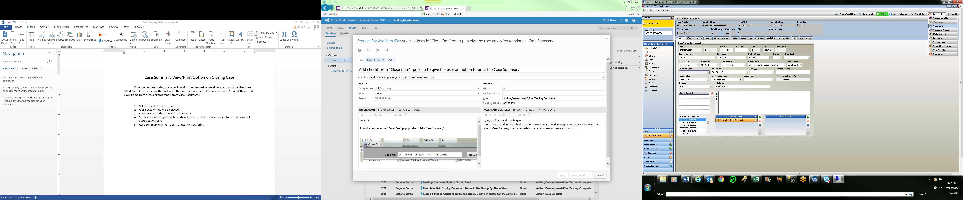

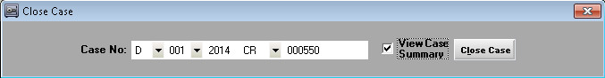

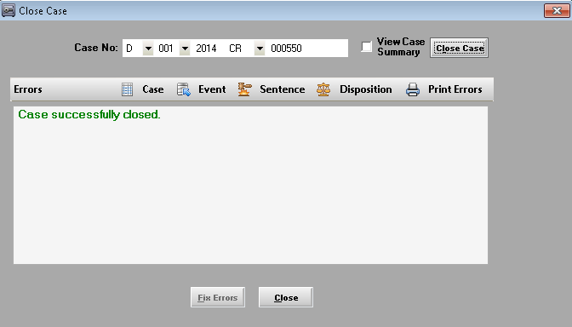

**Example of Case Summary Produced**

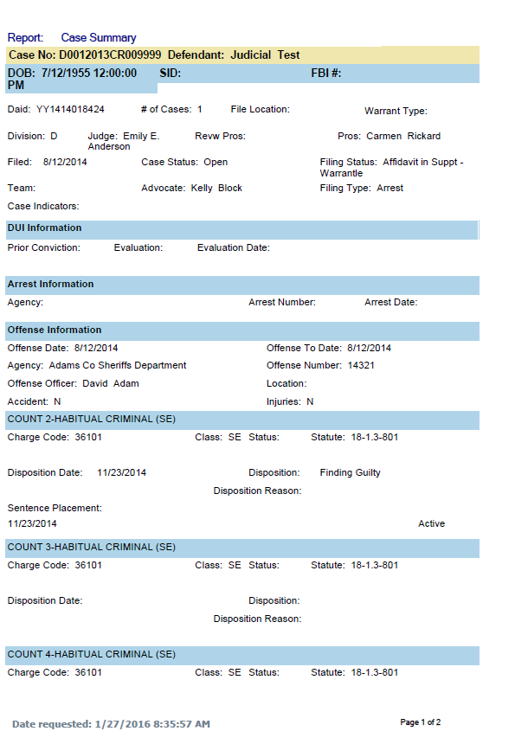

Review of Closing Cases in Action

Validation to close a case in Action follows these steps outlined below. To ensure you are able to successfully close your case look at these areas of the data entry and complete before you attempt to close a case.

Case Tab:  Warrant Type field must be changed back to empty indicating no warrant currently on case.

Event Tab:  All Court Events have an Event Action entered (describes what happened at that event) exception in the ENDJ Event Action which allows users to enter a future review hearing but close the case.

Disposition Tab:  All Charges in a case must have a correlating disposition attached, such as DMDA (Dismissed by the DA), FFGP (Finding Guilty Plea) etc.

Sentence Tab: All (Guilty Dispositions) appear on the SE tab and must have a correlating SE info attached to each.

Close Case is located under Case Tools- upper right hand corner in Action – Case Maintenance.

**Bug Corrections**

1. Charges in Traffic Case Entry was getting stuck if there was not an offense date range selected first. This has been corrected to give user message that these dates need to be entered now.

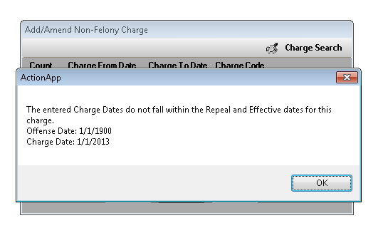

1. Case Events and Internal Events- Old Defense Attorney field that was free-form entry has now been grayed out to prevent user entry and encourage use of the correct Defense Attorney fields used state-wide.

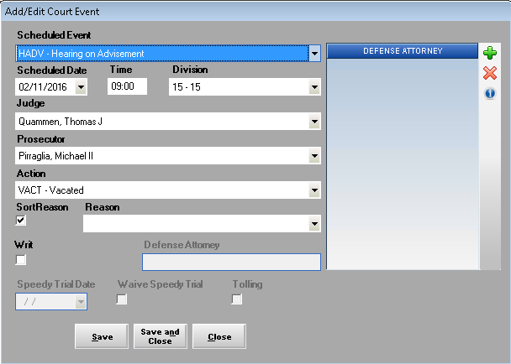

**Miscellaneous**

1. **Action Scan**- new enhanced release for high speed scanners and with improved user log in will be available for Districts.

Please contact [Kristi@cdac.state.co.us](mailto:Kristi@cdac.state.co.us) for more information on this.

1. Action will now capture more computer specifications of authorized Action Computers for help in upgrading Action components to user’s computers.
2. No-File Cases in Case Entry: The reason code selection has been removed as a required selection when No-Filing a case.
3. “Other Drug” has been added to the Drug List used in the DUI form and within Drug Charges in the variable selection drop down.
4. Defense Firm Search on the Case Tab: Search has been enhanced to look at Begins with instead of Contains for a more defined search.
5. Correction of Misspelling of Maintenance under GO on top toolbar selection.
6. E-filing Districts- we are removing the Related to Column on the e-filing form as there is not existing functionality for this. This will be implemented back when full functionality for relating document in Action is available.