aCTION ENHANCEMENT GUIDE

July 2016 Training Guide



July 29, 2016

CDAC

CDACweb.com

**Table of Contents**

1. Staff Tab in Action-…………….…………………………………………………………………….. 3-4
2. Victim Witness- Intake enhancement……………..………......................................... 5
3. Bond Amount Field ………………………………………………………………….……………. 6
4. Civil Cases linked to Criminal Cases …….…………………………………………………… 7-8
5. Prosecutor’s Case List ………………………………………………………………………………… 9
6. Miscellaneous …………………………………………………………………………………………….. 10
7. Action Scan V 3.1.1 ………………………………………………………………………………………… 11

Case Staff Tab

Action now has a Staff Tab on all cases that will allow Action users to select and add staff members connected directly to a case.

This tab includes these different staff member options:

* Multiple Prosecutors
* Admin Assistants/Paralegals
* DA in house Investigators
* 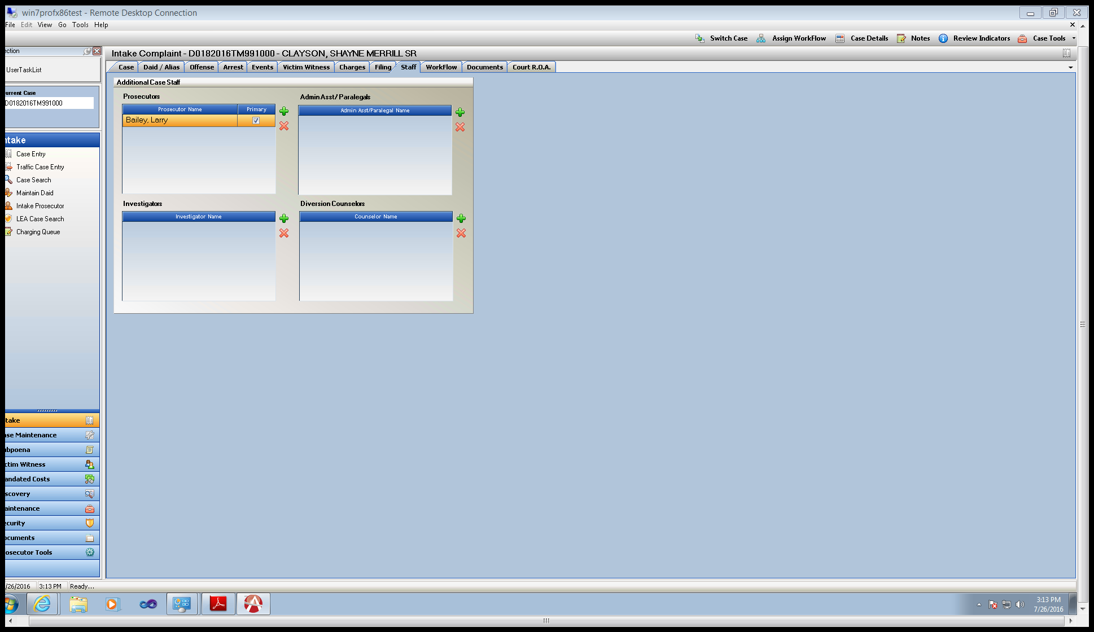Diversion Counselors

Prosecutors:

Primary Prosecutor entered from the Case Tab field in Action is the ACTIVE Primary Attorney on the case, used for ICCES alerts on e-filing, and Prosecutor Tools within Action. When adding Co-counsel simply click  to add additional prosecutors from your district to the case. You can change/update the Primary Attorney by clicking the Primary Check Box shown above as well. This will then update the Case Primary Prosecutor field.

Click  to add Admin/Paralegals; Investigators; Diversion Counselors

Click  to remove records connected to a case.

Adding Users to Maintenance Tables to then select from within your Action Case- Power User Function.

Maintenance Person Table Diversion Counselor, Investigator, Admin Ass/Paralegal Tabs

Navigate to appropriate tab and click Add- Enter User Information for each area, this allows the user to be selected within the new Action fields. These entries will need to be in-activated when a user leaves the office.

These entries are now accessible in the Staff Tab for Section onto your case. The Prosecutor list uses current Pros Tab.

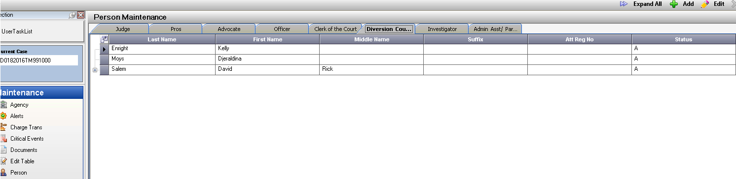

Minimum Data Entry field information for Add Record:

Last, First Name

Job Title

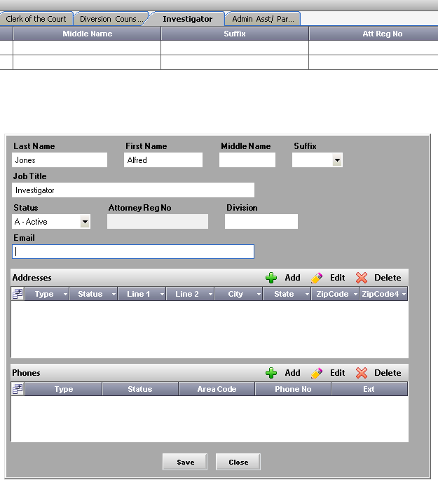

Victim Witness Intake Forms Only

Victim Witness Tab in Intake Forms now have additional functionality of Move UP and

Move DOWN This additional functionality will allow users to re-order their witness lists before a case is filed with the court.

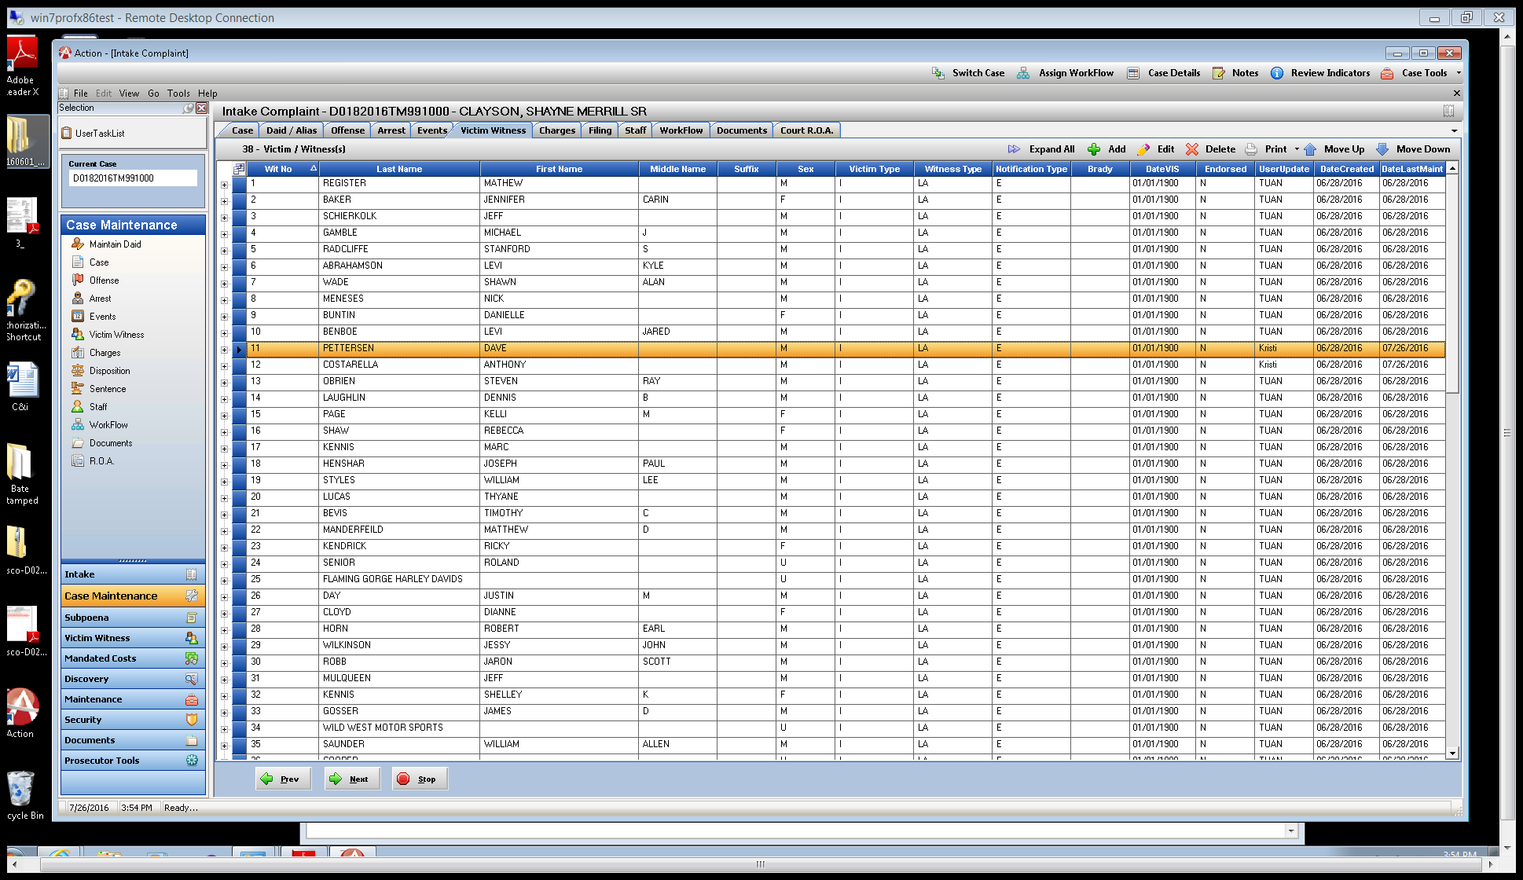Highlight the record you wish to move and then use the up and down arrows to move this witness into the desired location/witness number location. This option is only available in Intake as when a case is filed with Judicial we send over Victim and Respondent transfers for their system and the Wit #’s need to be retained.

Bond Amount Field

Action users can now enter a Bond Amount on the Charges Tab. This amount entered if the case is in Intake will be saved when the user creates the Complaint and Petition. The Bond Amount appears in both Intake and Case Maintenance and can be updated at any time to help track current bond amounts in your case.

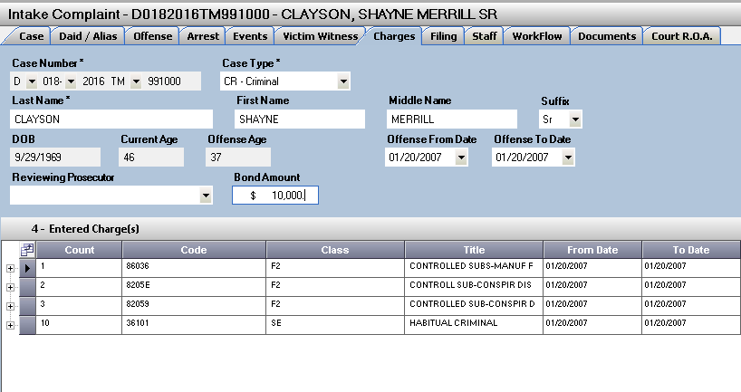

Bond amont is saved to Filing tab for use in preperation of filing documets. This defaulted value from the charges tab can be overwritten here if needed as in current functionality before producing documents.

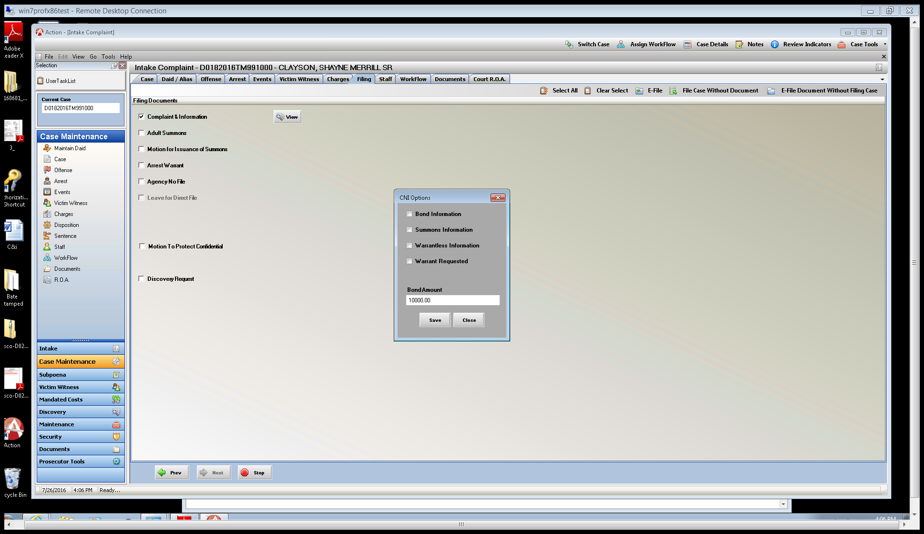

Civil Cases Linked to Criminal Cases

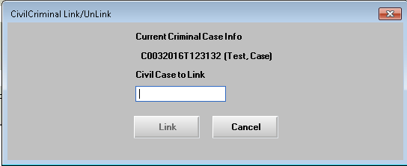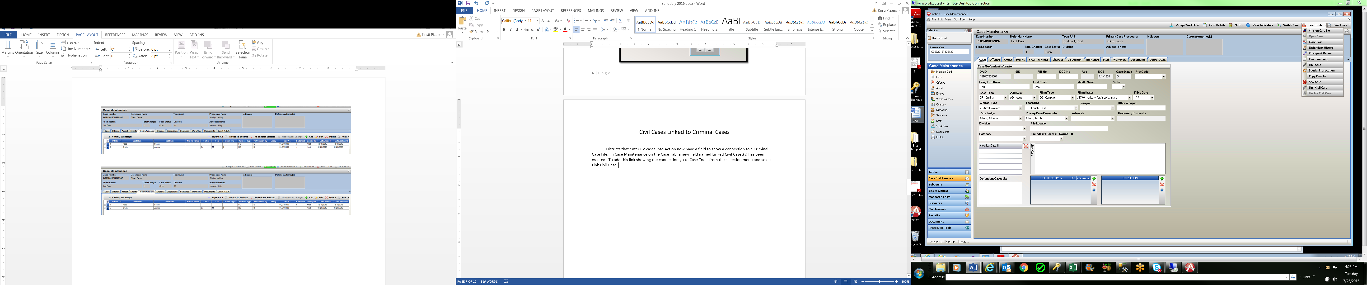 Districts that enter CV cases into Action now have a field to show a connection to a Criminal Case. In Case Maintenance on the Case Tab, a new field named Linked Civil Cases(s) has been created. To add this link showing the connection go to Case Tools from the selection menu and select Link Civil Case. Enter the full 15/16 case number sequence.

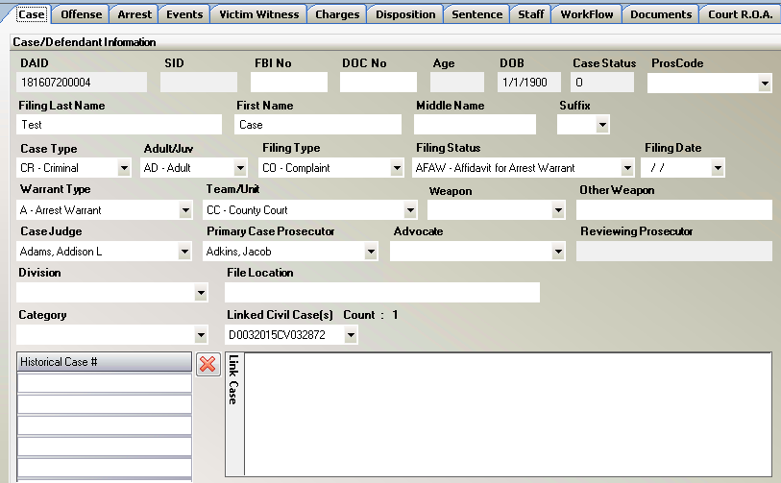

Unlinking Civil Cases, works the same way as adding. After a link has been made it can also be removed by again clicking on Case Tools, now selecting Unlink Civil Case. Select the case you wish to remove from the pop up display and click Unlink.

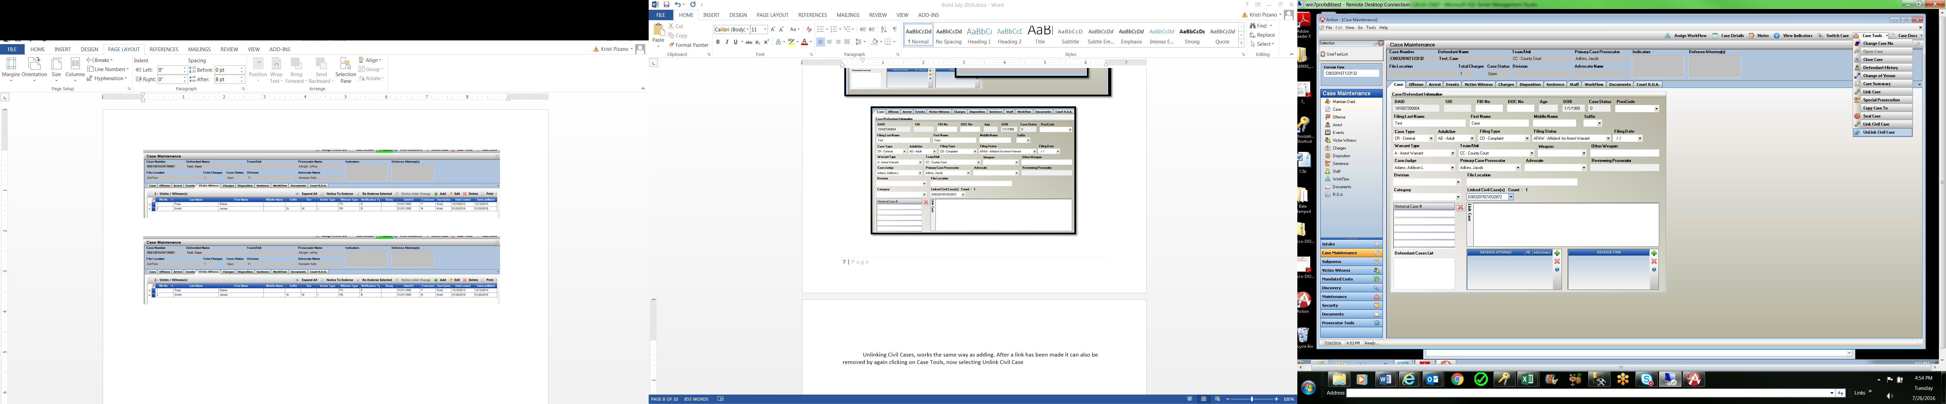

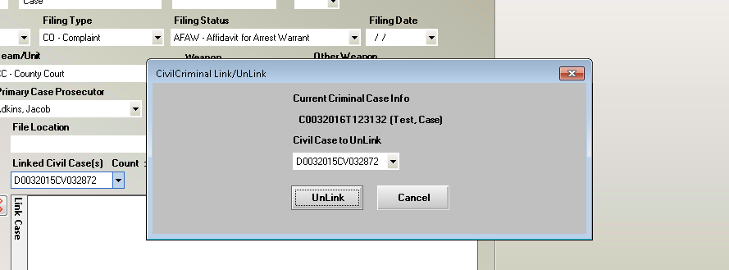

**Prosecutor Case List**

A new functionality to Display a Specific Prosecutor’s Case List in Action has been under Prosecutor Tools. This will default to the Prosecutors name logged into Action, or the drop down selection can be used to select any Active Prosecutor in your District.

The list returns all Open, Re-Opened and Pending Cases, where the prosecutor is listed as the Primary Prosecutor or as co-council from the new Staff Tab in Action.

The list includes columns on the following fields that can be sorted by click on the column header:

Case Number, Defendant Name, Division, Case Status and then if the attorney is the Primary attorney listed or entered as co-council through the Staff Tab indicated by a Yes/No display.

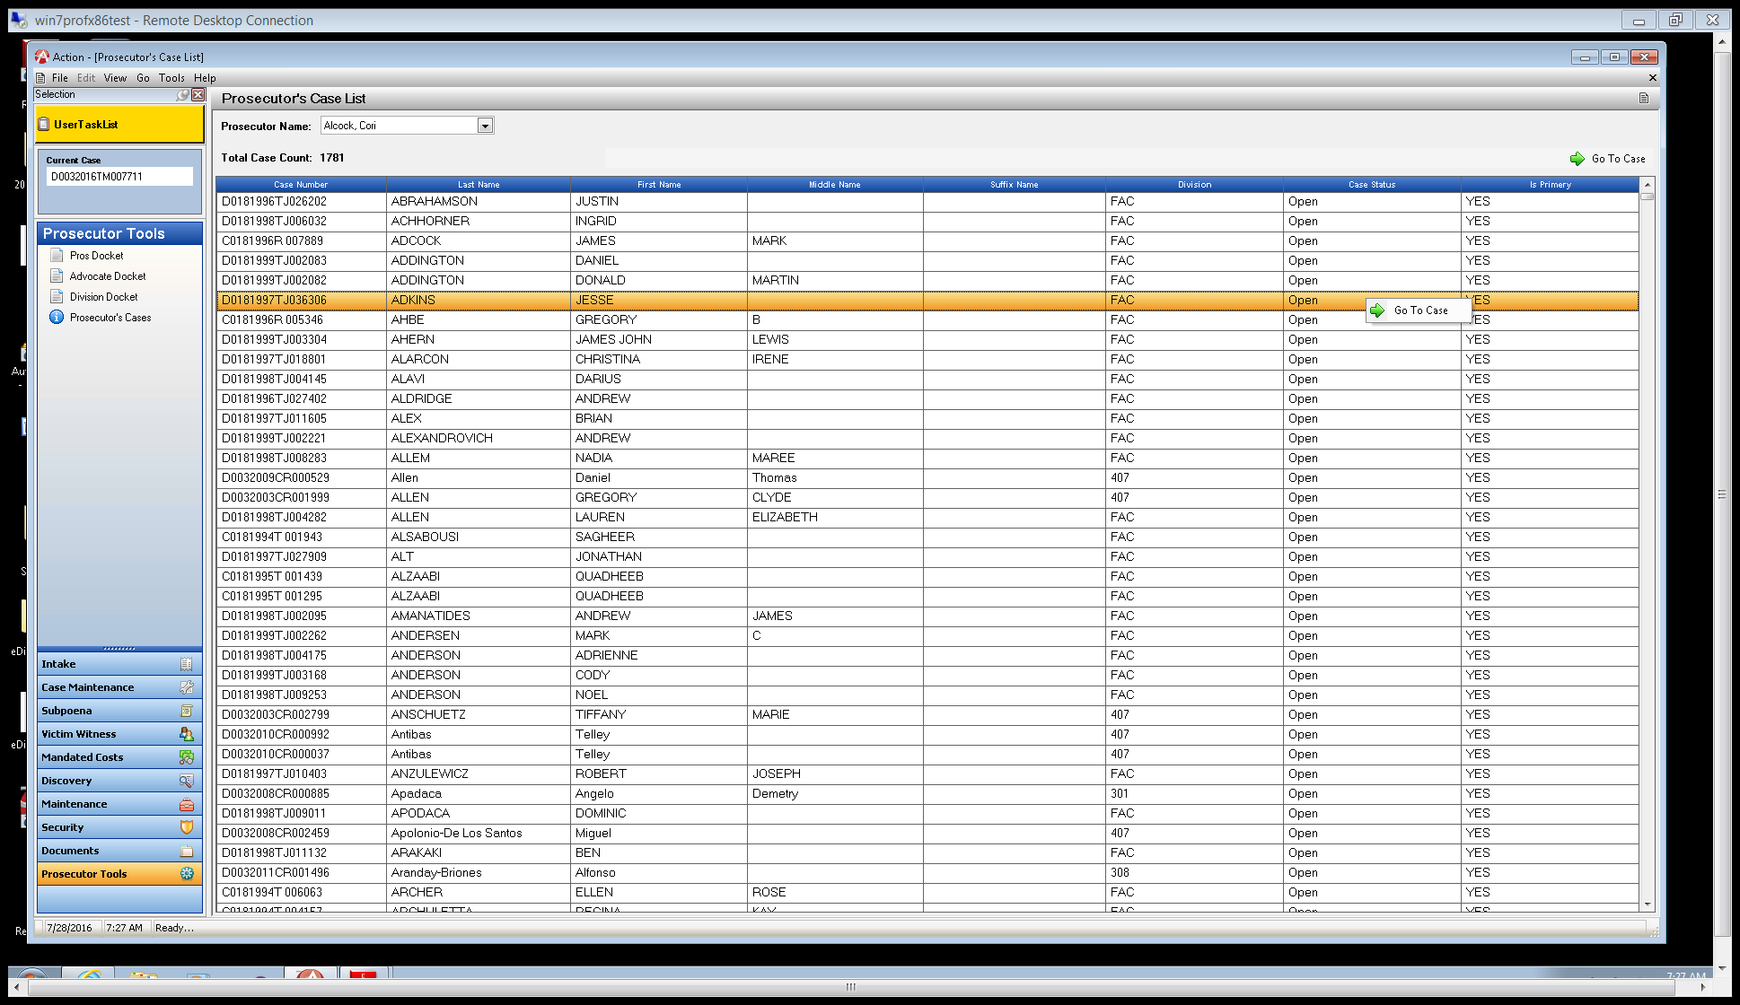From this displayed list the user can go directly to the case by highlighting the record and clicking on Go to Case or using a Right Click Menu Option – Go to Case.

**Miscellaneous**

Left Panel Display in Case Maintenance now includes quick selection of Staff Tab, Work Flow, Documents and ROA tabs in your case.

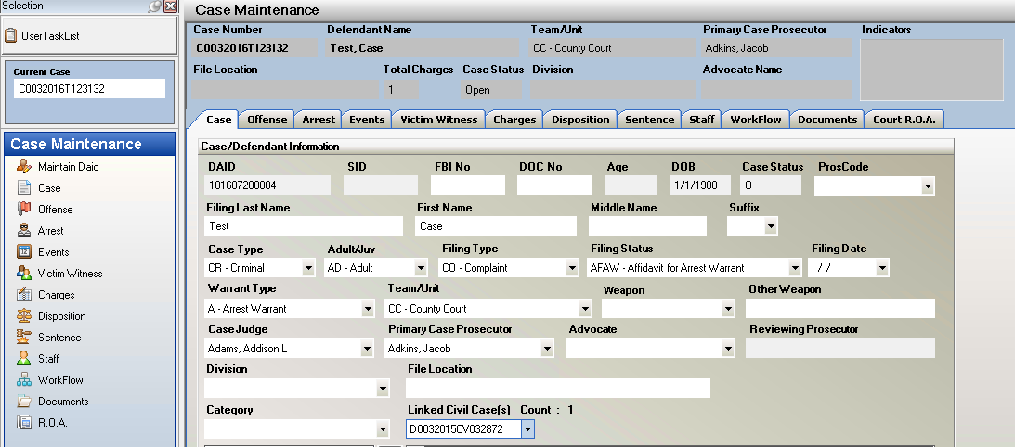

**Action Scan now with Action Scan Queue**

1. **Action Scan**/**Queue** is now available.

This enhancement adds a working queue where file can be scanned in and then added to a user generated queue that can then be accessed later to move files into the correct Action Cases by other users. This creates a new office workflow functionality allows great flexibility with how documents are scanned in at your office.

Please contact [Kristi@cdac.state.co.us](mailto:Kristi@cdac.state.co.us) for more information on this, and to set up a training review of this functionality.

* Note: This is a District setting that CDAC will turn on per request.

1. I also want to reiterate that Action Scan uses 3rd party software to obtain the images from scanners that requires a license to be purchased.  The cost of these licenses is $600 per computer where Action Scan is installed.  CDAC has purchased 3 licenses for each district, so you can install Action Scan on 3 computers for free, but will need to pay for additional computers.  Please contact CDAC before purchasing these additional licenses.