aCTION ENHANCEMENT GUIDE

November 2016 Training Guide



November 9th 2016

CDAC

CDACweb.com

**Table of Contents**

1. Interested Parties New Addition to Victim Witness Entries ………..………….. 3
2. Mandated Costs additional Updated/Entered by fields ……………….………..... 4
3. Subpoena Request Work Flow Template ……..…………………………….……………. 5
4. Staff Tab ……………………………………….…….…………………………………………………… 6
5. Re-Numbering Charge Counts ………………..……………………………………………… 7
6. Action File Cabinet Enhancements…………………………………………………………….. 8-21
   1. Local File Pick-up
   2. External Media Notification
   3. Batch – Pick up with receipt for Local Pickup
   4. Links
7. Miscellaneous ………………………………………………………………………………………… 22

Interested Parties- Victim Witness

New field addition to the Victim Witness Screen in Action. We have added a new column on the main display grid for Victim and Witness Entries and a new field on the Add/Edit Victim Witness form that will allow users to make connections between witnesses appearing on the VW table.

1. Enter all VW entries as normal
2. Edit the VW entry, select Add under the new Party Field- a listing of all the entered VW’s on the case is displayed. Select the VW and then select a Relationship. These will then display on the main Victim Witness form for easy identification.
3. Example: Enter a Child Witness or Victim; Enter a Parent or Guardian. On the Child’s entry you can add in the Parent or Guardian as the Interested Party and list the relationship as Mother.

** Please Note the Add/Edit VW screen has been updated and fields have been moved from previous locations to accommodate the new field.

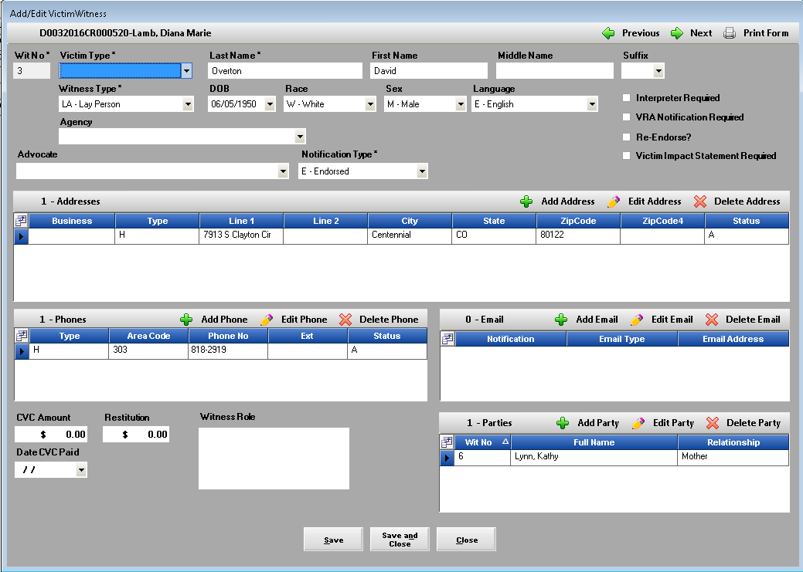

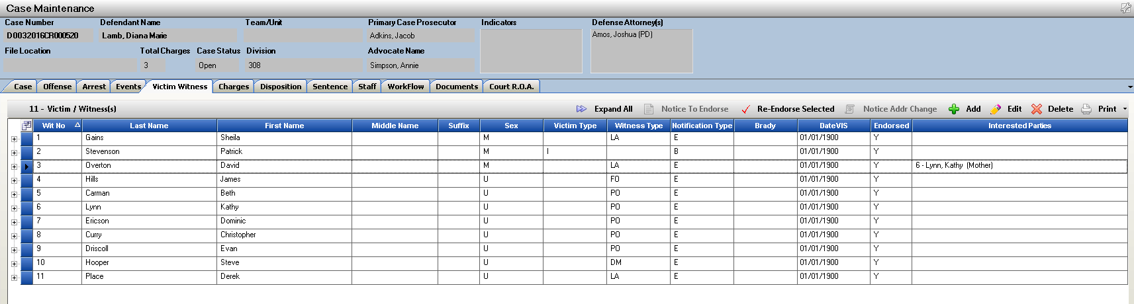

Mandated Costs

Mandated Costs have been updated so that as a user Edits an existing cost the initial entry date and entered by will now be displayed as well as when it was updated and updated by. This will help districts see additional information about the entries.

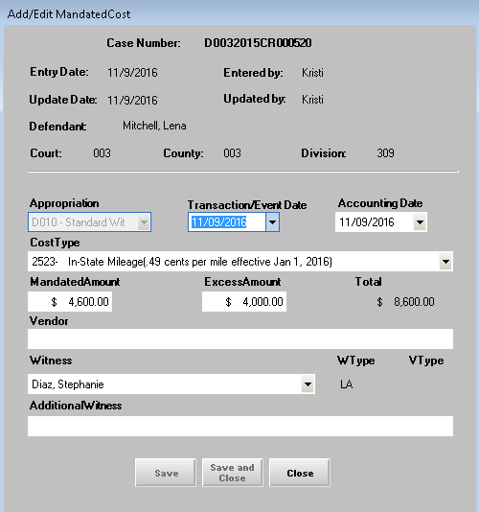

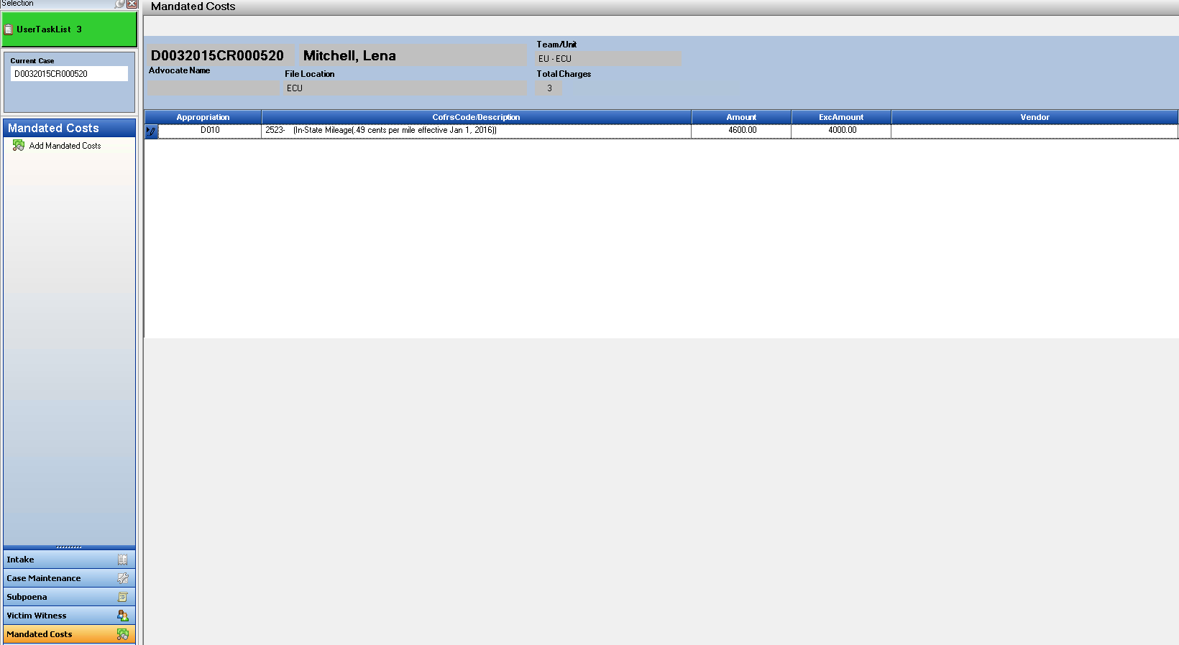

Work Flow Template- Subpoena Request

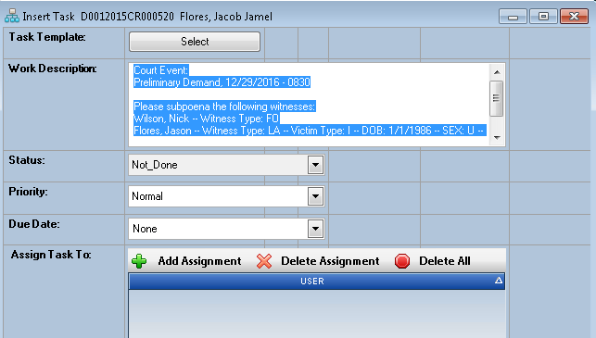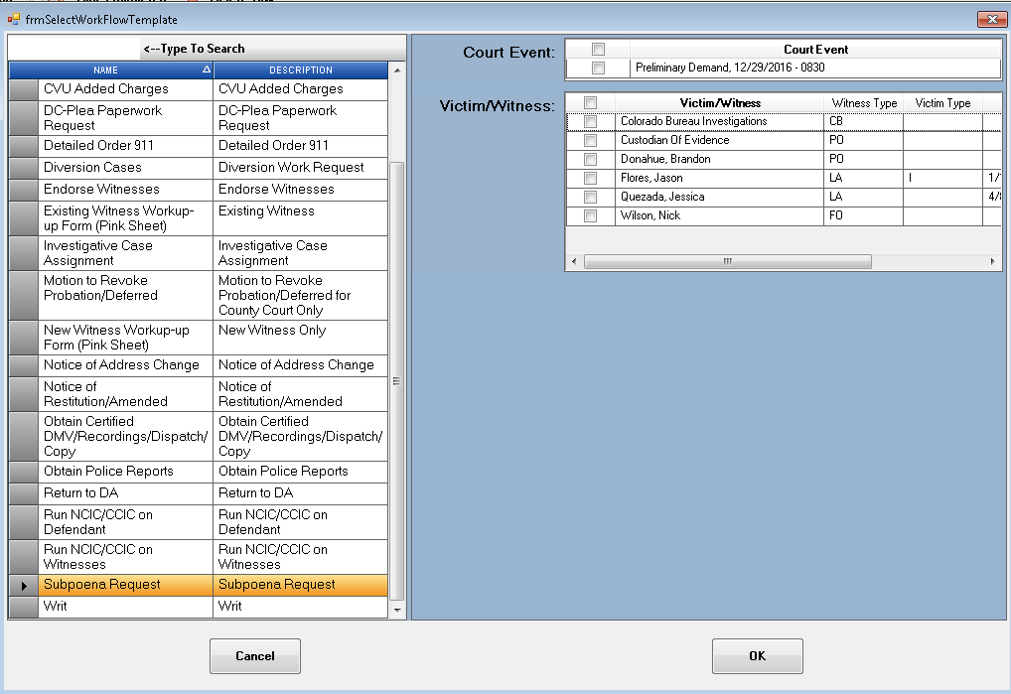 Existing Work Flow Template- Subpoena Request has been updated to provide a full view of all the Victim/Wtiness that appear on the case for easier selection. If you district does not have this template currently and would like it enabled- please email Kristi at CDAC to have turned on.

Staff Tab

Staff Tab enhancement for Special Prosecution Cases. The staff tab was not re-loading with the current districts staff members to select from. This has now been updated to bring in the correct staff lists for selection when a controlling county/district has changed.

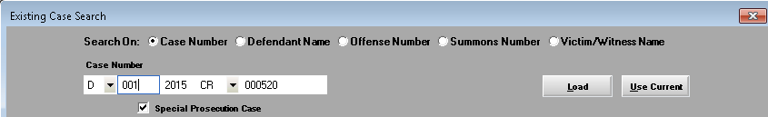

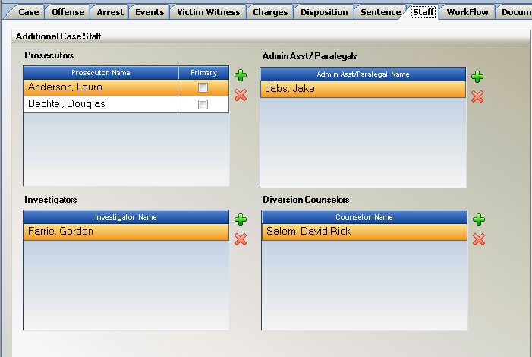

Re-Numbering Charge Counts

Charge Tab within Action will now allow a User to select the Count Number for the Charge. This was created for times when a district is handling an Indictment Case where there may be several

Co-Defendants and each is charged with different charge courts within the entire sequence of the indictment.

** To use this function a District needs to request to the Case Validation Check Turned OFF. This current check looks at charge sequences, and would need to be disabled so that this new process can work and filed through to Judicial.

On the Add/ Edit Intake Charge Screen- you will now see an Auto Increment Count check box- the default is always to be on- thus keeping currently functionality of auto incrementing charge counts.

If you need to enter a charge out of this sequence then Un-Click this check box and type in the charge count number desired. Next charge added will again to default to auto incrementing unless again un-clicked.

Example:

Counts 1-3 entered with Auto Increment On

Count 23 then added by unselecting Auto Increment and typing in 23

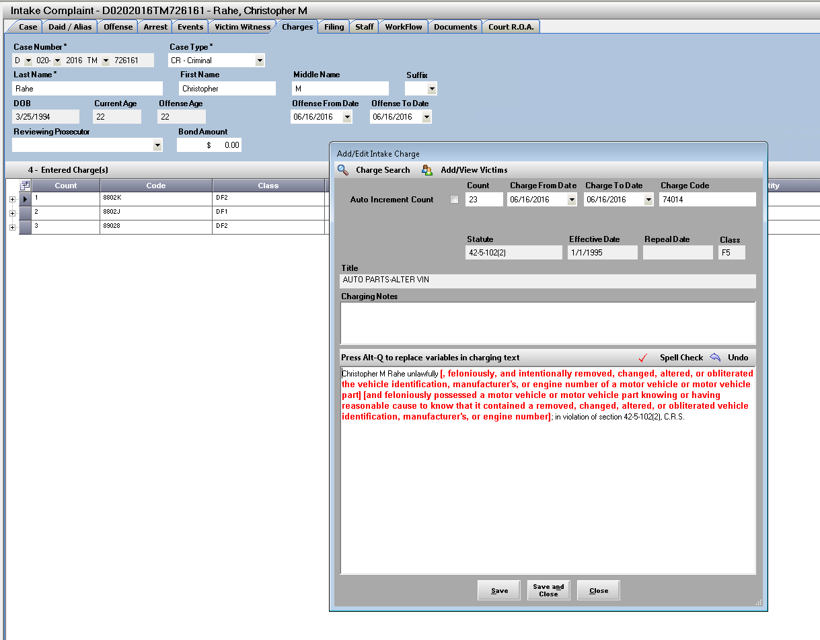

Action File Cabinet Enhancements

***This new functionality will be turned on for a District by request to CDAC.

Local File Pick-up:

Action file cabinet now provides a way to create notification of files that are added to the file cabinet but are chosen by the District not to be uploaded to eDiscovery website because of the large file size and time it take to either upload the material or for defense to download it.

External Media:

Action file cabinet can also now track any External Media that it part of the case but cannot be added to the electronic file: example Hard Drive brought in from law enforcement.

Settings:

When these setting are turned on for your district- Users select the Field Selector in the file Cabinet and select File Type(displays icons) and Local File Pickup (used to indicate file as local file pick up only) columns if not defaulted in view.

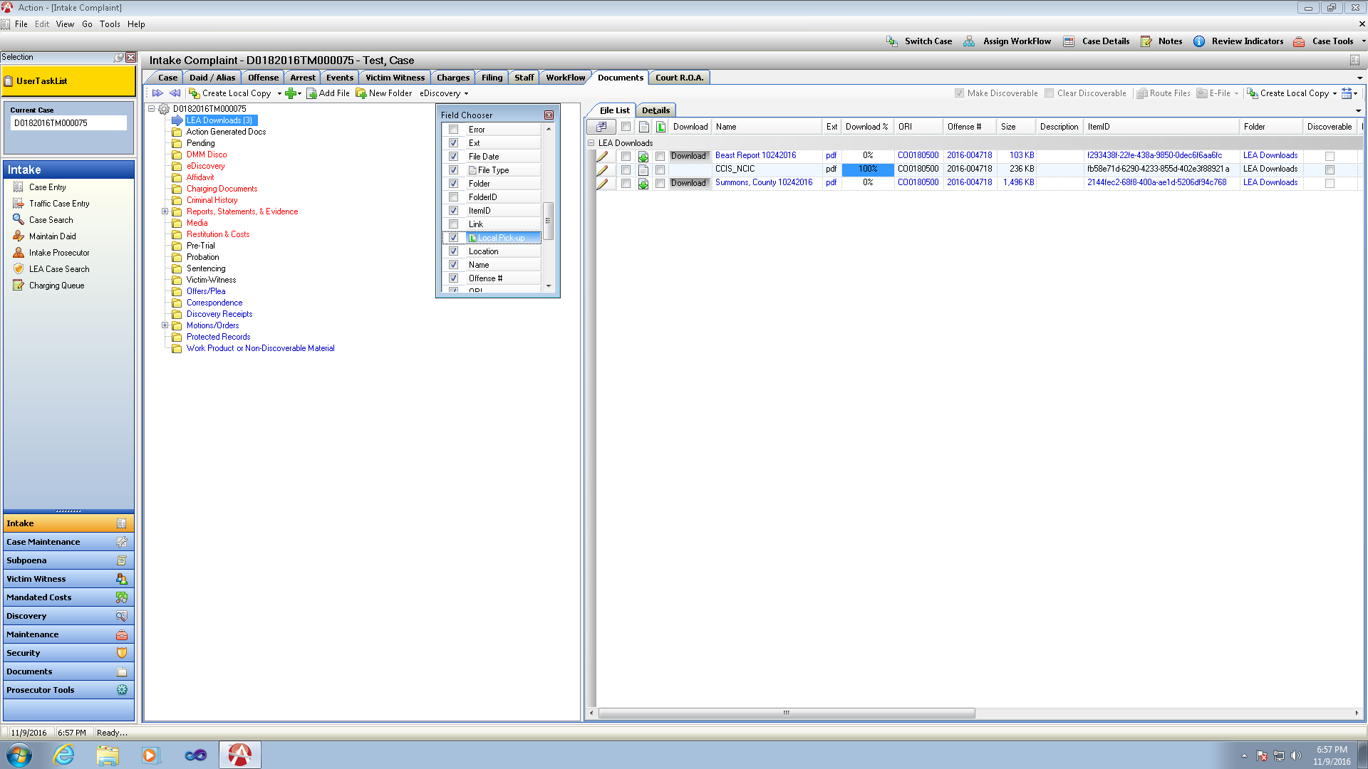

Local File Pick-Up



* Select File – click the Local file Pick up checkbox next to the filename in the Local File Indicator column.
* This marks the file as local file pick up only.
* Produce Discovery packet as normal on the case.

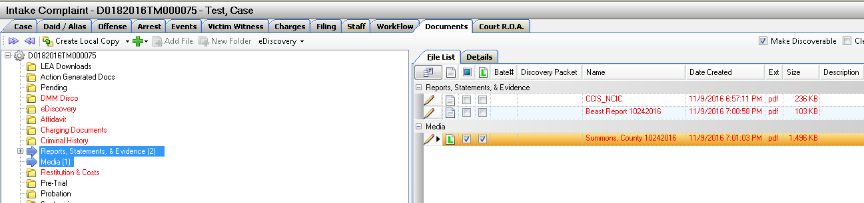

* Create Discovery item list will now show the files that were previously marked as local file pickup. User has the chance to update/edit this here before proceeding with creation of the discovery packet.

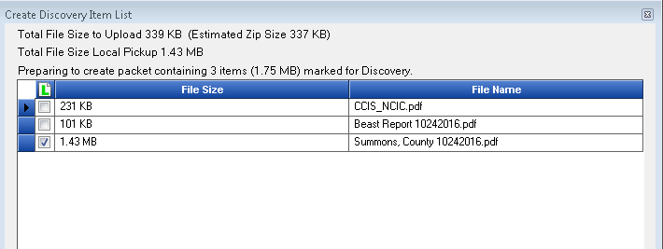

* Bate Stamp Discovery process as normal
* Upload Discovery to CDAC website – user has ability again to review files and select additional files for local file pick up or unselect- Estimated Zip Size is given as well as the File Size for Local Pickup. Districts may have an internal size limit that would help make this decision on what to upload or mark as local pickup.

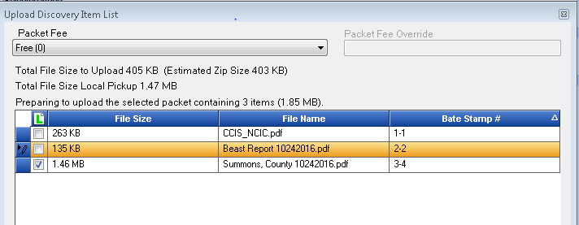

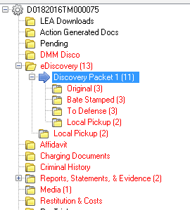

* New Local Pickup folder is generated under the Discovery Packet generated.
* Another Local Pickup folder is also generated under eDiscovery that will be a cumulative listing of all files marked as local pickup from all discovery packets.
* Discovery Packet
  + To Defense includes a new system generated document- Media List
  + Media List is a listing of all the files a Defense Attorney must pick up from DA’s Office.

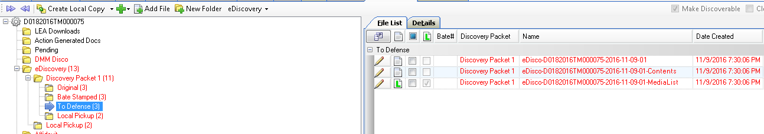

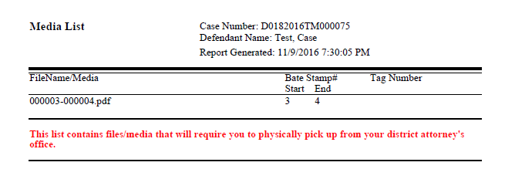

* Local Pick Up Folder
  + Copy of Media List
  + 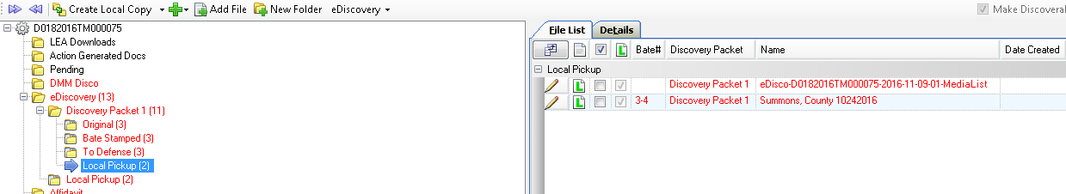File(s) marked a Local Pickup

External Media



* Highlight the Folder in the File Cabinet that you want this to be placed under.
* Click on the Green Plus Button – Select: New Physical Media
* Fill in Information about the External Media on the Right Panel of the File cabinet and Save

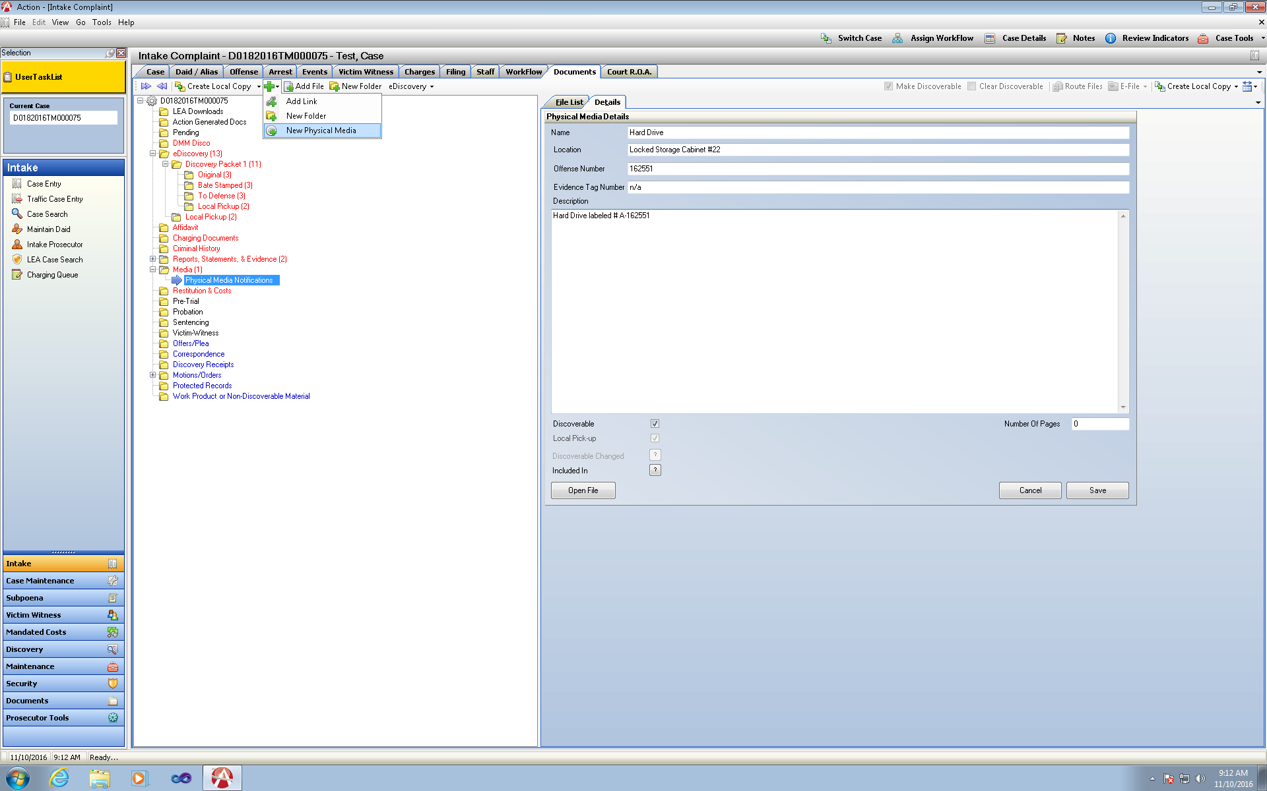

File Type Column displaying the Icons will show this new icon next to the created external media file list display.

File defaults as Local Pickup Only as the actual media does not exist within Action.

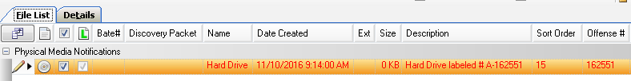

* Create Discovery Packet
  + Discovery item list will now show the files that are marked as local pickup only the local pickup check box is greyed out as there is not an option to upload this material.

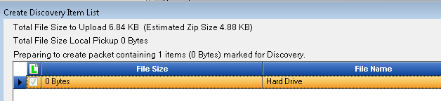

* Bate Stamp Discovery Packet as Normal
* Upload Discovery to CDAC website
  + User has ability again to review files and select additional files for local file pick up or unselect- The External Media file cannot be unchecked. Estimated Zip Size is given as well as the File Size for Local Pickup. Districts may have an internal size limit that would help make this decision on what to upload or mark as local pickup.

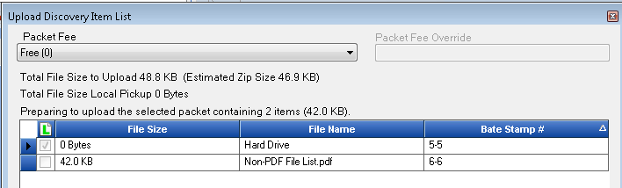

* Discovery Packet Created
  + To Defense includes a new system generated document- Media List
  + 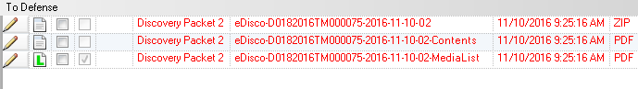Media List is a listing of all the files a Defense Attorney must pick up from DA’s Office.

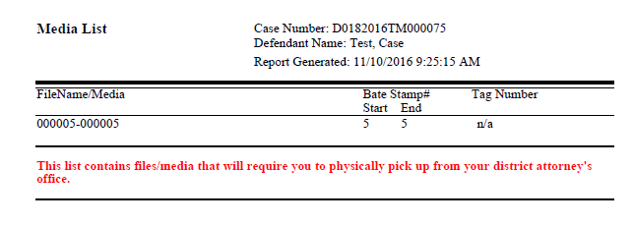

* Local Pick Up Folder
  + Copy of Media List
  + File(s) marked a Local Pickup (External Media Example)

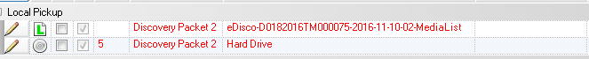

* Cumulative Local Pickup folder is also generated under eDiscovery that will be a cumulative listing of all files marked as local pickup from all discovery packets.

Example- I now have Local Pickup Files selected in Discovery Packet 1 and Discovery Packet 2

All files are shown under this Cumulative Local Pickup folder for User ease of identifying these files.

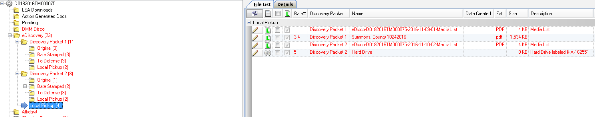

Defense Notification of Local Pickup Files

* Discovery Packet is uploaded to CDAC website with Local Pickup Files listed within a Packet.

Defense will receive email notification of new discovery available as in current practice. When they log in they will see their available Discovery and a new column marked as Local Pick-up Only. This lets them know immediately that this discovery packets contains items for Local Pickup.

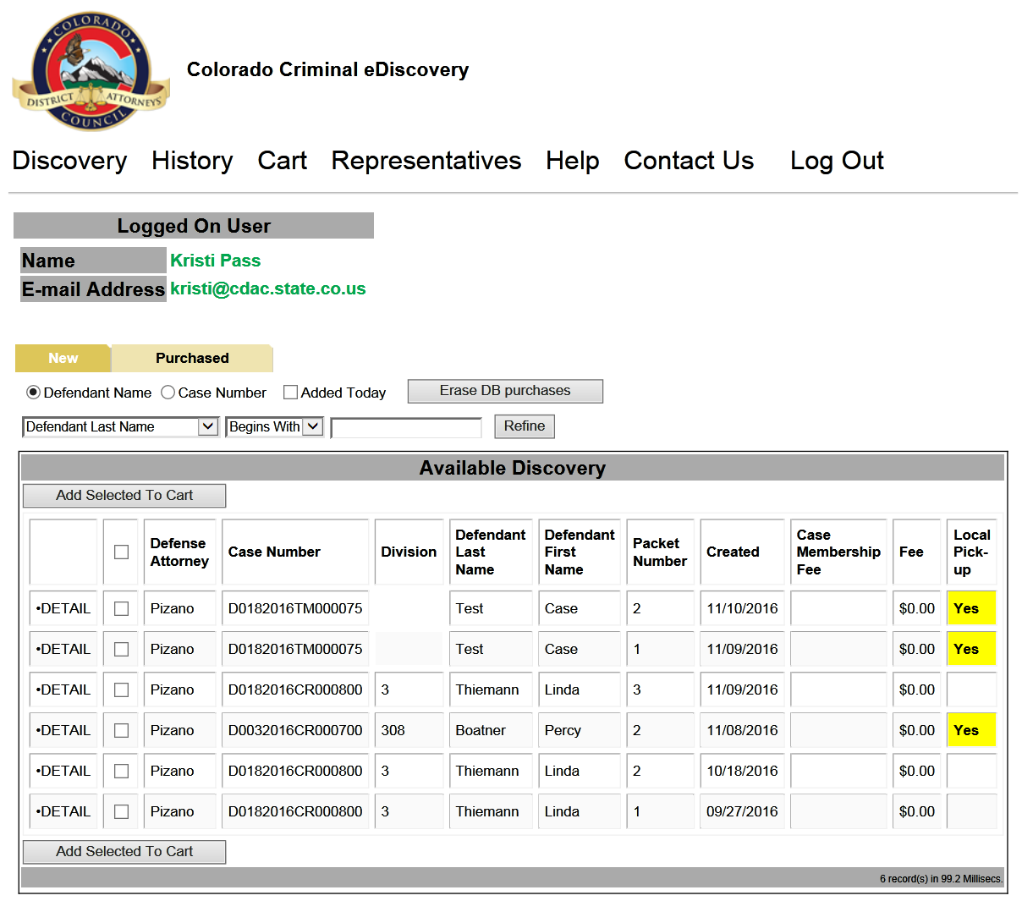

* Defense can click on Details and will now see files that can be downloaded and files that are only marked as Local File Pickup

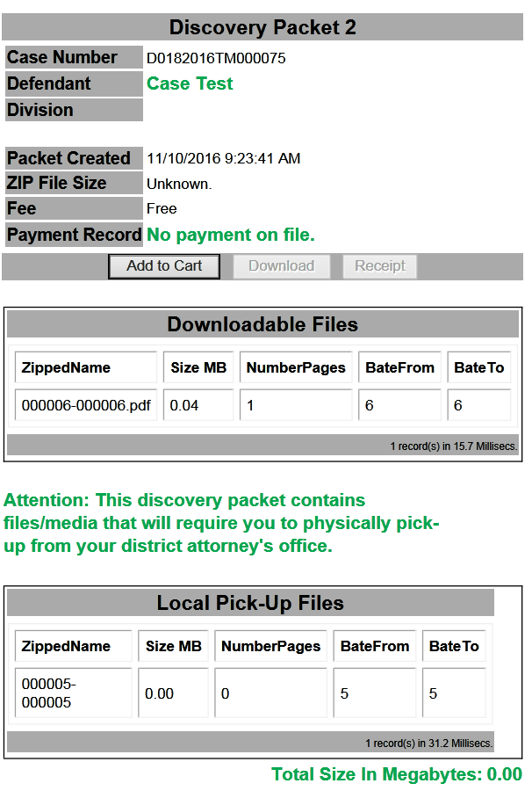

* After adding to cart and accessing the discovery packet on the Purchased tab the defense attorney will still see the new column for Local Pickup and when they download the files

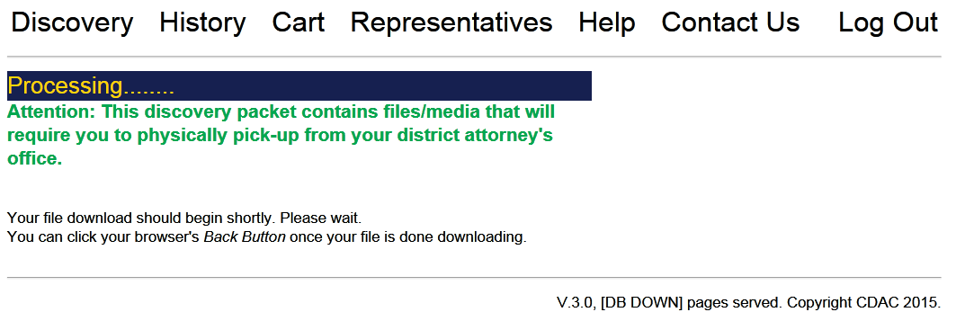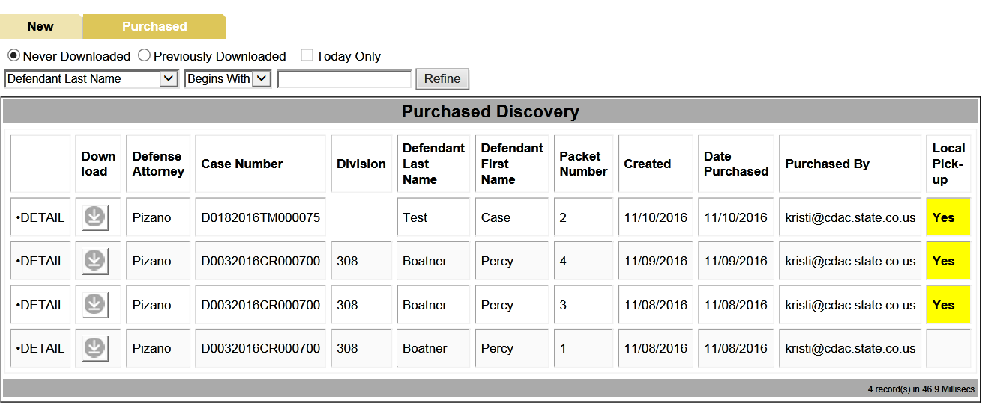

* 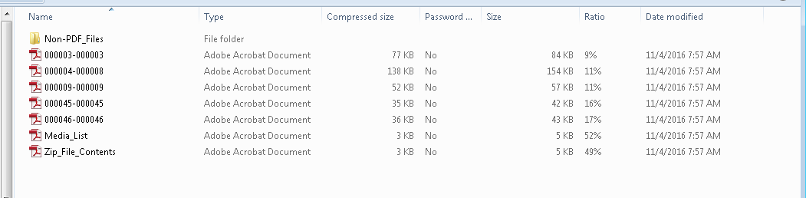Defense has the New Media Sheet with their ZIP File produced. They can then print and bring with them to pick up the local pickup files from your office.
* Depending on your internal practices, they can call/ come to the office and order the Local Media to be picked up with this sheet in hand.

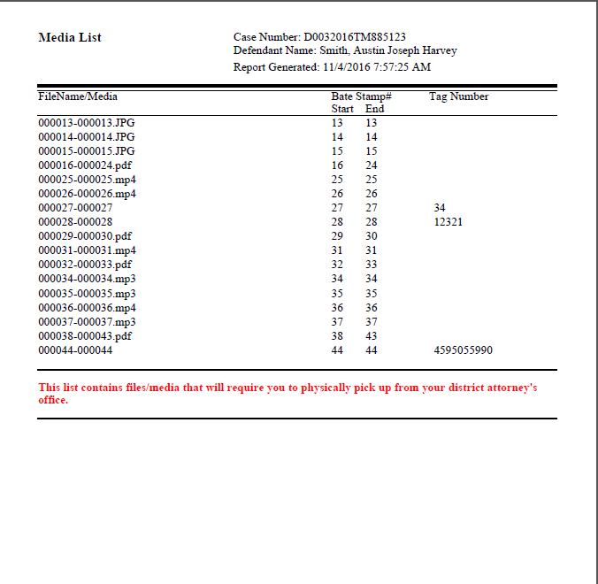

Defense Picking up Local Pickup Files

* Defense comes to pick up Local Pickup Files and External Media Files
* Action user would look up the case in Action and per Packet in the case that contains these files click on the Packet Name and select: Local Pickup – Save to Batch

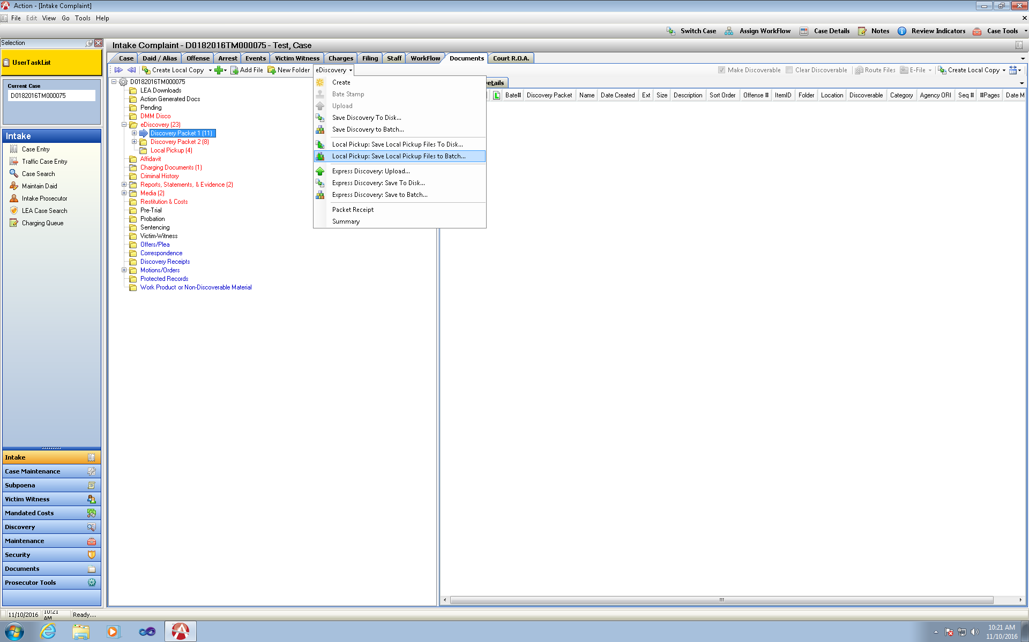

* Create a new batch name or an existing batch to add these file to.

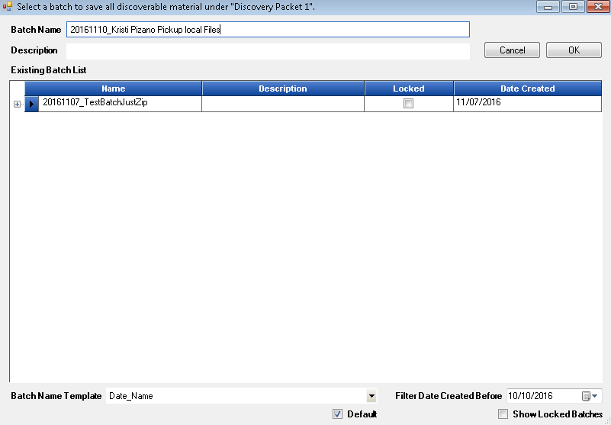

* 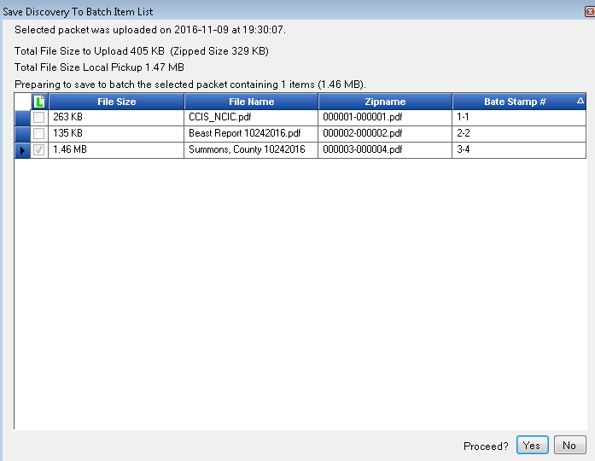Display of the files for Local Pickup – files with the Check

Access Batches from Discovery Tab

* Search for Save Batch Name-
* Highlight Batch – Zip files with Local Pickup Media are displayed on the right hand grid.
* Click on View External Media to see any External Media with this created packet that needs to be copied internally for defense (for DA user reference shows description Location, Tag # entered)
* Click on Pickup Batch
* Enter the Name of the Person picking up this batch of files
* 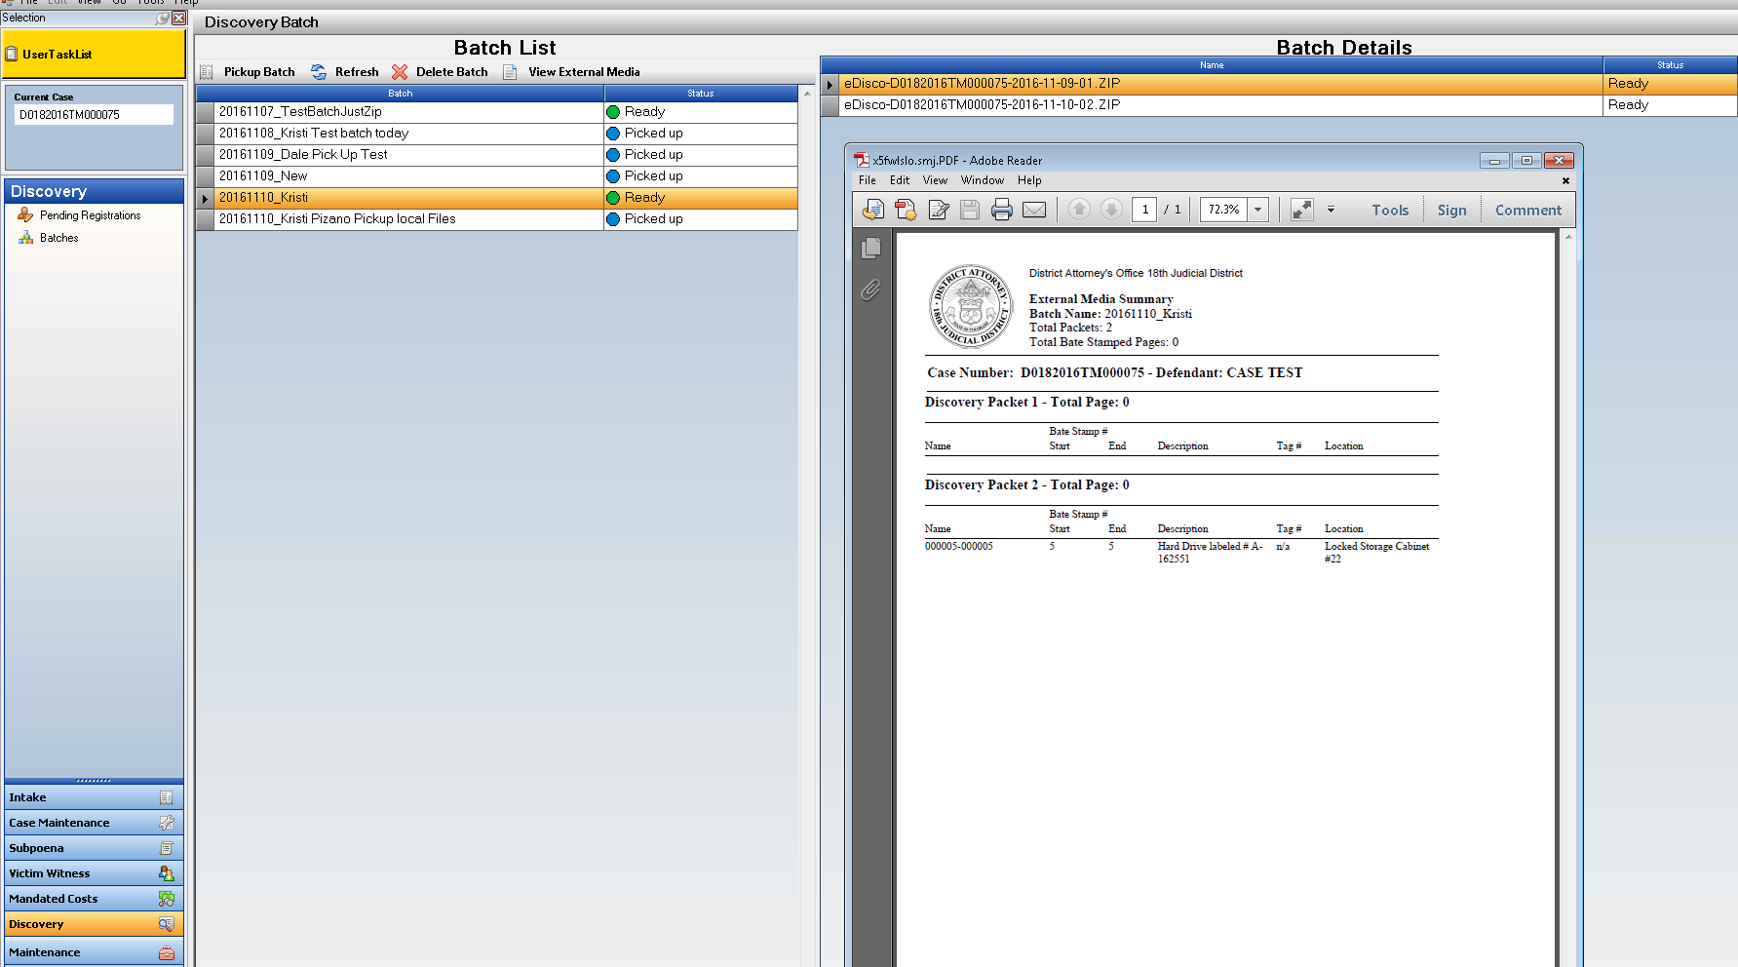Click on selected option
* Batch Receipt then appears to Print out and give to Defense to Sign as a Receipt to be collected and added back into your action case. The Name entered on “Pick Up” will be displayed then on the File Cabinet DA Receipt and Case Summary for Reference.

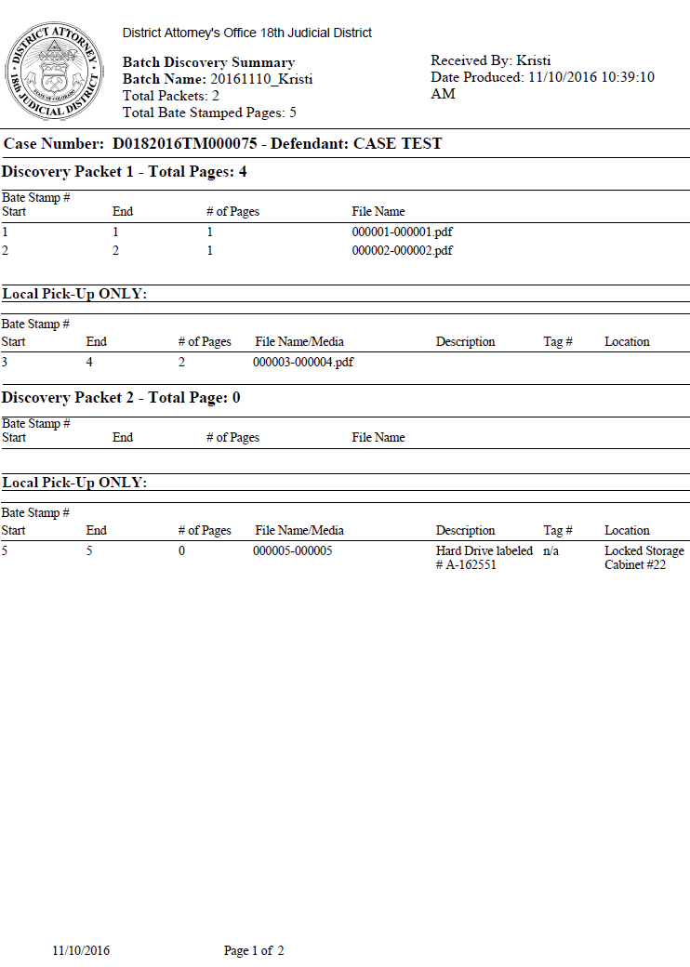

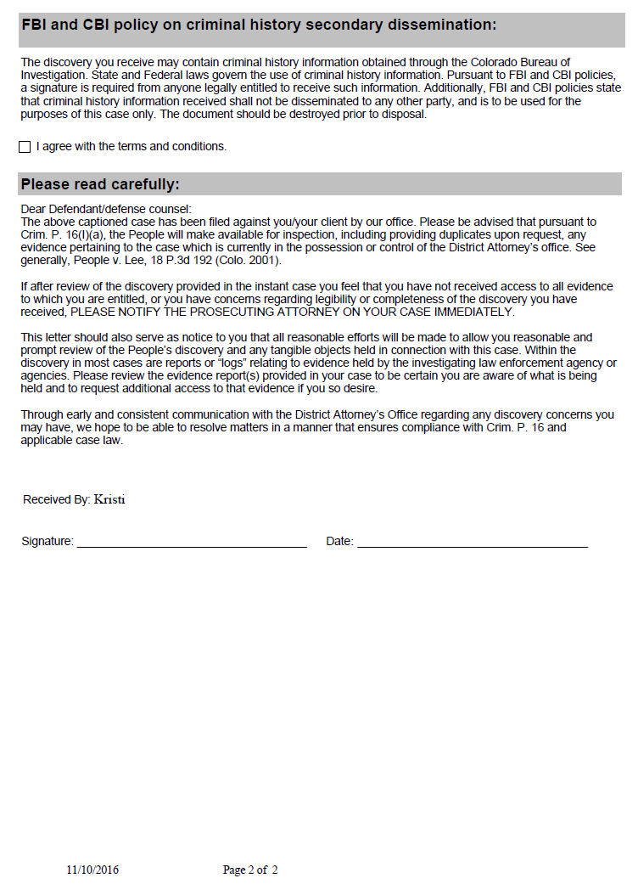

Links



* Highlight Folder that you wish to place a Link file into.
* Click on the Green plus button and select Add Link from the dropdown menu.
* Enter a Name, the Link address and a description.
* When this file is then opened it will direct you to this link.
* This can be processed as discovery and produces as a Pdf file.

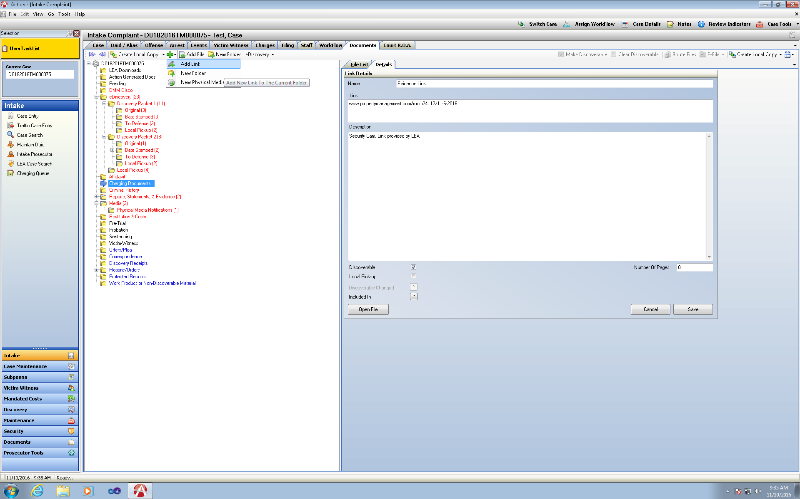



Miscellaneous

* Update to enter current defense attorney listed within Action on incoming events from Judicial on the Event Tab.
* Update on Transferred Events from Judicial- if Judicial Modifies an Event instead of creating a new Event correctly Action will bring in this is as a New Event as requested by the AUC group.
* E-Filing Action Generated Orders are not correctly associated with the Document Type of Proposed Order.