Action enhancement guide

August 2017 Training Guide



August 2017

CDAC

CDACweb.com

**Table of Contents**

1. Prosecutor Tools: Paralegal/Admin Docket ……………………………………………………. 3-4
2. Prosecutor Tools: Add Case # and Def Name in Header…….……………….………..... 5
3. VW Batch and Manually Produced VW Letters: Add Auto Note………….……………. 6-7
4. E-Filing: Disallow user to add/drop files larger than 3 MB…………………………………... 8-9
5. Copy Case Functionality: Allow any case to be copied to and from …………………… 10
6. Enhancement Fixes ……………………………………………………………………………..… 11

Prosecutor Tools: Paralegal/Admin Docket

Enhancement to add in a new docket option for Paralegal/Admins.

Based off entry of the Paralegal/Admin to the Staff Tab within the Action Case.

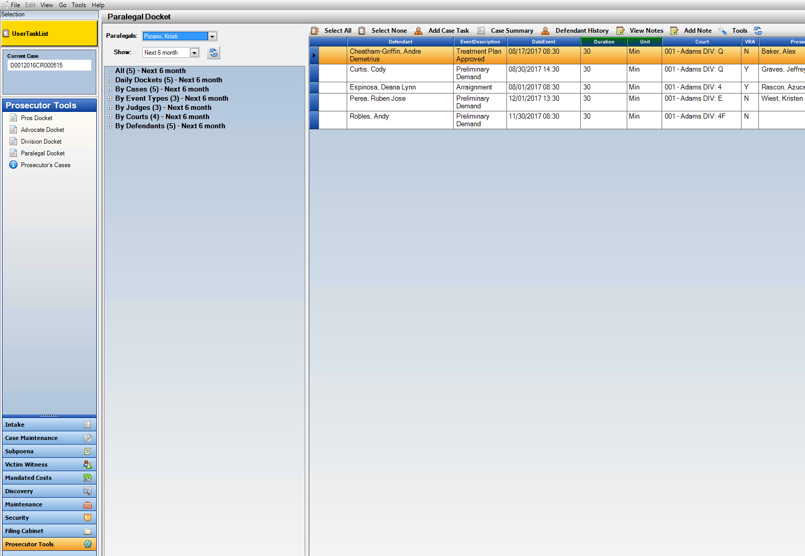To Access: Prosecutor Docket 🡪 Paralegal Docket

Entry on Staff Tab- Paralegal field then populates the new Prosecutor Docket.

Prosecutor Tools: To Default Action User Name to Dockets

Note: If a Paralegal/Advocate/Prosecutor comes into the Docket selections and their name does not default to the docket selection Power Users can go into Security 🡪 Users🡪 Edit User 🡪 Use the Person List drop down field to select the users entry from the Maintenance Person table. This connection then allows the docket to auto-populate to the User logged into Action.

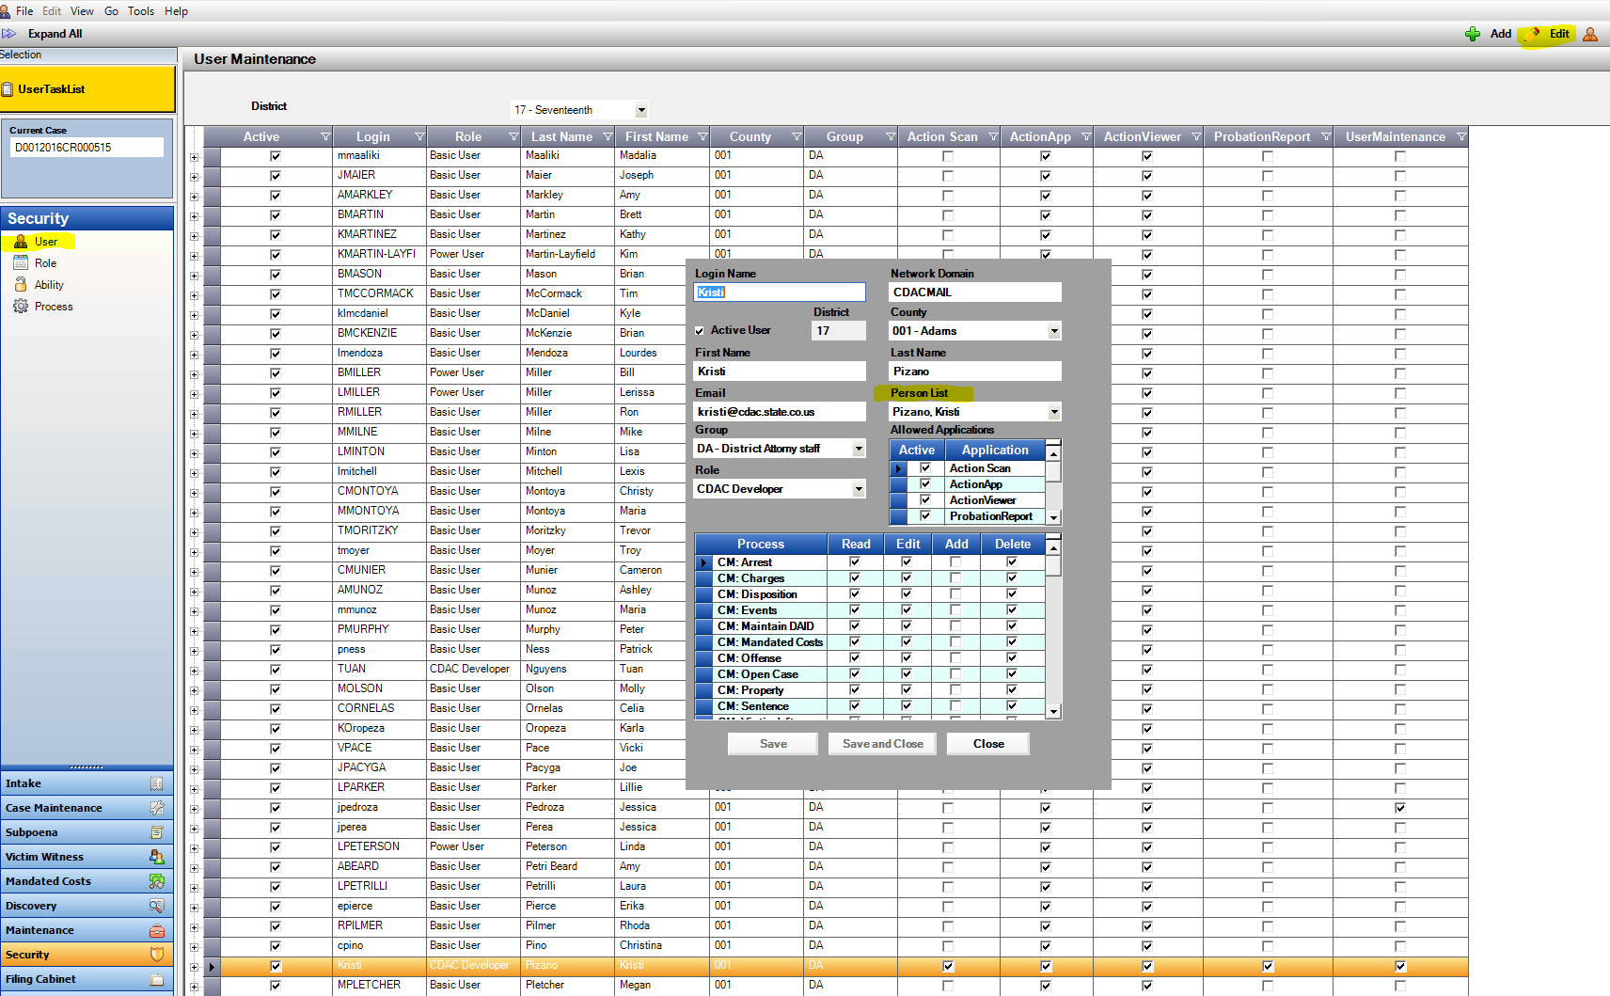

Prosecutor Tools: Notes minimized now display the case number and defendant name for easier recovery of an item in the tray.

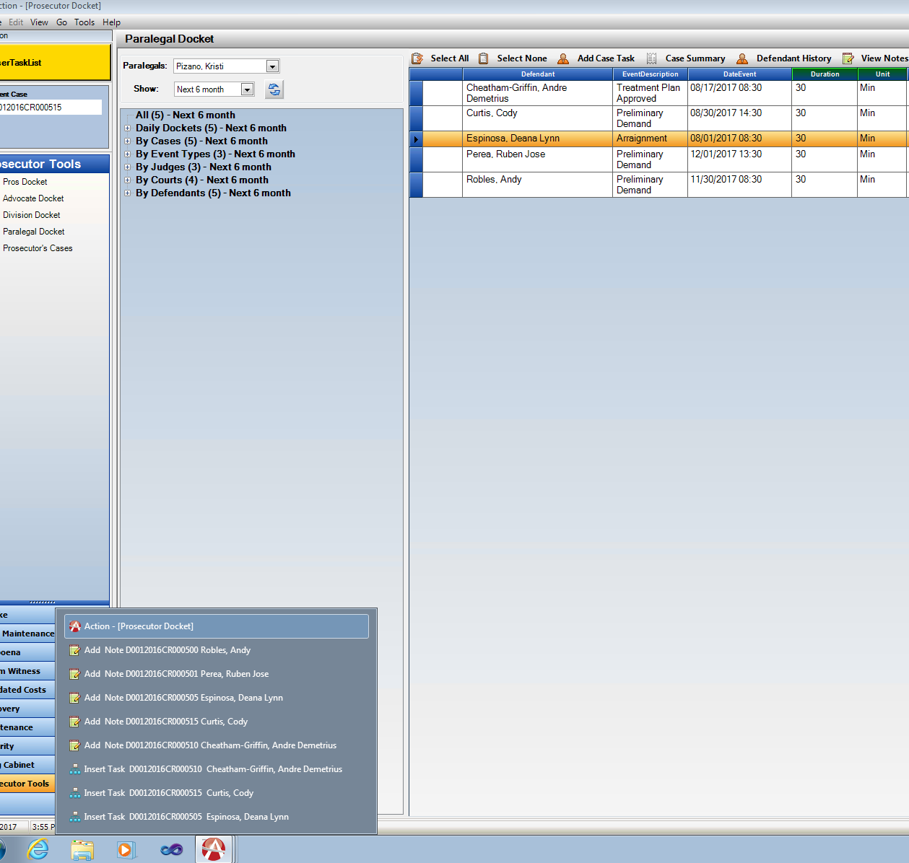

Victim/Witness Auto Generated Notes on

Notification Letter Production

**District Setting**: Please contact CDAC to turn on this function for your District.

Victim Witness Notification Letters either manually generated, or system generated through the Batch Process now have the options to create a system generated note per Victim/Witness that a letter was produced for.

Location: Victim Witness Notification Letters & Notification Batch Print

When is the note produced?

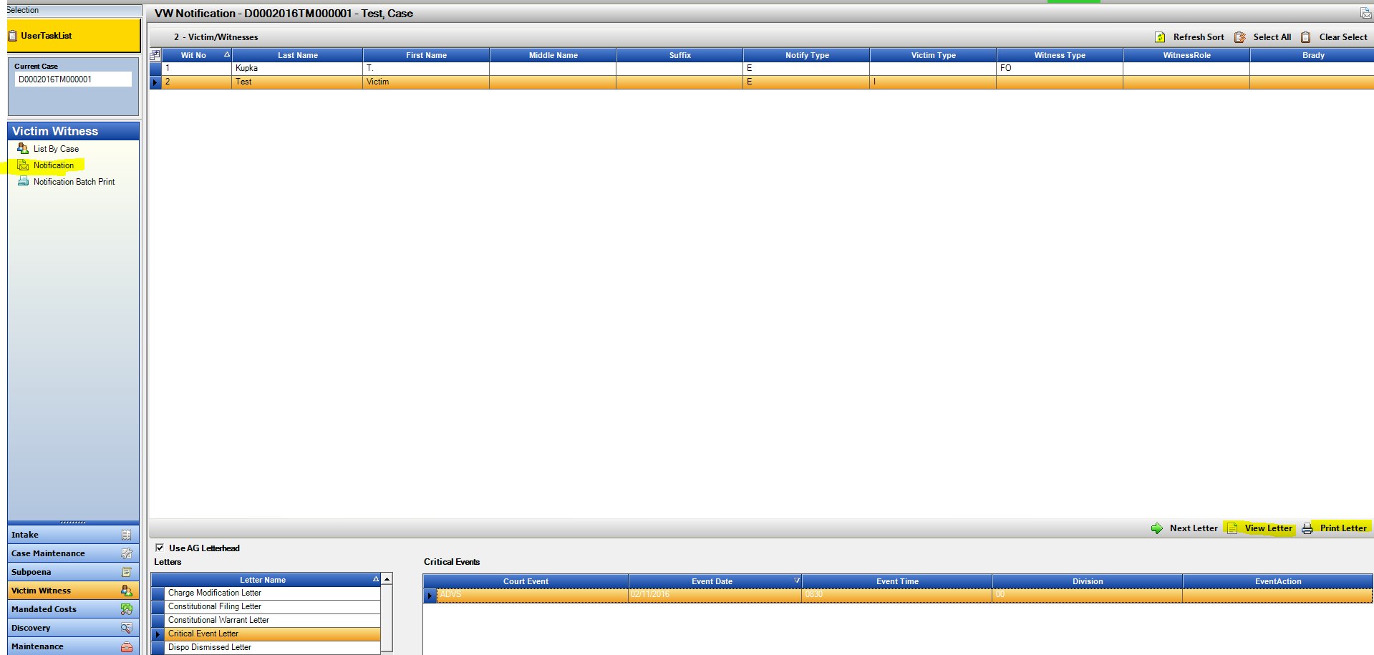**Manual Generation:** Highlight selected Notification Letter and click on View Letter, or Print Letter button. Each instance produces a note following the currently functionality of adding that documents to the Filing Cabinet: Action Generated Doc’s.

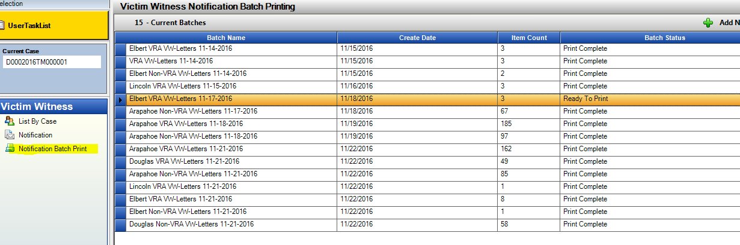**Batch Generation:** Every night a batched set of letters is generated based on daily data entry. When the batch is generated, the note is added at time of Production.

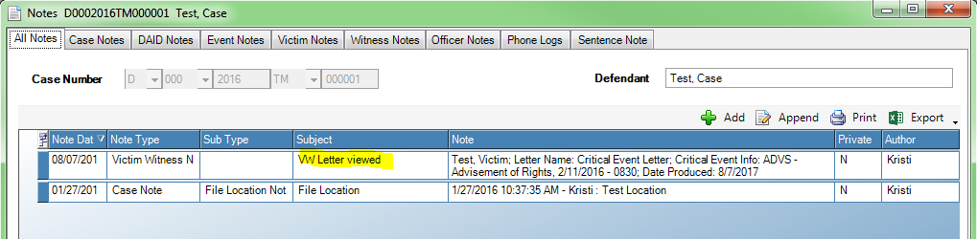**Displayed Notes:**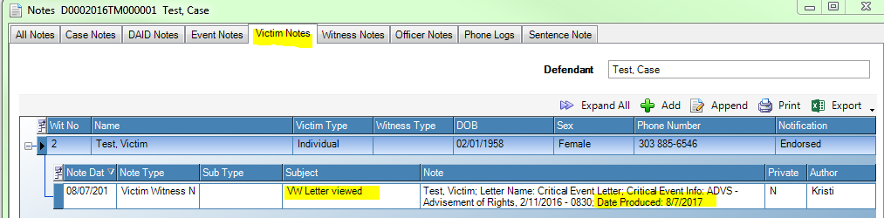

e-Filing – Enhancement

Preemptive Restriction message to user when a selected file to be

e-filed exceeds the CO Court’s E-Filing system limit of 3MB.

To assist Action user with e-filing, a new message will be displayed when a file is selected for e-filing if it exceeds the current 3MB restriction. This will help streamline filings for users that are currently experiencing unsuccessful filings due to this.

Message will be displayed from all access points for e-filing in Action:

Intake: Filing Tab

Action Generated Doc’s

Case Maintenance: E-File Documents

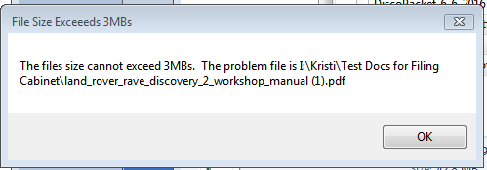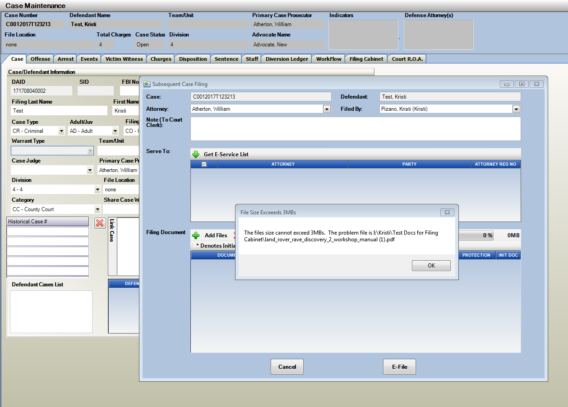 File Cabinet

If multiple files are being dragged onto the e-filing form- the message will display which one of the documents exceeds the 3MB, and will add the other selected documents onto the window.

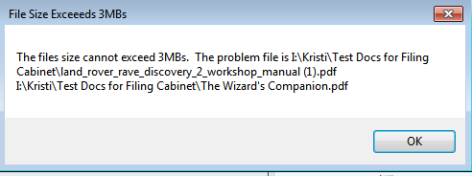If multiple files are over the 3MB limit, a second message displays to the user listing both files that need to be corrected before filing.

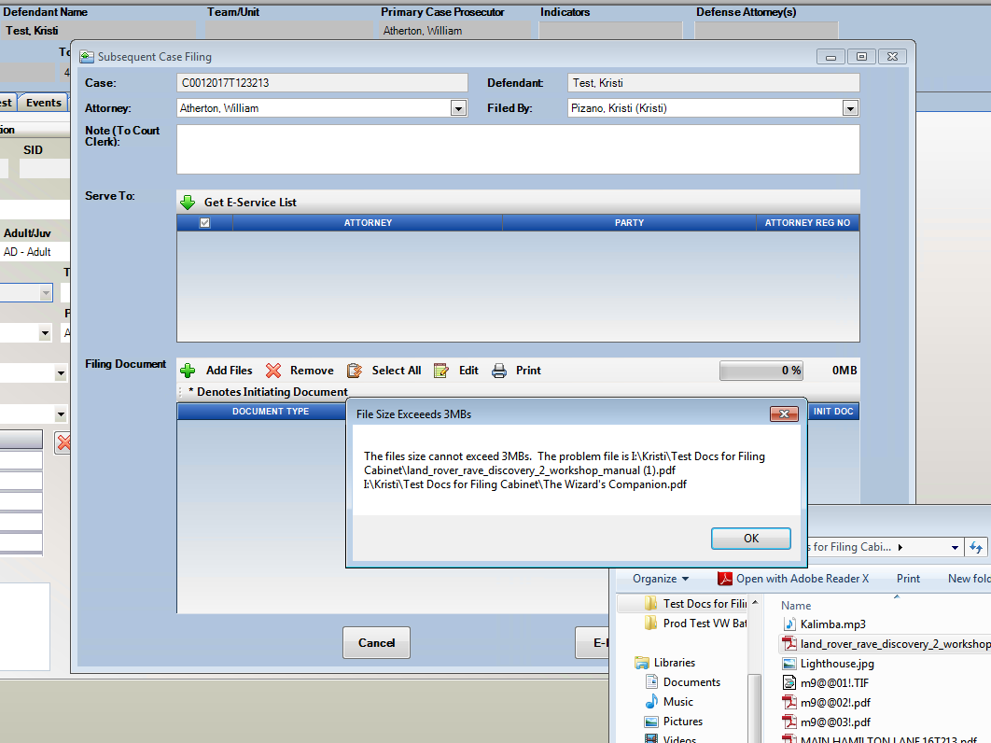

Copy Case to and Copy Case From

Copy Case To and Copy Case From selections have been enhanced to allow users to use this functionality between cases no matter if in Intake or Case Maintenance.

Training Video- location on CDACweb.com Action Page for review of Copy Case Functionality.

Intake to Intake

Intake to Maintenance

Maintenance to Intake

Maintenance to Maintenance

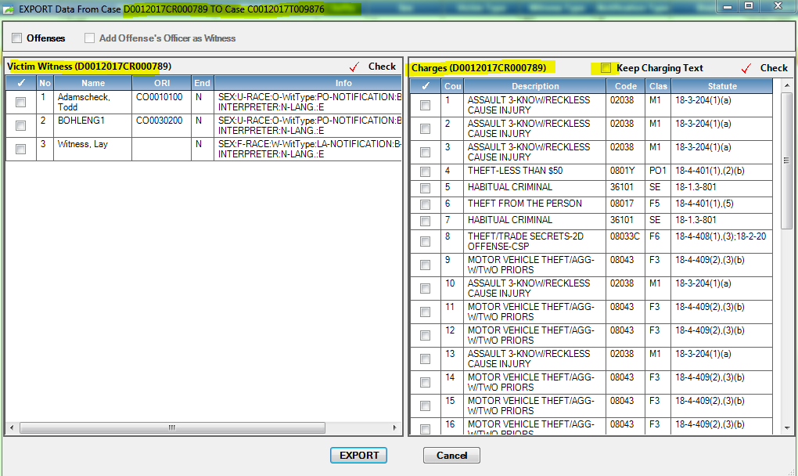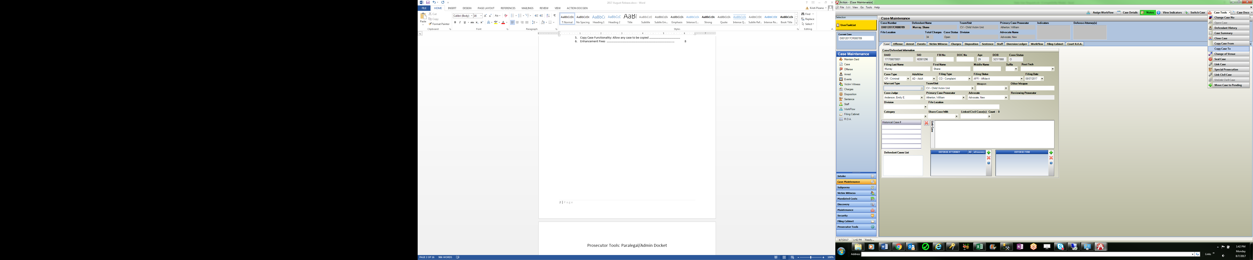Maintenance to Traffic Intake

Miscellaneous Enhancements

* Intake Charge Count Entry would often result in a message, “case update failed” This has been addressed so that charges will always overwrite another save operation so that charge entry will not be lost.
* LEA search screen if Defendant info from LEA was received with height of { 6’01” } was producing an error message due to the coma. This is now resolved.
* Charging Queue: Re-sort Fix, so the selected record remains highlighted without jumping to another row, even if columns are first sorted.
* Bate-stamp fix for Txt files that were too large to bate-stamp.