Action enhancement guide

February 2017 Training Guide



February 3, 2017

CDAC

CDACweb.com

**Table of Contents**

1. LEA Search Screen: User Select Display Options ………………………………………. 3
2. LEA Search Screen: Go to Case ………………………………….……………….………..... 4
3. LEA Offense Number Edit or Delete Message ……..…………………………….……………. 5
4. Defendant DAID: Edit DAID selection ……………………………………………………………... 6
5. Defendant DAID: Demographic New Fields .…………………………………………………… 7
6. Power User Feature- Move Case Back to Intake from Case Maintenance …..… 8
7. Action File Cabinet: Printing DOCX and PDF files …………………………………………… 9
8. eDiscovery Request Approvals: Auto Update of Defense Info. ………………………. 10
9. Subpoena: Subpoena Tracking Updates ………………………………………………………… 11-14
10. Subpoena: Subpoena Status ………………………………………………………………………….. 15
11. Officer Table: New Field Post ID ……………………………………………………………………. 16
12. Action File Cabinet Enhancements (Re-Release from November)………………….. 17-32
    1. Local File Pick-up
    2. External Media Notification
    3. Batch – Pick up with receipt for Local Pickup
    4. Links

LEA Search Screen

Users can now select columns to view on this screen and the order they wish them to appear in.

1. Click on the Field Selector on this grid- Select or Remove columns with the checkbox next to each available option. These selections will retain PER user within Action until that user changes them.
2. The selected columns on the displayed grid can be sorted to the user’s preference of order as well. Highlight a Column Heading and Drag and Drop to the sort location that you prefer.

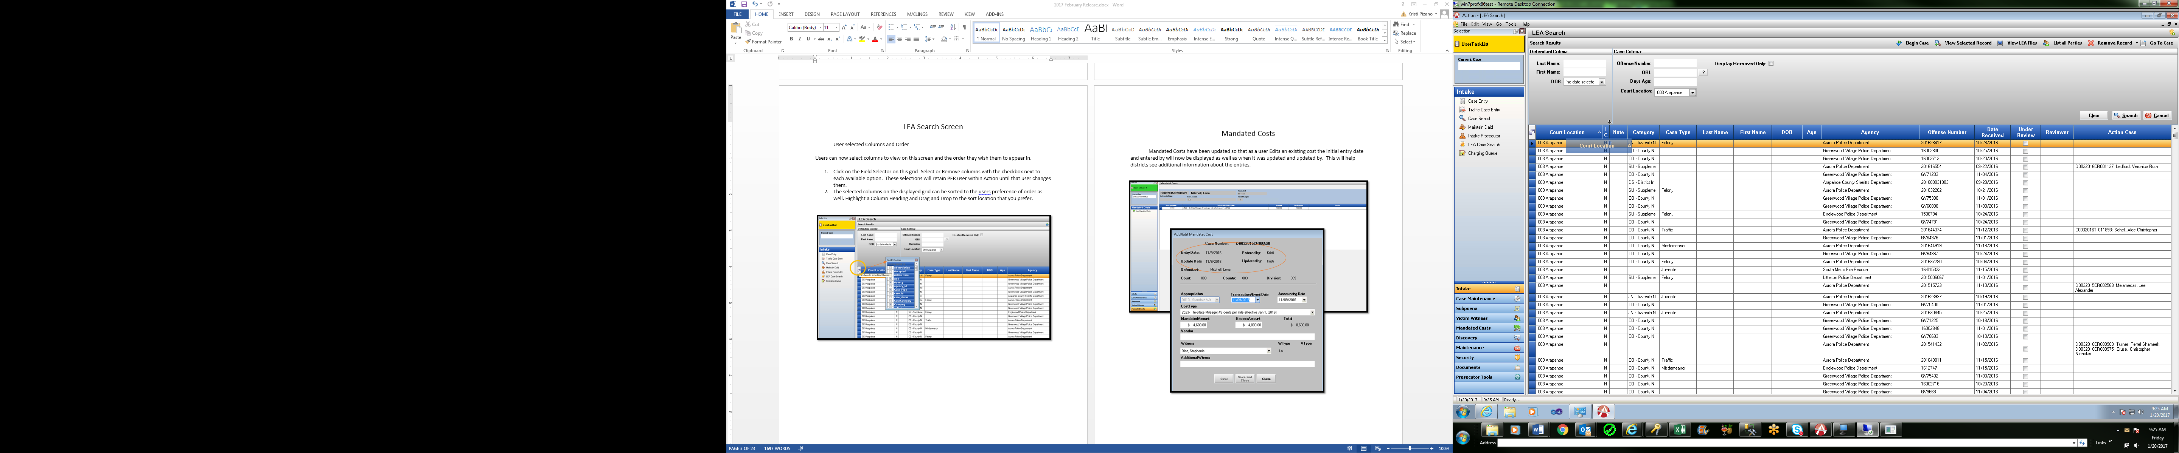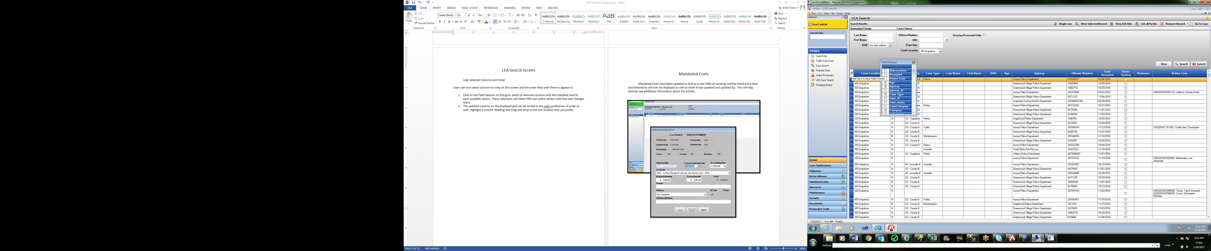

LEA Search Screen- Go to Case

Users can now select a row from LEA case search, and if it contains a case(s) in the Action Case column indicating there is an Action case with the same Offense # and ORI match- the user can select: Go To Case button on the screen now to launch the selected case within Action.

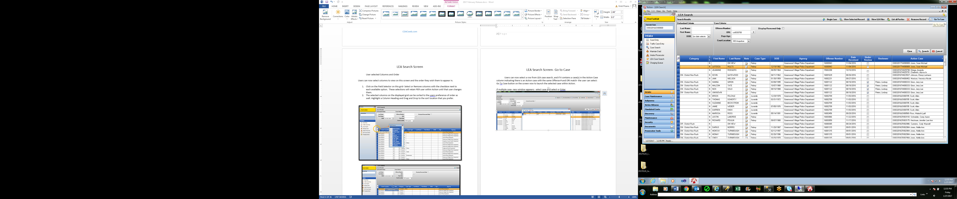

If multiple case- new window appears: select case and Go to Case or hit Enter.

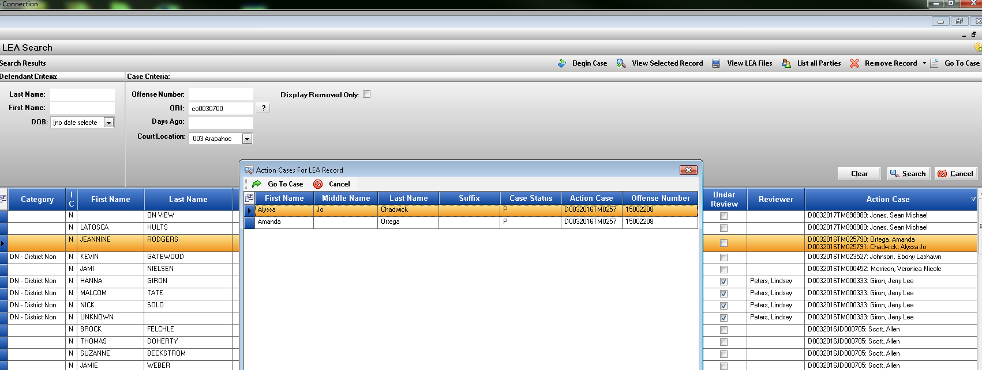

LEA Offense Number- Edit or Delete Message

Offense Number and ORI received by Law Enforcement on received cases in the Offense Screen will now display a message to the users if the Offense or the ORI is Edited/Deleted from the case.

Message to user that removing or editing the existing offense number or ORI will result in any

Un-Downloaded files from LEA in the File Cabinet being Removed- breaking the connection between the Action case and the Agency Case so it’s clear to the user before proceeding with the change.

Offense Tab:

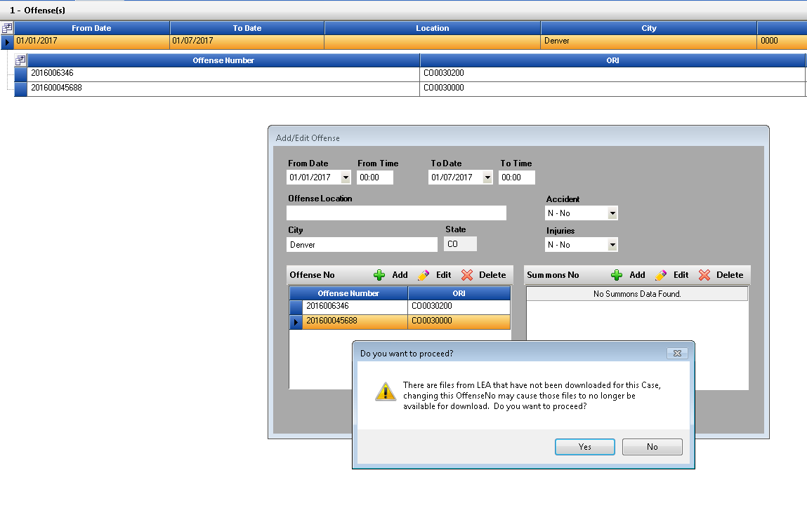

DAID: Edit Function

DAID search now includes an Edit Function, this will allow users to update the DAID before starting the Action Case with the selection.

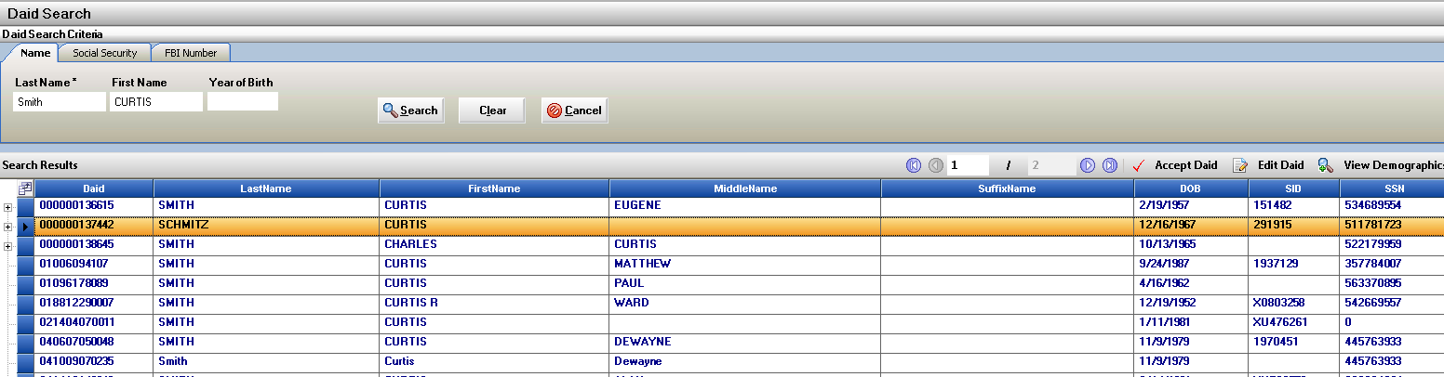Highlight DAID record and click on Edit DAID button.

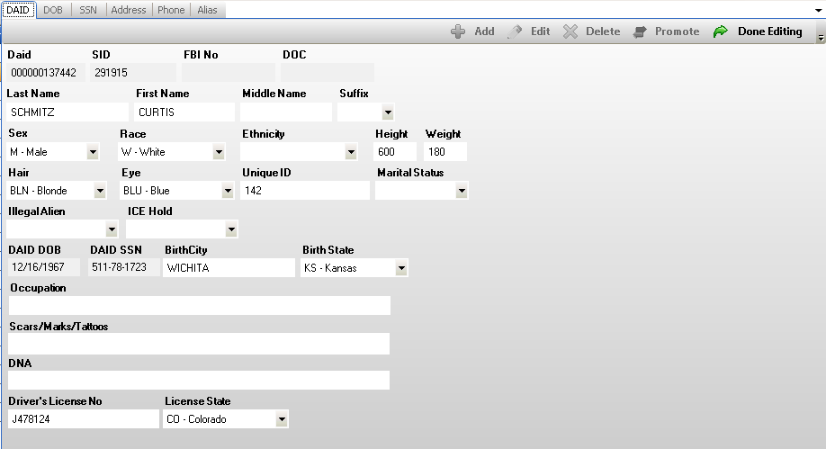DAID Maintenance Screen opens so you can Edit/Update DAID information – Click Done Editing when completed changes have been made and to return to the DAID screen to continue with Case Entry.

Defendant Demograhic Information - DAID

New fields have been added for additional demographic data collecting on cases. These fields are entered on the DAID/Alias Tab within Intake- or through Maintain DAID in Case Maintence.

They include:

Marital Status

Illegal Alien

ICE Hold

Occupation

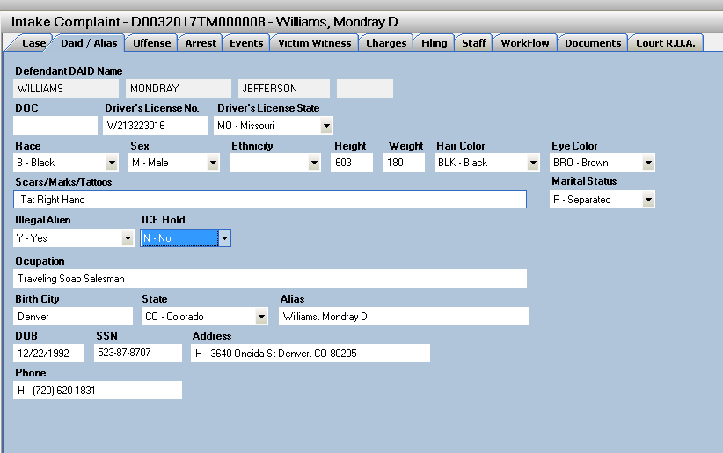

Move Case Back to Intake from Case Maintenance Function

(Power User Enabled)

New Power user feature to return a case to Intake that was filed into Case Maintenance.

While case is in an Open or Re-Open status in Case Maintenance a Power User can now select to have the case sent back to pending if it was accidently filed. Power user would open case- click on Case Tools and then select Move case to Pending Option. The case will then re-load from Intake.

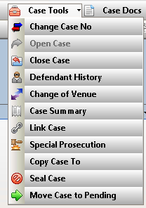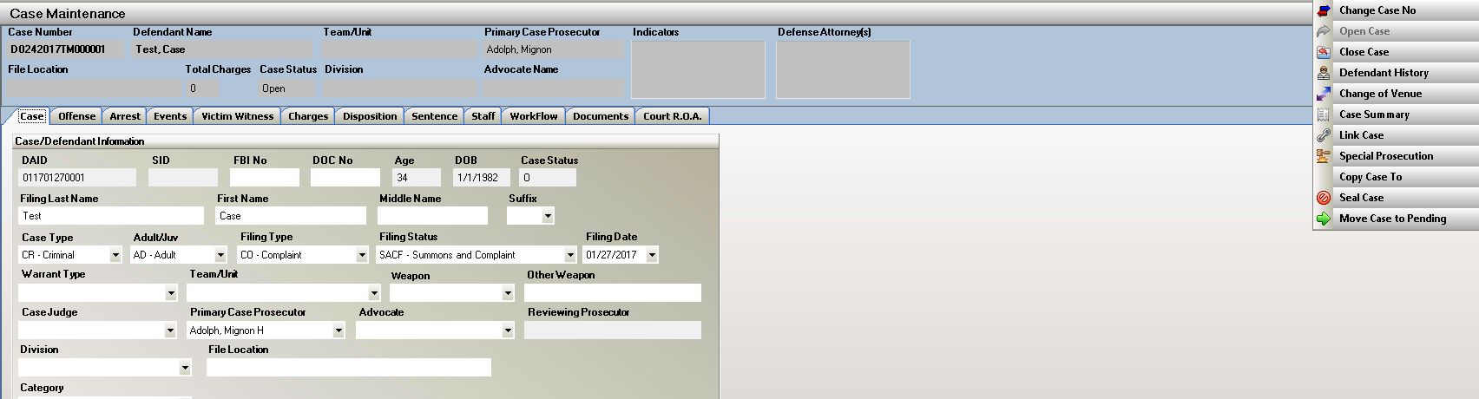

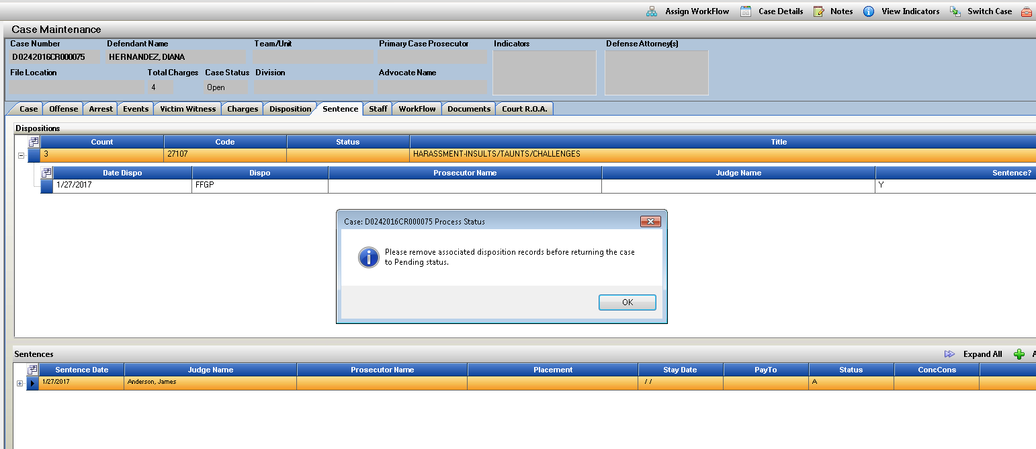If there is a Disposition or Sentence attached to the case- it cannot be moved back to pending unless the Dispo and Sentence information is removed first. Message will display to the user.

File Cabinet- Print Option for PDF and DOCX files

Action File Cabinet now has an option to print PDF and DOCX files directly from the program.

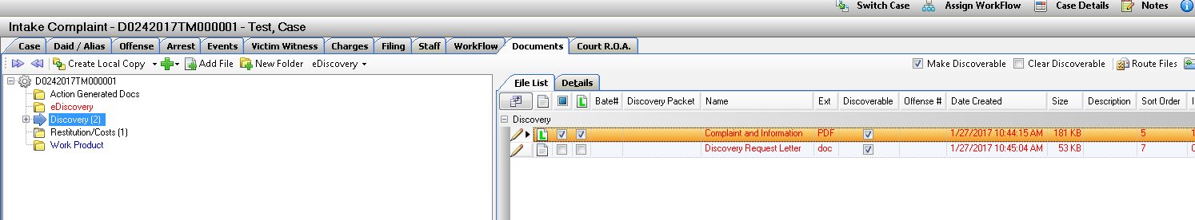Open the file cabinet select file- Right Click Option – if the file is a PDF or DOCX there is a Print Document option that can be selected.



eDiscovery Defense Registration Requests

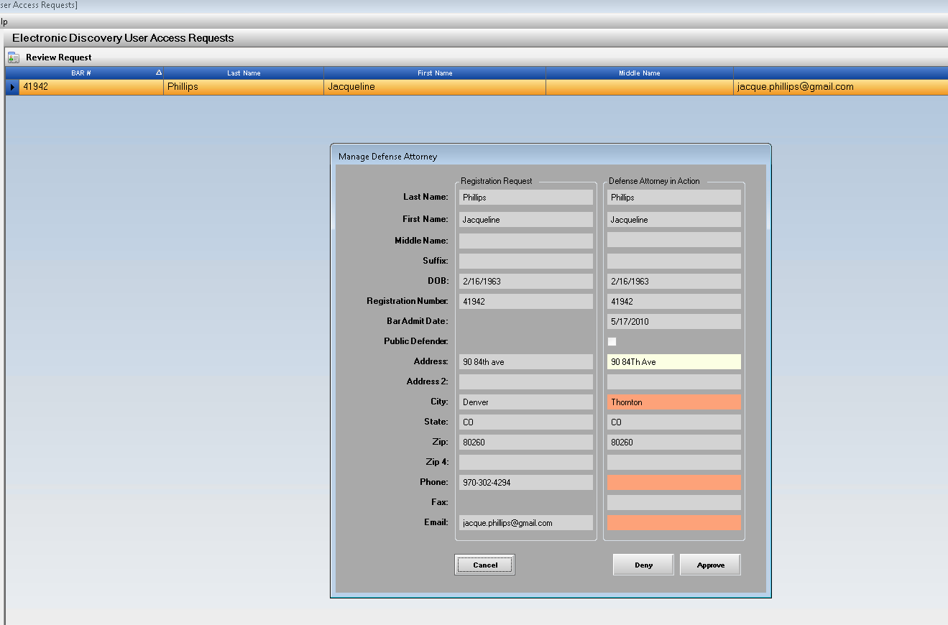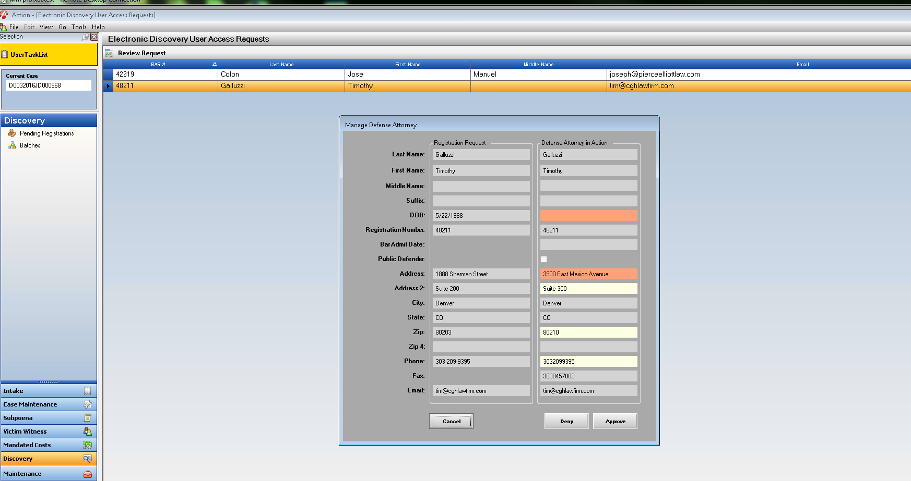Upon approval from the DA’s office the defenses registered information including address/phone etc. will automatically update within the Defense Attorney table in Action.

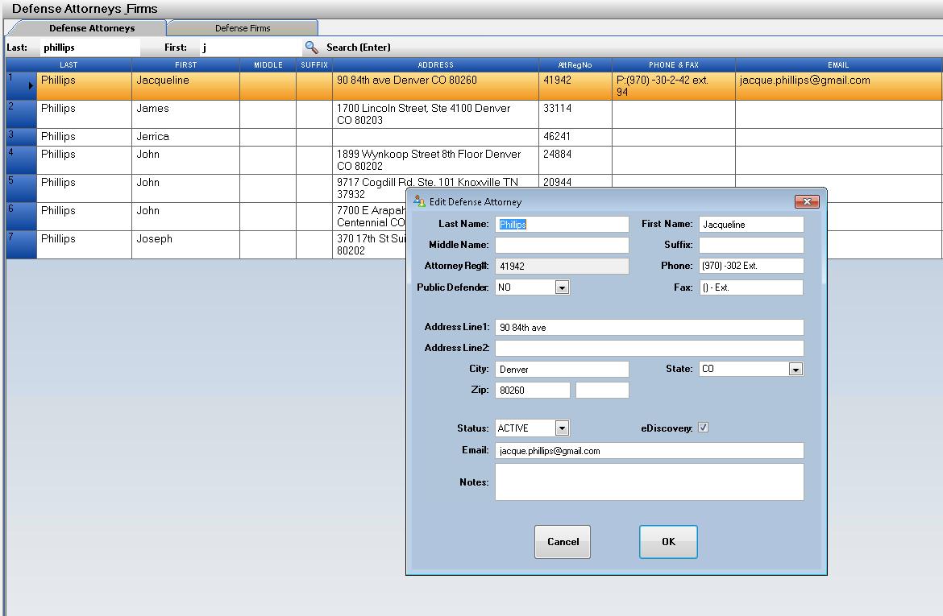

Subpoena Tracking

Subpoena Tracking Screen has now been updated for better flow of functionality and processing of the return waiver cards.

Process:

Return Cards are received by DA’s office

Enter Subpoena ID found on the waiver card

Tab out of the field and the Subpoena ID entered will be color coded according to the following:

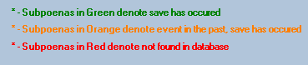

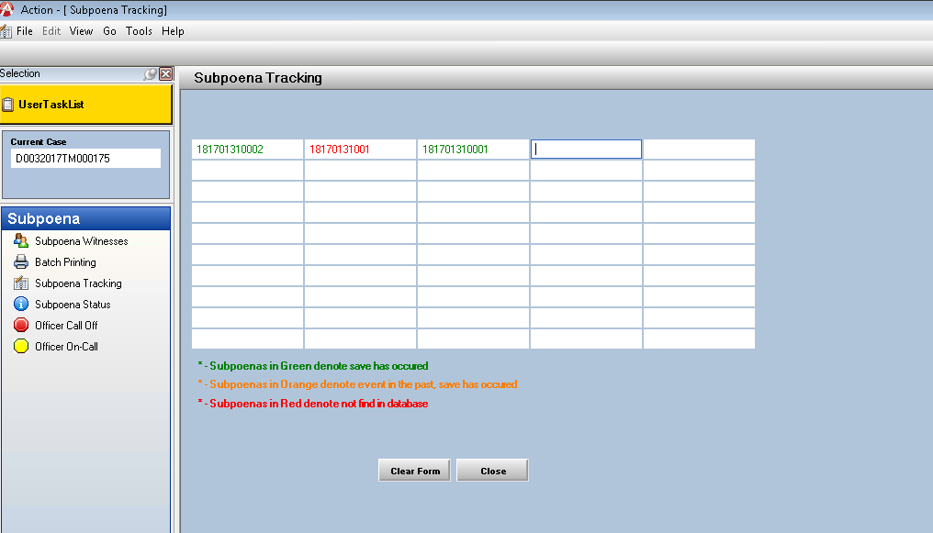

Right Click on the entered Subpoena ID for 3 options:

Edit Subpoena Status

Add Note

View Notes

Edit Subpoena Status:

Served:

User can enter Served Info- If Personally served Subpoena

Subpoena Updates:

Subpoena Status, Witness Status

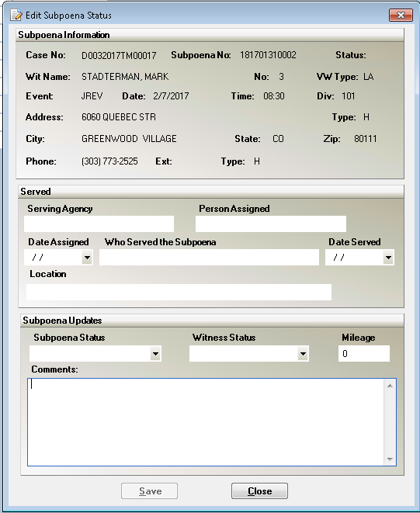Comments

Add Note:

Add Note brings up a new Note for the VW record connected to the Subpoena that are then saved to the case under the noting function within Action.

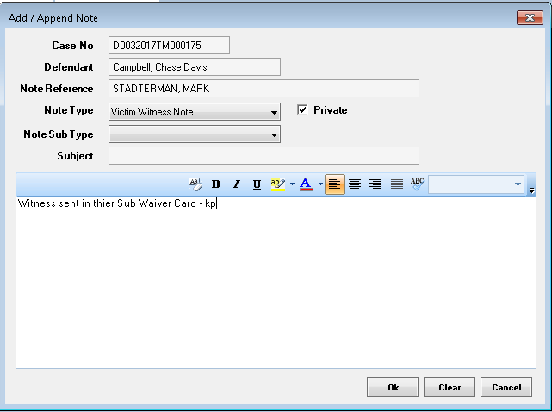

View Notes:

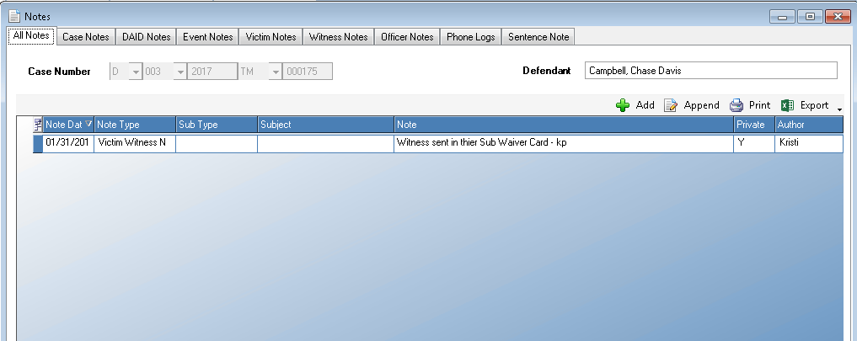View Notes brings up all Notes entered for this case for review if needed. Additional Notes can be added or reviewed.

Subpoena Status

Subpoena Status Screen:

Click on Subpoena Status

Enter Case Number and Load

Select Court Event to Review for the case

The Witness that Subpoenas were produced on will then appear listed.

Highlight a Witness Row and then Click on Edit Subpoena Status

User can now updated the Subpoena Status/ Witness Status/ Add Comments.

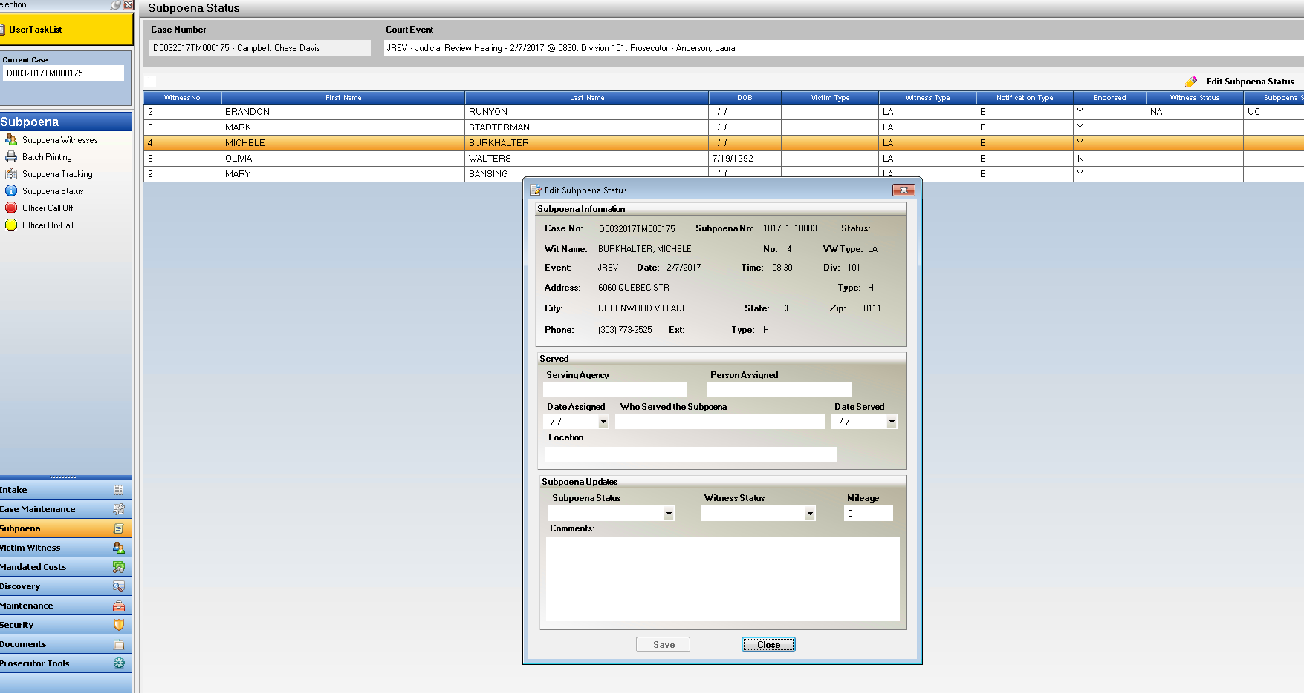

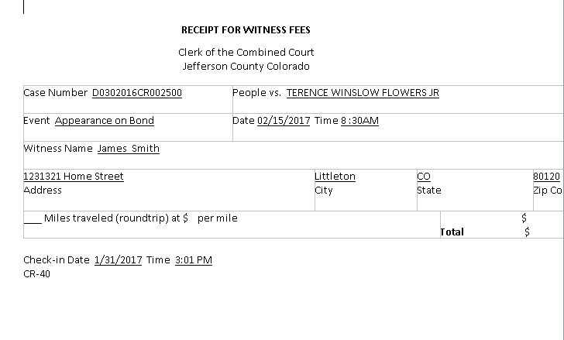

District 1- Jeffco

Subpoena Status –

Edit Subpoena Status- make Mileage entry and then click on Print Witness Fees. Receipt for Witness Fees is then generated and can be printed.

Officer Table – Maintenance

Officer Table- New Field for Post ID number

Power Users can now enter and update a unique POST ID number per officer within the Officer Table in Action. If the Post ID had previously been used on another entry it will not let the user re-enter on a different record. This is the first entry for Post ID numbers it will be added in other areas of Action in the future.

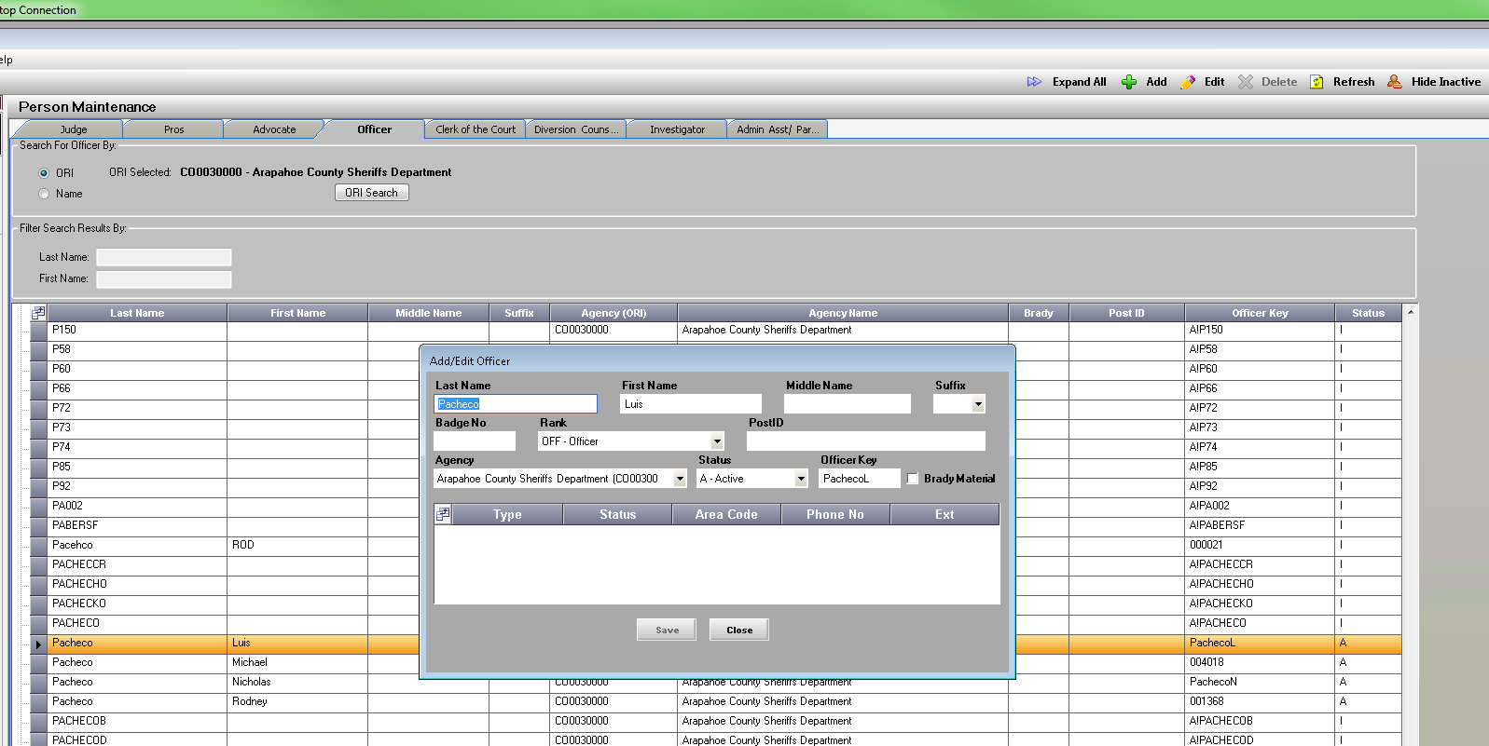

Action File Cabinet

***This new functionality will be turned on for a District by request to CDAC. Batch processing requires a server path location for the batches to be stored on your server.

Local File Pick-up:

Action file cabinet now provides a way to create notification of files that are added to the file cabinet but are chosen by the District not to be uploaded to eDiscovery website because of the large file size and time it take to either upload the material or for defense to download it.

External Media:

Action file cabinet can also now track any External Media that it part of the case but cannot be added to the electronic file: example Hard Drive brought in from law enforcement.

Settings:

When these setting are turned on for your district- Users select the Field Selector in the file Cabinet and select File Type(displays icons) and Local File Pickup (used to indicate file as local file pick up only) columns if not defaulted in view.

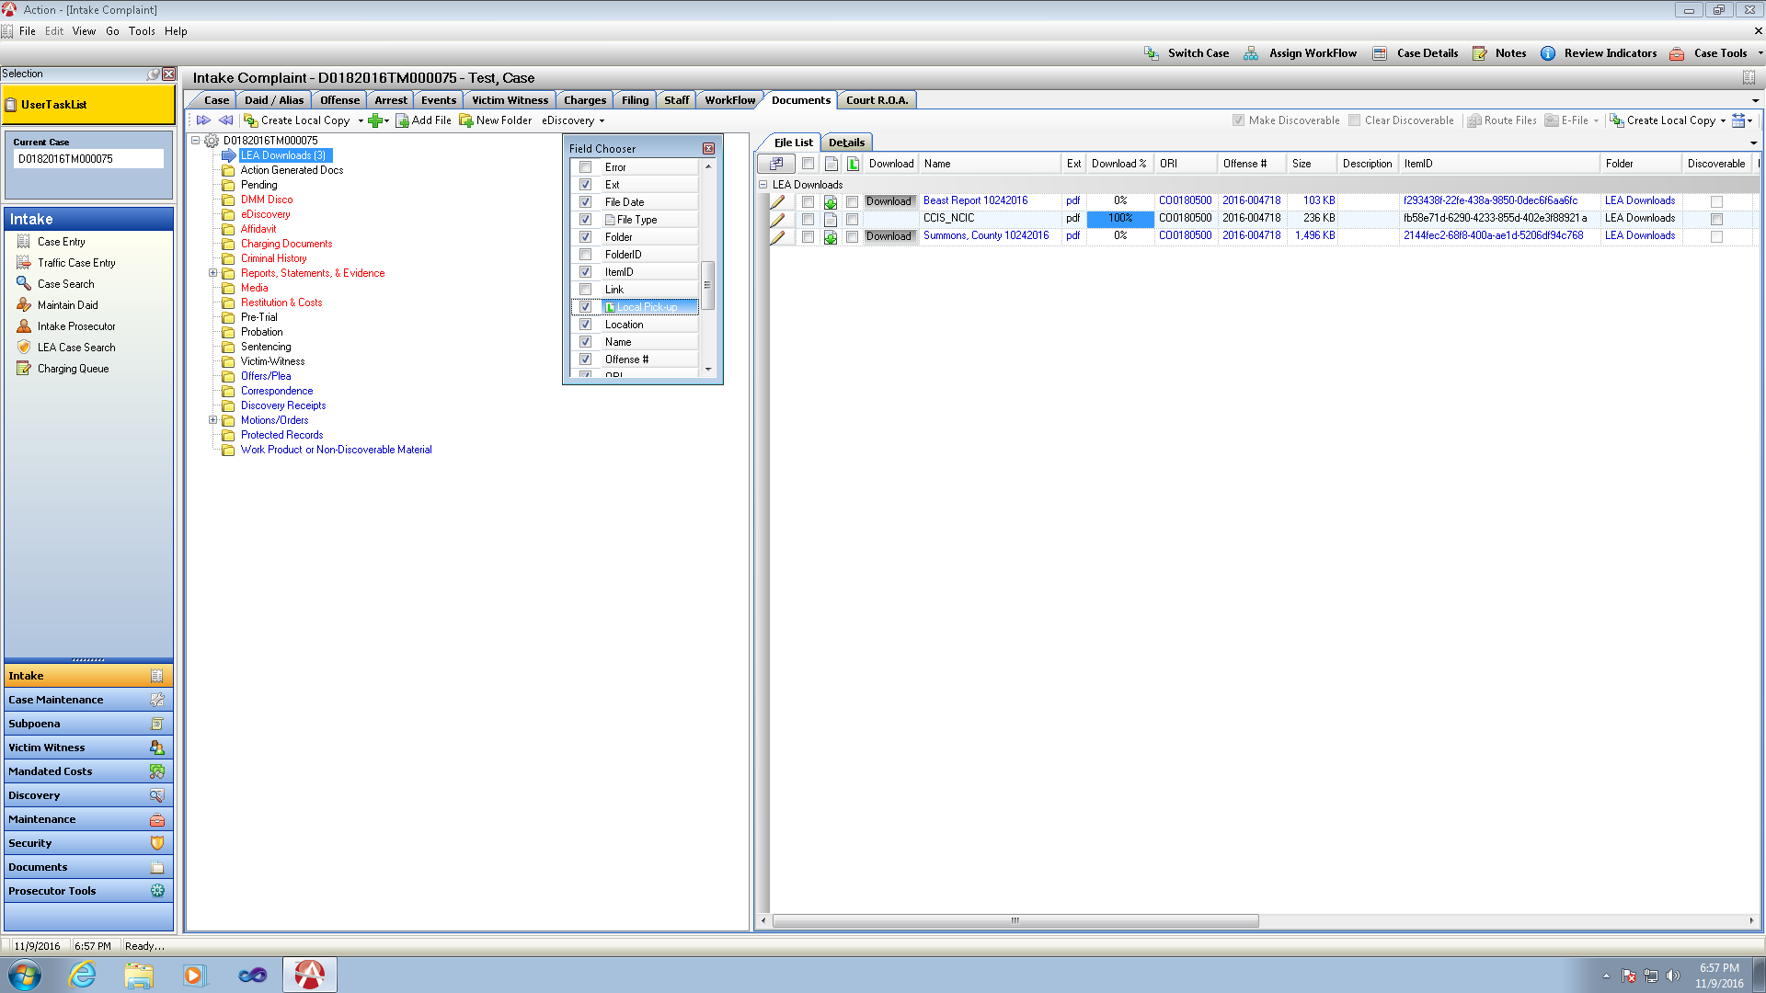

Local File Pick-Up



* Select File – click the Local file Pick up checkbox next to the filename in the Local File Indicator column.
* This marks the file as local file pick up only.
* Produce Discovery packet as normal on the case.

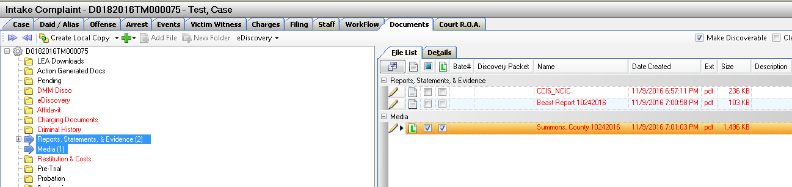

* Create Discovery item list will now show the files that were previously marked as local file pickup. User has the chance to update/edit this here before proceeding with creation of the discovery packet.

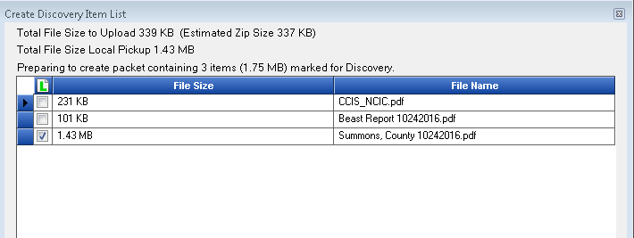

* Bate Stamp Discovery process as normal
* Upload Discovery to CDAC website – user has ability again to review files and select additional files for local file pick up or unselect- Estimated Zip Size is given as well as the File Size for Local Pickup. Districts may have an internal size limit that would help make this decision on what to upload or mark as local pickup.

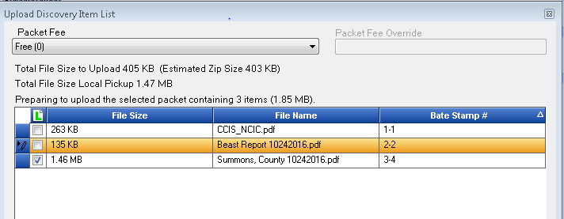

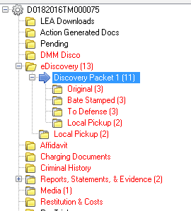

* New Local Pickup folder is generated under the Discovery Packet generated.
* Another Local Pickup folder is also generated under eDiscovery that will be a cumulative listing of all files marked as local pickup from all discovery packets.
* Discovery Packet
  + To Defense includes a new system generated document- Media List
  + Media List is a listing of all the files a Defense Attorney must pick up from DA’s Office.

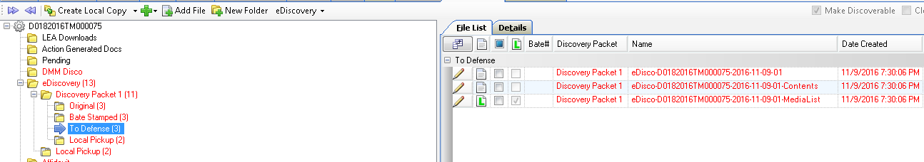

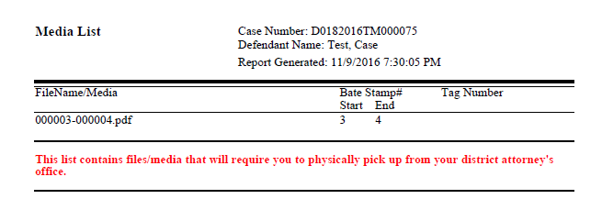

* Local Pick Up Folder
  + Copy of Media List
  + 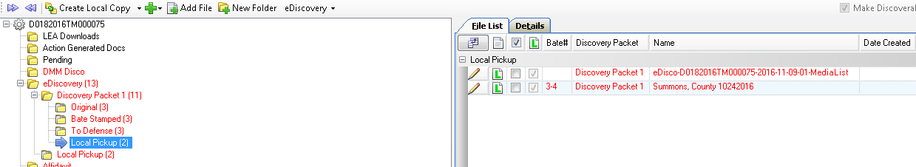File(s) marked a Local Pickup

External Media



* Highlight the Folder in the File Cabinet that you want this to be placed under.
* Click on the Green Plus Button – Select: New Physical Media
* Fill in Information about the External Media on the Right Panel of the File cabinet and Save

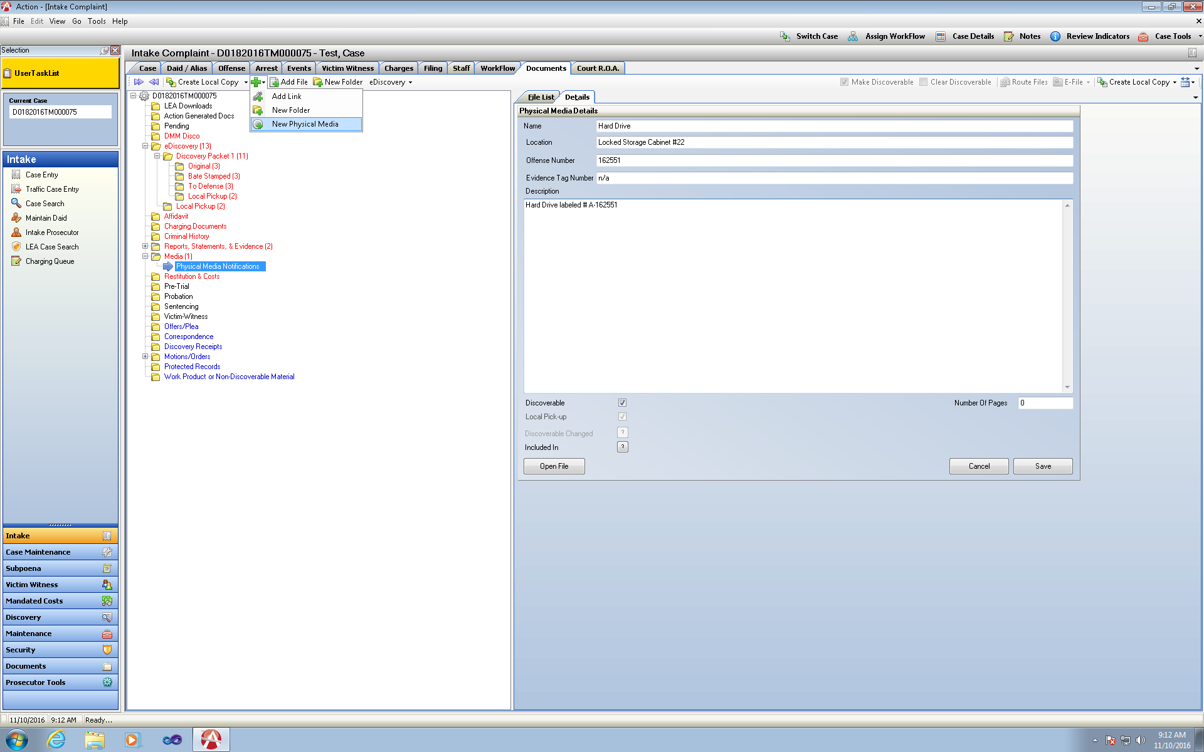

File Type Column displaying the Icons will show this new icon next to the created external media file list display.

File defaults as Local Pickup Only as the actual media does not exist within Action.

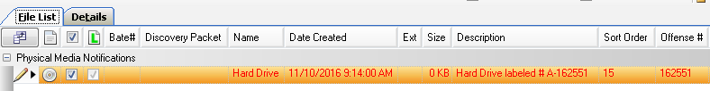

* Create Discovery Packet
  + Discovery item list will now show the files that are marked as local pickup only the local pickup check box is greyed out as there is not an option to upload this material.

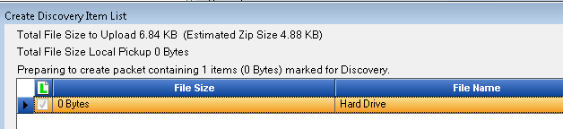

* Bate Stamp Discovery Packet as Normal
* Upload Discovery to CDAC website
  + User has ability again to review files and select additional files for local file pick up or unselect- The External Media file cannot be unchecked. Estimated Zip Size is given as well as the File Size for Local Pickup. Districts may have an internal size limit that would help make this decision on what to upload or mark as local pickup.

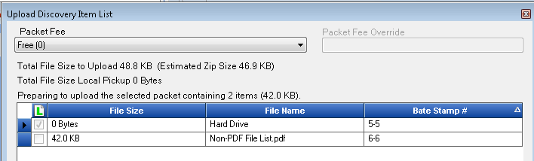

* Discovery Packet Created
  + To Defense includes a new system generated document- Media List
  + 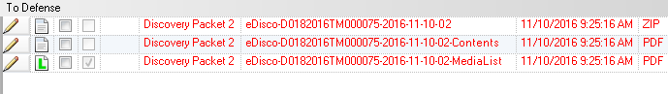Media List is a listing of all the files a Defense Attorney must pick up from DA’s Office.

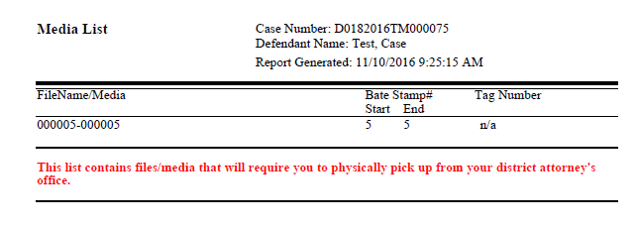

* Local Pick Up Folder
  + Copy of Media List
  + File(s) marked a Local Pickup (External Media Example)

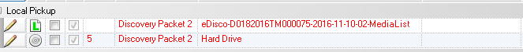

* Cumulative Local Pickup folder is also generated under eDiscovery that will be a cumulative listing of all files marked as local pickup from all discovery packets.

Example- I now have Local Pickup Files selected in Discovery Packet 1 and Discovery Packet 2

All files are shown under this Cumulative Local Pickup folder for User ease of identifying these files.

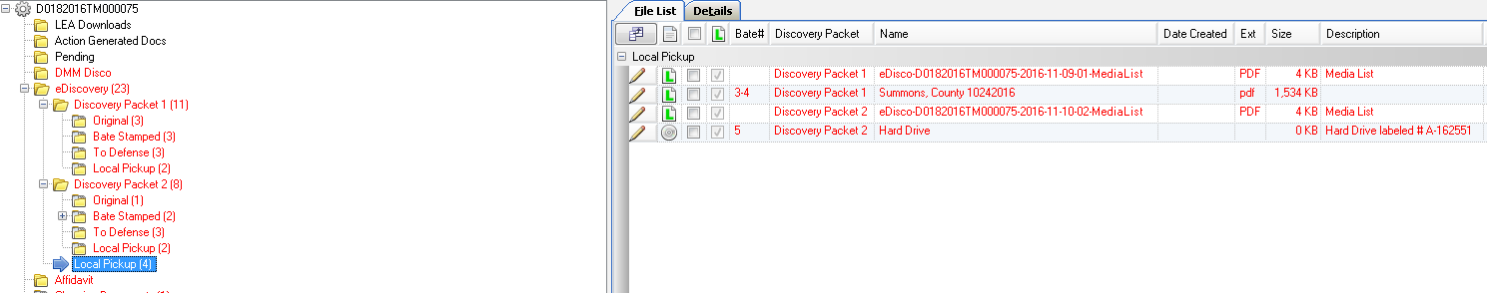

Defense Notification of Local Pickup Files

* Discovery Packet is uploaded to CDAC website with Local Pickup Files listed within a Packet.

Defense will receive email notification of new discovery available as in current practice. When they log in they will see their available Discovery and a new column marked as Local Pick-up Only. This lets them know immediately that this discovery packets contains items for Local Pickup.

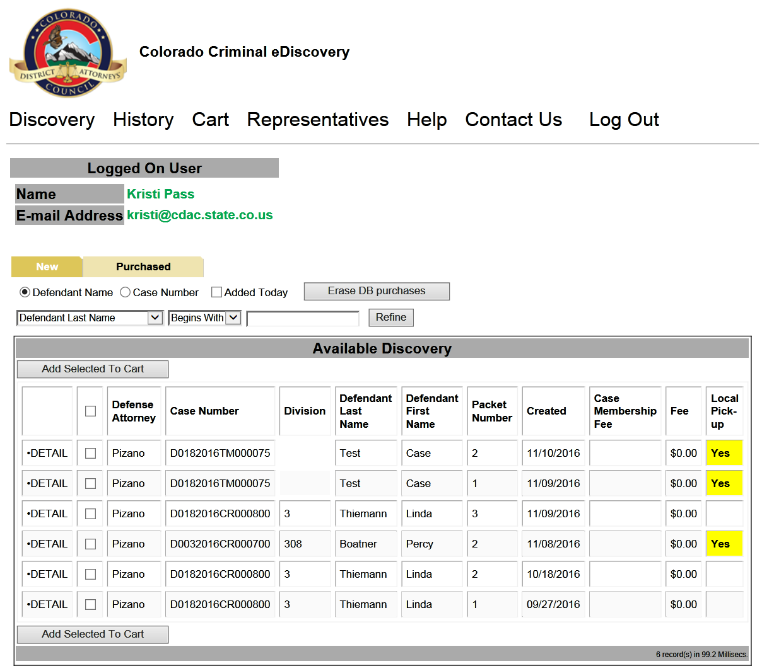

* Defense can click on Details and will now see files that can be downloaded and files that are only marked as Local File Pickup

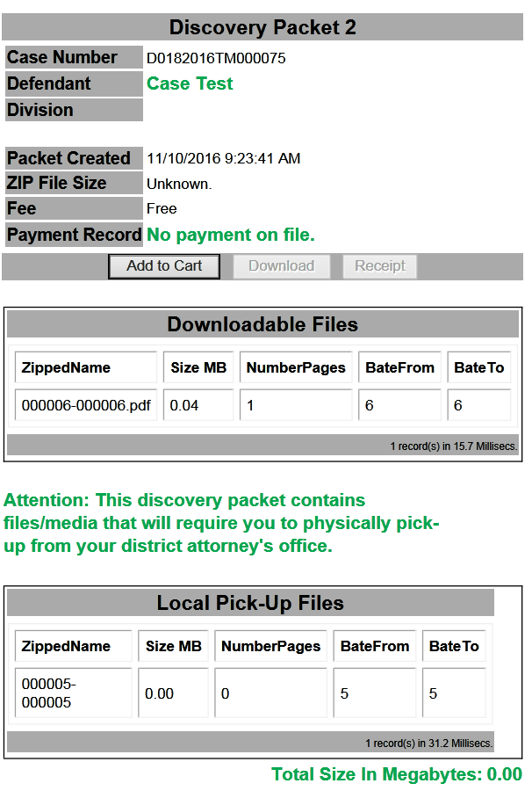

* After adding to cart and accessing the discovery packet on the Purchased tab the defense attorney will still see the new column for Local Pickup and when they download the files

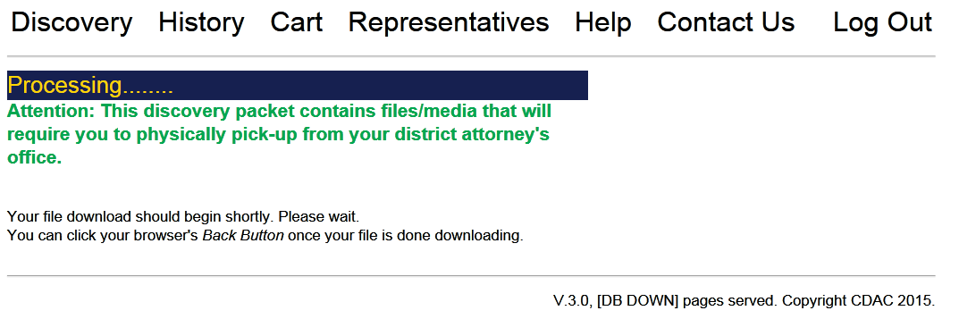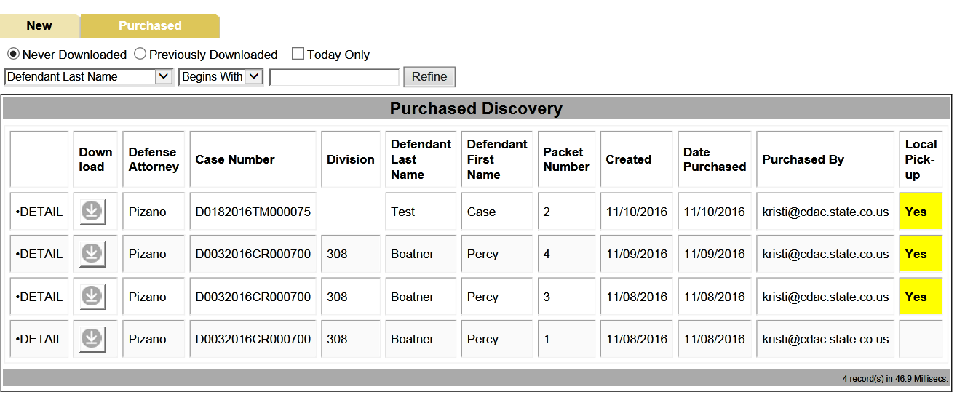

* 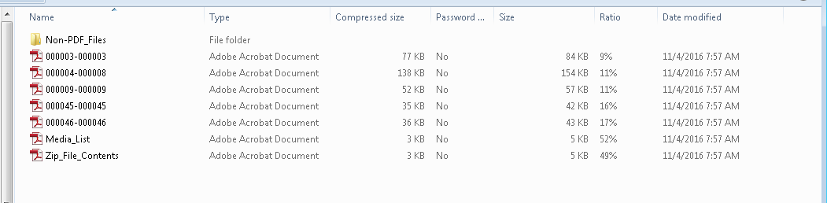Defense has the New Media Sheet with their ZIP File produced. They can then print and bring with them to pick up the local pickup files from your office.
* Depending on your internal practices, they can call/ come to the office and order the Local Media to be picked up with this sheet in hand.

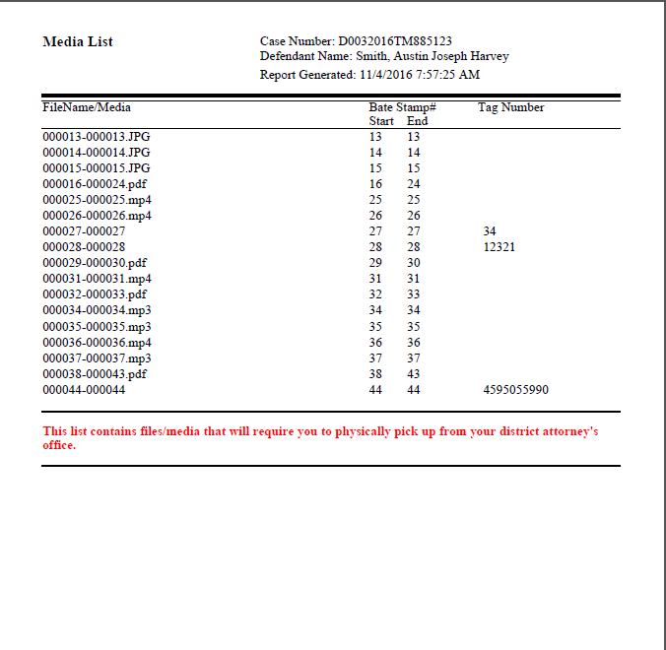

Defense Picking up Local Pickup Files

*Note using this feature requires a District Server Path to save Batches to for processing. Please contact [Kristi@cdac.state.co.us](mailto:Kristi@cdac.state.co.us) for information on setting this up and turning this function on.

* Defense comes to pick up Local Pickup Files and External Media Files
* Action user would look up the case in Action and per Packet in the case that contains these files click on the Packet Name and select: Local Pickup – Save to Batch

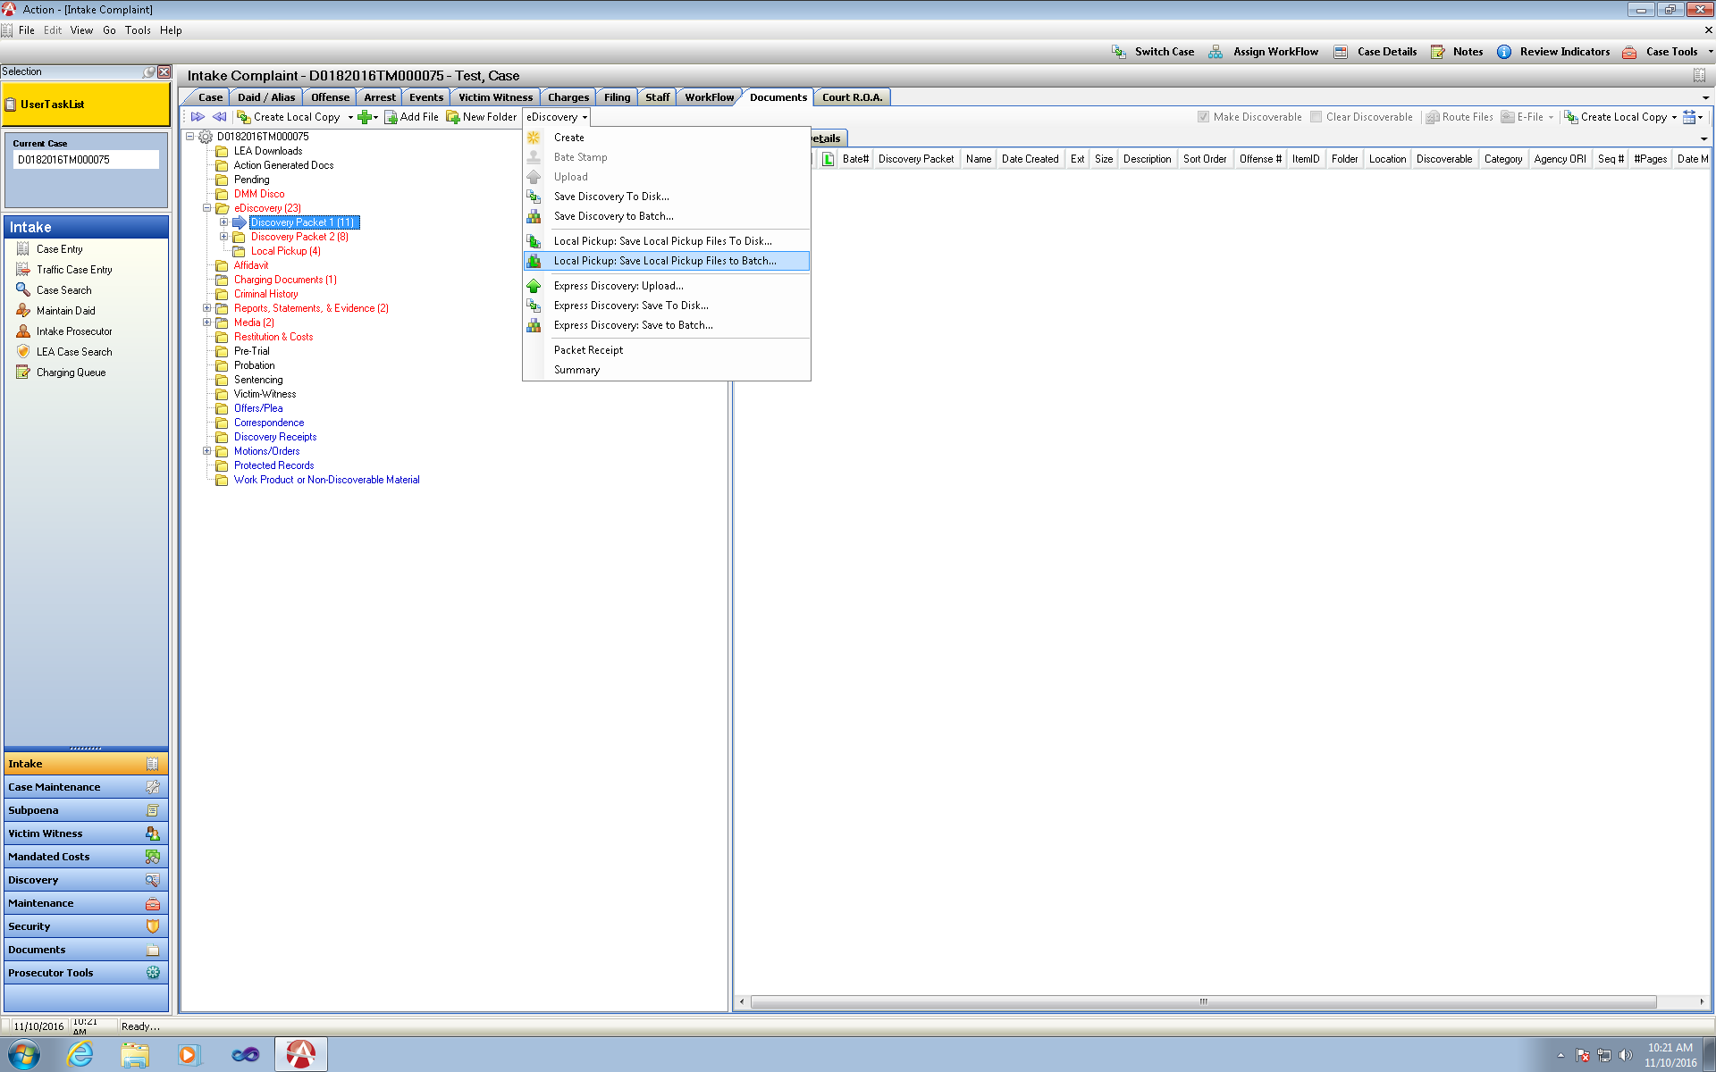

* Create a new batch name or add to an existing batch previous created that is still in a Ready Status indicating it has not yet been processed.

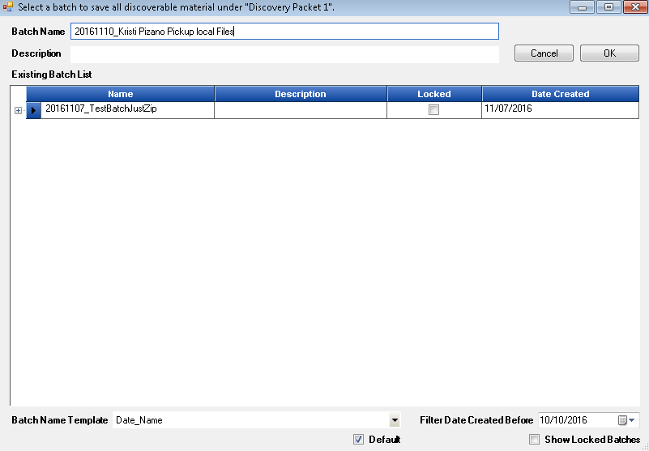

* Review Display of files set as Local Pick up
* Click Proceed

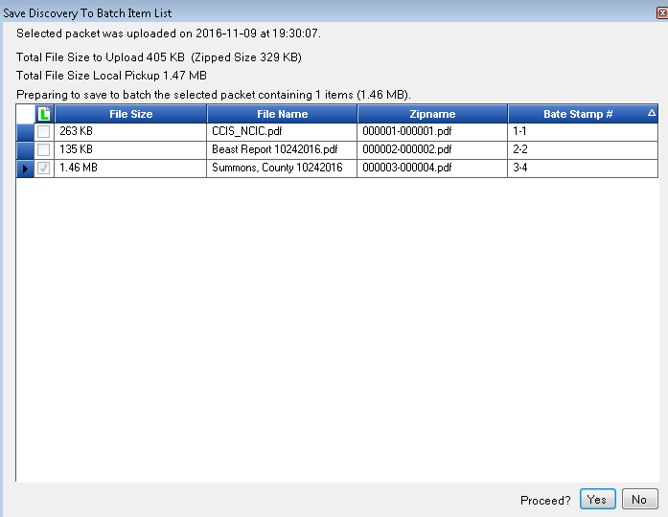

Access Batches from Discovery Tab

* Search for Save Batch Name-
* Highlight Batch – Zip files with Local Pickup Media are displayed on the right hand grid.
* Click on View External Media to see any External Media with this created packet that needs to be copied internally for defense (for DA user reference shows description Location, Tag # entered)
* Click on Pickup Batch
* If there are multiple Defense attorney’s entered on a case a Pop up window with them will appear for the users selection on who to process this for.
* Enter the Name of the Person picking up this batch of files
* 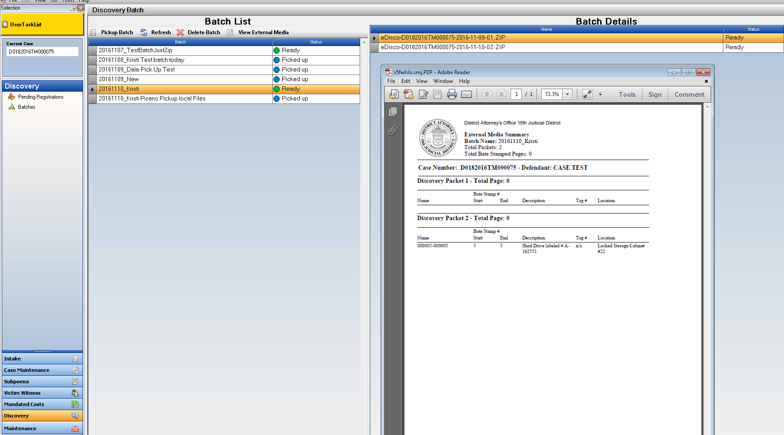Click on selected option
* Batch Receipt then appears to Print out and give to Defense to Sign as a Receipt to be collected and added back into your action case. The Name entered on “Pick Up” will be displayed then on the File Cabinet DA Receipt and Case Summary for Reference.

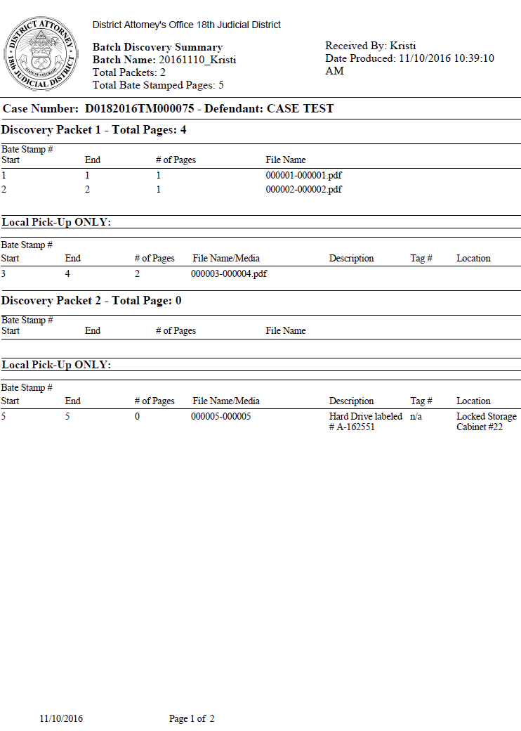

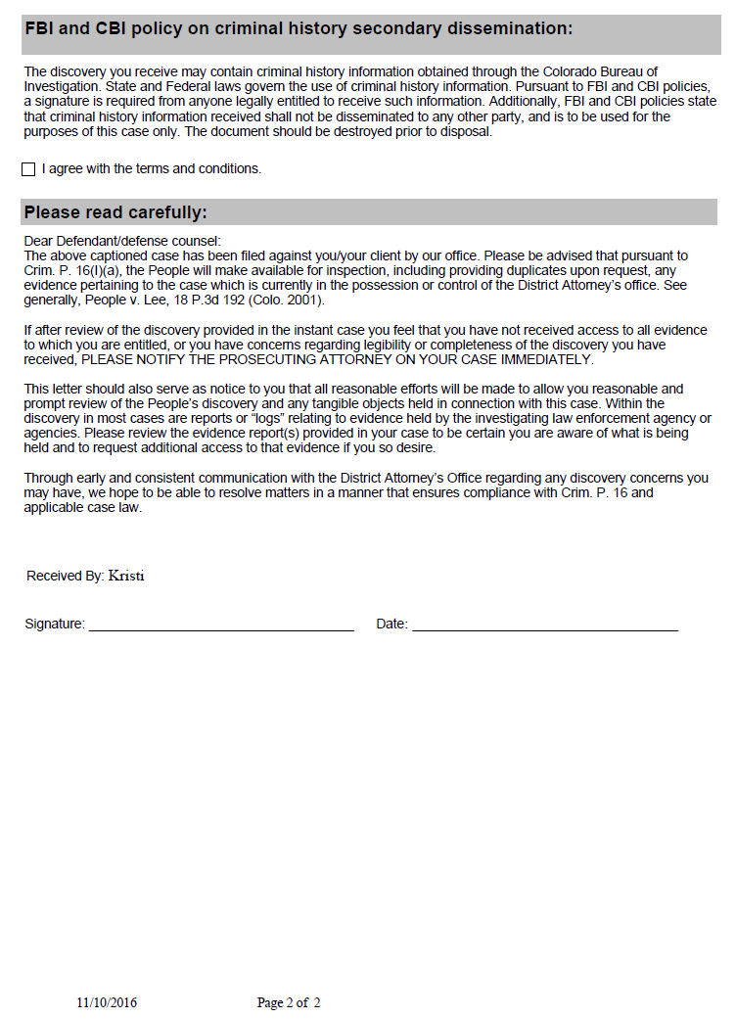

Links



* Highlight Folder that you wish to place a Link file into.
* Click on the Green plus button and select Add Link from the dropdown menu.
* Enter a Name, the Link address and a description.
* When this file is then opened it will direct you to this link.

