Action enhancment guide

June 2017 Training Guide- Mini Release



June 6, 2017

CDAC

CDACweb.com

**Table of Contents**

1. Notification to District of Delay in Transfer of LEA File……………………………………. 3
2. Case Sharing – Attorney General’s Office …………………….……………….………..... 4
3. Prosecutor PDF – open file correction ………………..…………………………….……………. 5
4. File Cabinet new District Settings property of folders……………………………………... 6-7
5. File Cabinet- Background Processing Queue ……………………………………………… 8-12
6. File Cabinet- Error Handling on Queue Operations ………………………………………..… 13
7. File Cabinet- Locked Case Processing ………….…………………………………………… 14
8. File Cabinet- Cancel/View Existing Active Locks ………………. ………………………. 15-18
9. File Cabinet- Background Processing Options ………………………………………………… 19-20

Notification to District of Delay in transfer to LEA case to Action

CDAC can now set up notifications to your district by user email, to update them in the event that file sent from an agency has a delay that requires technical update due to case data issues that sometime arise.

Please confer with your district and send CDAC a couple of contact users that would receive these notifications in the instance this occurs.

Sample Email:

**From:** Info   
**Sent:** Wednesday, May 31, 2017 6:24 AM  
**To:** Tuan Nguyen <[tuan@cdac.state.co.us](mailto:tuan@cdac.state.co.us)>  
**Cc:** Tuan Nguyen <[tuan@cdac.state.co.us](mailto:tuan@cdac.state.co.us)>; Lisa Rittenhouse <[LISAR@cdac.state.co.us](mailto:LISAR@cdac.state.co.us)>; Craig Evans <[craig@cdac.state.co.us](mailto:craig@cdac.state.co.us)>; Kristi Pizano <[Kristi@cdac.state.co.us](mailto:Kristi@cdac.state.co.us)>  
**Subject:** CDAC: LEA Case Processing Delay Notice - AGENCY: Broomfield Police Department - ORI: CO0640100 - LEA CASE#: 2017-00025302

* There has been a minor delay in making the case below available to the DA's Office.
* The Case has been submitted by the LEA. It is currently being reviewed by CDAC due to issues with the case data.
* Normally, this is a short delay and no action is needed from the DA's Office as the case will be processed automatically once all data issues have been resolved.
* **If this is an urgent case, please contact CDAC.**

|  |  |
| --- | --- |
| LEA Agency ORI: | CO0640100 |
| LEA CaseNo: | 2017-00025302 |
| Date Submitted: | 5/31/2017 6:03:55 AM |
| Transaction#: | 181149 |
| Status Date: | 5/31/2017 6:24 AM |
| Error: | Timeout expired. The timeout period elapsed prior to completion of the operation or the server is not responding. |

Case Sharing with the Attorney Generals’ Office

New functionality to share your District’s Action case with the AG’s office. Unlike the Special Prosecution function that moves a case handling from one to the other, this function will allow co-access to the case. This means both districts can add notes, review data etc.

This functionality is turned on per Districts Request to CDAC when they are ready to share a case with the AG’s office.

This function resides on the Case Tab in Action

Field labeled: Share Case With

*Note: The File Cabinet documents however are not shared. Anything added by the originating district will not be accessible to the AG’s office and vice versa.  Creating perhaps a Folder in the file cabinet labeled: AG Case Documents where they can store any files if needed may help decrease confusion.

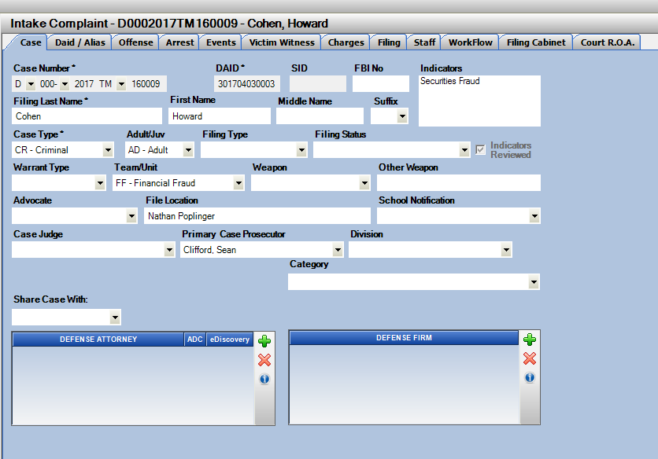

Prosecutor PDF –Open File Issue

File Cabinet enhancement to the creation of the Prosecutor PDF Document.

There was an issue with the previously released creation of this Prosecutor PDF file indicating the file was open and could not be created or new pages appended to it.

This has been addressed and corrected to process successfully.

This will also re-build the Prosecutor.pdf document if created prior to the re-write to ensure your copy is correct and updated.

Note: This is a District Setting, Manual or Automatic mode. CDAC will update per each Districts request.

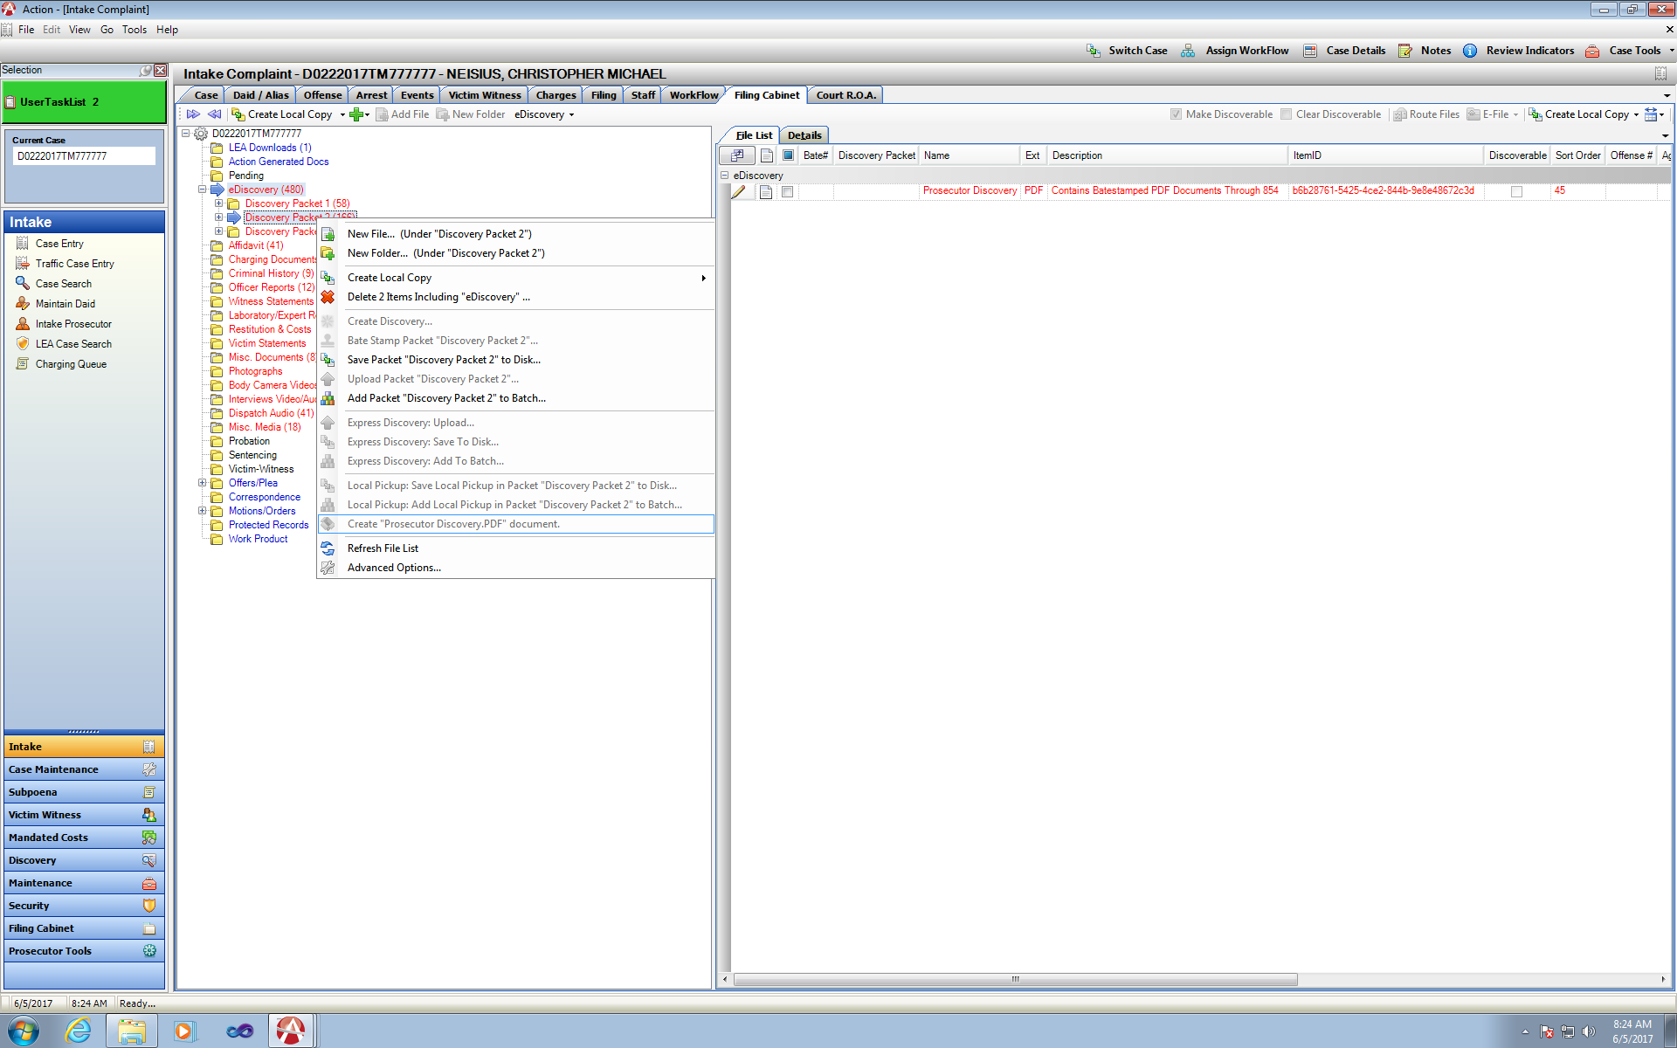

File Cabinet – New District Settings

Folder Properties

Filing Cabinet:

**Folder property Settings for LEA Downloads and Action Generated Doc’s**

District Selection:

1. Off Normal/ Current Functionality
2. LEA Downloads-Prevents User from Marking Downloaded files in this folder as Discovery.
3. LEA Downloads-Prevents User from Routing Downloaded files that are in this folder.
4. LEA Downloads-Prevents # 1 and #2 User cannot mark as Discovery or Route files from this folder.
5. Action Generated Doc’s-Prevents User from marking these files in the folder as Discoverable.
6. Action Generated Doc’s- Prevents user from Routing Files through Workflow.
7. Action Generated Doc’s- Prevents # 4 and #5 User cannot mark as Discovery or Route files from this folder.
8. LEA Downloads and Action Generated Doc’s Folders- Prevents a user from marking files in either folder as a Discoverable Document and Prevents user from Routing Documents through Work Flow.

With the setting on in any combination- either the Discovery check box with be disabled or it the files are attempted to be routed a message is displayed to the user indicating to move the files first into a different folder before routing.

This applies to all files that are un-zipped within LEA Downloads as well.

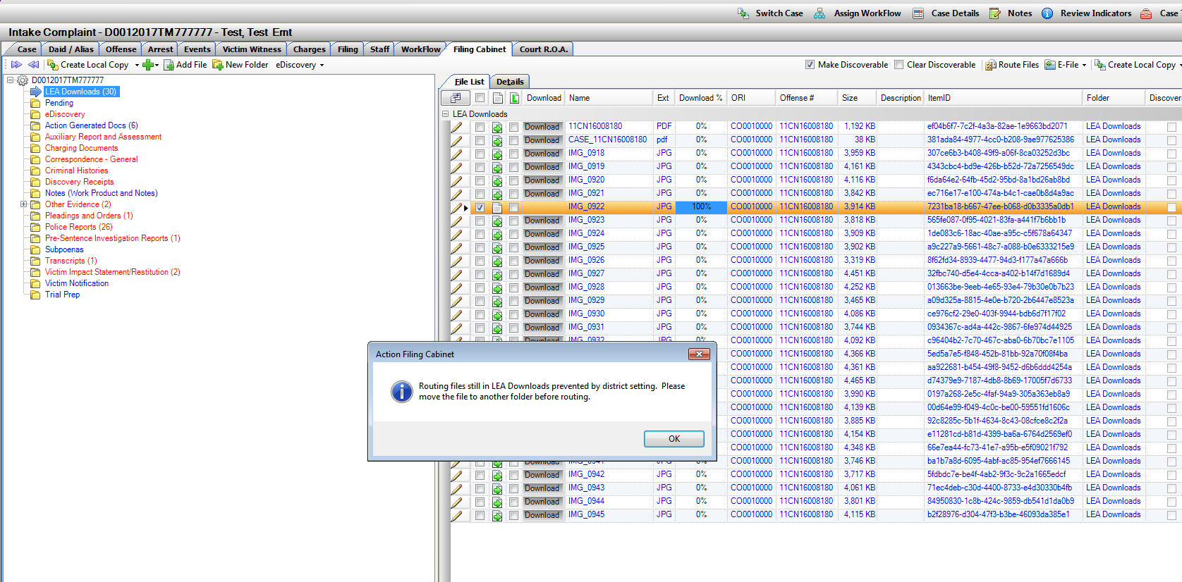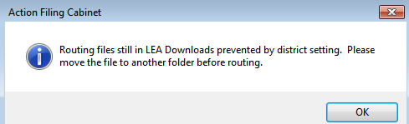LEA Download Folder

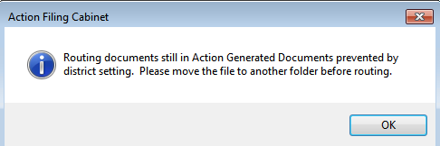Action Generated Docs

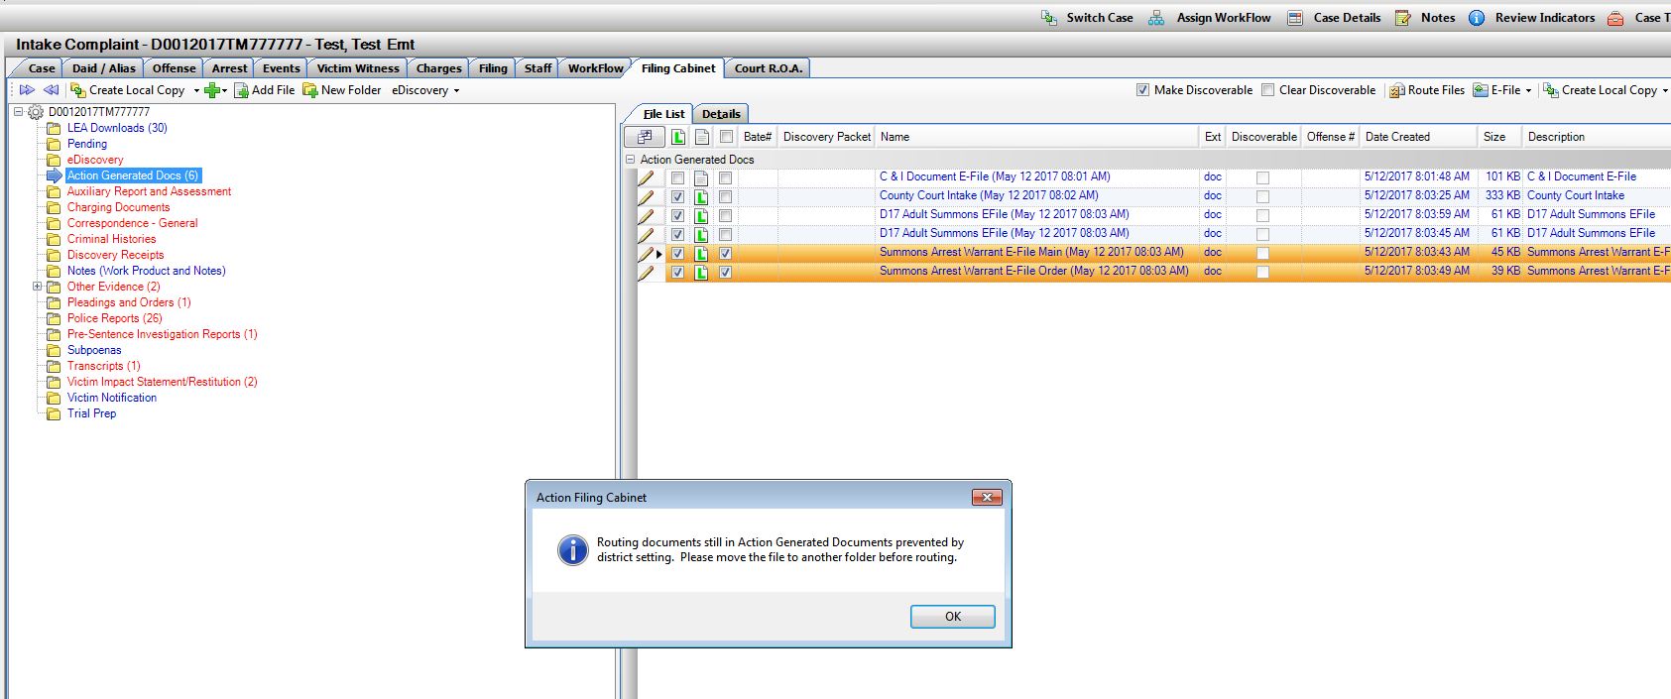

File Cabinet- Background Processing Queue

Processing Queue function provides a continued workflow for user when processing selected Discovery options without waiting for each operation to complete to move on to another case.

Queue Functions include:

* Manual creation of Discovery Packet
* Manual Bate-Stamping of Discovery Packet
* Manual Selection of Upload, Save to Disk, Save to Batch Options
* All Express Discovery options

The queue has several features to allow the user to:

1. Pause Current Operation
   1. Current Operation Processing appears in Green, Pause will turn text Yellow.
2. Resume Paused Operation
   1. Paused appears in Yellow Text, then back to Green when processing.
3. Pause All
   1. Pausing the processing of all operations in the queue instead of going to the next queued operation.
4. Resume All
   1. Resumes processing of operations previously paused
5. Cancel
   1. Cancels operation selected, if the operation that is canceled is the one being processed it will complete the current process before canceling. (Example: Express Discovery Upload selected, if you cancel during the bate-stamp process it will continue to bate-stamp and then cancel the next operation – upload.)
6. Cancel All
   1. Cancels all operations in the queue.

Settings options within the Queue:

Default ON: Auto Follow Running Process, auto runs the next operation awaiting processing.

Default ON: Remember Position, queue remembers your position of queue and operations awaiting to be processed.

Default OFF: Automatically Hide Successful Operations when completed.

**Note: This queue is Active per Action Session. If you log out of Action with Queued files to process you will receive a message warning you first, in you continue you will lose unprocessed queued items.

This process is a District Setting, please contact CDAC to have this functionality turned on for your District.

When enabled, a user will process discovery with either method of producing a discovery packet, manual or express options.

This Queue window can be closed, minimized as its running. It opens automatically when a new operation is added. It can also be opened from the File Cabinet if closed – eDiscovery drop down- Advanced- Open Discovery Queue.

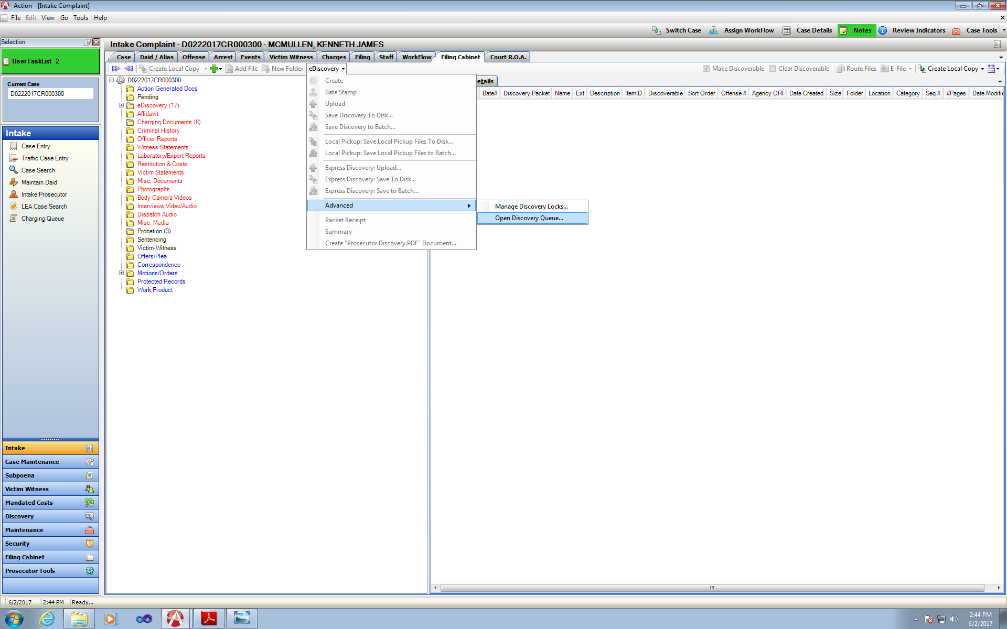

The Process will be displayed to the user in a new Pop-Up window- Filing Cabinet Discovery Processing Queue. With description of case, packet, operation, etc. shown below.

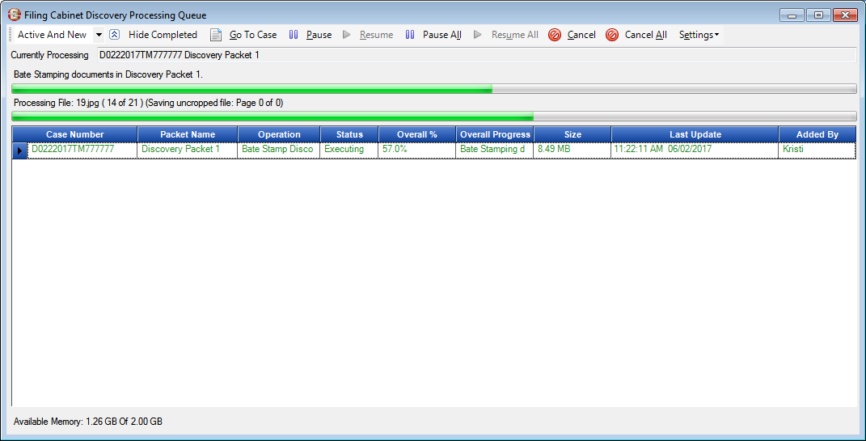Processing – Text in Green

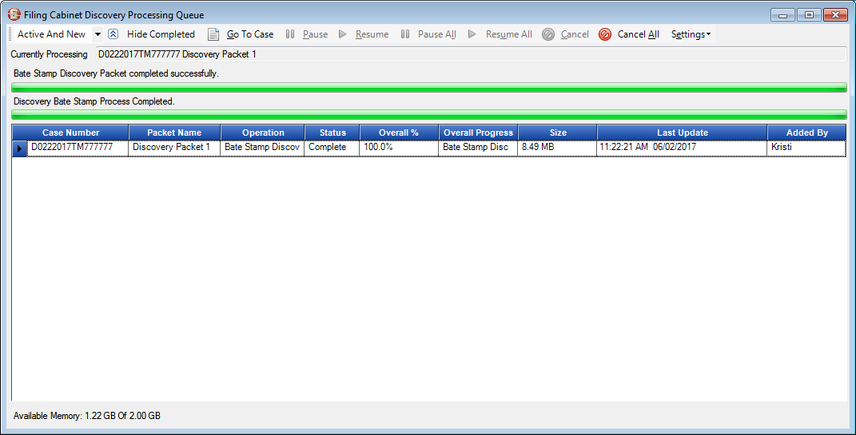Completed Successful Operation- Text in Black

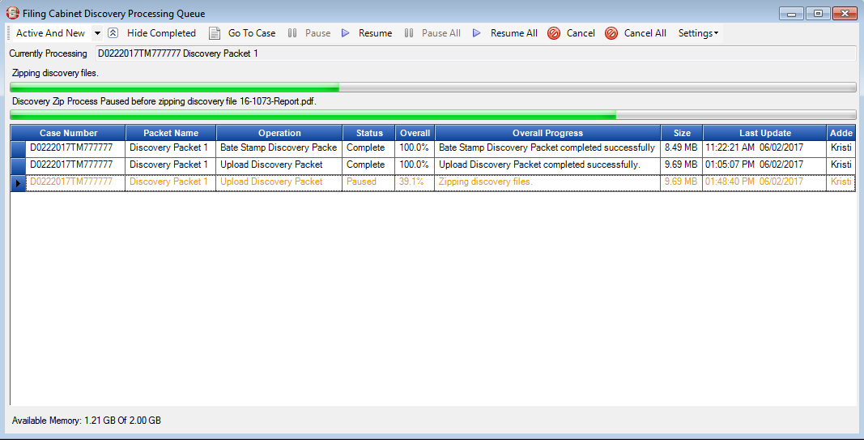Paused Operation

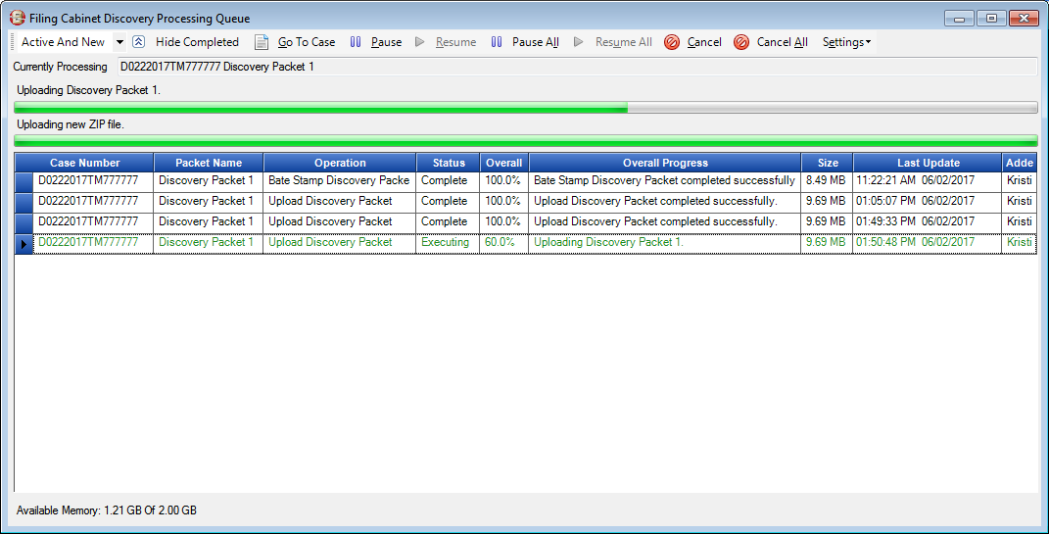Resume Operation

Multiple Cases – Queued Operations

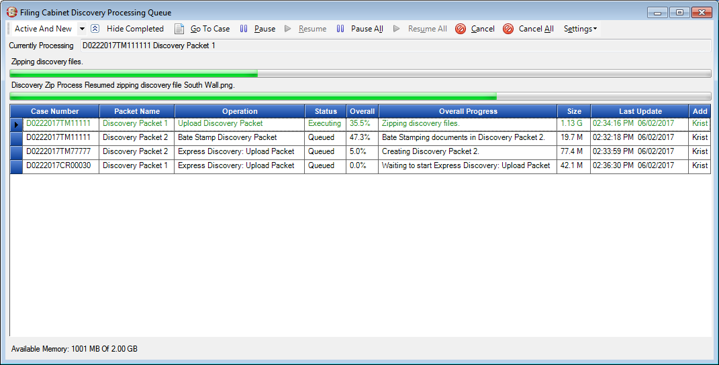

If an operation it taking a long time to run, and you want to get other packets completed, Pause the slow one and the next in line will begin to execute.

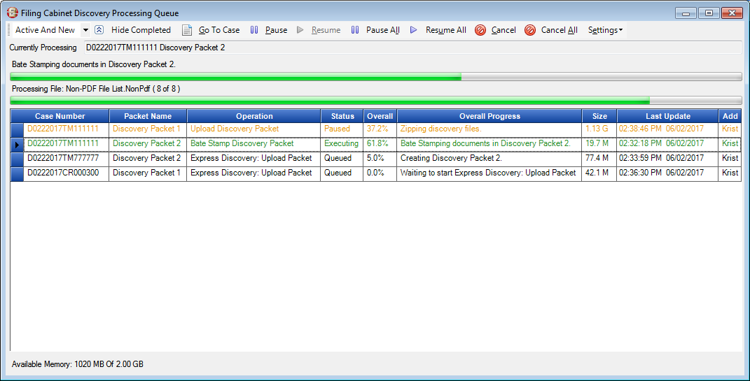

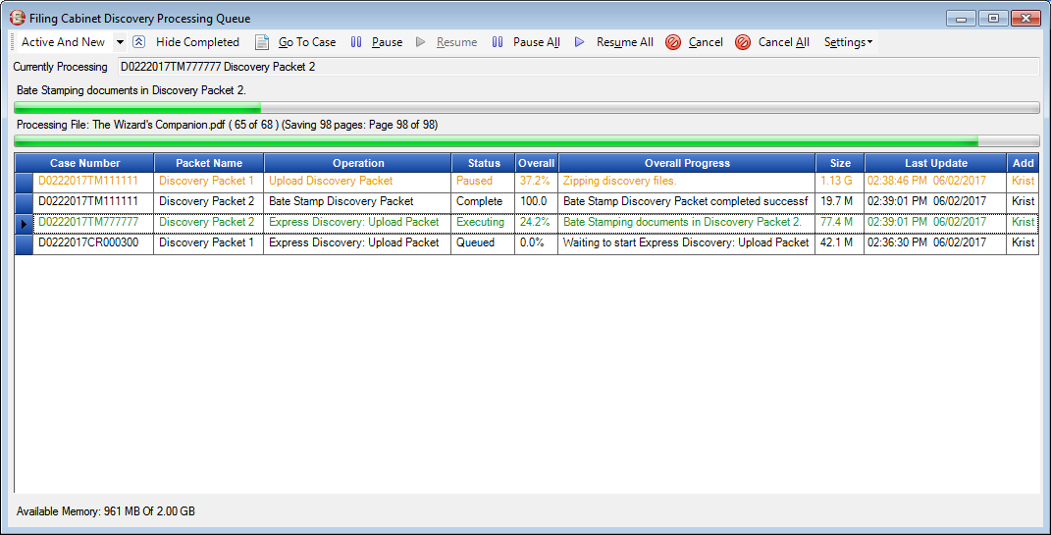

Errors on Queue Operation

If there is an error with an operation when it’s processing the system will Pause for Error Status and they system will move on to process the next Queued operation.

A Packet can have errors for various reasons, in this example one of the files the Bate-Stamp process is attempting to bate-stamp an open document.

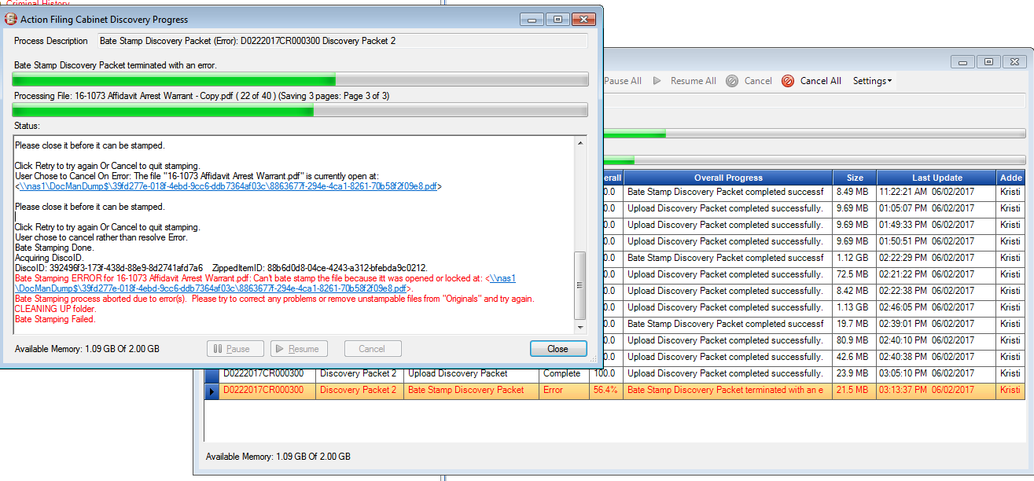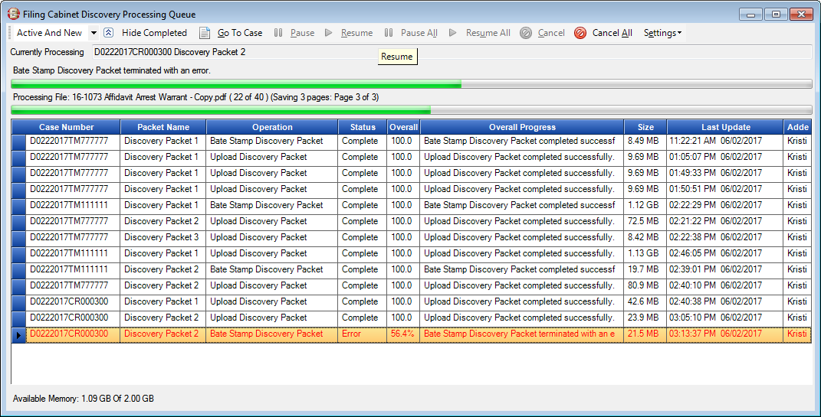Double click on this error to bring up the details of error. Highlight record and use Go-To-Case button to navigate directly to the case as well. Correct Error and re-select next operation to complete.

Locked Case Processing

Case processing of additional packets becomes locked to ensure that there can only be 1 packet being created/processed at anyone given time for a single case. This is to prevent for example 2 users attempting to process the same discovery on the same case and to keep discovery bate-stamp in order it was added.

A Discovery Lock for Error Window opens to the user that is secondarily processing discovery indicating Discovery cannot proceed because of an existing discovery lock.

It lists which Action User has this locked currently, lock time and date also with a description.

Screen for reference if you need to go back and review. User gets message that their packet was not completed.

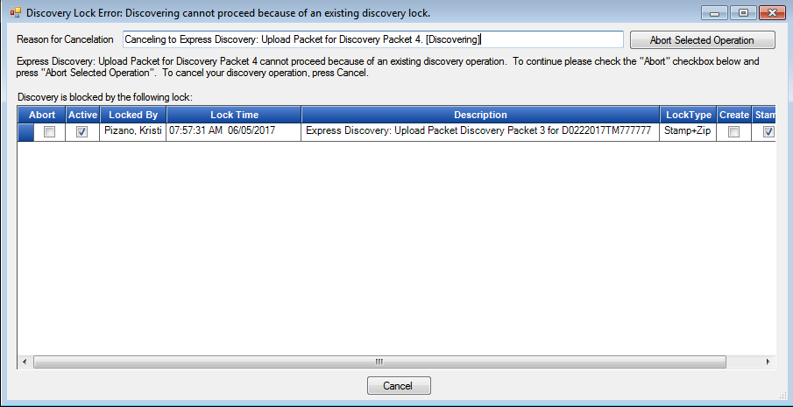 Shows that another user is currently processing Express Discovery Packet 3.

Shows that second user’s attempt to create Packet 4 on case is canceled due to lock by other user.

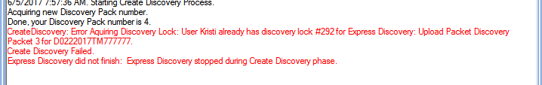

Cancel Existing Locks and Viewing all Locks on a Case

User with the office can be set up with the specific action of removing a lock on case.

Lock About Permissions- set up by request to CDAC per user. Allows the user to type in a reason for cancelling any locks on a case and cancel it’s processing.

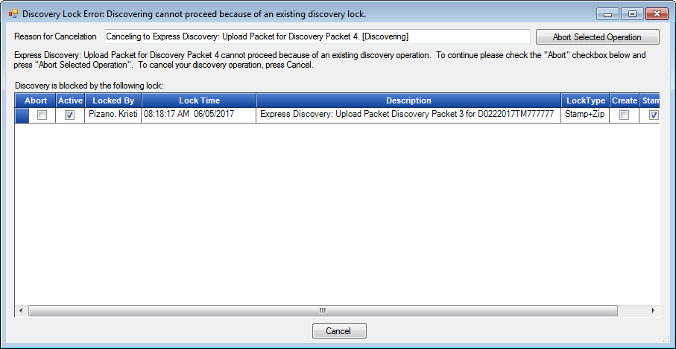

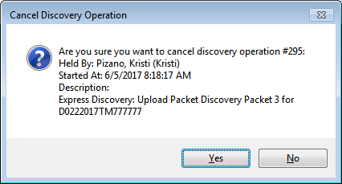

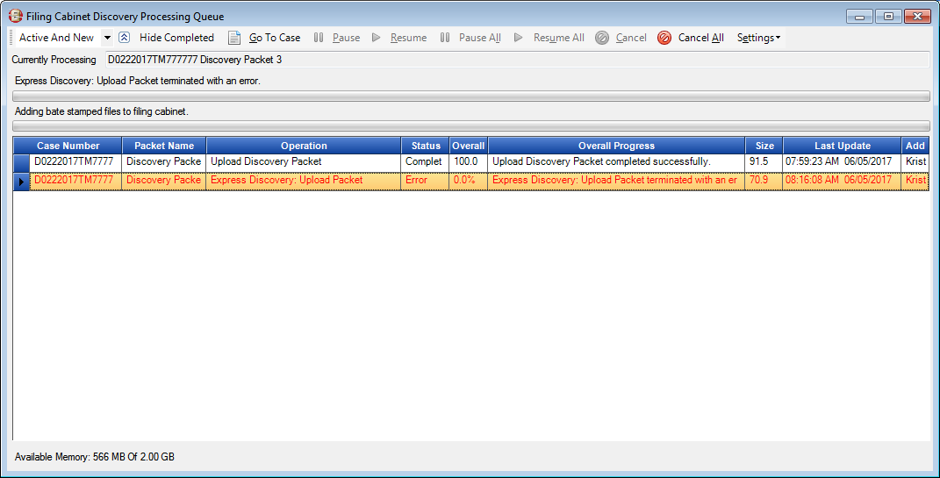Displayed Error Status on Discovery Processing Queue to User that added the operation.

Per Case, a User can also abort locks or view all past locks by accessing eDiscovery 🡪Advanced 🡪 Mange Discovery Locks

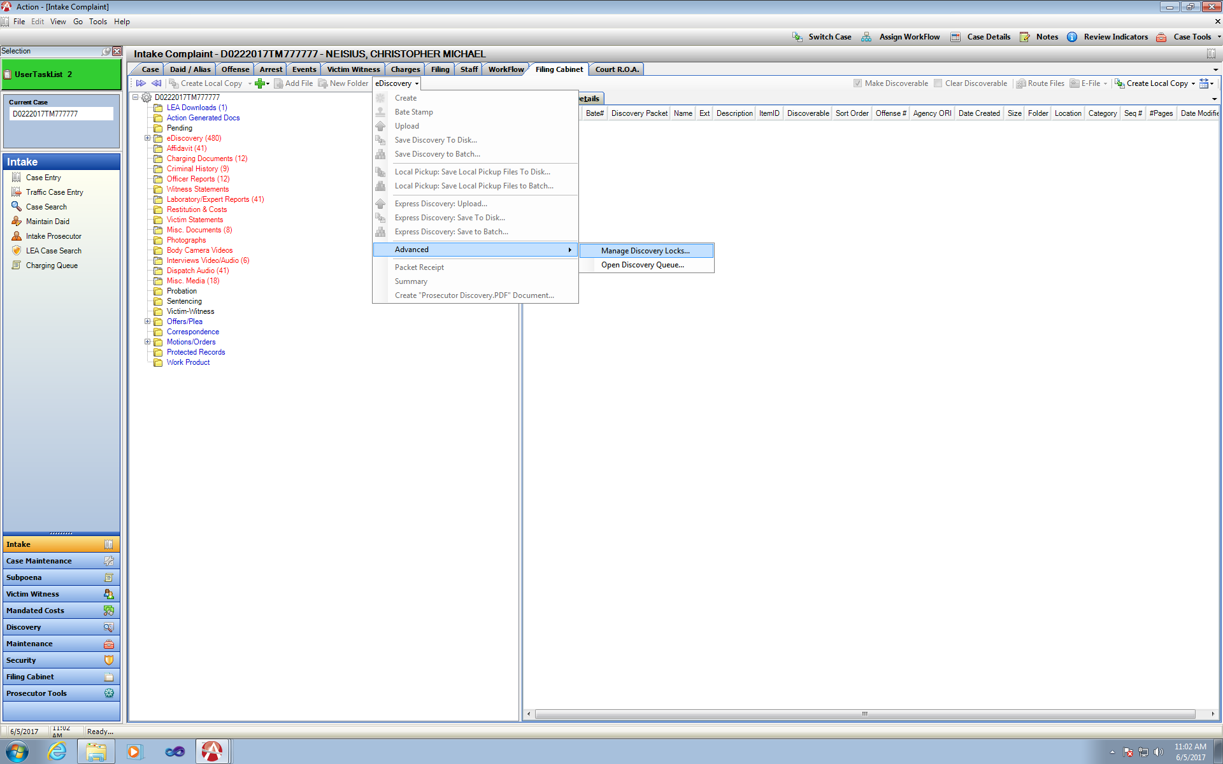

Active Locks are displayed by default if any.

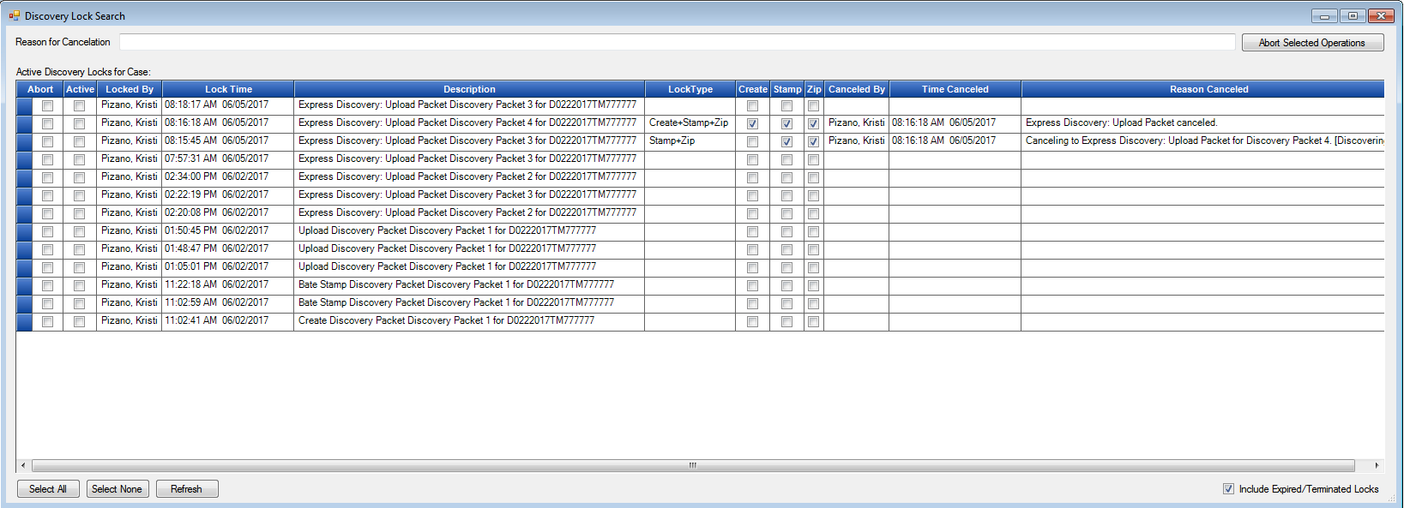Click on Include Expired/Terminated Locks to view all per case.

Paused for Error

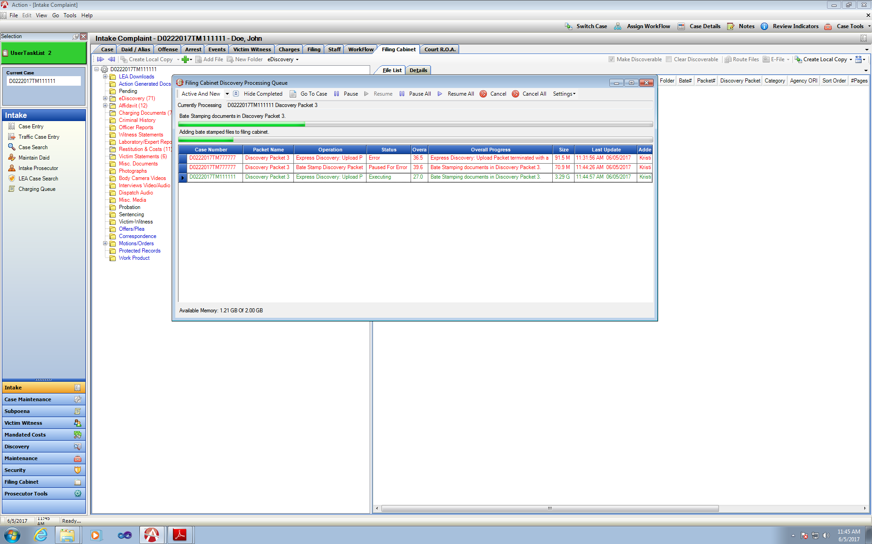If there was an Error with processing an Operation for instance if a document was open on the case and the bate-stamping operation was trying to run. The user would see the packet on the background uploader with Paused for Error Status. This pauses the progression of the packet until the user can fix the issue, the background processing continues to the next Queued item.

Double click the Paused for Error Operation to view details and message about which file is open. Ensure file is closed and then select Retry.

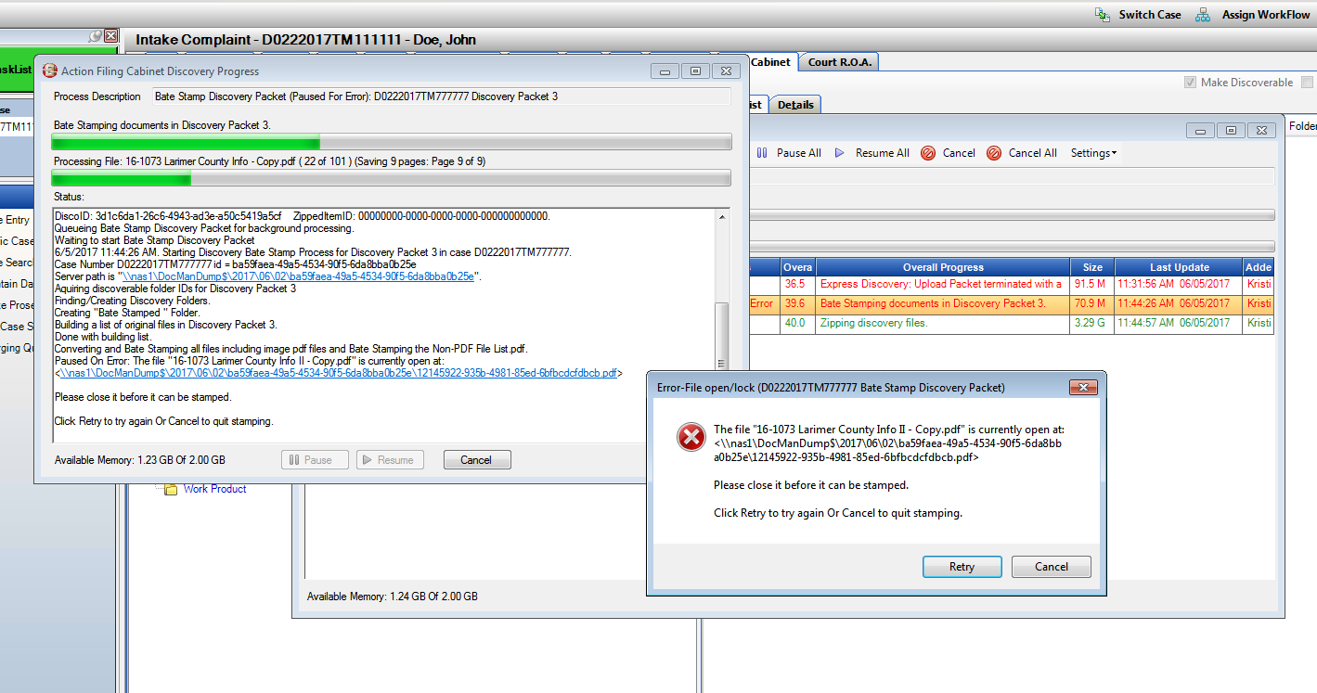

When error is fixed (in this instance closing the opened file), status updated to Paused if another operation is already running and then will be the next operation to execute.

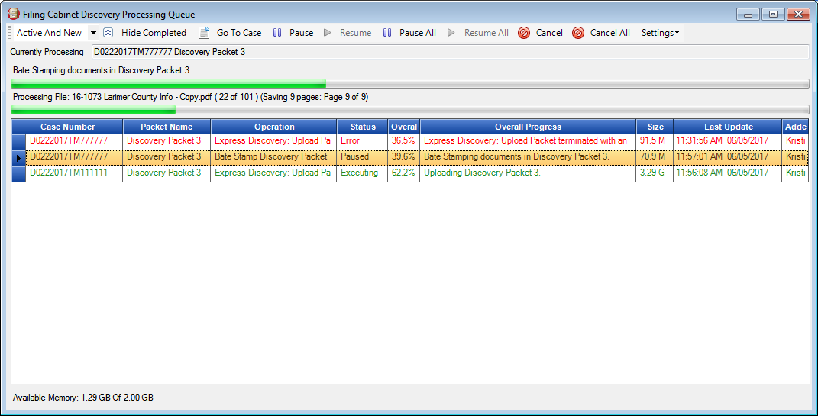

Background Processing District Options

There are several settings that can be applied for a district with Background processing to select from for set-up.

1. Leave Off – current functionality plus Cancel Button
2. Express Discovery Only will go to Background Processing
3. Uploading Operation will only go to Background Processing
4. Batch Processing Only
5. Bate-Stamping Only
6. All Operations will go to Background Processing

Background Processing is Running- Do not Close Action-

Error/Warning message Displayed to User:

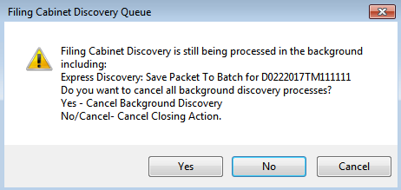

With Queue turned off, users will have the functionality to cancel selected operation when running as well. Please note that Cancel will leave a discovery packet in an incomplete state- it finishing the current operation it is on and then cancels to finish the other options (if express Discovery is used).

Example of message when Cancel while packet was uploading (using Express Discovery).

