Action enhancement guide

October 2017 Training Guide



October 6, 2017

CDAC

CDACweb.com

**Table of Contents**

1. Intake Case Entry: Enhancement of shown fields ……………………………………….. 3
2. Case Maintenance Banner: Add Paralegal …….……………….…………………………….. 4
3. Prosecutor Tools: Paralegal Case Listing ………………………………….……………………. 5
4. Prosecutor Tools: Defaulting action user name ………..…………………………………... 6
5. Subpoena Tracking: Default subpoena status to “Returned” ……………………….. 7
6. Subpoena Status Screen: Enhancements ……………………………………………………….. 8
7. Intake: Special Prosecution ……………………….………………………………………………….. 9
8. Victim Witness Screen: User defined columns and order …..………………………..… 10

Intake- Case Tab Addition of Fields

Intake form on the Case Tab will now display the cases historical case numbers, defendants other cases linked by common DAID, and co-defendant linked cases.

These have been displayed in Case Maintenance but were not included in the Intake forms.

Review of functionality

Historical Case Numbers:

Show previous case numbers used on this cases-typically a TM/TC changed to a CR/JD/M/T case. A Power User can remove a historical case number if used in error – highlight the historical case number and click on the RED X. This allows that case number to be used on another case if necessary.

Defendant Case List:

Defendant Cases that are connected to a common DAID are displayed in this field. If a defendant has multiple DAIDs, these can be sent to CDAC to have them merged together so cases are seen in this listing. Users can click on these cases within their district to open and review instead of performing a separate case search.

Linked Cases:

Users connected cases are shown here. Users make these links in Intake via the Offense Tab- Link Case button. When cases entered share a common ORI and Agency Offense Number they appear on the Link Button selection for a user to connect.

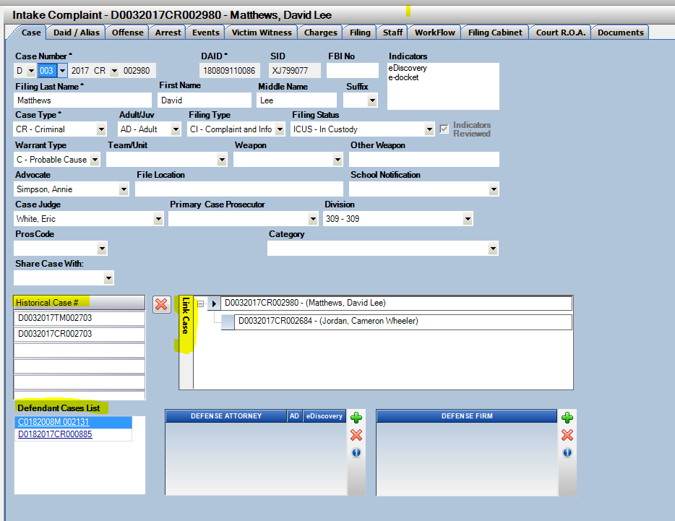

Case Maintenance

Case banner now shows Paralegal Assigned field from the entered field on the Staff Tab. This was AUC group requested to display the Admin/Paralegal assigned to the case from any tab on the case within Action. Total Charge field was removed per AUC group to accommodate the space.

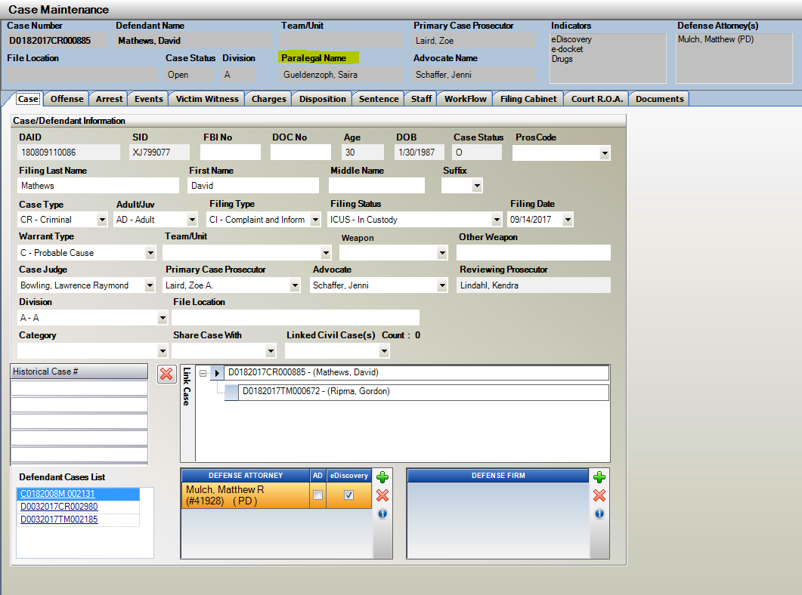

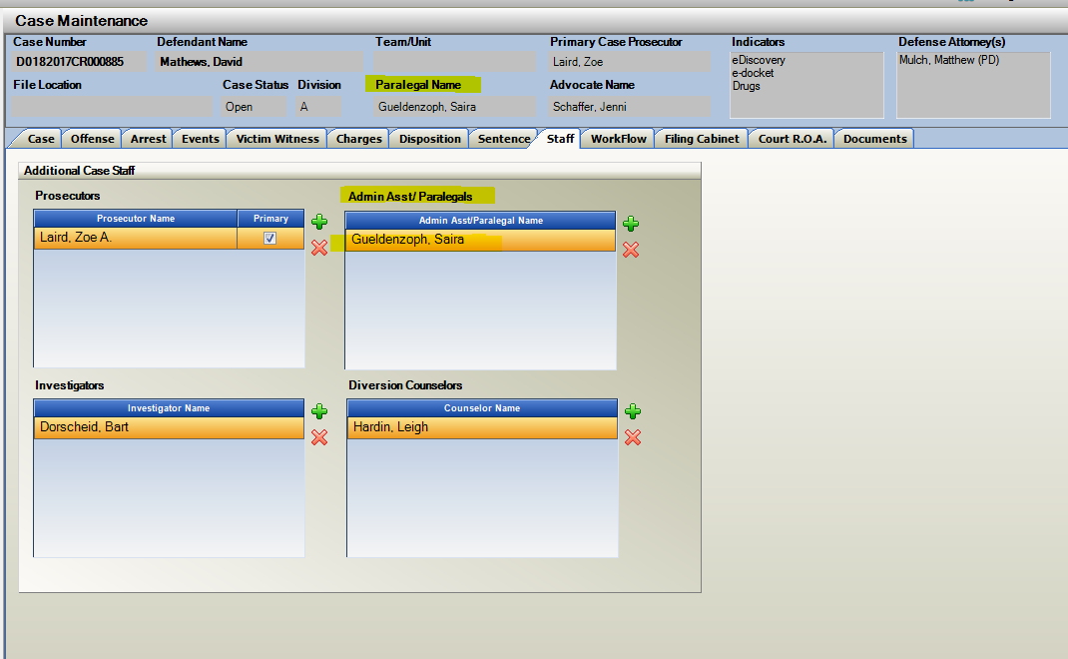

Prosecutor Tools: Paralegal’s Cases

In addition to the last build where a Paralegal Docket was created, there is now a Paralegal’s Cases List.

All cases assigned to a specific entered paralegal can now be accessed through this view regardless of pending events.

This display is based off entry of the Paralegal/Admin to the Staff Tab within the Action Case.

To Access: Prosecutor Docket 🡪 Paralegal Docket

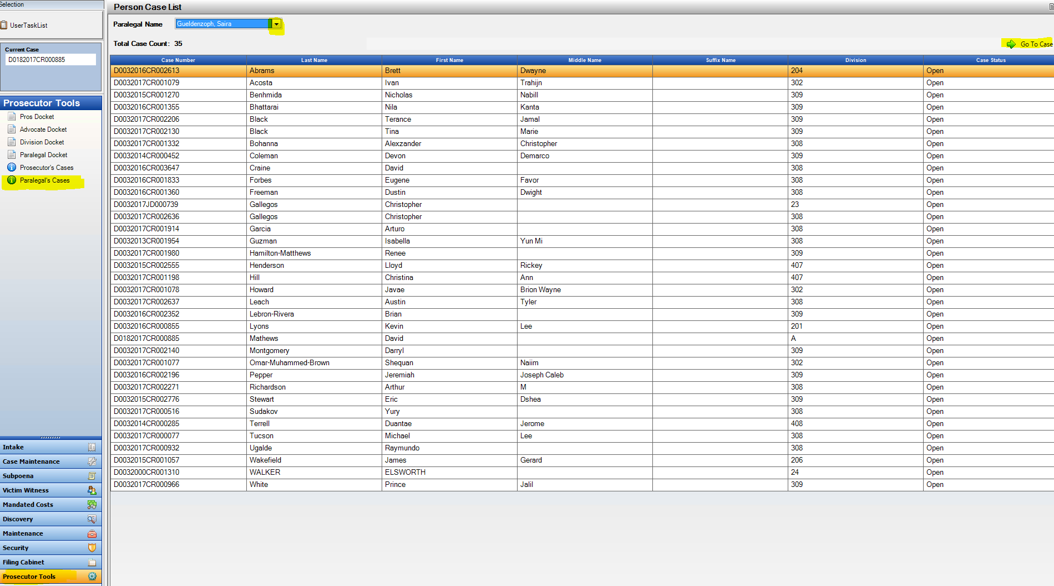Prosecutor Tools: To Default Action User Name to Dockets

Note: If a Paralegal/Advocate/Prosecutor comes into the Docket selections and their name does not default to the docket selection Power Users can go into Security 🡪 Users🡪 Edit User 🡪 Use the Person List drop down field to select the users entry from the Maintenance Person table. This connection then allows the docket to auto-populate to the User logged into Action.

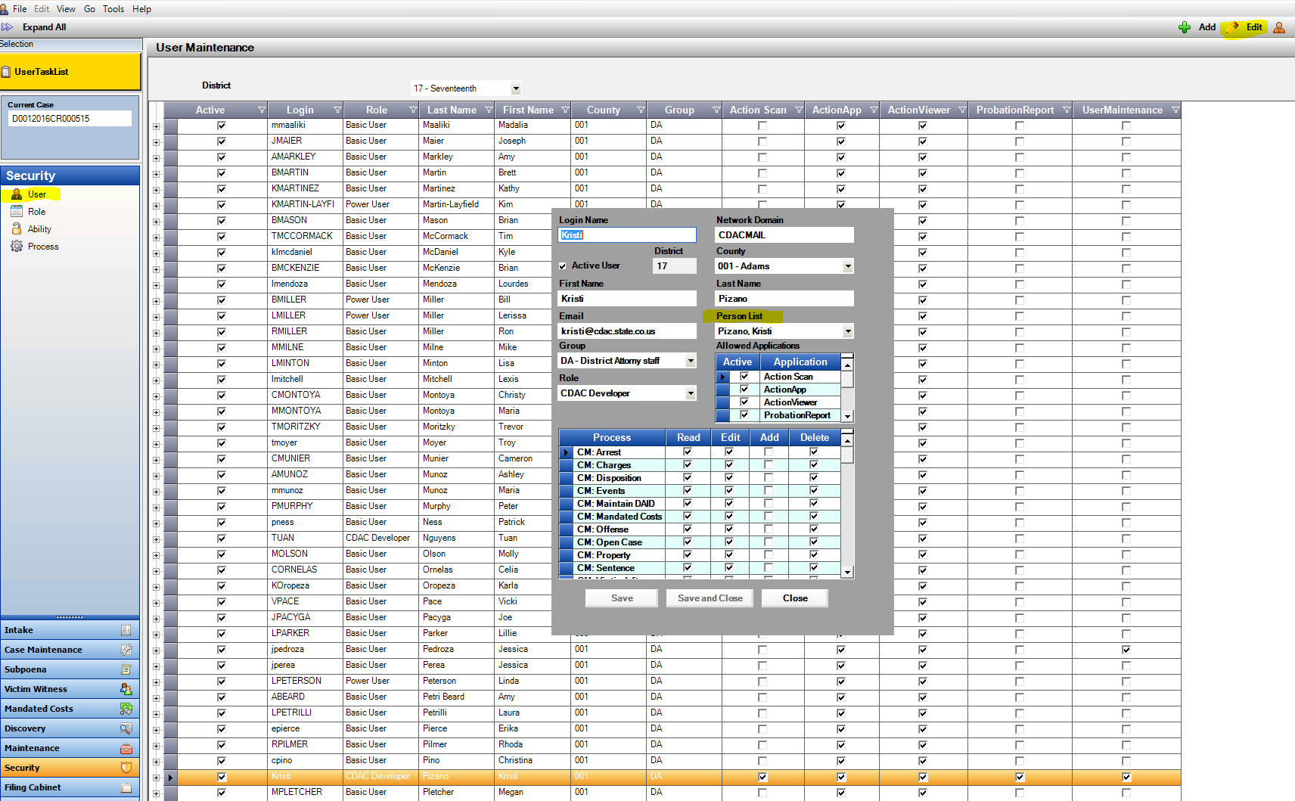

Subpoena Tracking

Subpoena Tracking enhancement to default the Subpoena Status of “Returned” when the Subpoena ID is entered on the tracking screen. This status can be viewed by right clicking on the subpoena ID entered selecting Edit Subpoena Status or by clicking on Subpoena Status Screen.

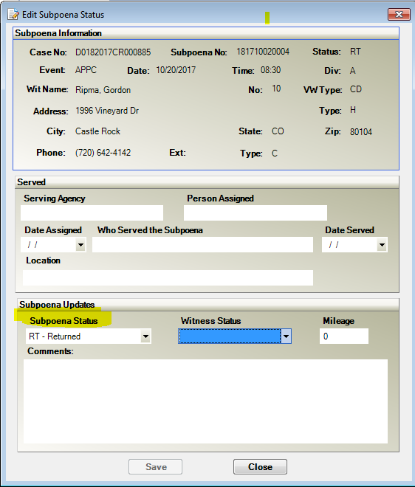

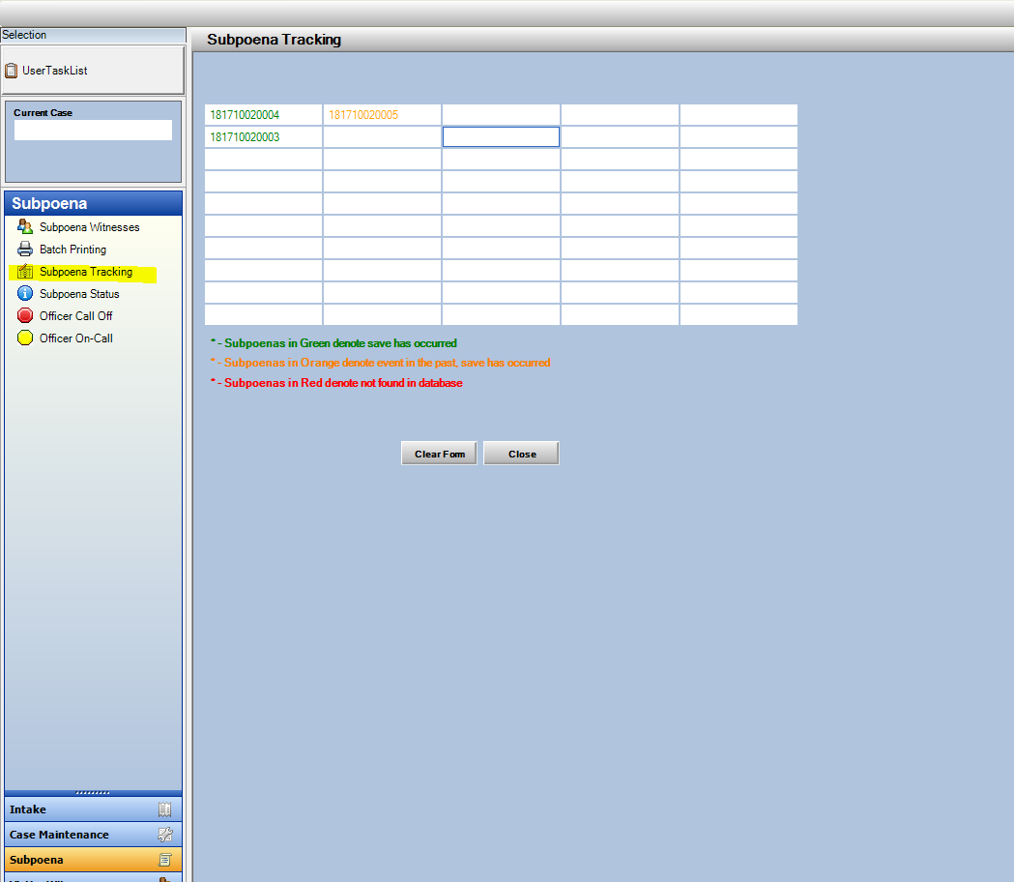

Subpoena Status Screen

Subpoena Status Screen will now display the full description of the Subpoena Status and Witness Status, previously only showing the codes.

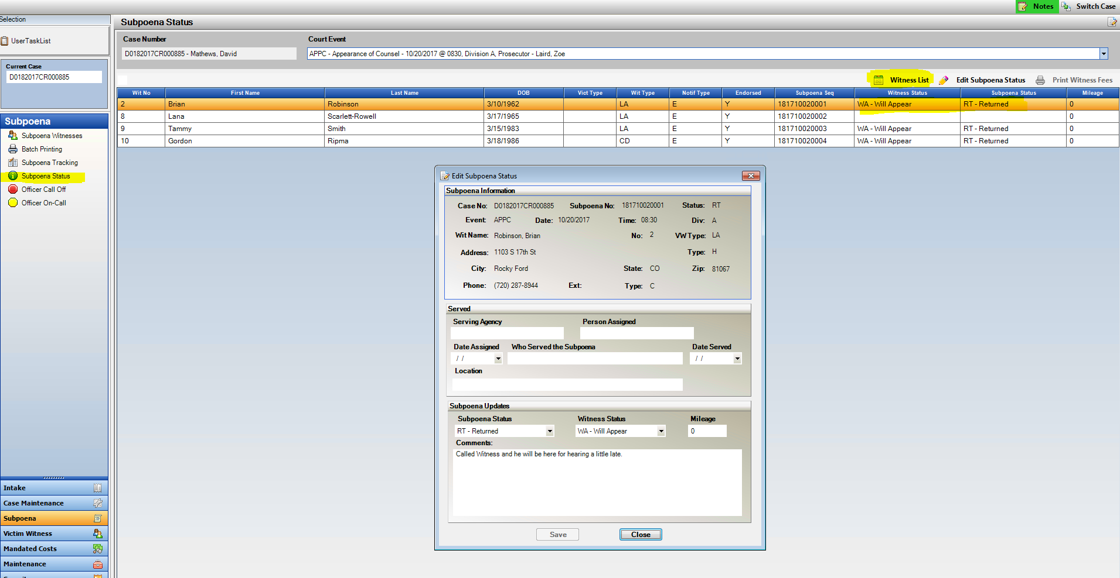The Witness List report that is on the Event tab and on the Prosecutor Tools within Action is now also accessible on the Subpoena Status Screen. This report shows a user the subpoenas for a specific event on a case and the current subpoena status and comments if entered.

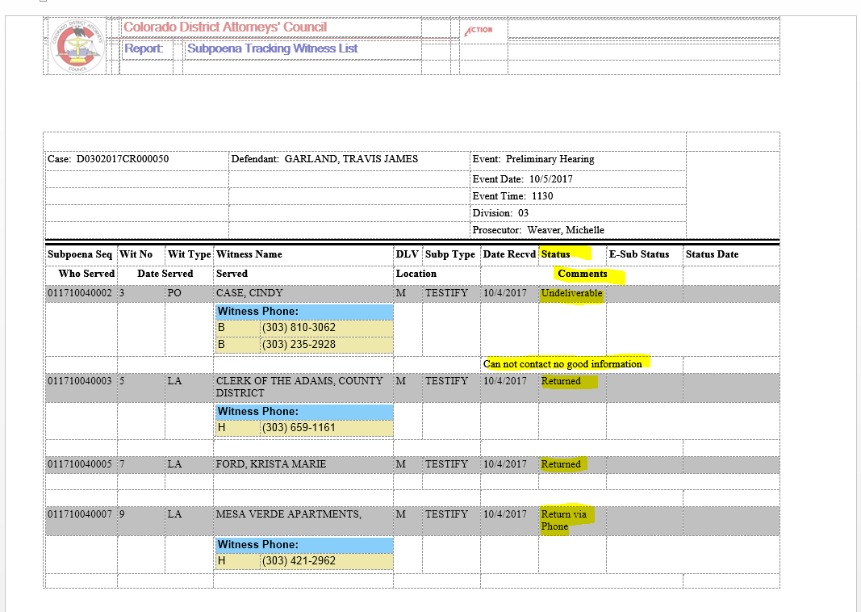

Intake- Special Prosecution Option

The special prosecution functionality is now available on Intake cases. This existing functionality for cases within Case Maintenance was broadened for the instances where a special prosecution case needs to be charged by the receiving district for filing.

This function is located under Case Tools – drop down selection to Special Prosecution.

Enter the receiving districts District and County Location and then Save.

This removes access from the original district and gives access to the receiving “controlling” district.

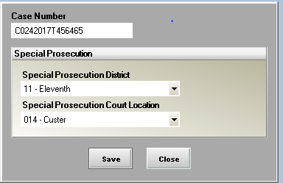

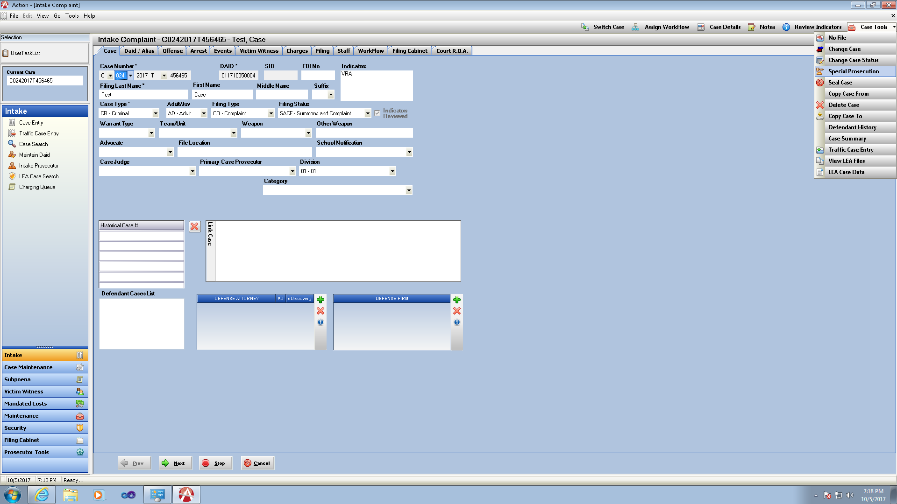

Victim Witness Tab

User selected columns and order

Users can now utalize the Field Selector Tab on the VW Tab to re-arrange columns or hide/show columns that are most important to them.

These changes are persistant per Action user until they decide to change them again.

Click on the Field Chooser to click to show a column and un-click to hide the column.

Drag and drop columns to any order position.

