Action enhancement guide

December 2018 Training Guide



CDACweb.com



**Table of Contents**

1. eDiscovery: LEA Case Search enhancements ..…..……………………………………… 3-4
   1. View LEA Files- Contains a date column.
   2. Remove Option- Display of Action User that removed record.
   3. Start case with No-Defendant Option fix.
   4. Capitalization/Auto-Formatting Defendant and Victim Witness names.
2. Intake: Initiating Events Screen………………………………………………………………………… 5
   1. Multi-Selection of records to be removed all at once.
   2. Division Search added to Case Entry search options.
   3. Formatting of Social Security Number field.
3. Intake: DAID/Alias Screen …………………………………………………….…………………. 6
   1. ICE field added to Defendant’s Information.
   2. Promote functionality for DOB and SSN.
4. Linking Cases: ……………………………………………………………………………………………… 7-10
   1. Link Co-Defendants in Action provides pop-up to users to indicate a

possible co-defendant case match.

* 1. “Keep Charging Text” option is now auto defaulted.
  2. Endorsed status of a witness will clear when copied to new case.

1. Officer Lists: Drop Down Selections based on ORI ……………..………………….. 11-12
   1. New Option to sort Officer dropdown selections lists by entered Badge

Numbers.

1. Charging Queue: Intake Cases……………………………………………………………………….. 13
   1. Screen in now Non-Modal- can be left open/minimized while working

in Action.

* 1. Case Number Search Option added.

1. Prosecutor Tools: User customization……………………………………………………………… 14
2. Charges Tab: User customization …………………………………………………………………… 15
3. Doc Gen: New Data Variables ………………………………………………………………........ 16-17
   1. Short Case Number- example 18CR561
   2. Separate DA City, DA State, and DA Zip
   3. VW Sub-list of selected victim/witness entries for same document.
4. Miscellaneous Bug Corrections ………………………………………………………………………. 18

eDiscovery: LEA Search Screen

**LEA Search Screen- View Files**

Option to View LEA Files now includes a Date Received Column next to each file for reference.

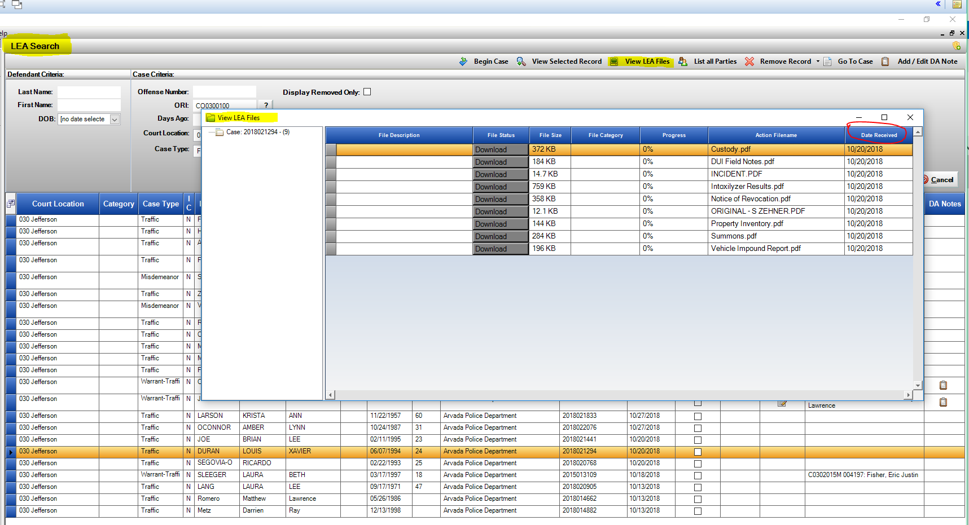

**LEA Search Screen- Option to Begin Case with No Defendant (under List all Parties).**

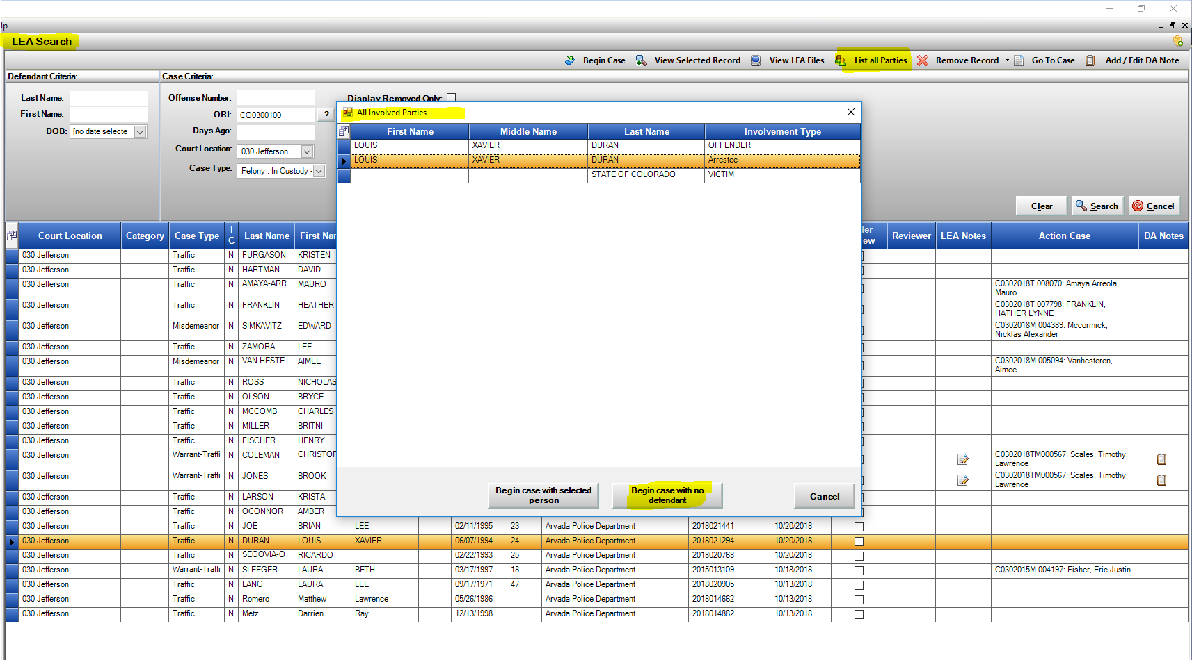This brings in the LEA case data, but not the associated person so a user can select/enter their own defendant information. This is an enhancement to the existing feature, where previously if a record was highlighted that name was carried through instead of bypassing the name record.

**LEA Search Screen- Display Removed Only View.**

When a received LEA case is removed by an Action User- using one of the available removal options (Duplicate, No Needs, Supplemental) the user that removed the record is now displayed under the “Display Removed Only” view in a new column- “Removed By”.

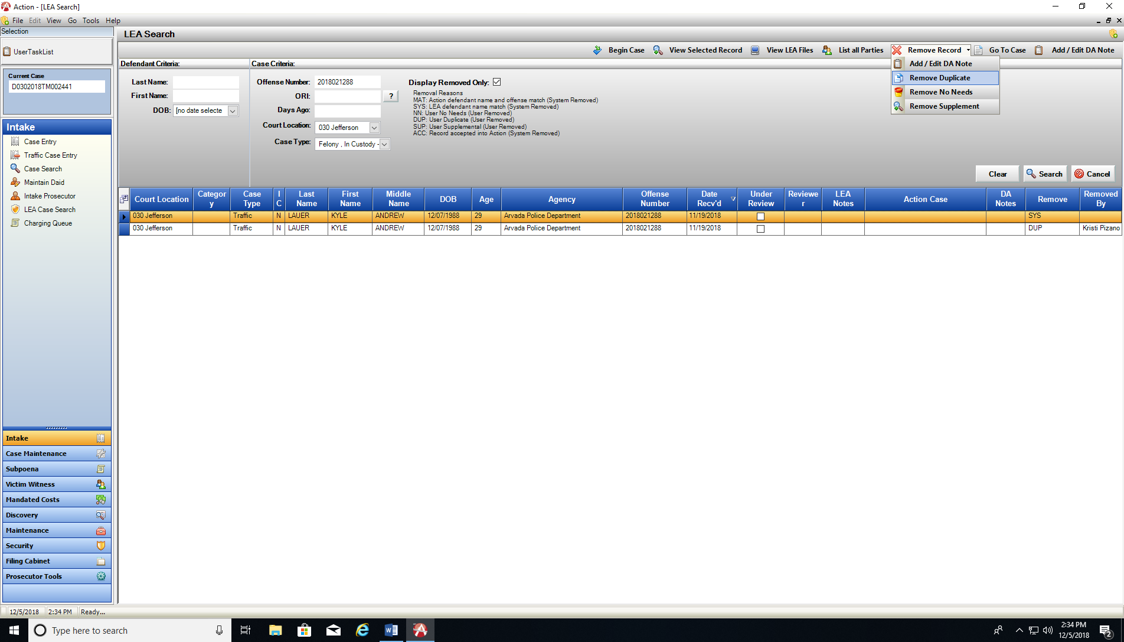

**LEA Search Screen- Auto-Formatting of names.**

Defendant and VW Involved Parties that are sent from LEA into a newly begun Action Case will now default to auto-formatting for capitalization to assist users with less data manipulation.

Sent from LEA: MIKE SMITH JR.

Auto Formatted: Mike Smith Jr.

Intake: Initiating Event Screens

Traffic Entry & Case Entry Initiating Screens

1. 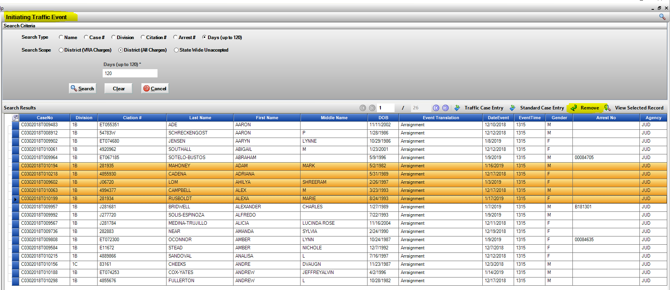Remove multiple records at once, instead of one at a time. Highlight multi-rows and click on Remove Option.

1. Case Entry will now include a Division Search Variable to help find cases in a particular division quicker.
2. 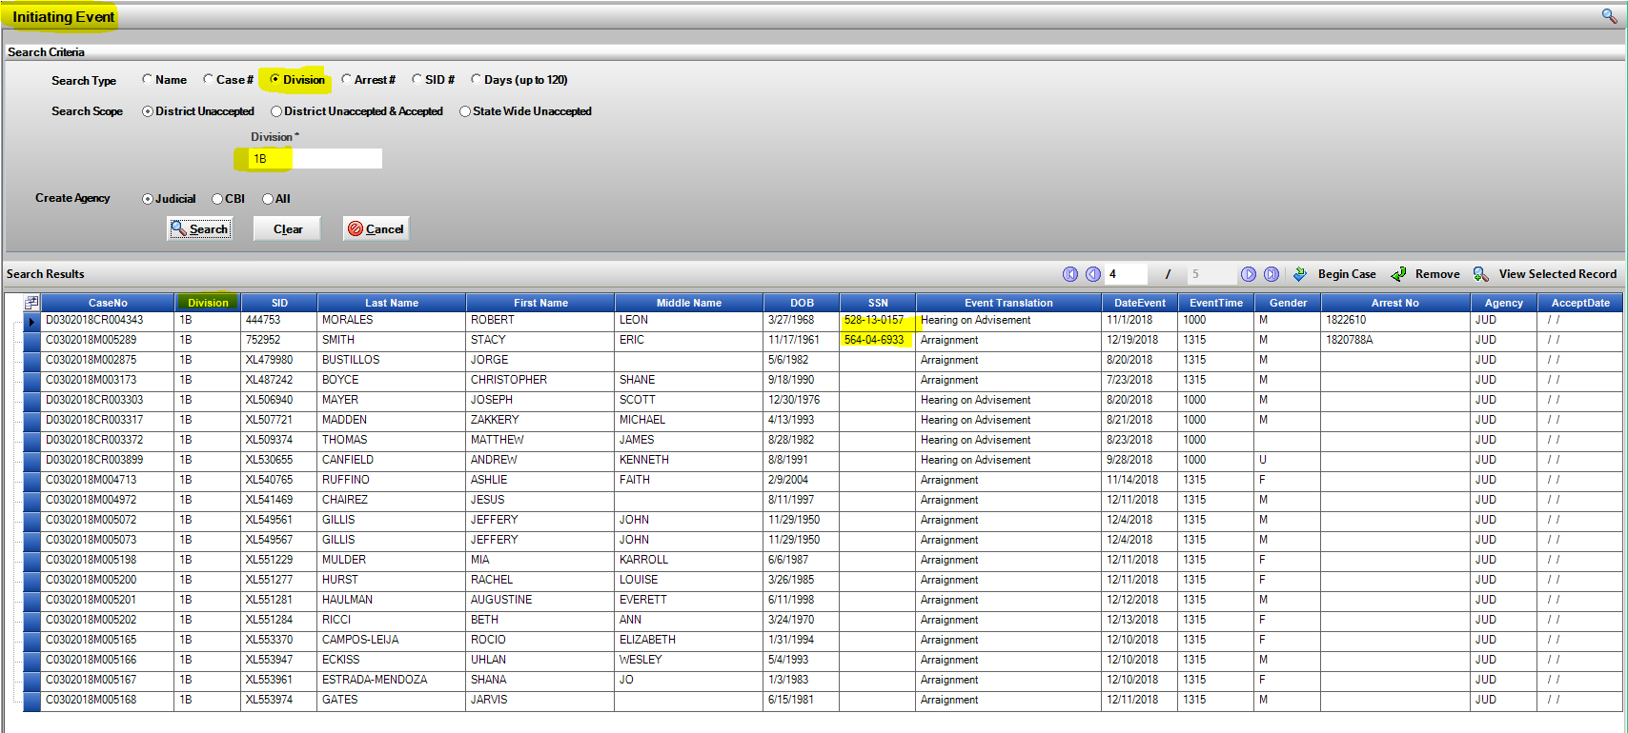Social Security Number- re-formatted on display grid.

Intake: Case Entry- DAID/Alias Screen

New field for tracking Defendant’s ICE number has now been created. This is accessible on the Intake DAID/Alias Screen or through Maintain DAID.

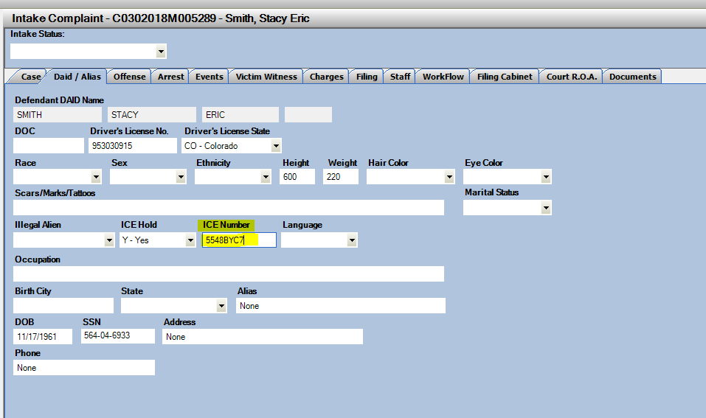

In Case Entry process users will now be able to Promote/Update the DOB and SSN fields within the screen. Enter multiple DOB, SSN and use the Promote function from here instead of Maintain DAID screen to assign the relevant data.

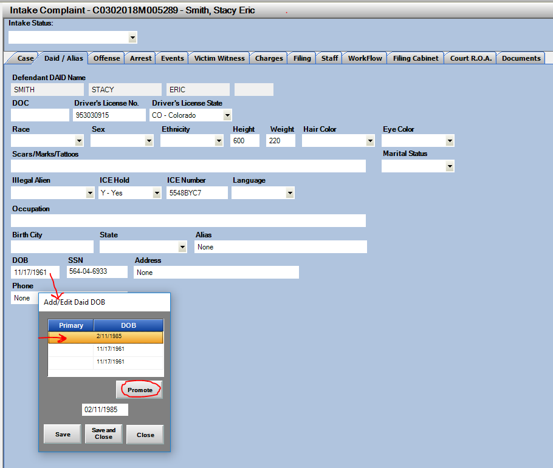

Linking Cases: Co-Defendant Notice Pop-up

Notice to users that an existing potential co-defendant exists within Action will appear as a Pop-Up Window after the Offense Number/ ORI has been entered onto an offense and Save and Close is selected. It matches based on this Offense Number/ORI combination. If you click “OK” the Link Case Mgt. Screen opens for you to review and make the correct links of Co-Defendants.

.

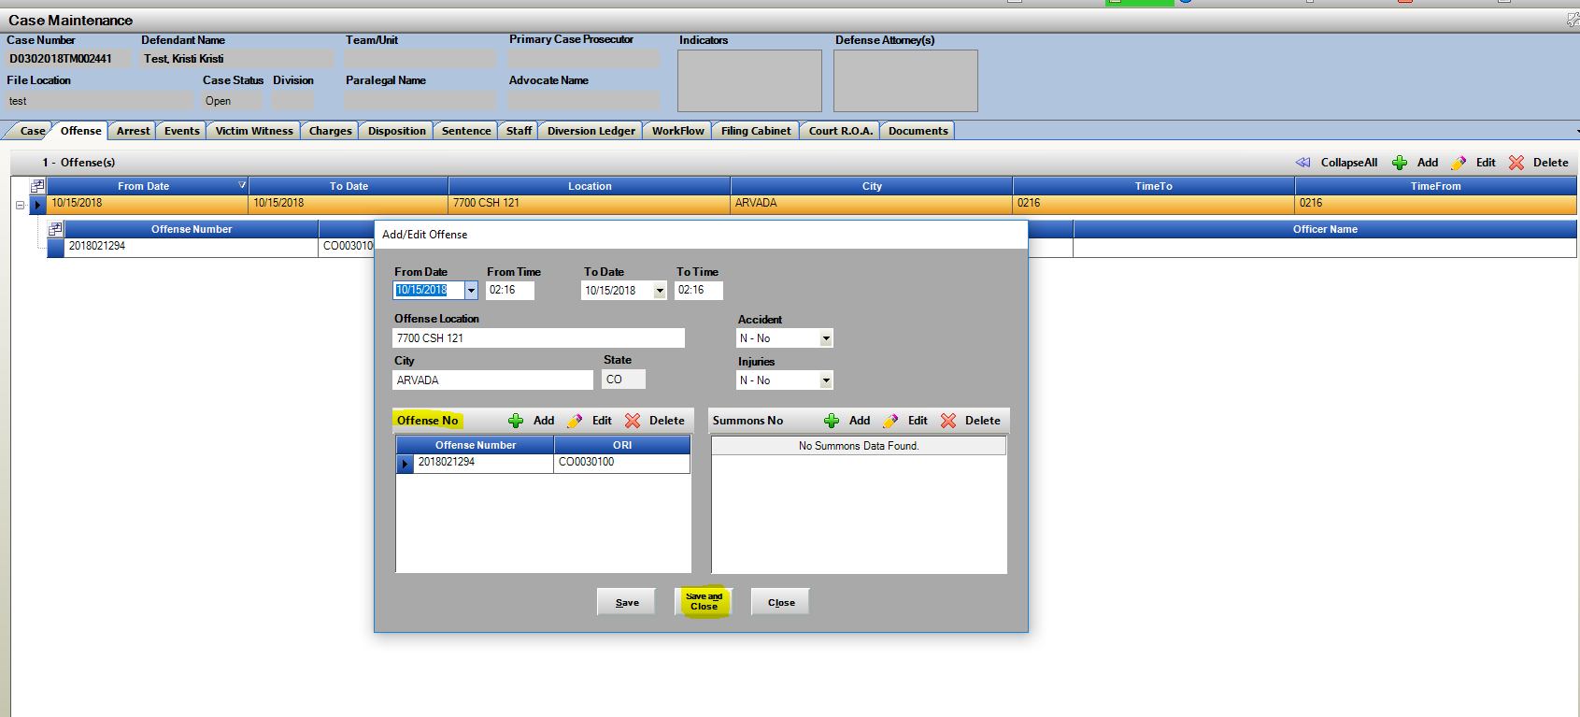

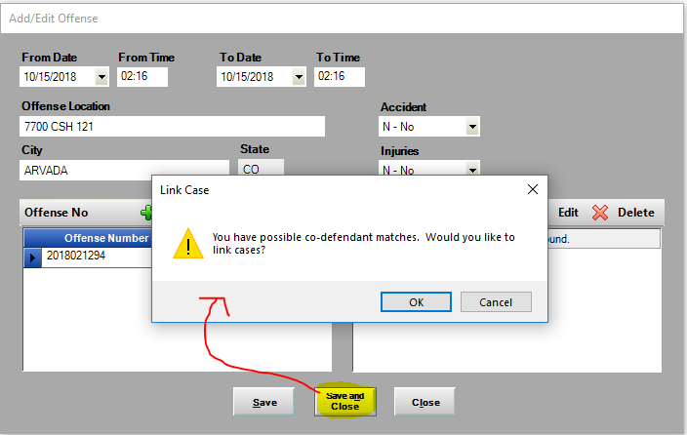

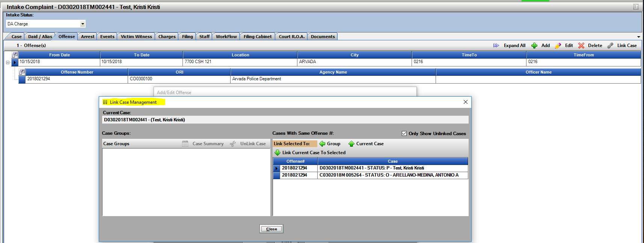

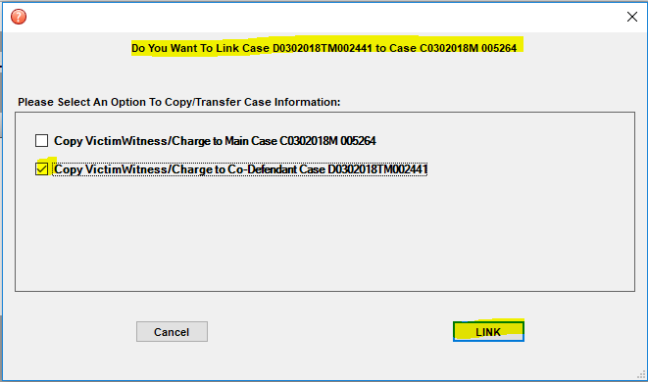Link Case Options Window Appears for Copy/Transfer Options of VW and Charges from one case to the next.

Copy Data From and To Window Opens for Users selection to copy the VW entries and Charges-

* Option under Charges to Keep Charging Text (referencing replaced variables in charges) is now Auto-Checked.

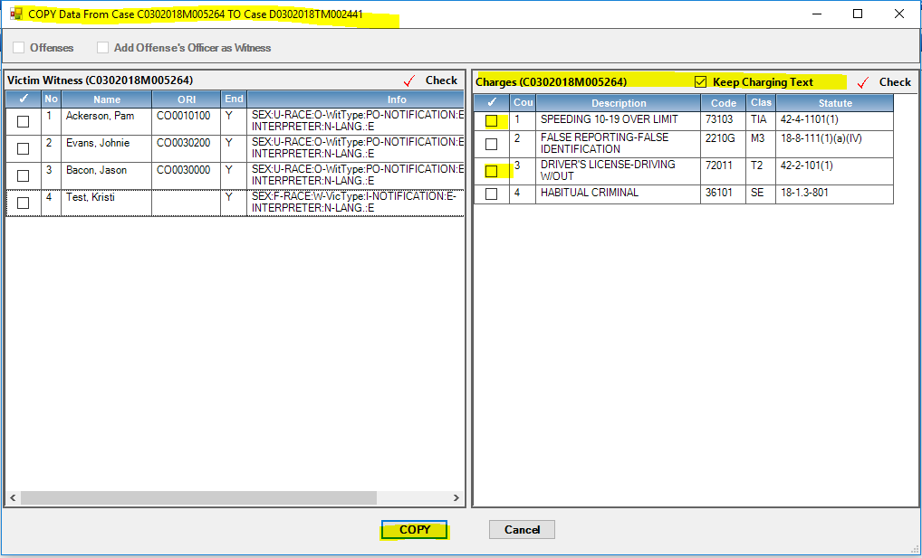

* VW Copy Function will no longer carry over the Endorsement status from the case you are Copying From. Previously for example if you copied witnesses from a Case Maintenance to Case Maintenance Case (both filed) the Endorsement flag was retaining from the other case. This has now been corrected.

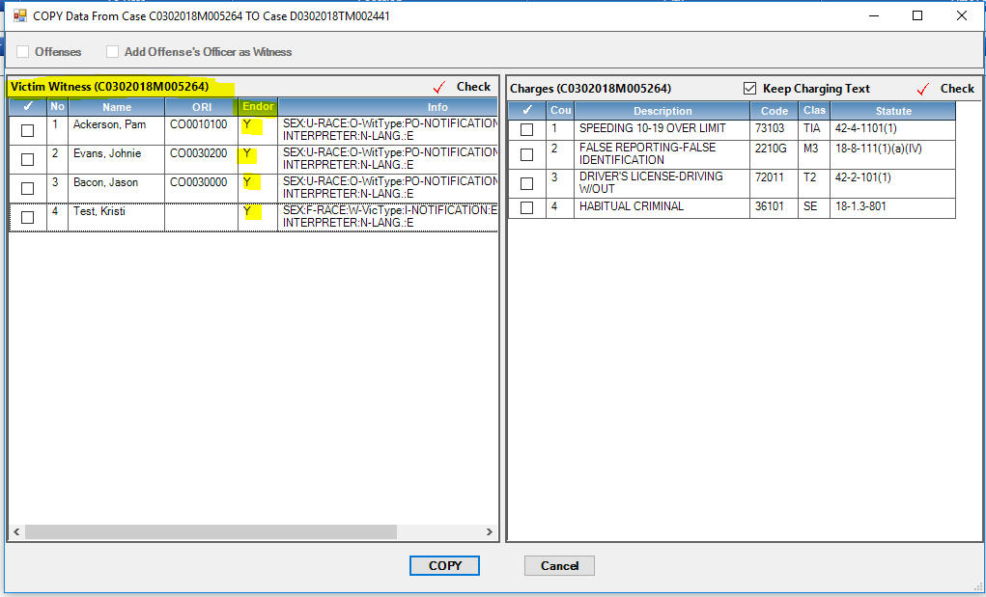

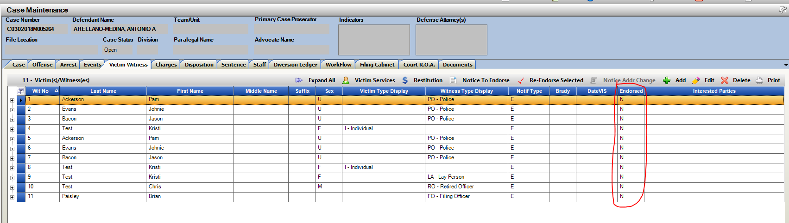Copied VW entries, now ready for the Notice to Endorse them on the receiving case.

Officer Lists: Sorting by Badge Number Option

New Option to sort Officer lists by the Officers Badge Number. Use the checkbox “Sort Badge #” to switch from the defaulted alphabetical sorting of last name, to a sort based on the entered badge number for alternative search method. The officer badge numbers are Power User entered within Action added to the officer records. If there is incomplete or incorrect info. a Power User can edit this information by going to Maintenance 🡪 Person 🡪 Officer Tab. Select Officer and Edit existing record, make entry and Save and Close.

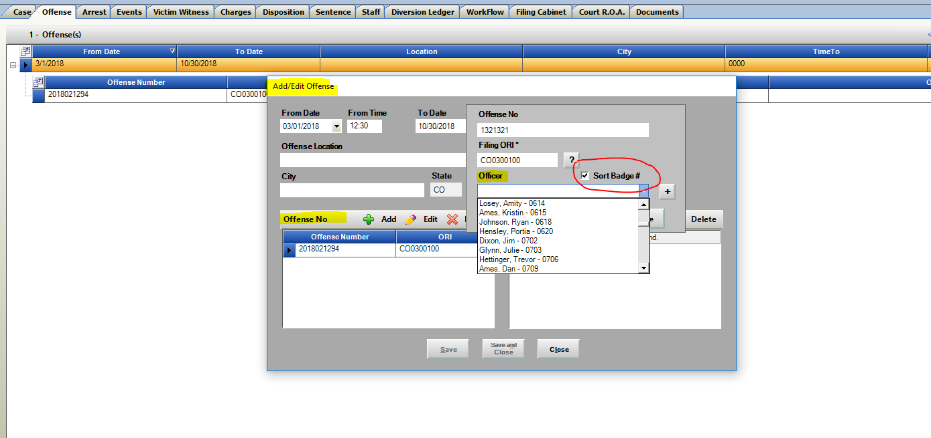

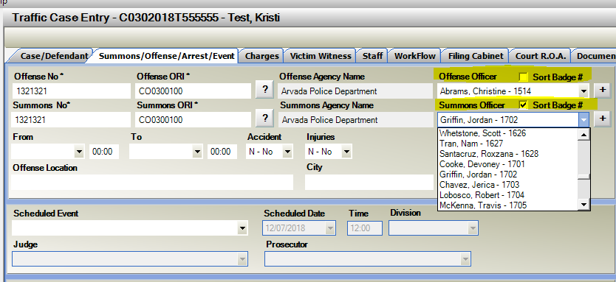

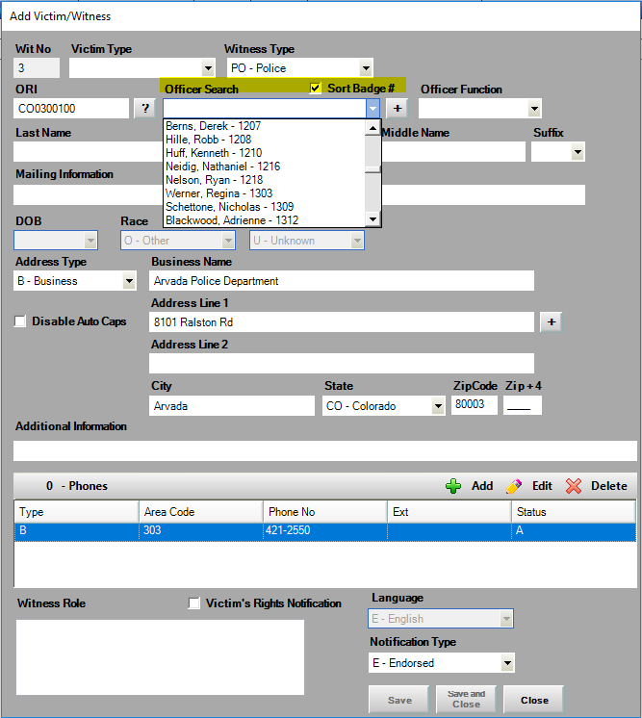

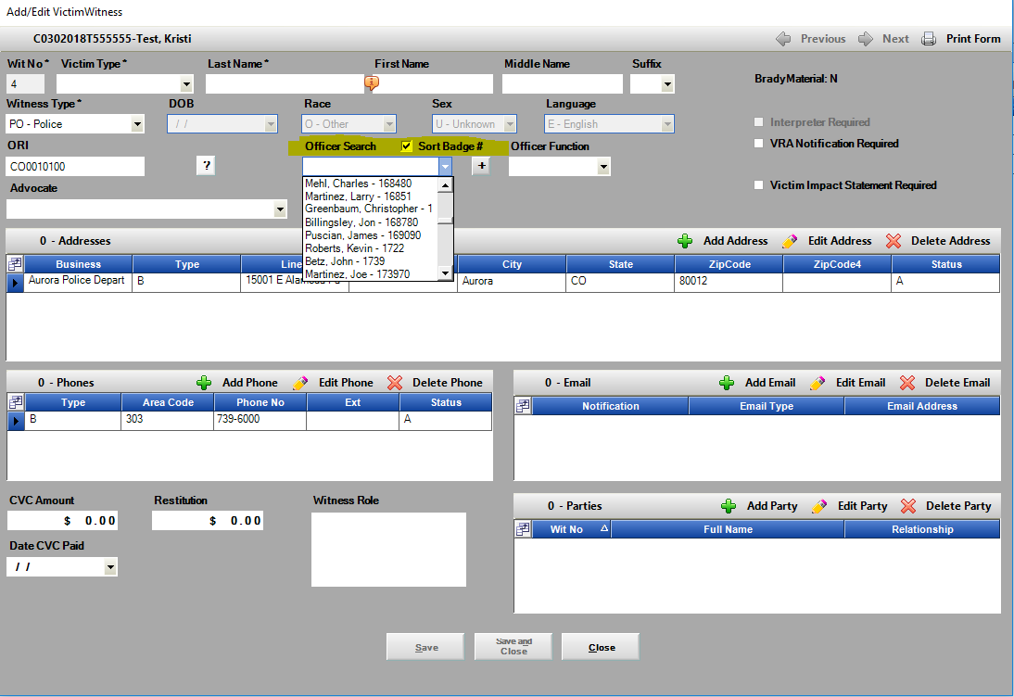

Intake: Charging Queue

Charging Queue screen now has the functionality to be left open independently of working on cases within Action. It can be used on a separate monitor; it can be minimized or be used on the same screen Action is running on. This will provide an easier option for those utilizing this Intake function to update statuses quickly without having to go back and forth into the case itself. The fields update immediately between the case and the Charging Queue.

Case Number Search has been added to the Charging Queue for quicker direct access to searching for specific cases. Toggle the checkbox for Search by Case Number on and off as needed.

Refresh Button on Charging Queue will update with newly entered or updated cases that fit the variables searched on. This is only user driven re-fresh.

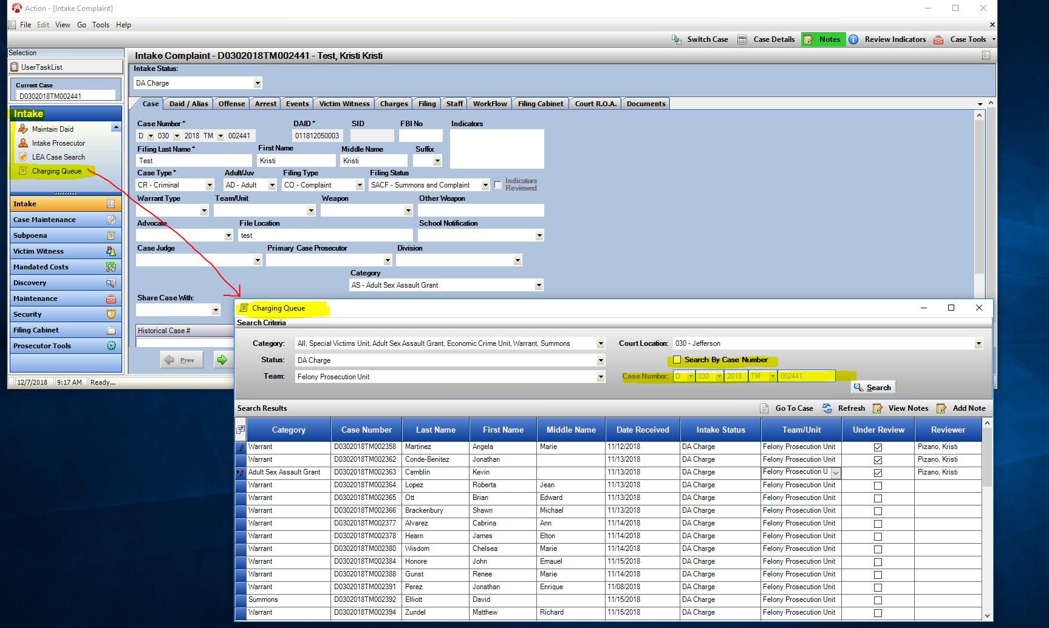

Prosecutor Tools: User Customization View

Prosecution Docket, Advocate Docket, Division Docket and Paralegal Docket- all now have the ability added for users to sort the existing columns into a preferred order. This order is evoked until the user changes his/her options for display. Note a Reset Columns button to allow the user to return to the Default column positions. Drag columns into desired positions.

Note * Each Docket has its own independent column sorting that will save.

CDAC will be introducing a column selector in an upcoming build for further user customization.

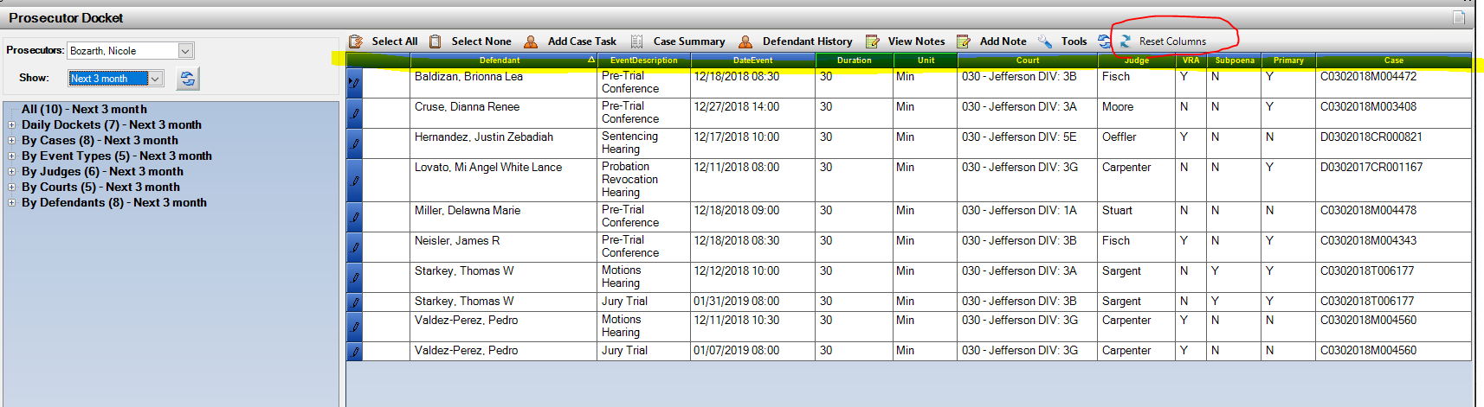Default Column View:

Re-Sorted Column View for User

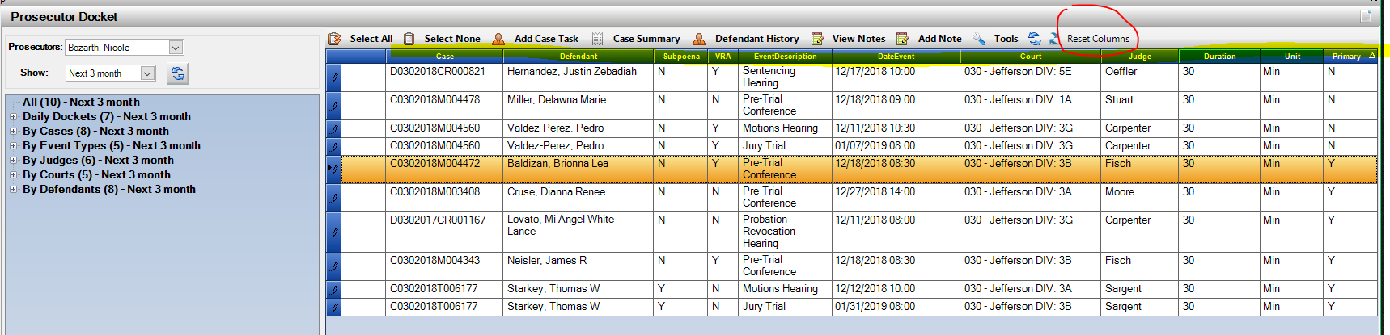

Charges Tab: User Customization View

Charge Tab within Action is now set up for a user customization view. Using the Field Chooser highlighted below, each user can select the columns views that they would like to see by default each time they access this screen. Clicking and Unclicking column names in Field Chooser. Columns can also be re-arranged per user which will also be retained.

Note * Charge Tab in Intake and Case Maintenance are independent and would require a user to set each to their user preference.

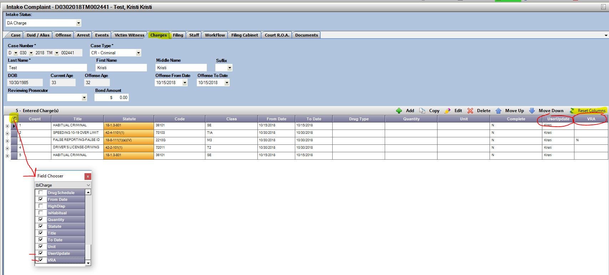

Reset Columns button- defaults columns back to original default.

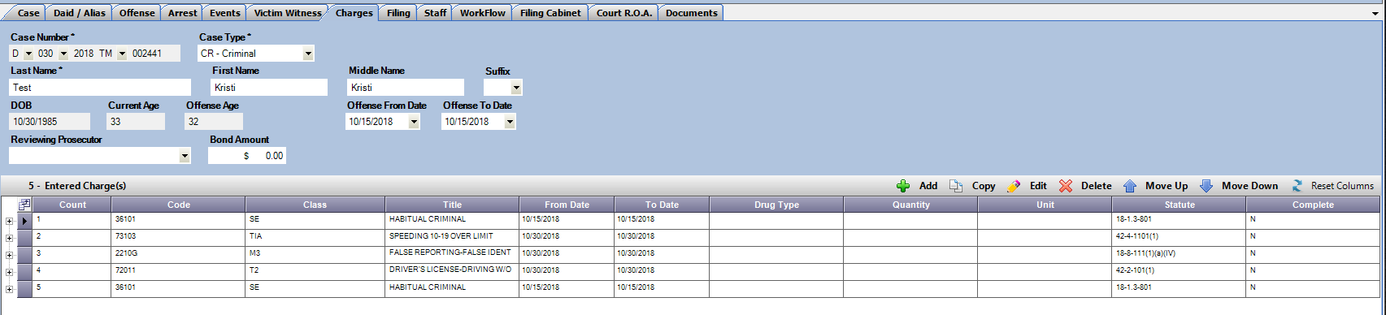

Doc. Gen- New Data Variables

For districts currently utilizing Doc. Gen. there are several new enhancements for this build. *Contact Kristi for questions on Doc. Gen. Trainings.

They include the following:

1. View and Download Functionality added to the Published Tab.
2. Optimization of loading speed for Doc Gen Document Lists.
3. New Data Objects

**Doc Gen New DATA Object List (Copy and Paste list below to separate document to test in Work Space)**

1. **Short Case Number String Example: 18CR22 (Located Case Tab)**

<<[Case.CaseNoShort]>>

1. **Separate Variables Requested for City, State ZIP (Located Case Tab)**

**Separate: DA City**

<<[Case.DACity]>>

**Separate: DA State**

<<[Case.DAState]>>

**Separate: DA ZIP**

<<[Case.DAZipCode]>>

**Combined: City State ZIP Code**

<<[Case.DACSZ]>>

1. **Victim Witness Selection List (Located Victim Witness Tab)**

* Select Empty VW Selection List
* Or One Column VW Selection List
* Or Two Column VW Selection List

(Example of Empty VW Selection List)

<<foreach[SelectedVW in Case.VWSelectionList]>> RemoveIfEmpty

<<[SelectedVW.Name]>> RemoveIfEmpty, Number: <<[SelectedVW.WitnessNo]>> RemoveIfEmpty, <<[SelectedVW.AddressLine1]>> RemoveIfEmpty <<[SelectedVW.AddressLine2]>> RemoveIfEmpty <<[SelectedVW.CSZ]>> RemoveIfEmpty

<</foreach>> RemoveIfEmpty

Miscellaneous

1. Bug Fix: Case note button was Green even when notes hadn’t been entered. This has been updated so that it only turns Green again once notes are added to an Action Case.
2. Bug Fix: Officer VW entries- if an officer connected to an ORI had been entered as a VW, then a user would edit the record and select a different ORI the previous phone # was not updating. This is now corrected.
3. Bug Fix: Error produced when double clicking DAID search records in some instances. This has been corrected.
4. Bug Fix: Occasional error/mix match of records on Primary Case Prosecutor and what was appearing on the “Staff Tab”.
5. Bug Fix: LEA received data pull into Action only valid Suffix info. for VW entries.
6. Bug Fix: Charge Codes with future repealed dates are now displayed as current Active Charges, not “Repealed”.
7. Bug Fix: Power Users Option- Security 🡪 Users Table Fix for displaying “Inactive” User Records.
8. Bug Fix: Prosecutor Tools- Add Note Functionality from a selected case has a corrected tab order sequence change.
9. Bug Fix: Charge Tab- There had been a drop-down calendar option for updating charging dates that did not change the dates. This has been removed as editing the charge is best practice on this.