Action enhancement guide

July 2018 Training Guide



CDACweb.com



**Table of Contents**

1. Victim and Witness Types- Descriptions of codes …..……………………………………… 3
2. Events, Dispositions and Sentences- Descriptions of codes ….……….………………. 4-5
3. User Task List- Add Note and View Notes Options …………………………….………...... 6-7
4. Miscellaneous Bug Corrections ………………………………………………………………………. 8

VW Screen- Type Descriptions

Victim and Witness codes are now displayed within Action to help users quickly identify the code that was selected. These changes will appear on the Victim Witness Tab, Notification Screen for VW Letters and under Victim Witness List by Case Selections.

Previous:

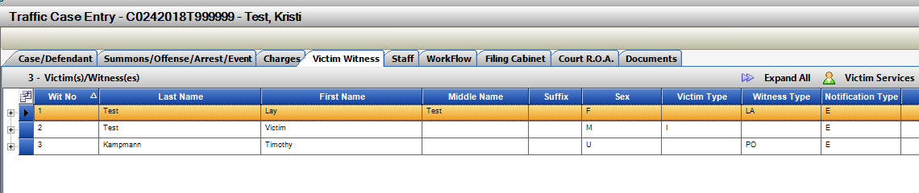

New Display:

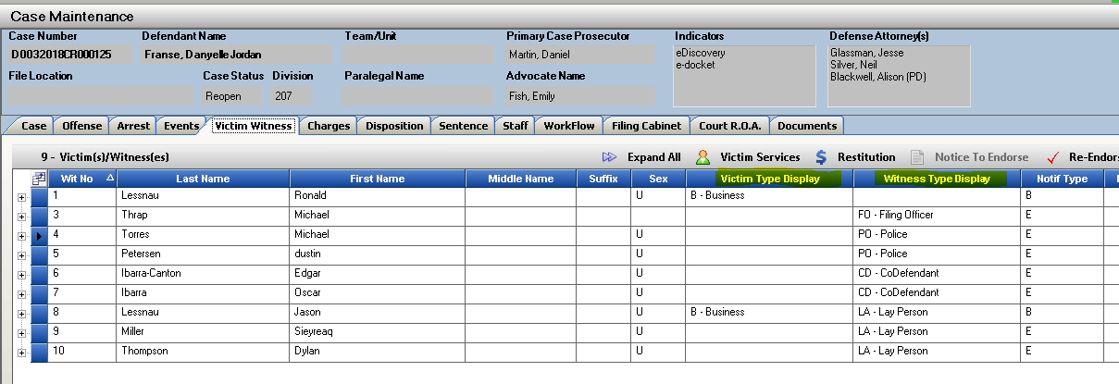

Events, Disposition and Sentence Descriptions

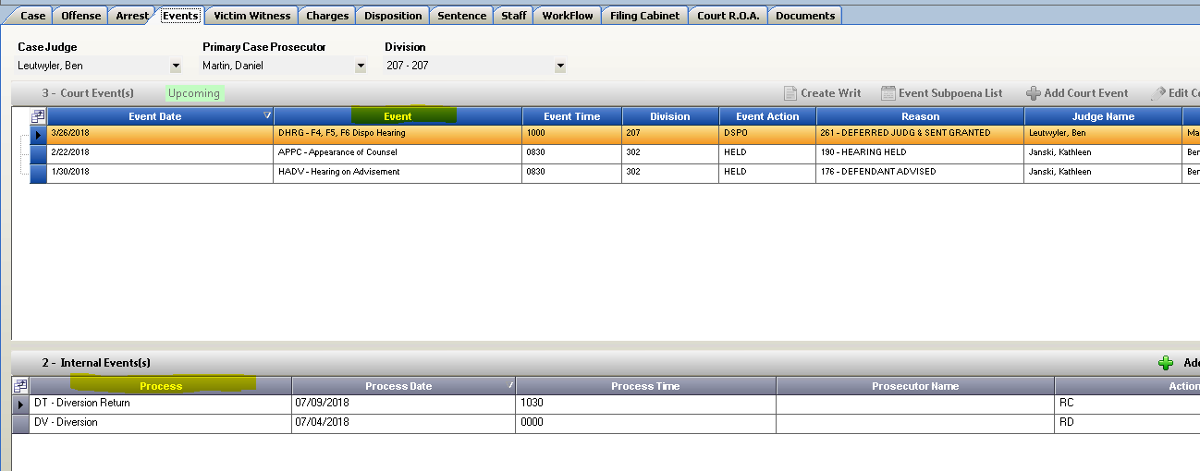Descriptions of codes for Events, Internal Events, Dispositions, Sentence Penalties and Sentence Conditions are now displayed for easier identification. Subpoena Tracking screen also updated reflecting the event description.

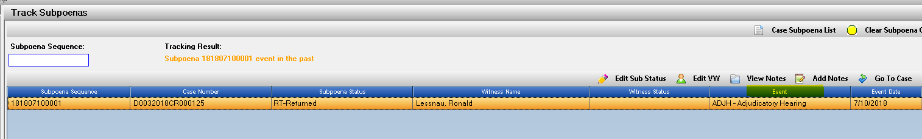

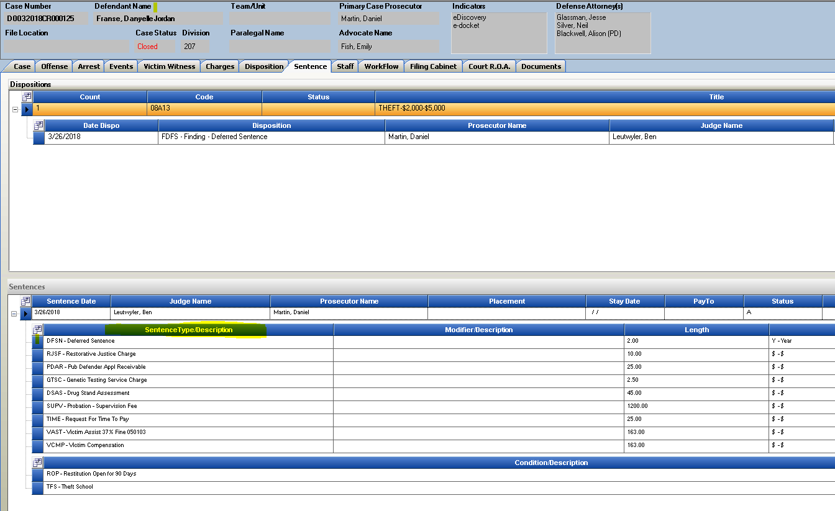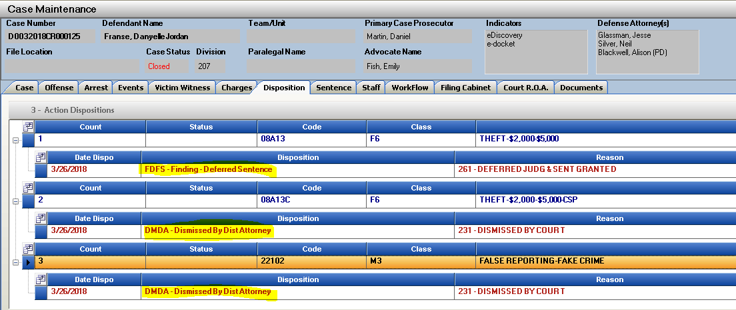

User Task List- View and Add Note Options

User task list now includes options to View and Add Notes to cases that are appearing on the list.

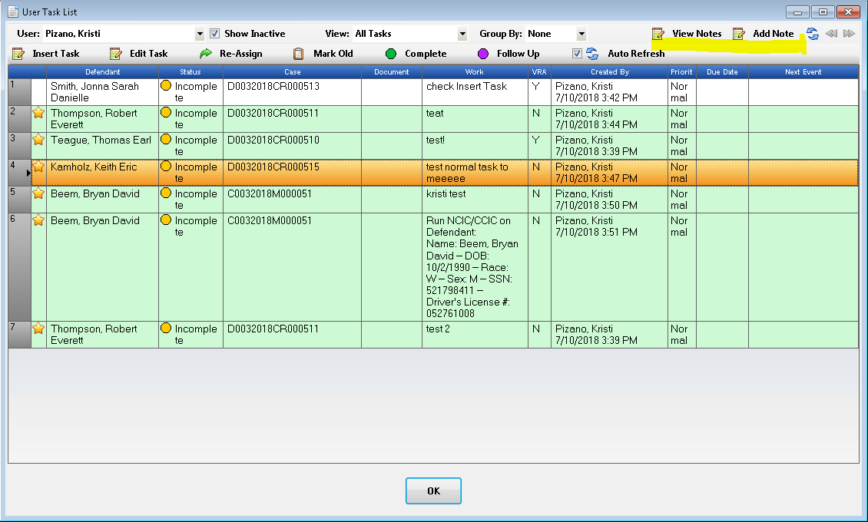You can highlight a case and click on either option. These 2 selection when the windows open can be minimized so you can continue your work in Action or have open on another screen. Much like they function in Prosecutor Tools.

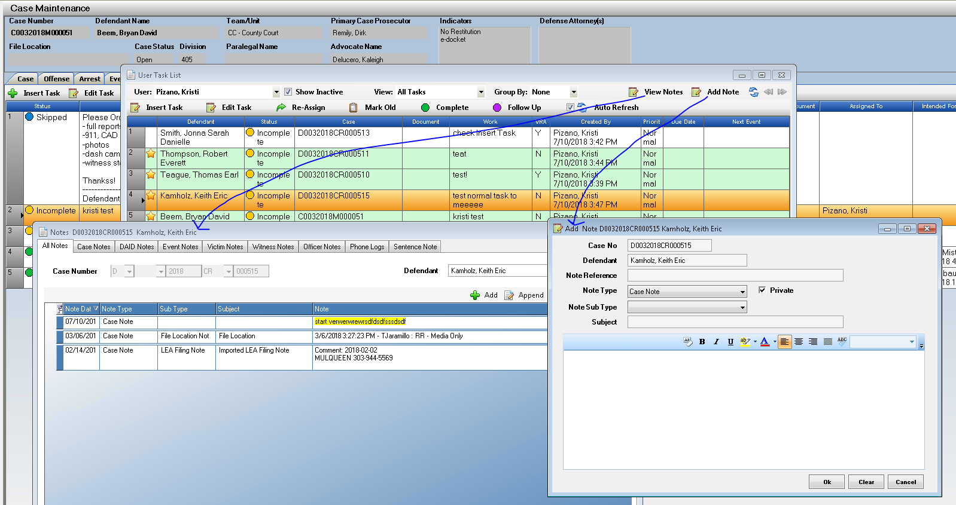

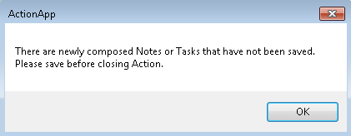When minimized, the open windows will stack in the Action Icon Tray and can be re-called from there until Saved. If you attempt to close Action when you have pending unsaved notes, it will give you a message reminding you to save.

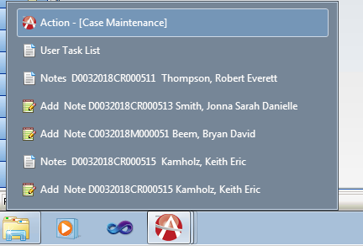

Miscellaneous

1. Bug Fix: Officer Call Off corrected to only display Produced Electronic Subpoenas.
2. Bug Fix: Event Tab fix hot key Alt E for Edit record, and Alt L for Event Sub List.
3. User Table: Only display DA users within District, removed from view Action Viewer external users.
4. Doc Gen Enhancements for Piloting Districts.