Action enhancement guide

March 2018 Training Guide



March 22, 2018

CDAC

CDACweb.com

**Table of Contents**

1. Initiating Event Screen- Do not display already created Action case …..………. 3
2. Defendant Demographic- Add Language Field ………………….……………….………..... 4
3. Charge Table Search- Repealed Charge List ………..…………………………….……………. 5
4. User Task List- User Preference Columns ……………………………………... 6
5. User Task List- View Completed Today ……………………………………………… 7
6. Work Flow Task – Larger Task Description Field ………………………………………..… 8
7. *Work Flow Templates- Investigator Assignment and Criminal History Request.. 9-10
8. Victim Witness- VIS Date Column Update ………….…………………………………………… 11
9. Subpoena Tracking & Status Screens- Add Edit VW ………………. ………………………. 12
10. *Victim Witness- VOCA Tracking Screen ………………………………………………… 13
11. *Victim Witness- Email Notification of VW Letters ……………………………………………. 14-15
12. Prosecutor Tools- New Subpoena Column Displayed ………………………………………. 16
13. Prosecutor Tools- Events Added To Secondary Prosecutors Docket ………………… 16
14. *Case Notes- Setting for District to Default to Private Notes …………………………….. 17
15. Miscellaneous…………………………………………………………………………………………………… 18
    1. Inactive Prosecutors, Advocates and Paralegals will not display on header.
    2. Double Click on Offense to open Edit form.
    3. Double Click on Internal Events to open Edit form.
    4. Copy Case Functionality – includes Interested Party connections.
    5. Close Case- returns users to the Event’s Tab.
    6. Victim Witness Screen- Resize for Surface 4.

*Items marked with asterisk denote a setting that CDAC will turn on per request of the District.

Initiating Event Screen

Intake:

Initiating Event and Traffic Initiating Event Screens have been updated to reflect only cases from Judicial that have not been started within Action yet. If you are searching for a particular case with no matches, do a case search within Action to see if it was already created.

Case Entry:

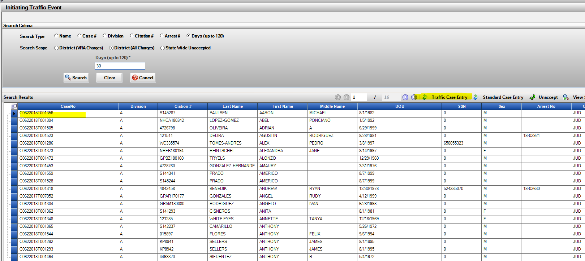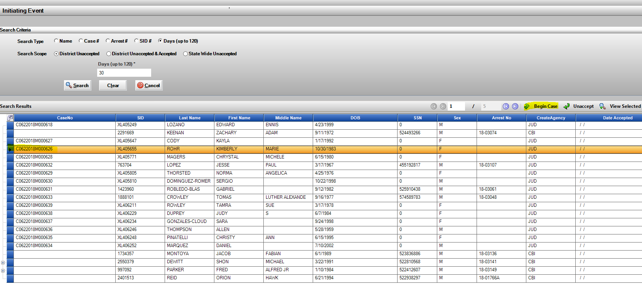Traffic Case Entry:

Defendant Demographic – Language Field

New field created for defendant demographic to track defendant’s language.

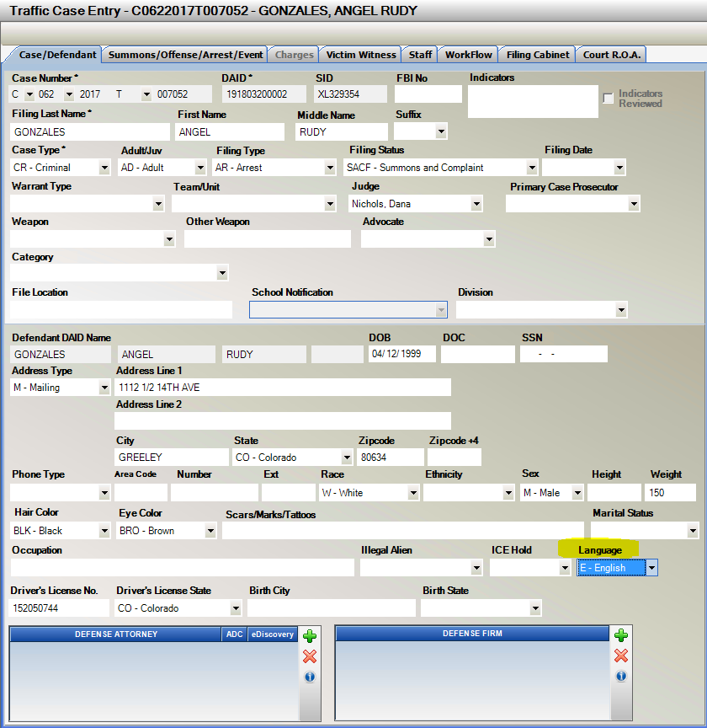This new field is found in Intake both on Case Entry and Traffic Entry as well as the Maintain DAID screen for updating defendant information.

Traffic Case Entry:

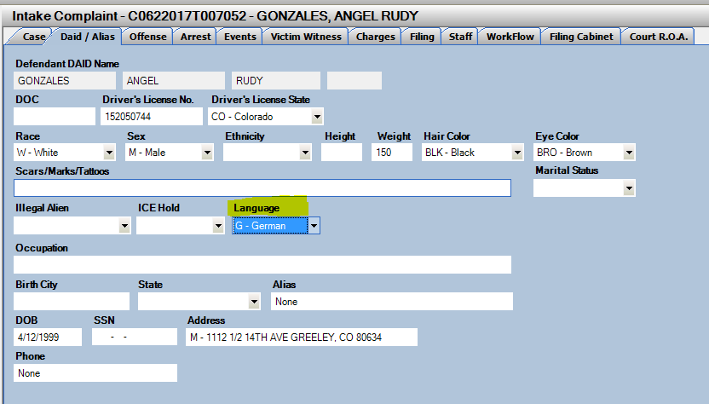

Case Entry:

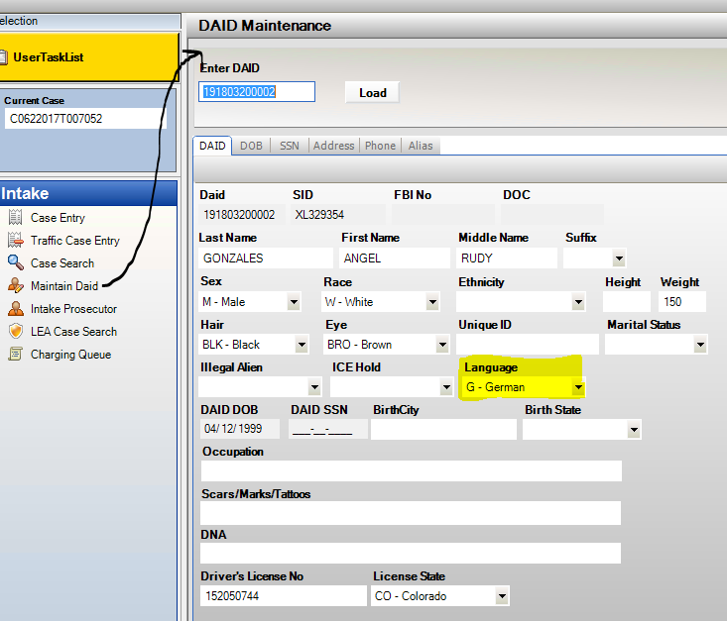

DAID Maintenance:

Charge Search

The independent charge search has been updated so that the default search is showing charges that are currently valid as of today’s date.

To view your results for Repealed Charges, unclick the No Repealed Charges and click on Search again.

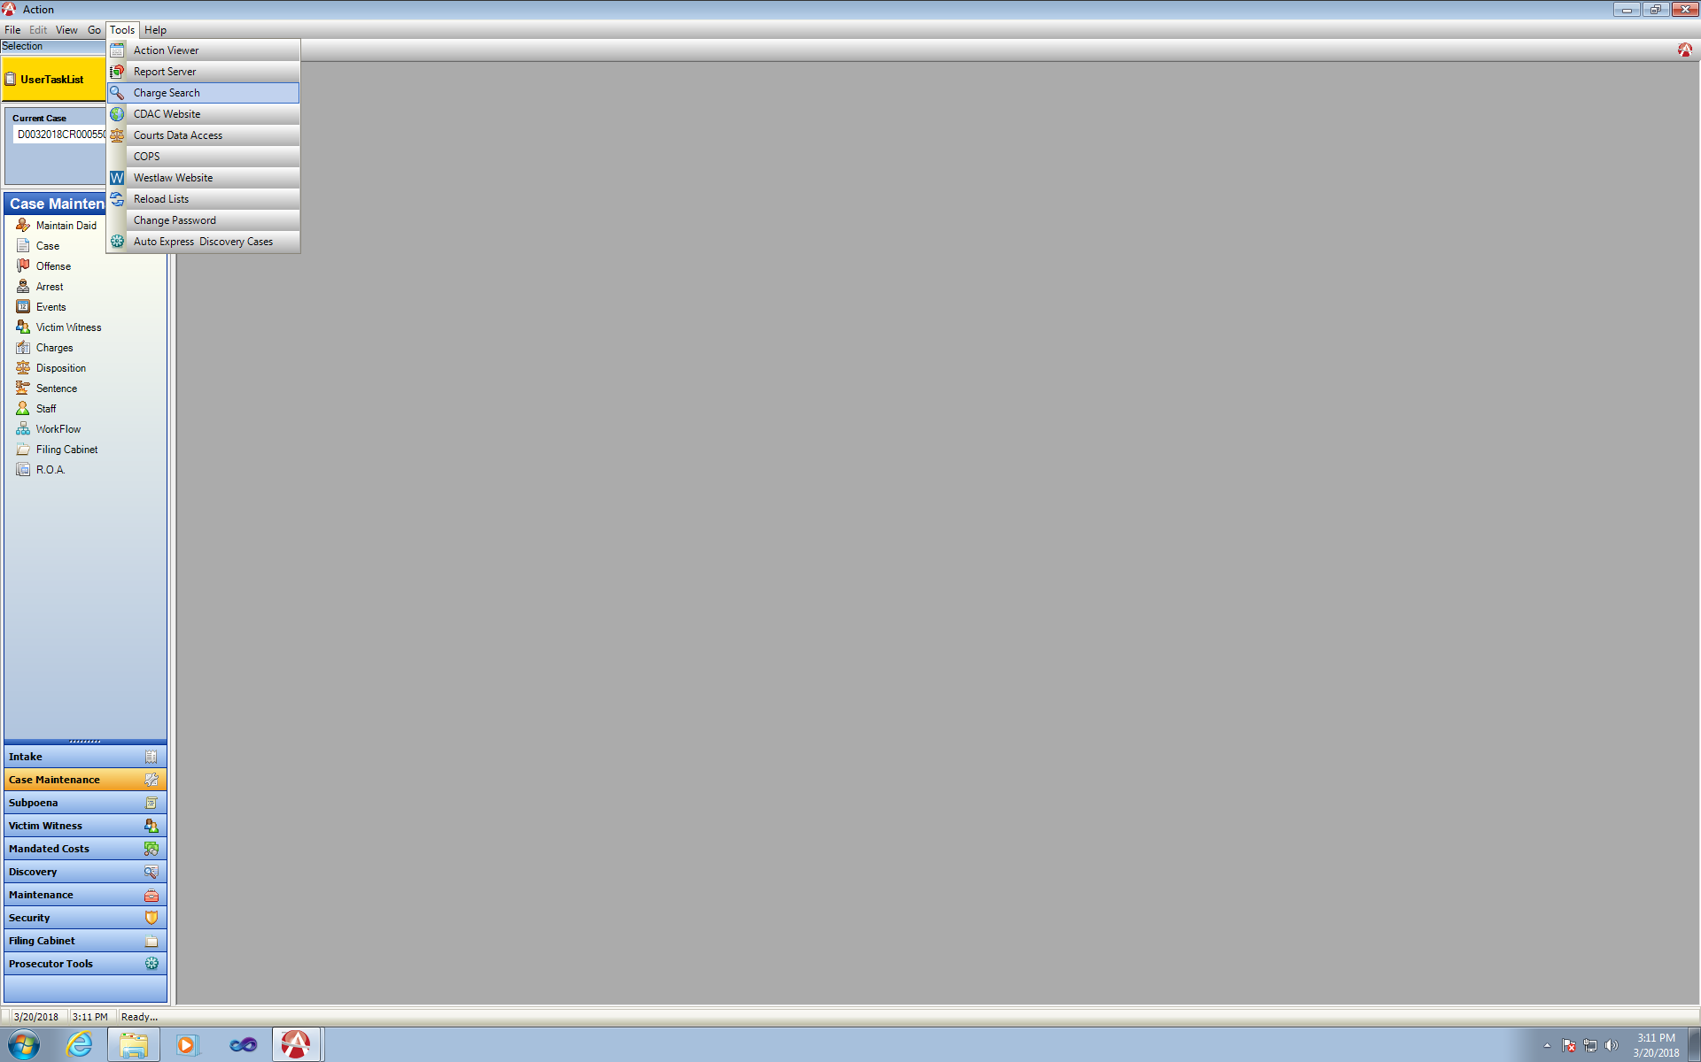

Tools: Charge Search

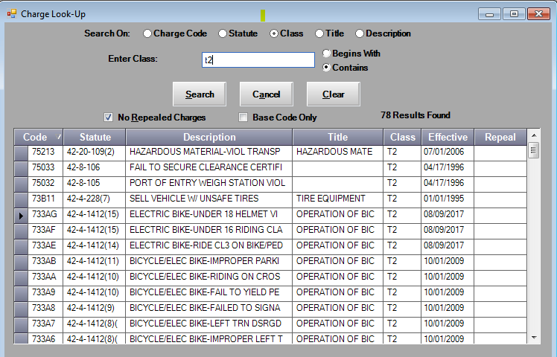

Default Search: Active Charges

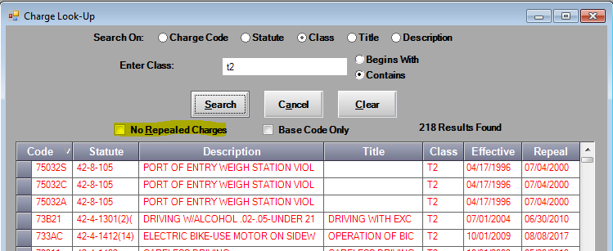No Repealed Charges: Unchecked

User Task List- User Preference Columns

User Preference Column Order. Users can now rearrange the viewable columns on the User Task List, these will become that specific user’s order every-time they log into Action. These can be changed at any time by clicking on a column header and dragging to the desired position.

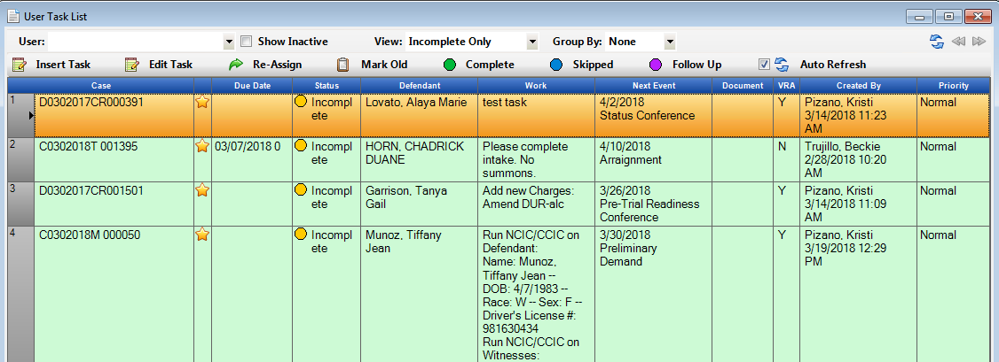

Change in column positions:

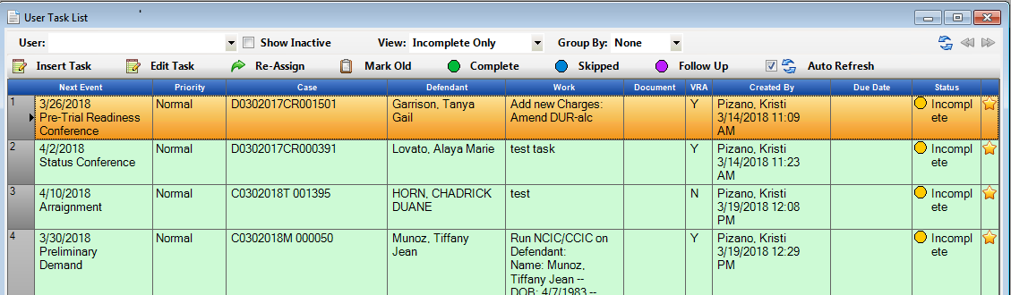

User Task List- View Tasks Completed Today

User task list has a new view to show a user’s Complete Tasks for the day.

Under View: Select Completed

This view is read only- the Go to Case right click option is available to open the Action case directly.

If a listing of completed tasks is needed beyond this default, there is a report in Action Viewer- Reports- Work Flow Folder where that can be run. This was to provide the user with a quick look back on the day’s tasks that were marked completed.

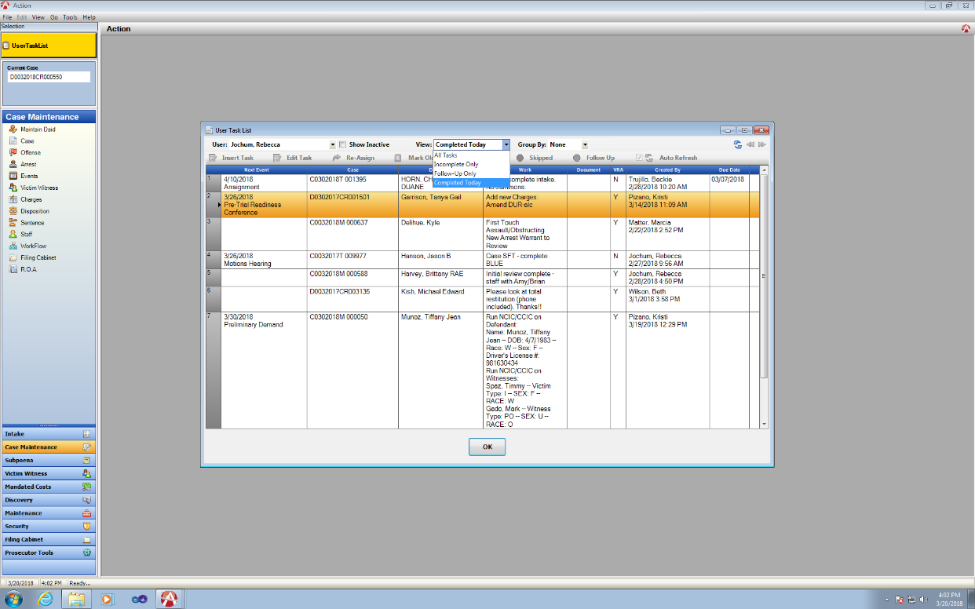

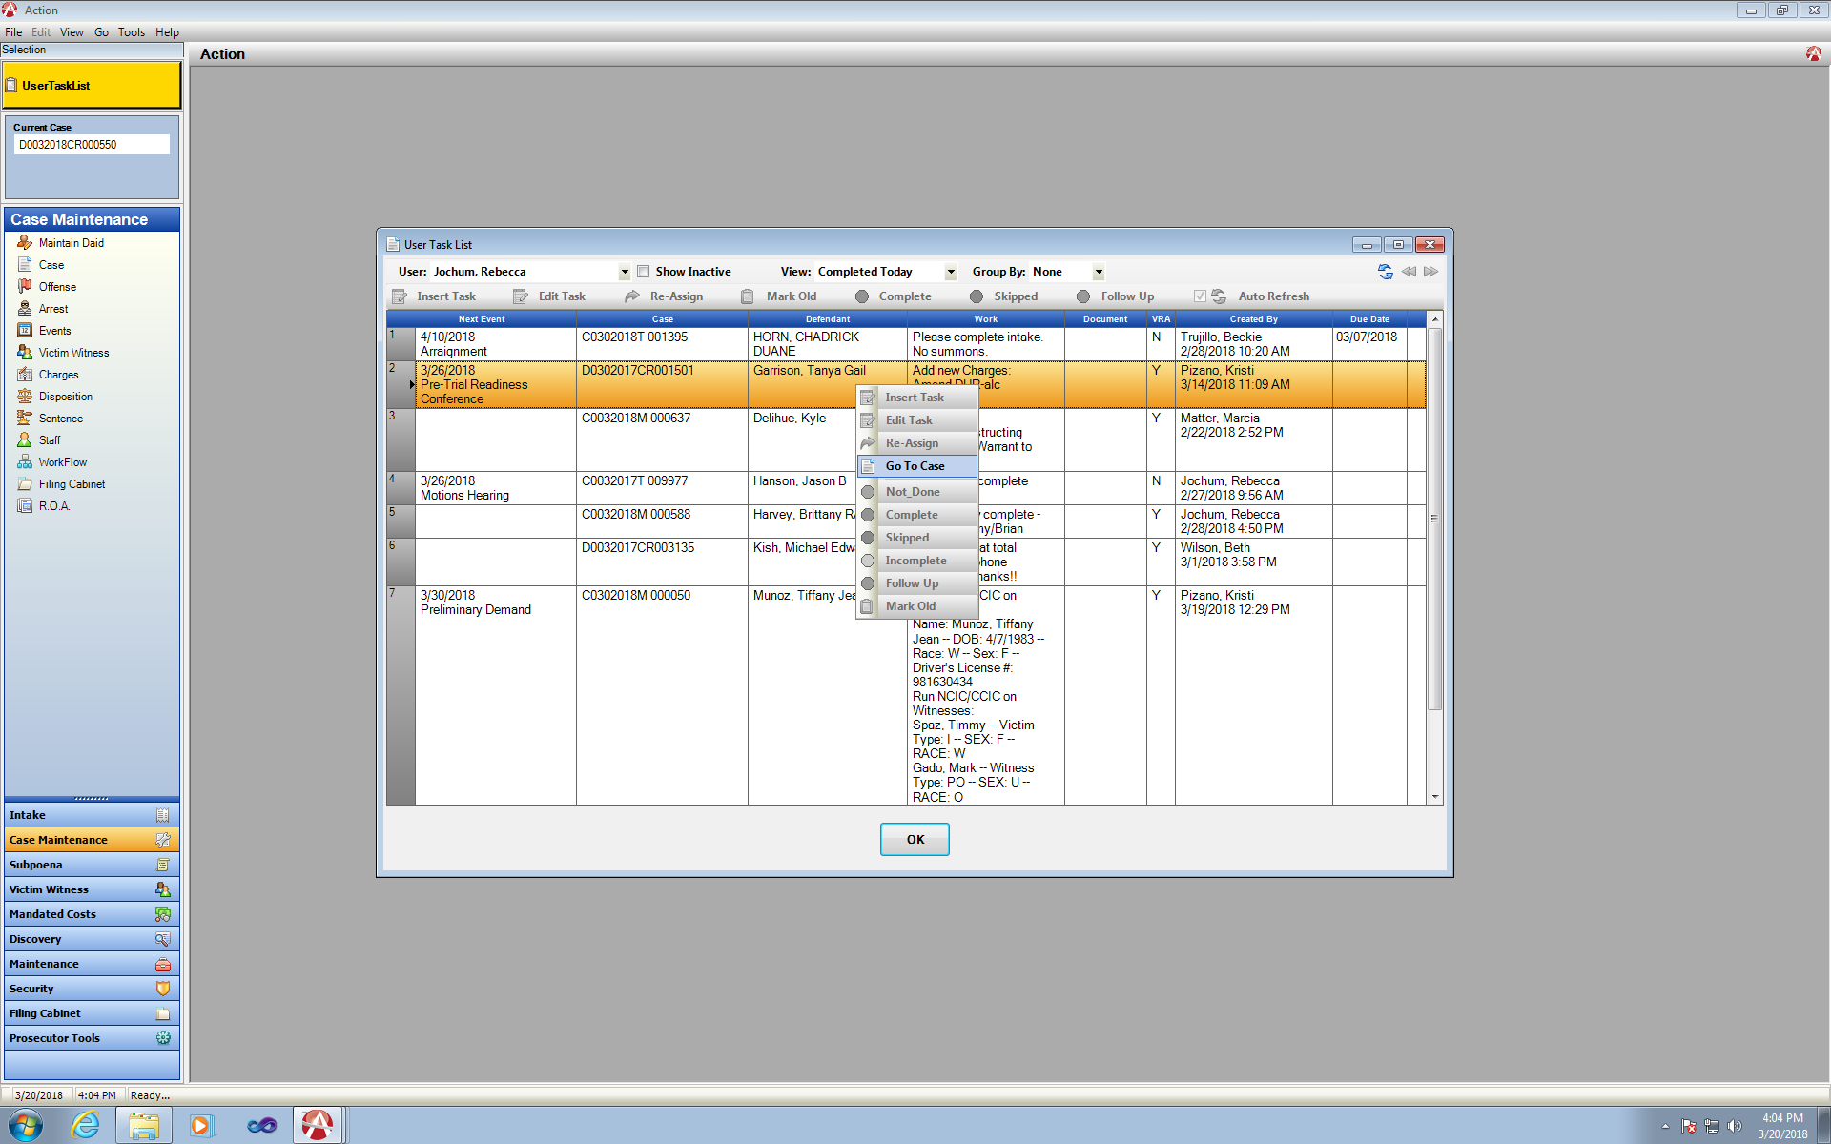

Work Flow- Insert Task

Work Flow insert task screen, was expanded to have a larger space to show the work descriptions being entered.

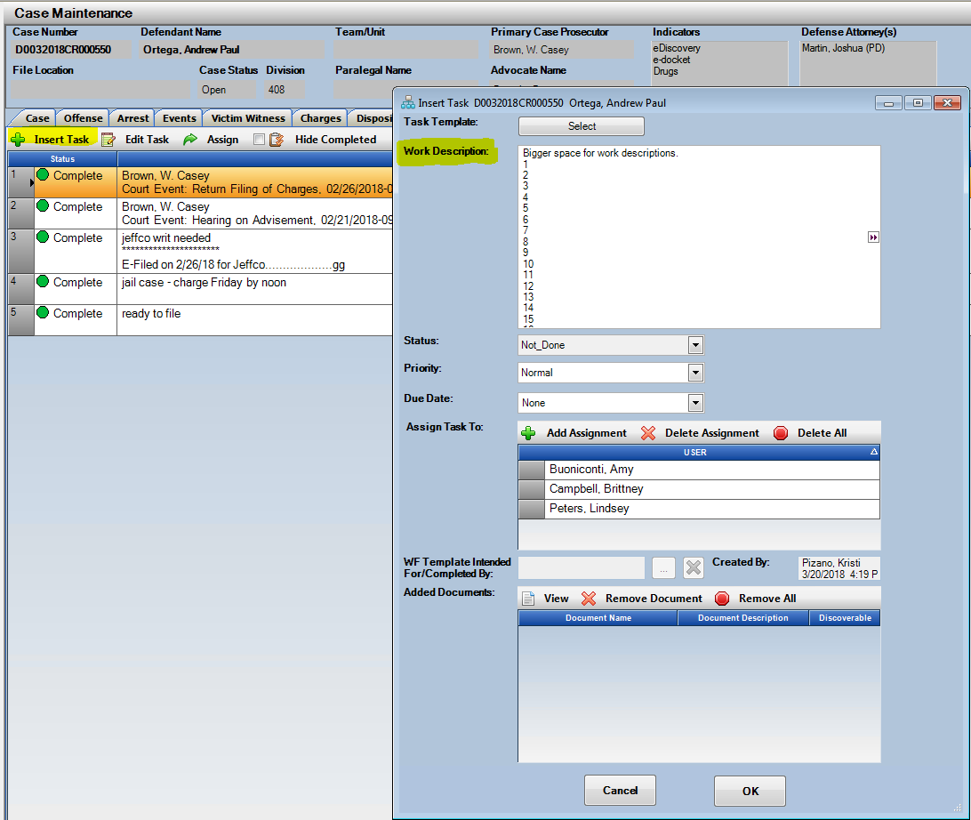

Work Flow Tab:

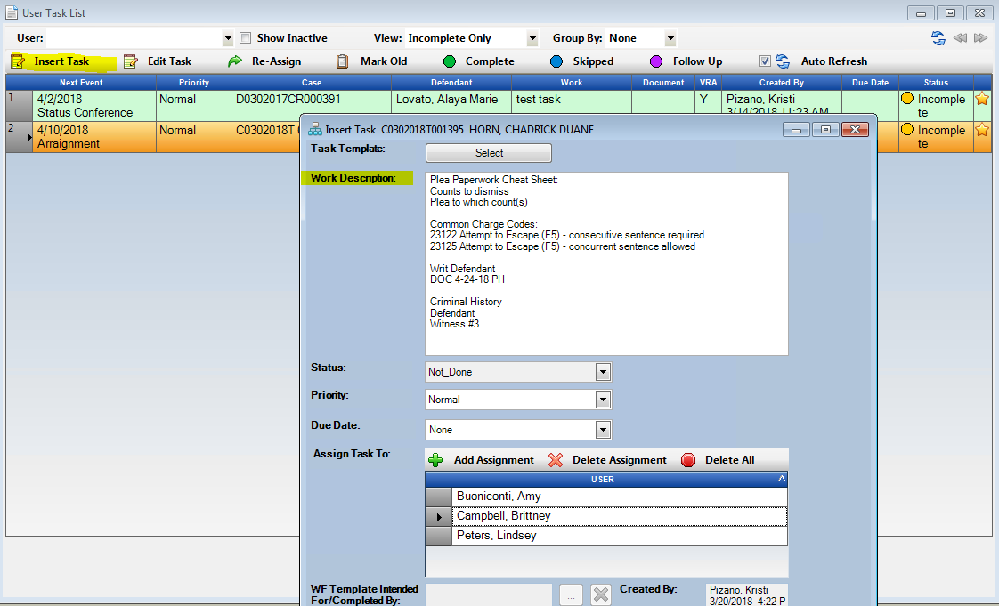

User Task List:

Work Flow Templates- Available Templates

Two templates have been updated for your Districts use. If you do not currently have these and would like turned on please contact CDAC.

1. Investigatvie Case Assignement – updated to include VW Address and Phone number.

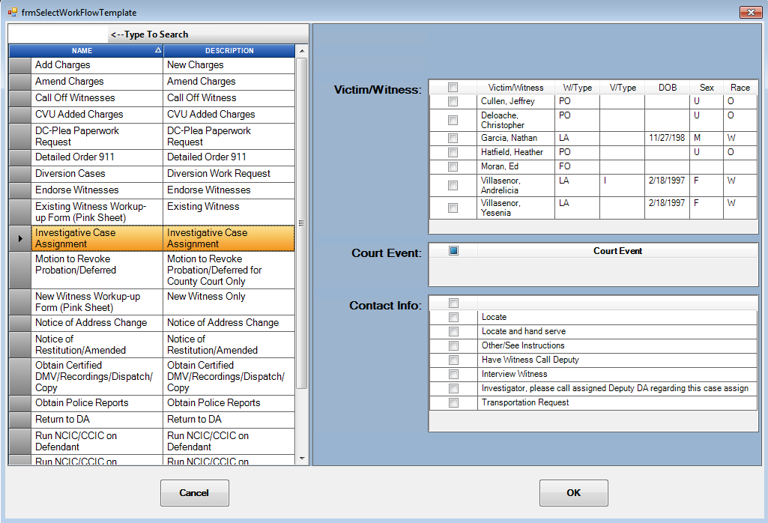

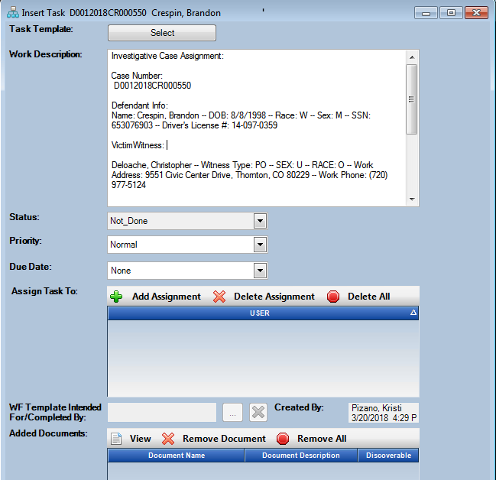

1. Criminal History Request- update to include both Defendant and Witness Request

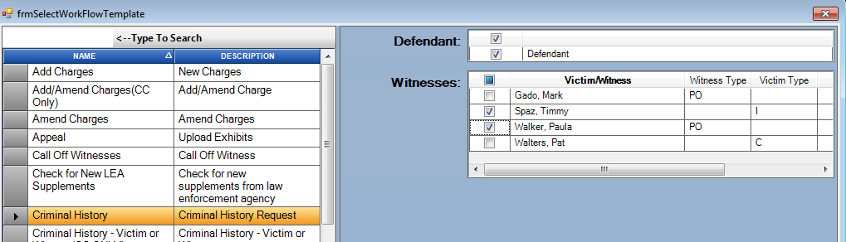

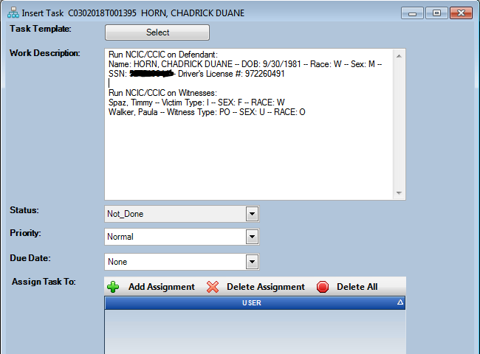

Victim Witness Tab- VIS Date Column

VW Tab will now only display an entry in the VIS column when one is entered by the user. Previously had default date of 01/01/1900.

This data field is utilized by the following steps:

1. VW Add/Edit window.
2. Check box for Victim Impact Statement Required.
3. Check box for Victim Impact Statement Received.
4. Enter Date in the Date VIS Received field.

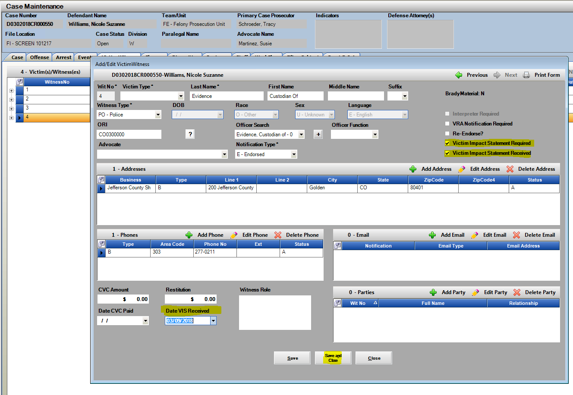

Date Displayed on the VW Tab grid.

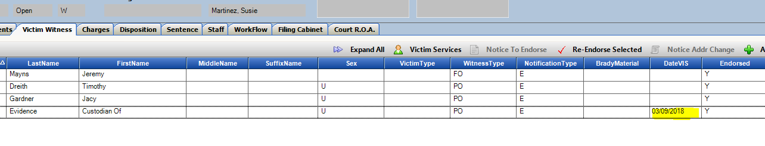

Subpoena Tracking and Subpoena Status – Edit VW

Subpoena Tracking: Right Click Option to Edit the VW record tied to the subpoena returned.

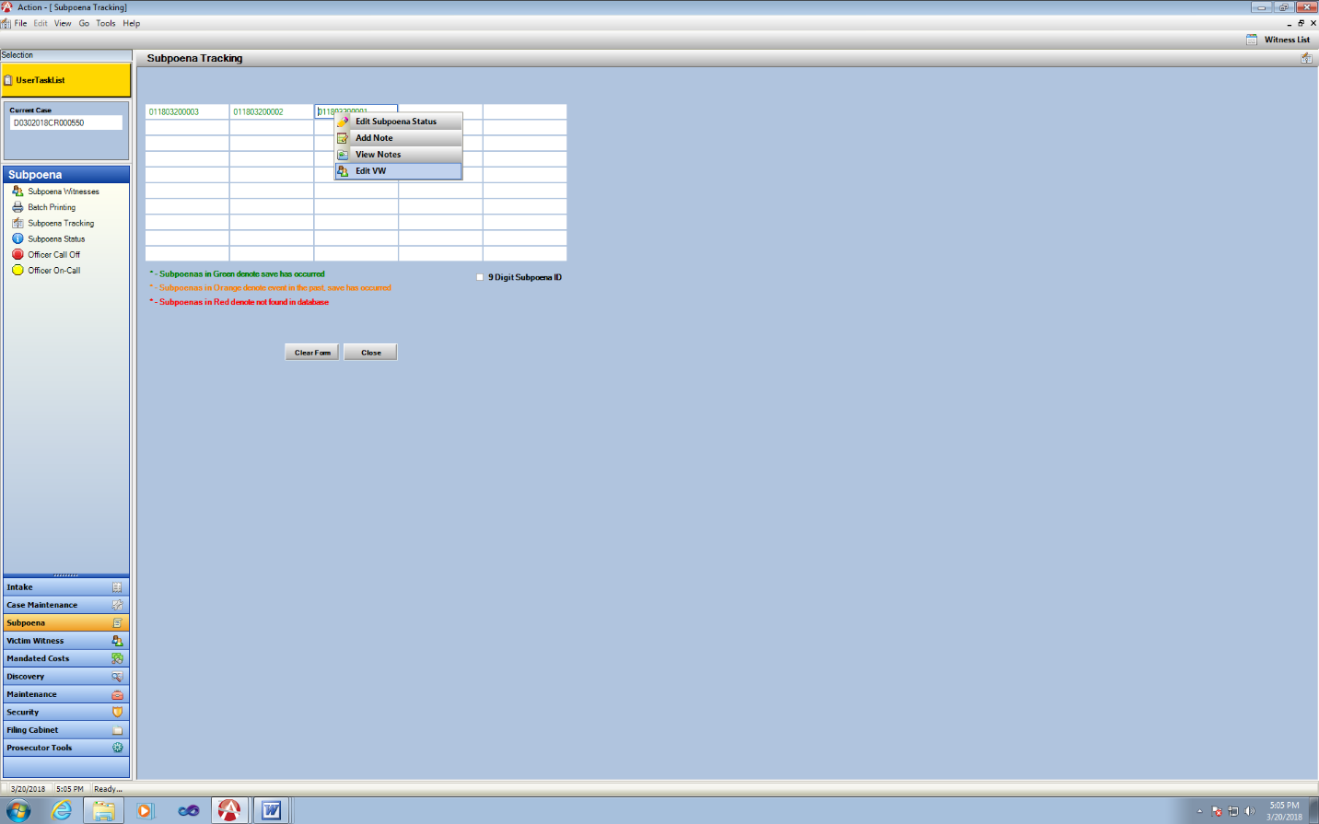

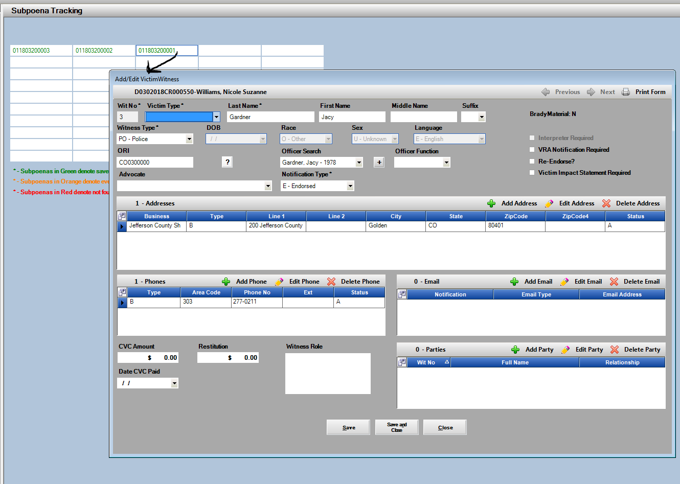

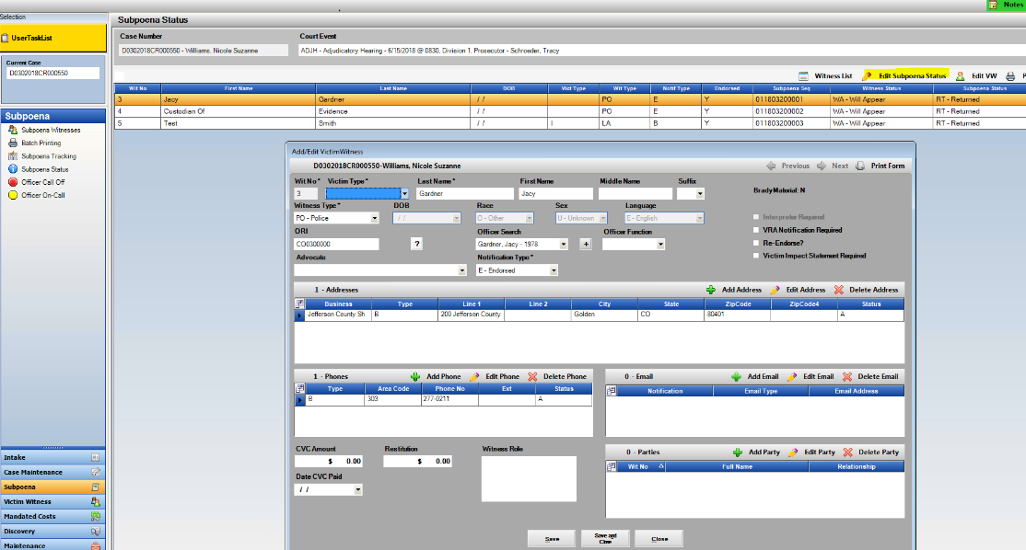

Subpoena Status:

Victim Contact Services Screen

Victim Contact Services Screen has been created within Action.

**This is a District Setting that will need to be turned on by CDAC by the request of the District.

User Permissions: User must be set up as a Victim Services Specialist/Advocate within the District to see this selection to Add Contact Information.

Functionality:

1. Highlight Witness on Tab, select Victim Services.
2. Victim Services Screen then loads.
   1. Add/Edit Victim Contact Information
   2. Remove Contact Information
   3. Show: Active or Removed Information
   4. Selections made on check box method.
   5. Memo: Free Form Note associated to the contact provided. (This creates a VW Note on the case level, Victim Witness Note – Sub type: VRA Compliance.)
3. Report for Statistics: Action Viewer- Reports- Victim Witness Folder: Report: VOCA Statistics and VOCA Statistics Itemized.

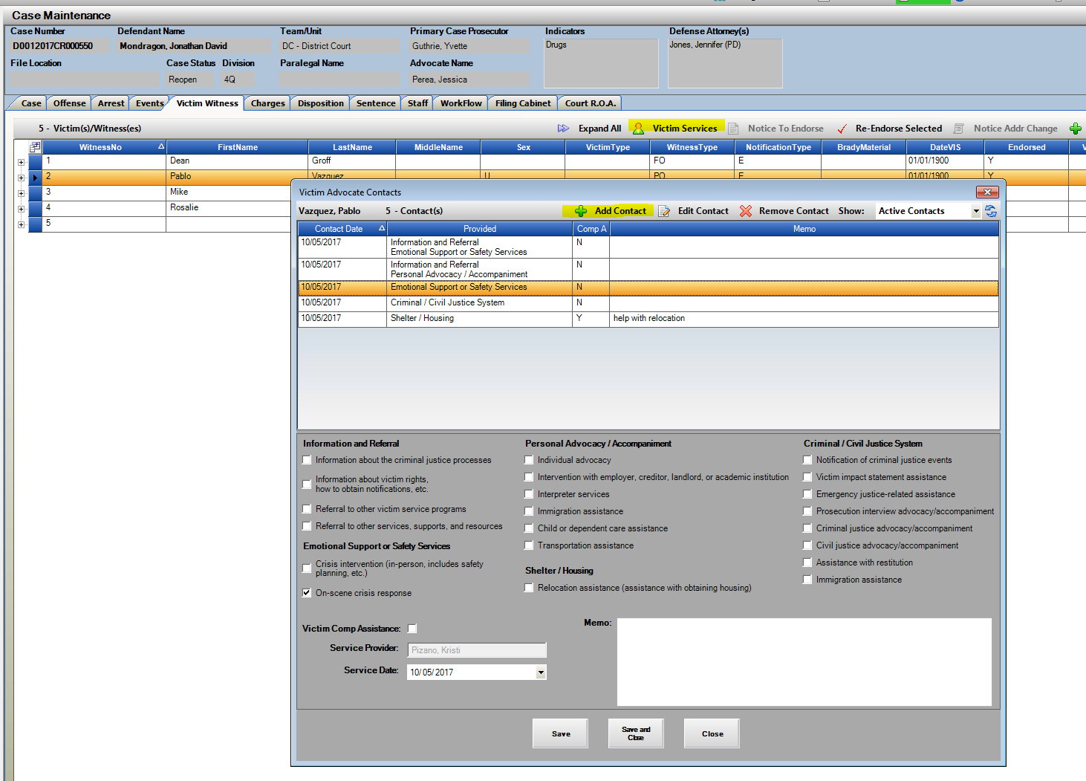

Victim Witness – Email Notification Letters Option

**Victim/Witness Email Notification process is a District Setting turned on by CDAC per request from the District.

This process requires CDAC to create a District email used for notification purposes. The District is then responsible for monitoring sent emails.

When enabled users may enter an email contact per victim/witness on the VW Tab.

1. Add Email to VW record on the email field.
2. Check the Send Notification Checkbox; Save and Close.

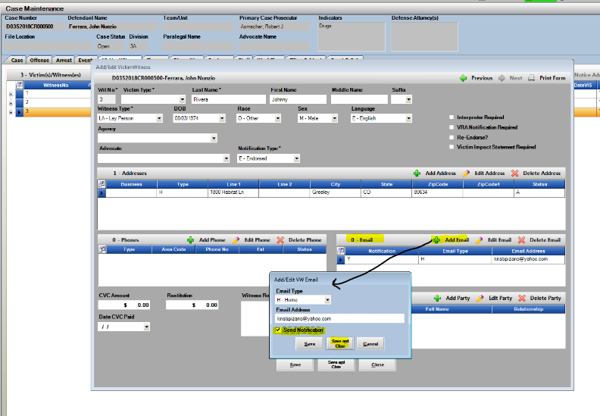

1. Victim Witness Notification

Process can be enables for Manual Production of Letters and Batch Processes. We would want to start with Manual Production before going to the Batch Process with a District.

Notifications will work the same where a VW is selected, then the type of Letter. If the VW entry is then marked with an email with send notification checked the Email Letter Option will then be enabled for selection.

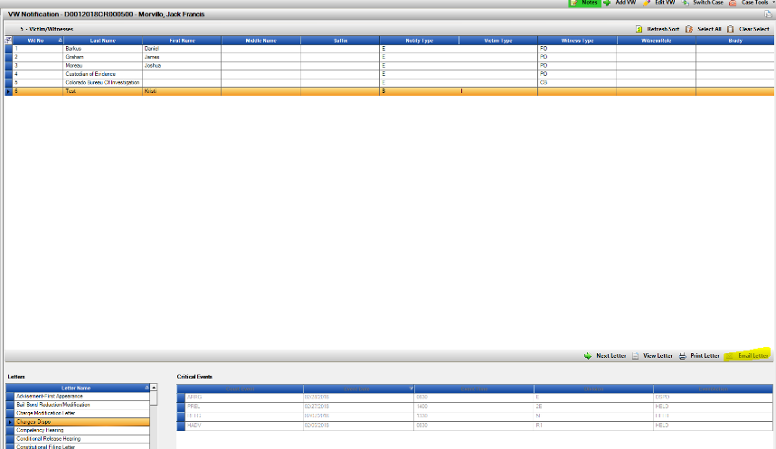

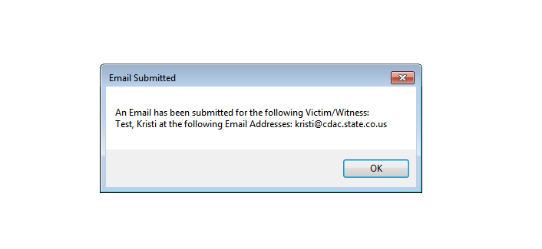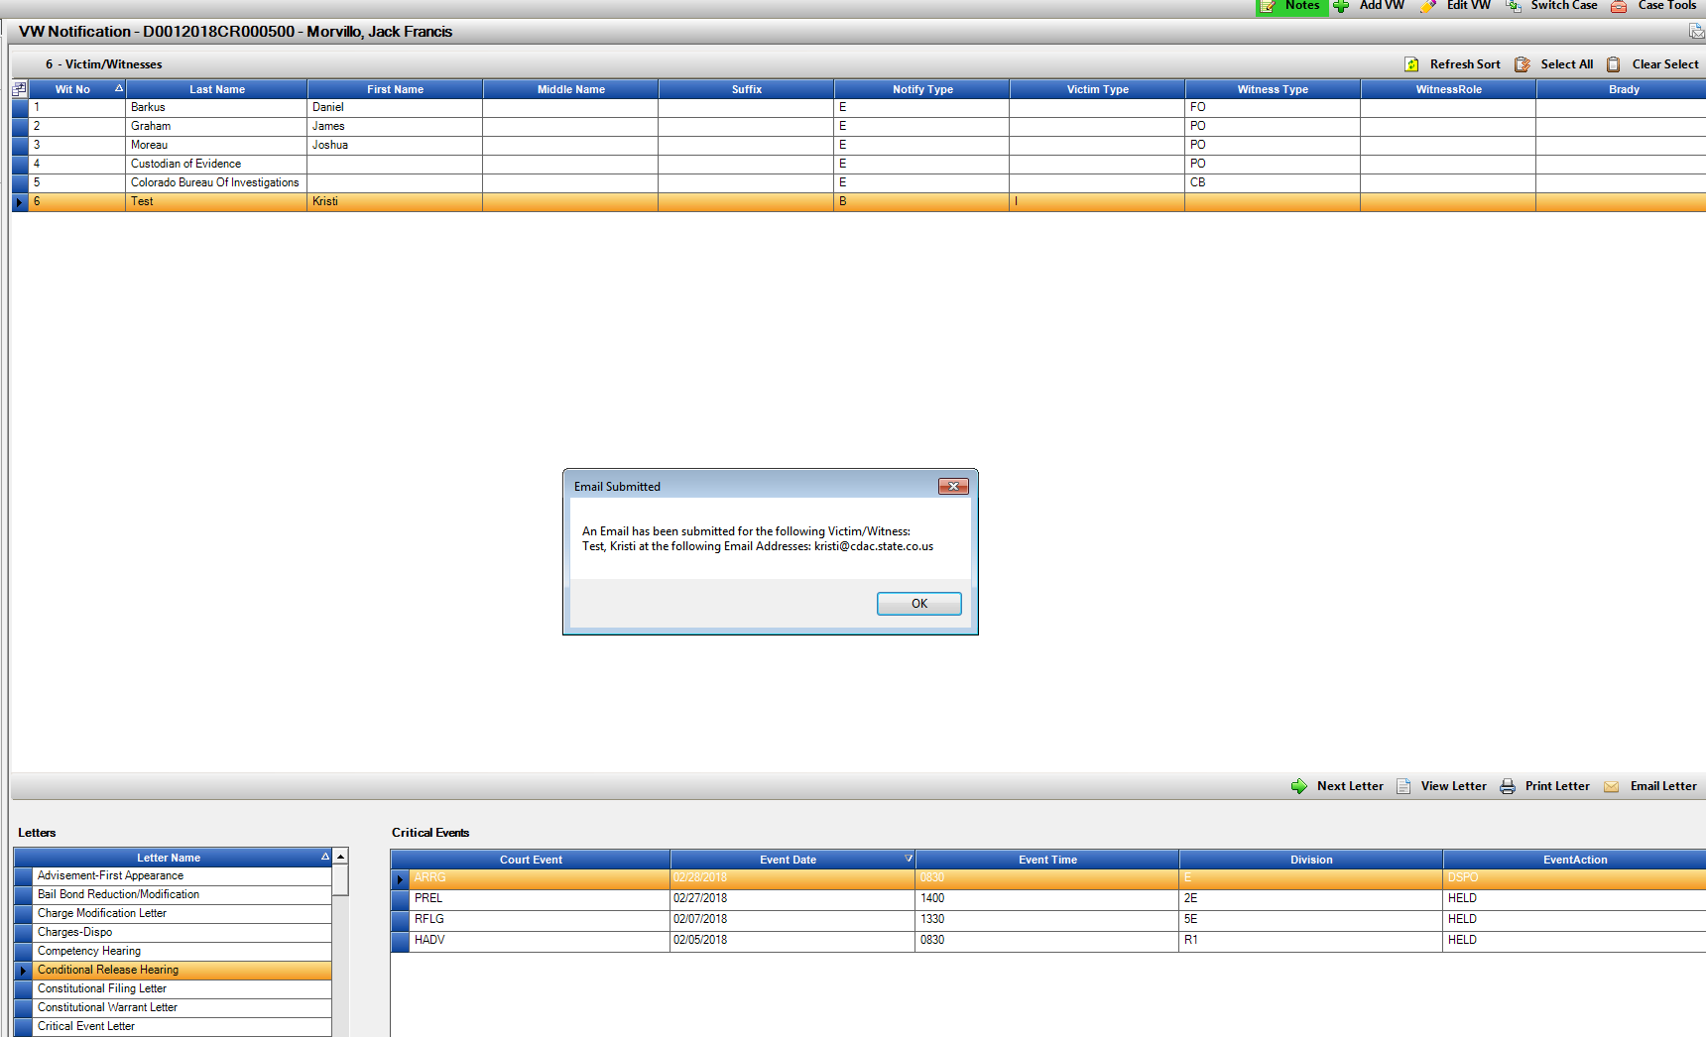Received email example:

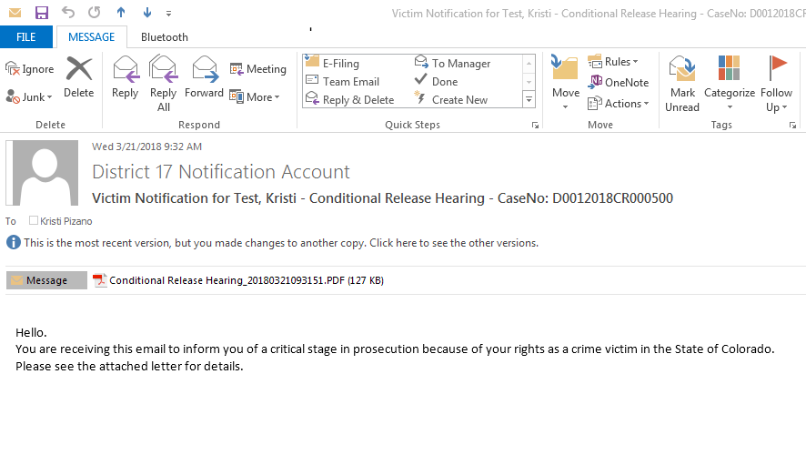

Prosecutor Tools- Subpoena Column and Secondary Prosecutor

Prosecutor Tools:

1. Dockets now include a column referencing Subpoena. This will let the users know if Subpoenas generated through Action have been done for the case/hearing that is displayed.

Reminder- Users can Right Click on a row and select witness list to view the Subpoena Tracking Report if Subpoena Returns are tracked within Action. This provides a quick update on status of subpoenas sent on the hearing.

1. Prosecutor Dockets will now display events for all prosecutors listed on the Action case. Primary plus additional secondary attorneys added from the Staff Tab. Primary attorney designation is shown in a new column Primary Y/N.

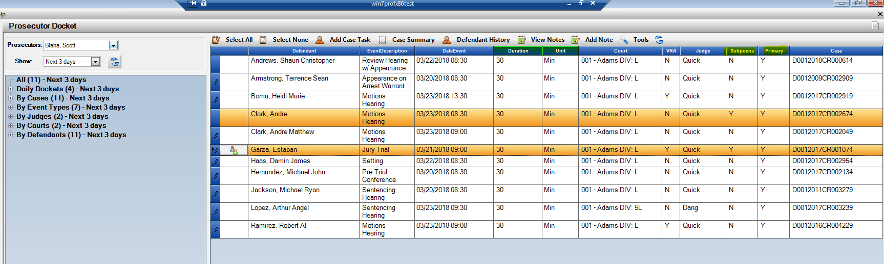

Right Click: Witness List to view Subpoena Status for Hearing.

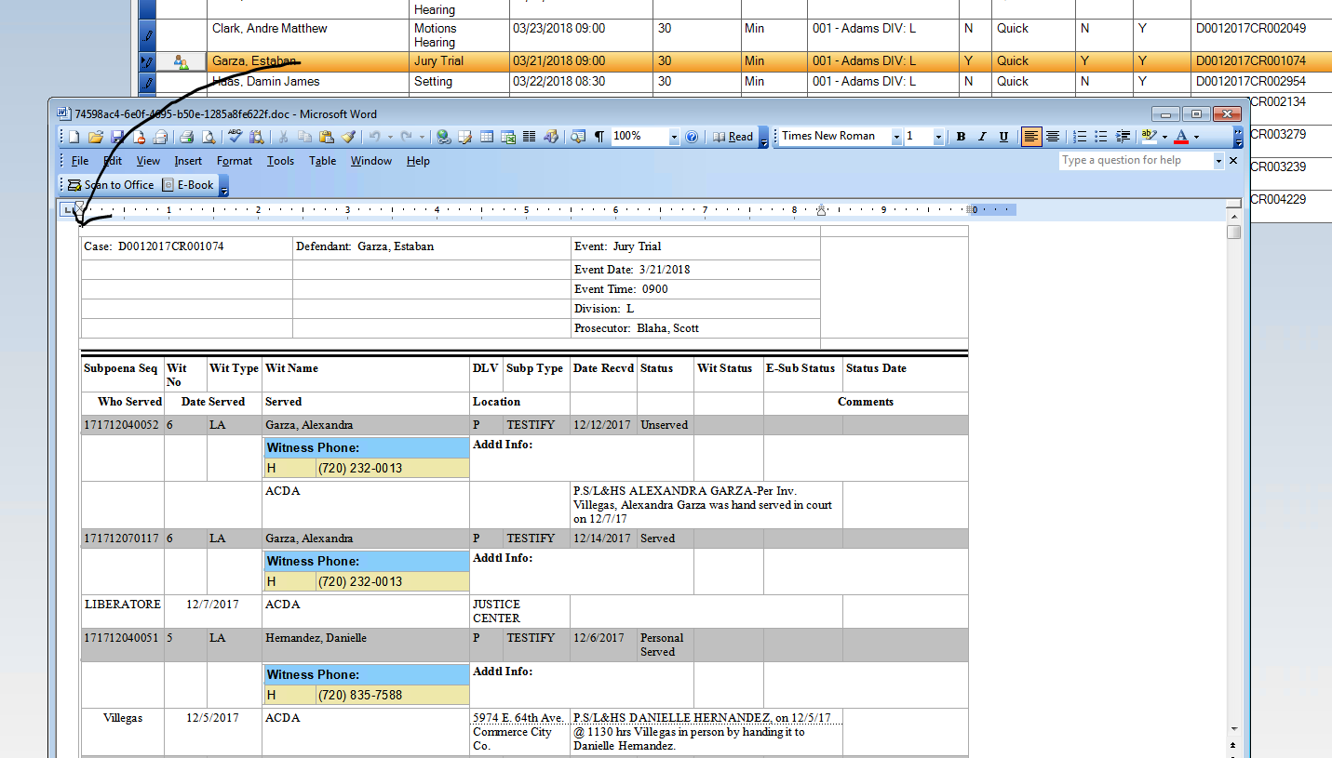

Case Notes- District Setting- Private

Noting Control

**New District Setting turned on by CDAC to default all notes entered by the district as Private.

These notes are shared via. Action viewer with other DA’s offices if they are not set to private.

Please contact CDAC to have this feature enabled for the district.

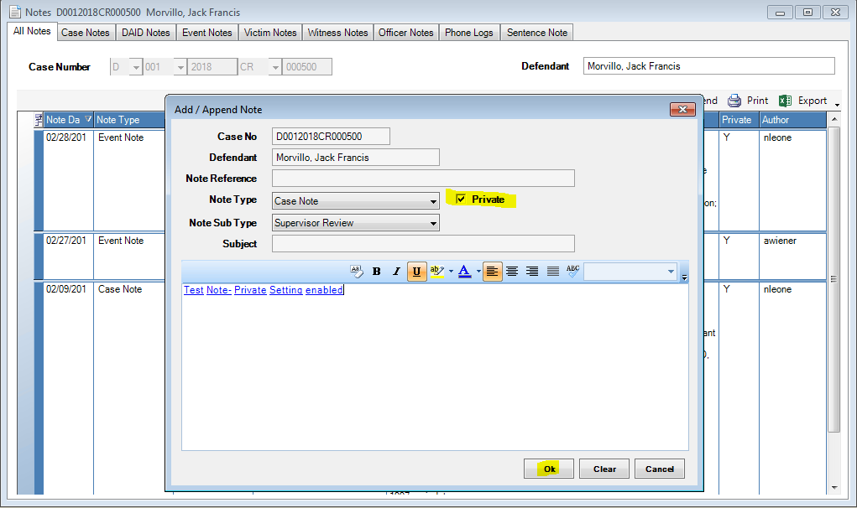

Miscellaneous

* Inactive Prosecutors, VW Advocates and Paralegals will no longer display on the case header after being made Inactive within Action. This is a power user function- Maintenance 🡪 Person 🡪 Prosecutor Tab/ Paralegal Tab/ Advocate Tab.
* Offense Tab: Double clicking on an Offense in Case Maintenance will now open the record as a quicker option then clicking on Edit.
* Events Tab: Double clicking on an Internal Event will now open the record as a quicker option than highlighting and clicking Edit.
* Copy Case Functionality: Copy To and Copy From will now preserve any Interested Parties when copying from one case to another.
* Upon setting a case in action to Closed Status the case will return to the Event Tab.
* Victim Witness Tab- Re-sized for better resolution on Surface 4 screens.