Action enhancement guide

May 2018 Training Guide



CDACweb.com



**Table of Contents**

1. Action Subpoenas with Bar Codes on Waiver Cards……………………………………… 3-4
2. ***Subpoena Tracking Screen- new design ------------------------------------------------- 5-10
3. Offense Tab- Auto Expand Offenses ….……………..……….……………….………..... 11
4. Event Subpoena List …..………………………….………..…………………………….……………. 12-13
5. Miscellaneous…………………………………………………………………………………………………… 14
   1. WF Skipped Status Removed
   2. Clerk of Court Entry Bug Fix
   3. Hot Key Fix- VW Tab ALT +S now back to Switch Case. ALT +C now used for Victim Service Screen.
   4. Add Event Populating to Notes Bug Fix
   5. LEA Search Officer Notes resolving correcting in Noting Control
   6. Prevent deletion of Dispo if Sentence record attached.

*Items marked with asterisk denote a setting that CDAC will turn on per request of the District.

Subpoena Bar Code Option for Waiver Cards

Produced Action Subpoena now will have the option to resolve the Subpoena ID (Tracking Number) as a scan bar-code.

This is to increase speed while processing returned waiver cards through Action for tracking purposes.

If your district would like to use the bar-code method the following steps need to be followed:

1. Install the attached barcode font.
2. Each computer that prints/generates subpoenas would need to have this font installed.
3. Purchase a hand held scanning device for scanning/ tracking purposes.

If your district chooses to not have these displayed as a barcode, then no action is needed. The Subpoena ID will continue to display on the Subpoena but will have an asterisk in front and behind the number.

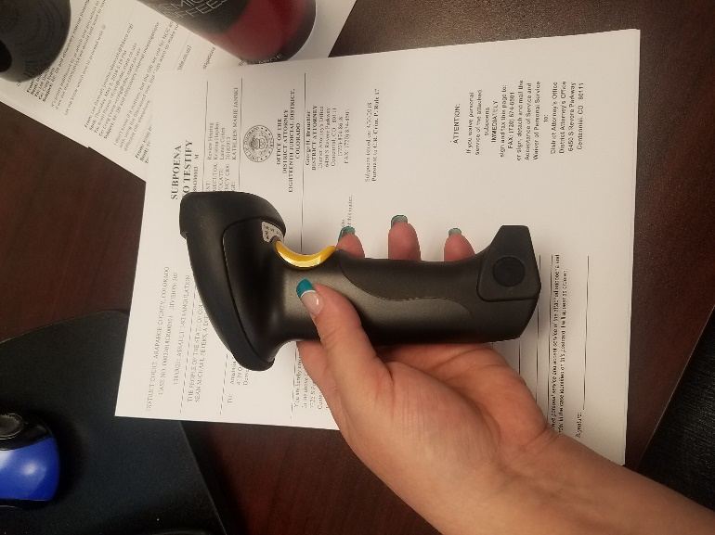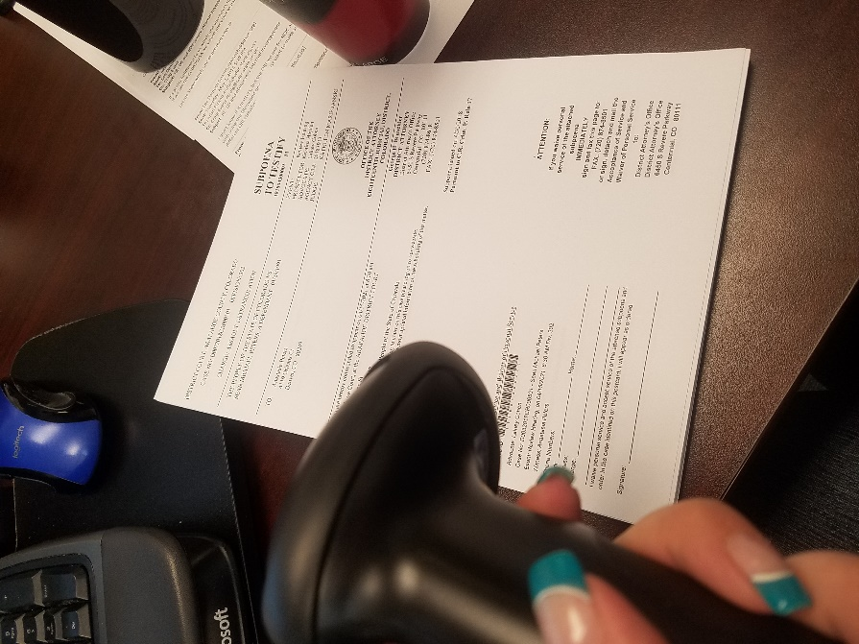

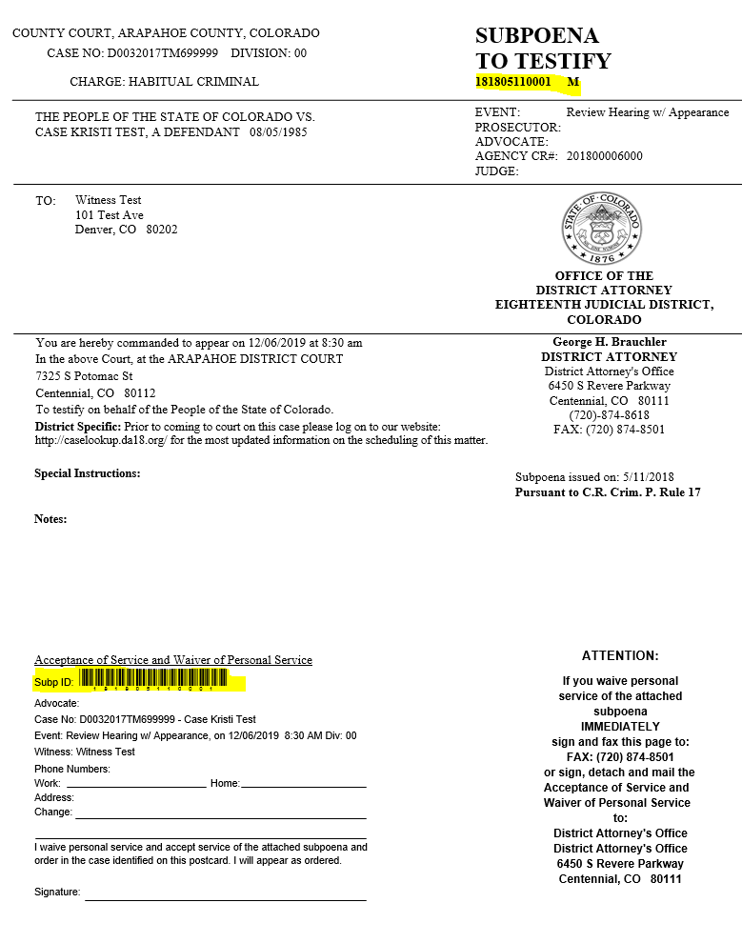

**With Bar Code Font installed produces like this:

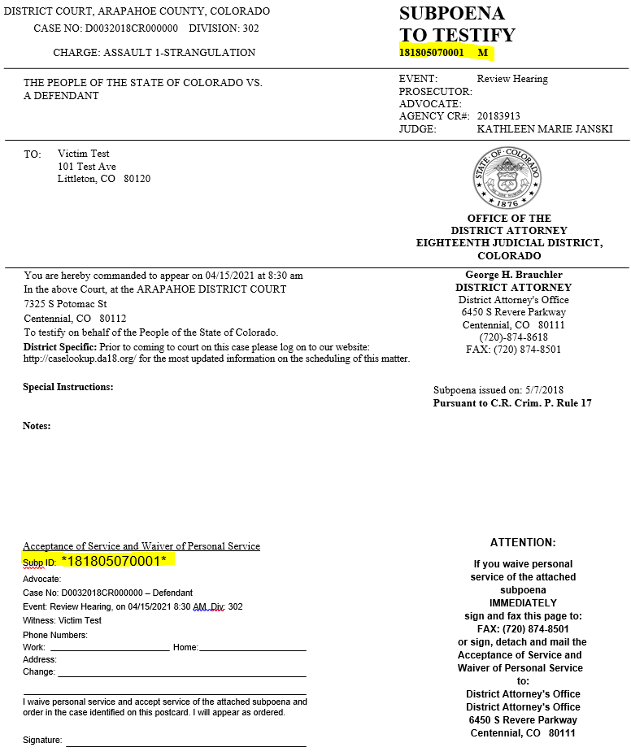** With Out Bar Code Font

Subpoena Tracking

**District setting; please contact [Kristi@cdac.state.co.us](mailto:Kristi@cdac.state.co.us) to have this turned on.

Subpoena Tracking within Action has been redesigned for easier and quicker use. Subpoena tracking lets the users track returned subpoenas waiver cards, that will then keep other staff members updated as to the status for upcoming events.

Location:

Subpoena🡪 Subpoena Tracking selection.

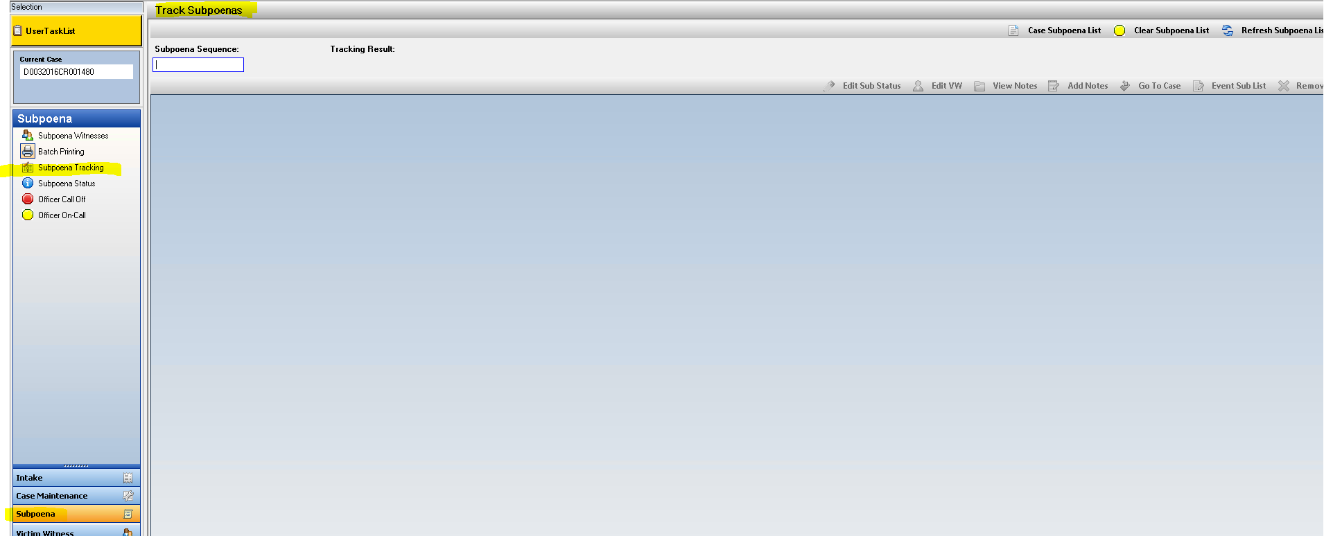

User enters the Subpoena Tracking ID number on the returned waiver cards either by manual key entry or scans in the barcode on the waiver card with a hand held scanner.

Note: Please contact CDAC regarding Bar Code appearing on your Subpoenas. This will include a font install on users’ computers that generate subpoenas. Without the install the Subpoenas will produce with the Subpoena ID number listed as in current practice.

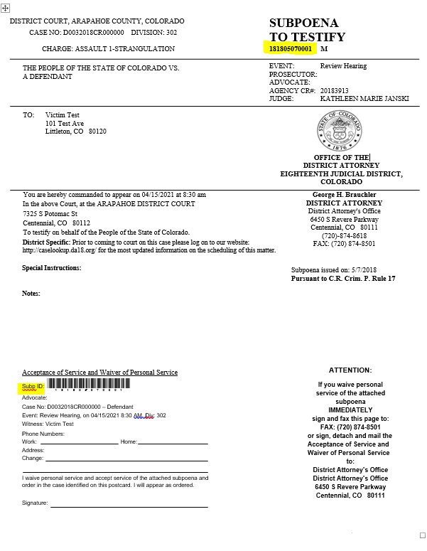

When the Subpoena number is typed in or scanned in it will create a row on the screen indicating the specific information regarding the subpoena.

Case Number

Witness Name

Subpoena Sequence #

Subpoena Status

Witness Status

Event, Event Date, Event Time

Division

Subpoena Status and Witness Status columns can be updated on the grid using the drop down selections.

Note: Subpoena Status defaults to “Returned” when it has been entered through tracking.

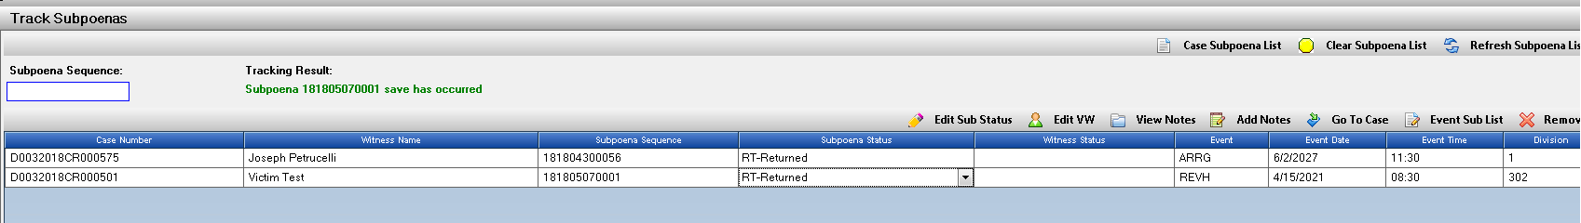

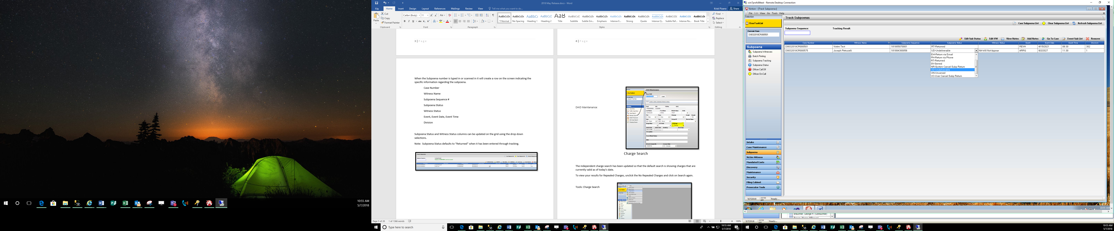

Screen Options include:

1. Edit Subpoena Status
   1. Let’s users update Subpoena information – quick access and enter notes regarding the subpoena.

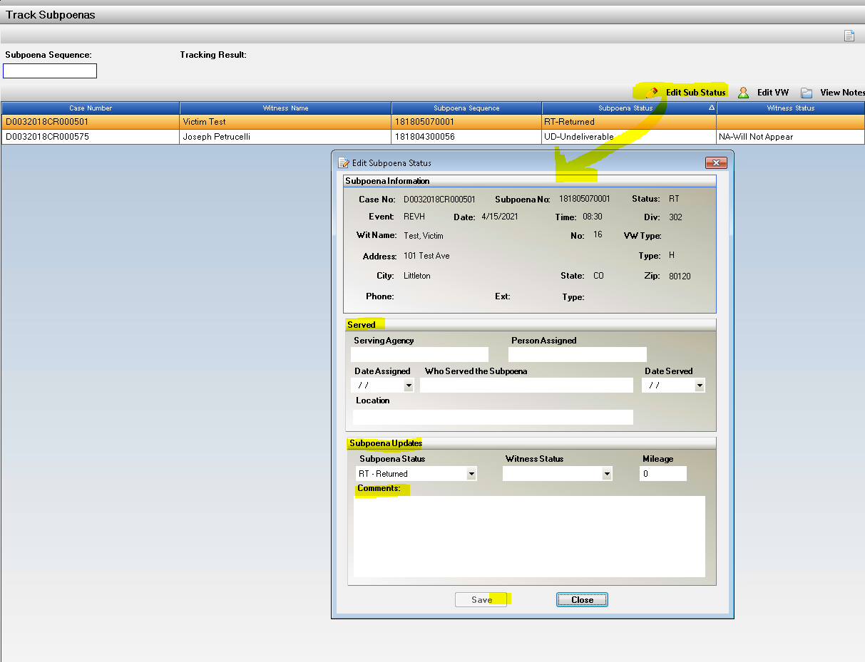

1. Edit VW entry
   1. 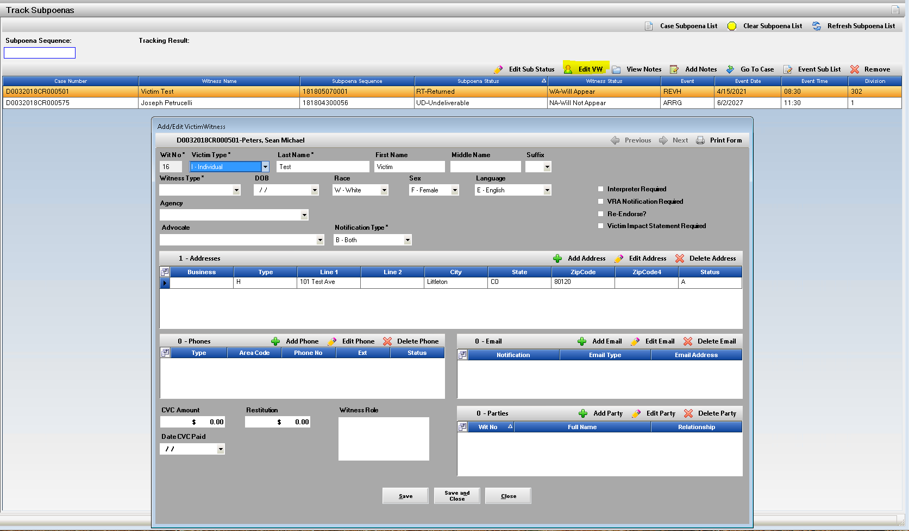Edit the VW entry, update address/phone etc.
2. View Notes:
   1. 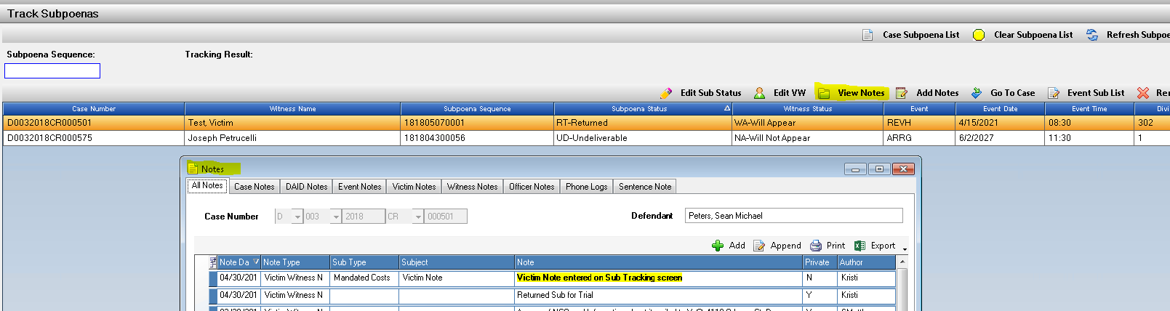View all notes existing on this case.
3. Add Notes:
   1. 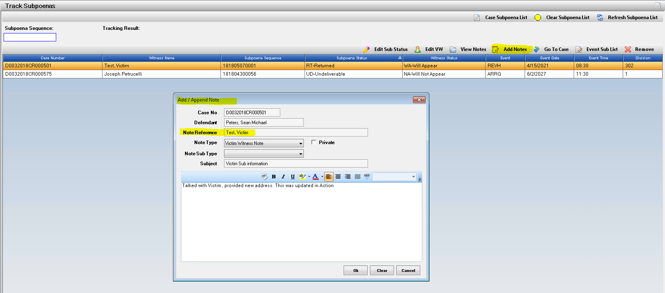Add note to the VW person that is highlighted on the grid.
4. Go To Case:
   1. 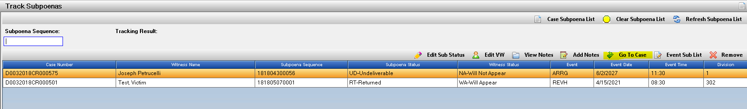Select to open case within Action, re-click on Subpoena Tracking to return to results.
5. Event Sub List
   1. 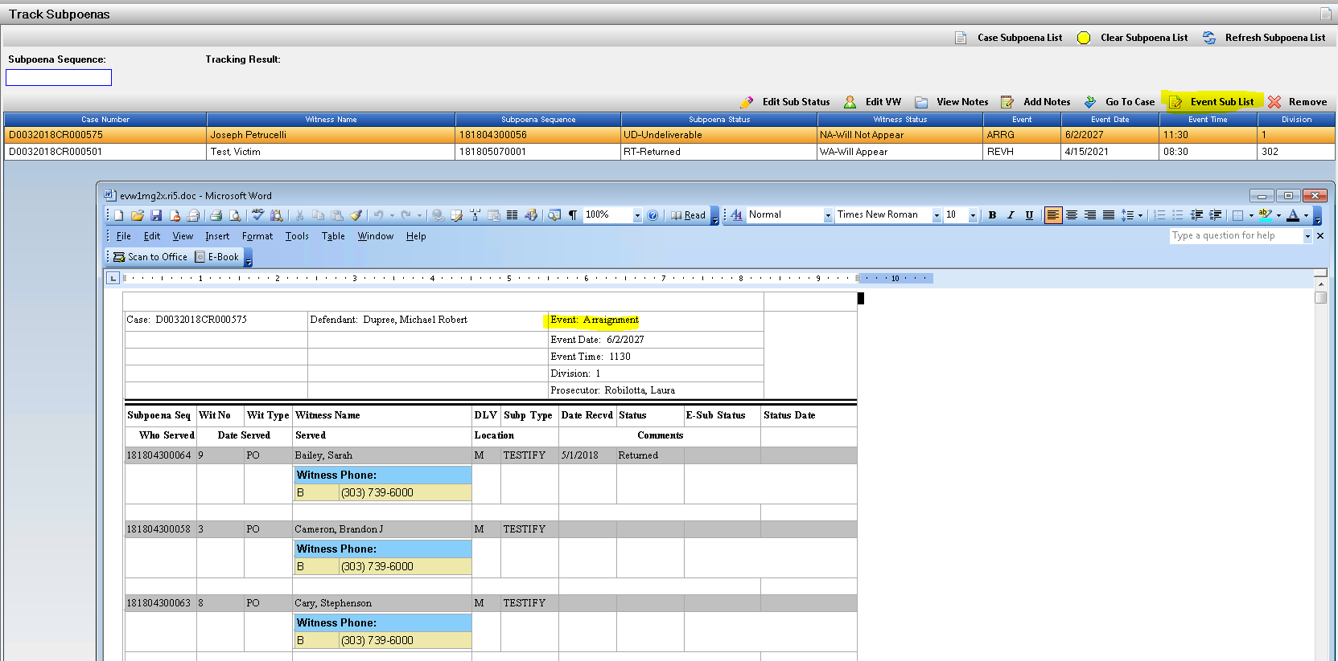Subpoena Witness List Report- launches report for current status of event highlighted.
6. Remove
   1. Removes Subpoena record from tracking if entered/scanned in error.
   2. 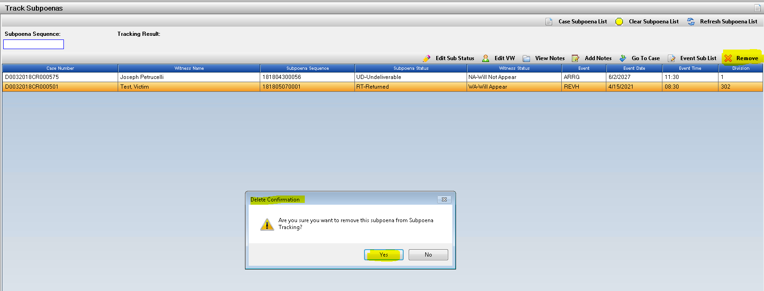Pop up message to user to ensure they want to remove – will return to a status of never tracked.

Offense Tab- Case Maintenance Auto Expand Entries

Offense Tab in Case Maintenance will now as a default auto expand to show the Offense Numbers/ORI entered. This is to match functionality of Intake Offense and to access information quicker after case is filed.

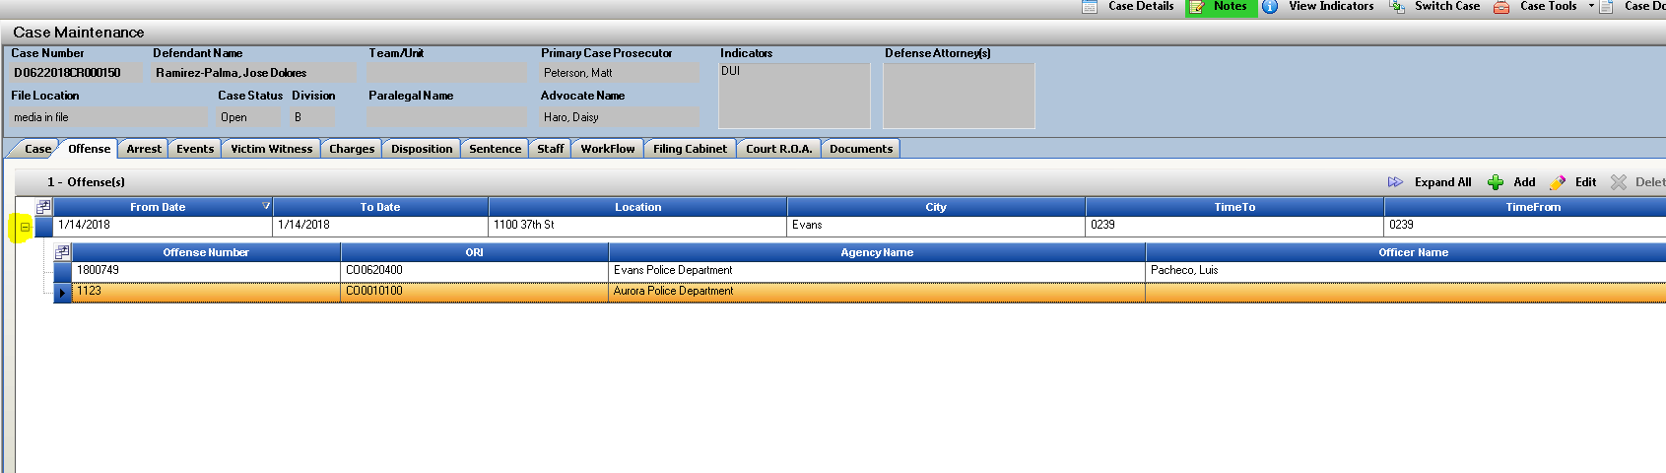

Event Subpoena List

**Event Subpoena List** button {previously named “Witness List”} has been renamed to better describe the function. This button has also been updated to launch the report directly without needing to re-enter a case number, re-select the event and then have it launch. This report now opens directly when selected.

Screens to Access this report:

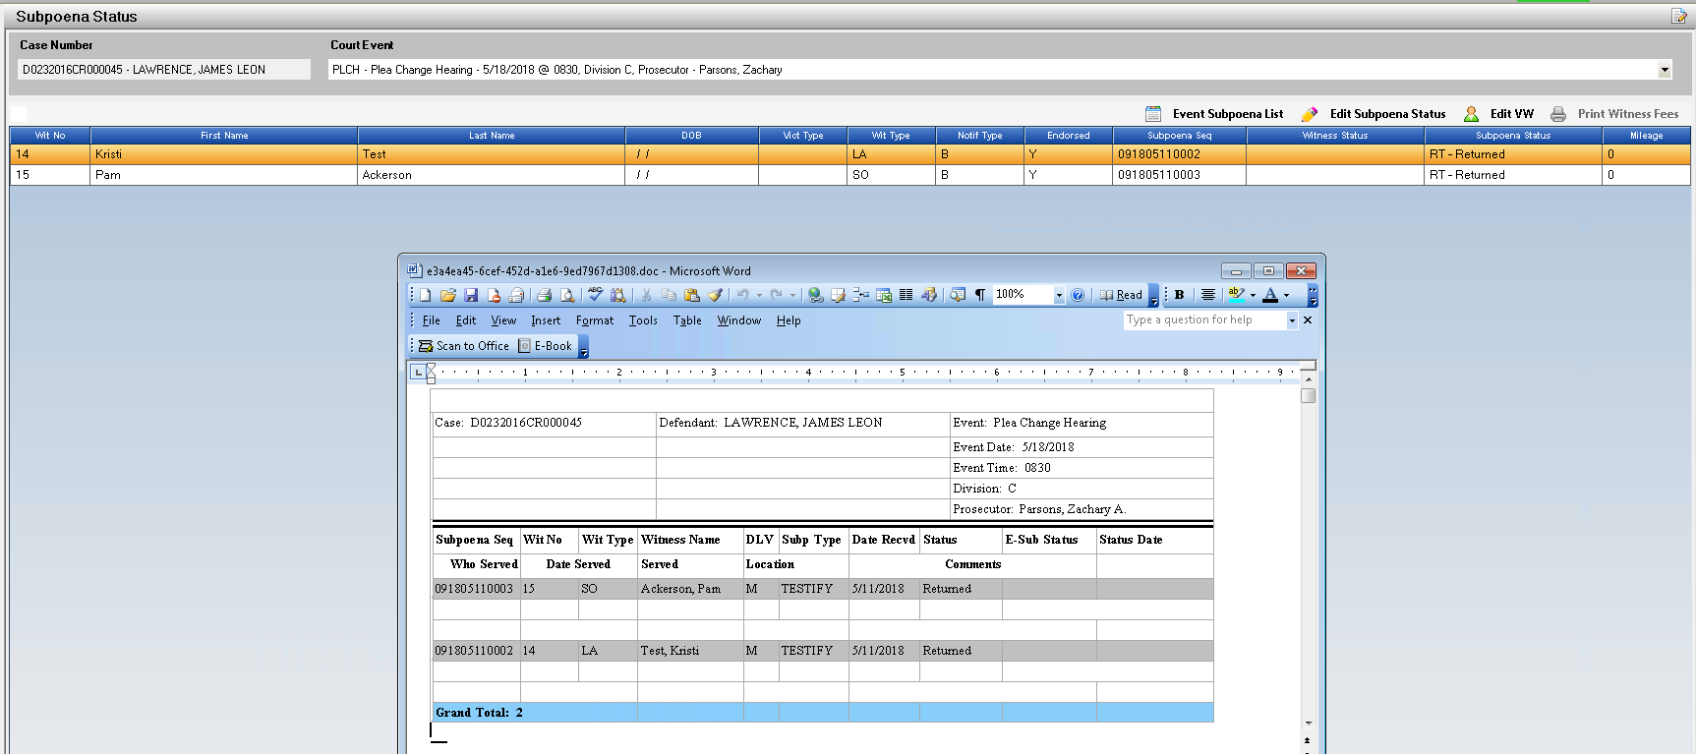Subpoena Status:

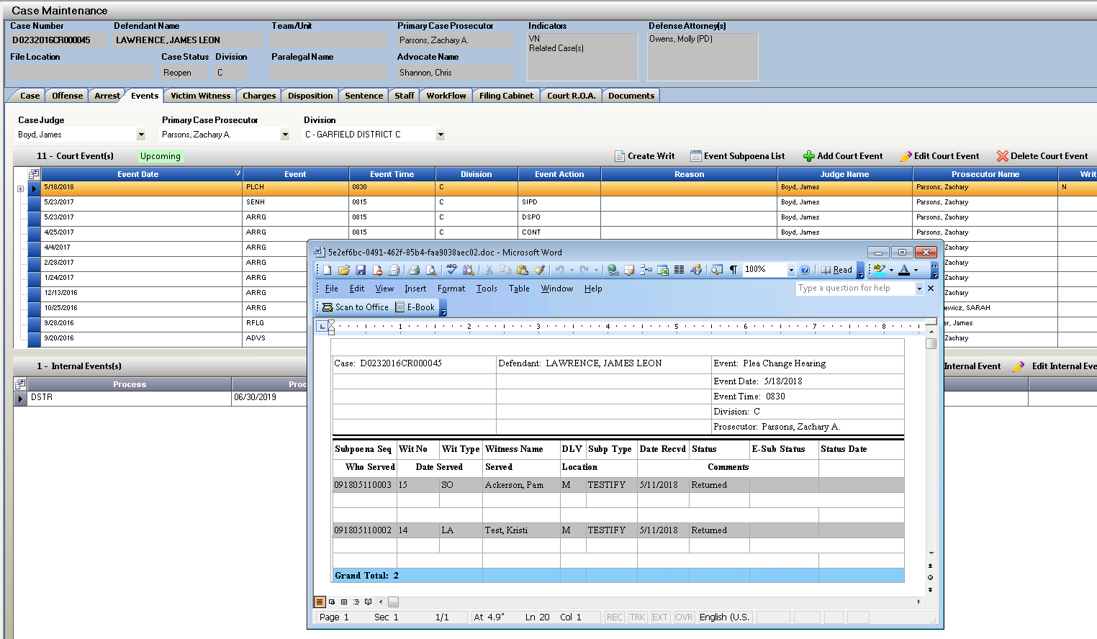

Event Tab:

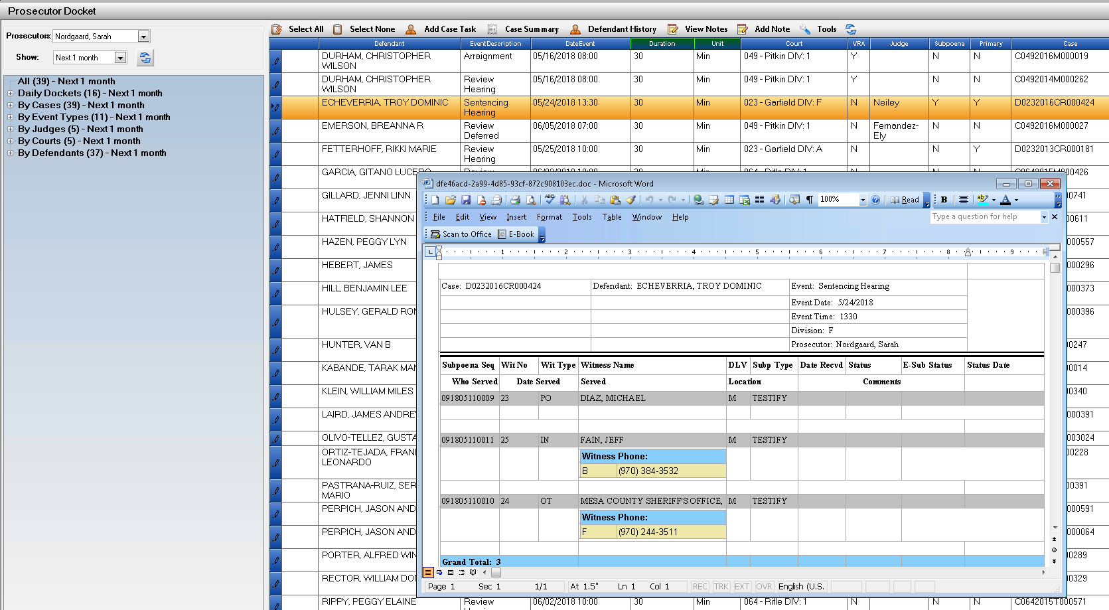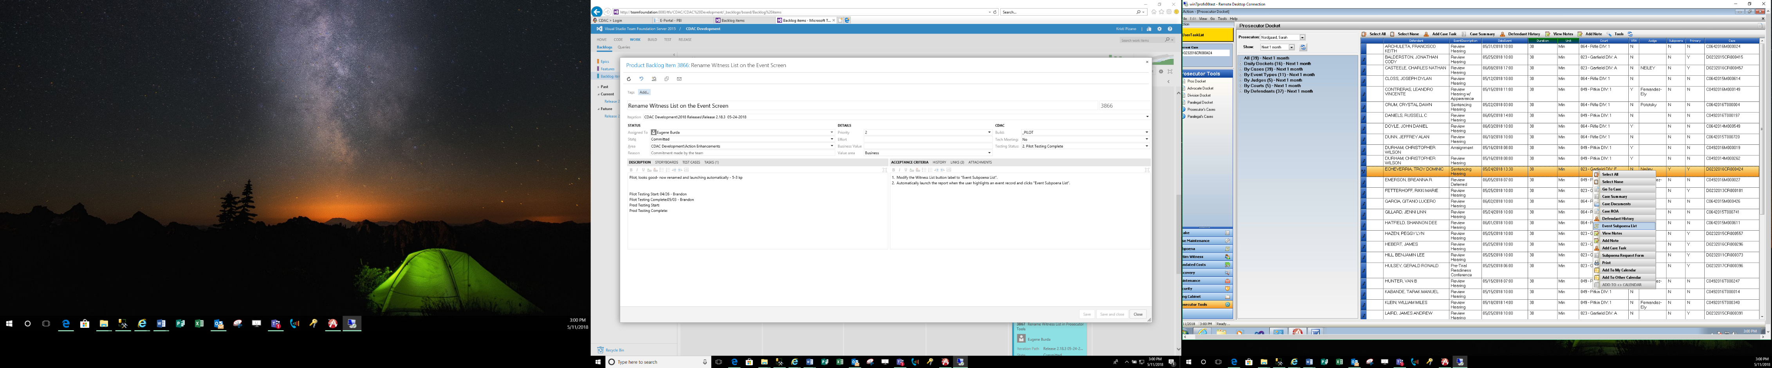Prosecutor Tools: Right Click Selection- when Subpoena Column = Y

Miscellaneous

1. Workflow Status of “Skipped” has been removed as a current selection status. This will not remove any of the previous tasks with this status. This will only remove option for new tasks created. This option was initially created for the Auto Tasking which would allow a user to “Skip” certain auto filled tasks if not suited for the case they were working. **Note Report on Action Viewer/ Work Flow Folder can be run to view all tasks with current status of Skipped if needed.
2. Clerk of the Court Entry- under Maintenance🡪 Person –> Court Clerk had a bug where the first entry was not editing correctly. This is now resolved.
3. Fix for a Hot Key on the VW tab within Action to keep as Alt + S for selecting Switch Case, it had been changed to bring up the Victim Service screen. Service Screen now coded for Alt +C as a hot key selection. **Hit Alt on your keyboard to view the underlined Hot Key’s on a page.
4. Bug Fix: If a New Court was added from Pros Dockets on a case, then you went into the Noting Control the New Event was not populating in without re-starting Action. This has been corrected so the new event added displays correctly in notes after it’s added by this method.
5. LEA Search Screen- Officer Notes- when LEA is submitting notes some of the tags would populate into the notes making them hard to read, these have been resolved so that they come through without. Making the note clear.

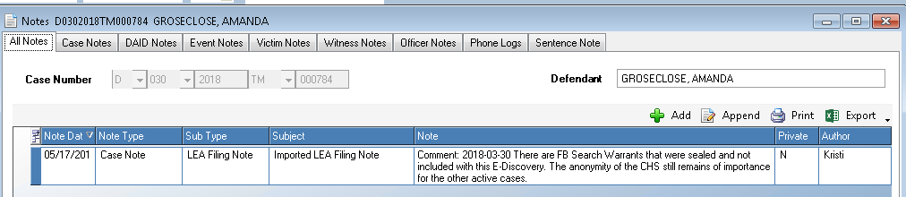

1. Bug Fix: Do not allow users to Delete Dispo Records if there is an attached Sentence Record for that Charge. SE would need to be deleted first. Message will display to user.