Action enhancement guide

October 2018 Training Guide



CDACweb.com



**Table of Contents**

1. Intake: Initiating Event Screen Enhancements …..……………………………………… 3-4
   1. Allow User to Remove Records
   2. Display Case Division
   3. Display Court Event and Date/Time
   4. Options to view only Judicial/CBI or Both Options
2. Intake: Intake Status Field …………………………………………………………………………… 5
   1. District Specific/Definable Status field – currently used on the Charging

Queue.

1. Intake: Charging Queue Enhancements ………………………………………………………. 6
   1. Screen will remember individual user selections as preference
2. Linking Cases: ……………………………………………………………………………………………… 7
   1. Link Co-Defendants in Action enhanced to preventing grouping
3. User Task List/ Workflow Enhancements ….……….……………………..………………….. 8-9
   1. Creating and editing tasks can now stay open or can be minimized to allow

continued work in Action.

* 1. Larger work description field view.

1. Subpoena Status Screen: …………………………………………………………………………….. 10-11
   1. Display new column for E-Sub status
   2. Display Subpoena delivery method on main screen
   3. Fix to On Call screen- Show only produced subpoena
2. Doc Gen: New Data Variables ………………………………………………………………........ 12
   1. User Selected Offense/Summons if multiple of a case
   2. Case Indicators
   3. School List
3. Miscellaneous Bug Corrections ………………………………………………………………………. 13

Intake: Initiating Event Screens

Case Entry- Initiating Event Screen

1. Remove button- allow users to remove records sent by Judicial or CBI, to make this a working list instead of display. Highlight record and click on Remove. If a record is removed in error, contact CDAC to have placed back on this screen.
2. New Columns Added: Division, Event Translation, Date Event, and Event Time
3. Create Agency Options: Default- Judicial Records, but Users can select CBI or All option to view all records sent to us.
4. Judicial Cases that already exist within Action will not be displayed on this listing.

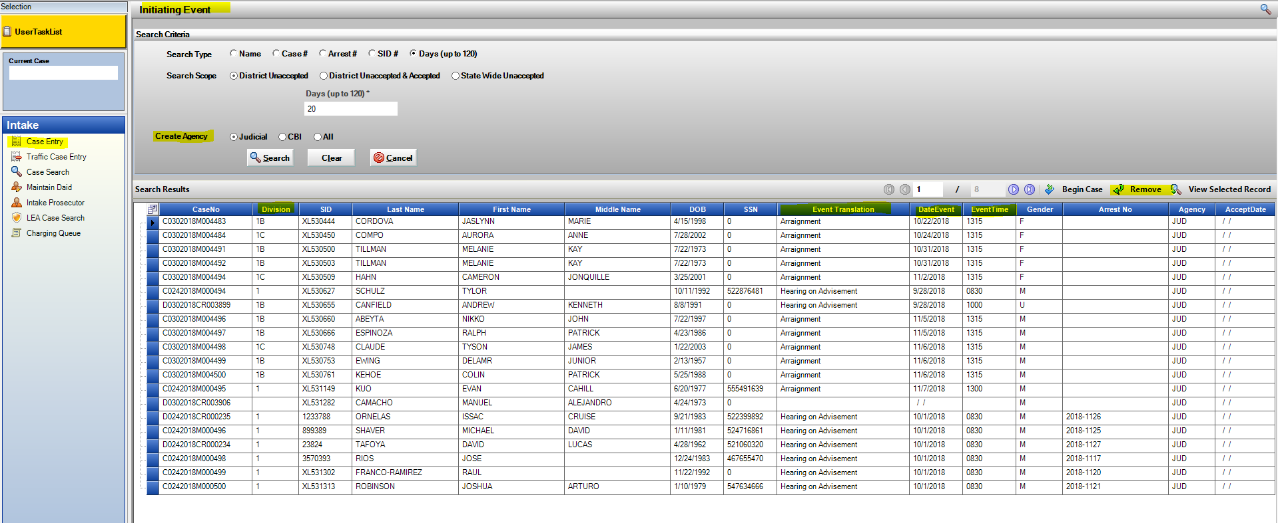

Traffic Entry- Initiating Event Screen

1. Remove button- allow users to remove records sent by Judicial or CBI, to make this a working list instead of display. Highlight record and click on Remove. If a record is removed in error, contact CDAC to have placed back on this screen.
2. New Columns Added: Event Translation, Date Event and Event Time.
3. Judicial Cases that already exist within Action will not be displayed on this listing.

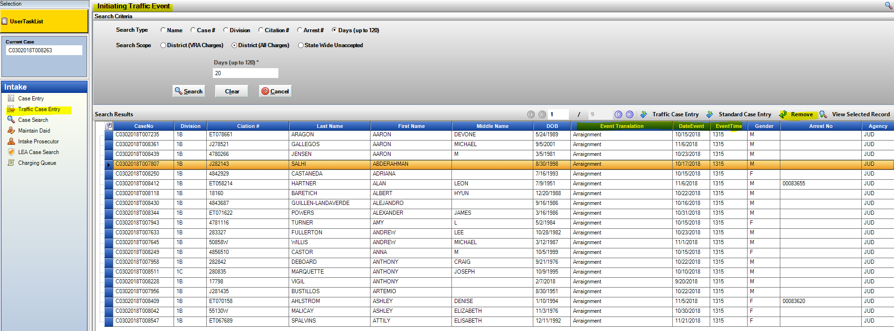

Intake: Intake Status Field

Intake Status has been added to the header on all Intake cases. This will allow for quick updating of the current status. This is the same status already appearing on the Charging Queue, but accessible from the case directly. These Intake Status are district specific, for status to be added, contact CDAC.

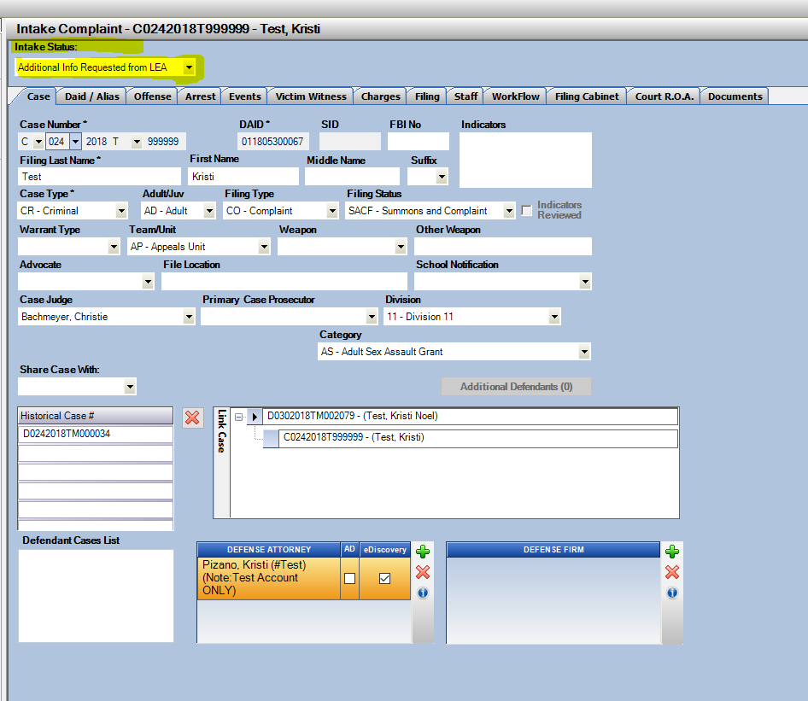

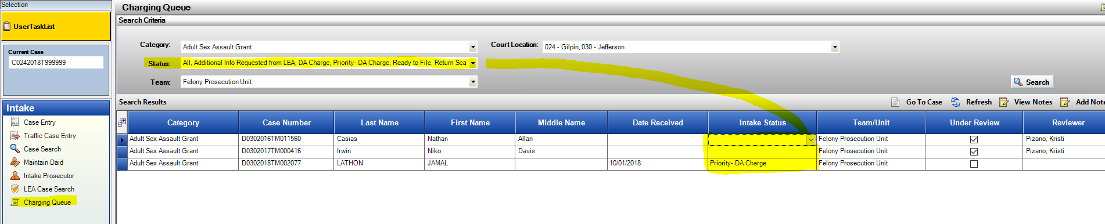

Intake: Charging Queue

Charging Queue will now remember the user’s selection of the Category, Status, Team, Court Location. This will help the users find their interested case sub-sets more quickly. They can change variable selections at any time.

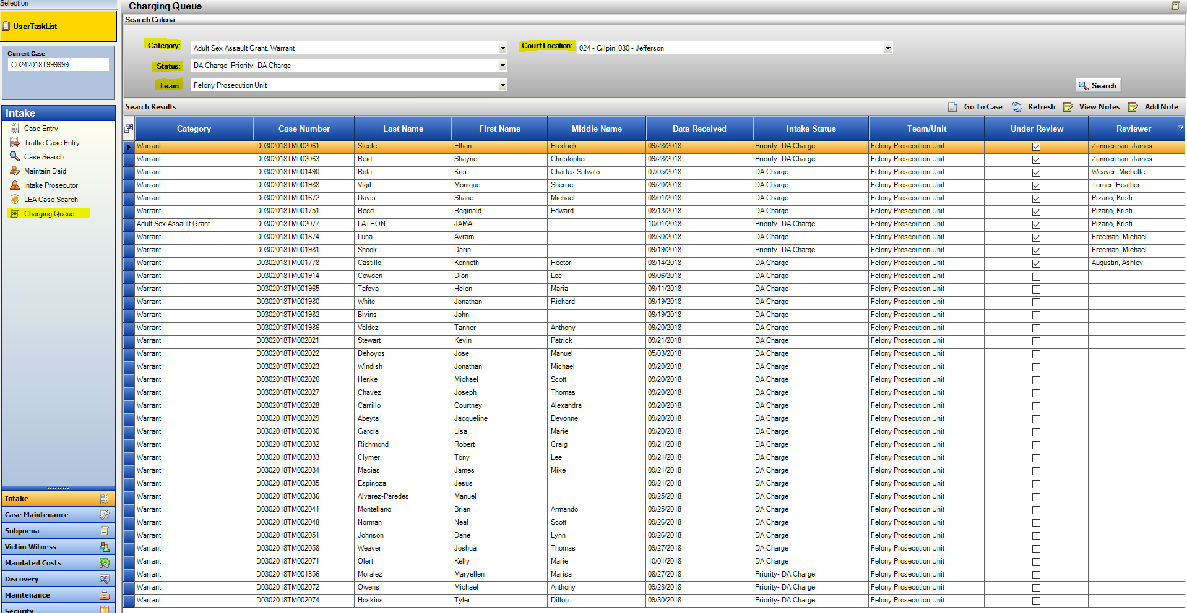Intake Status will update if updated on the case directly or from the Charging Queue back to the case.

Co-Defendant Linking of Cases

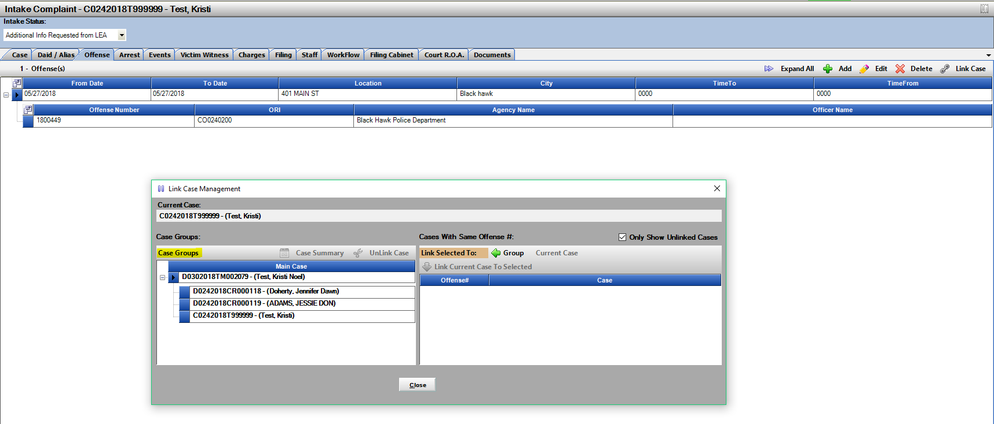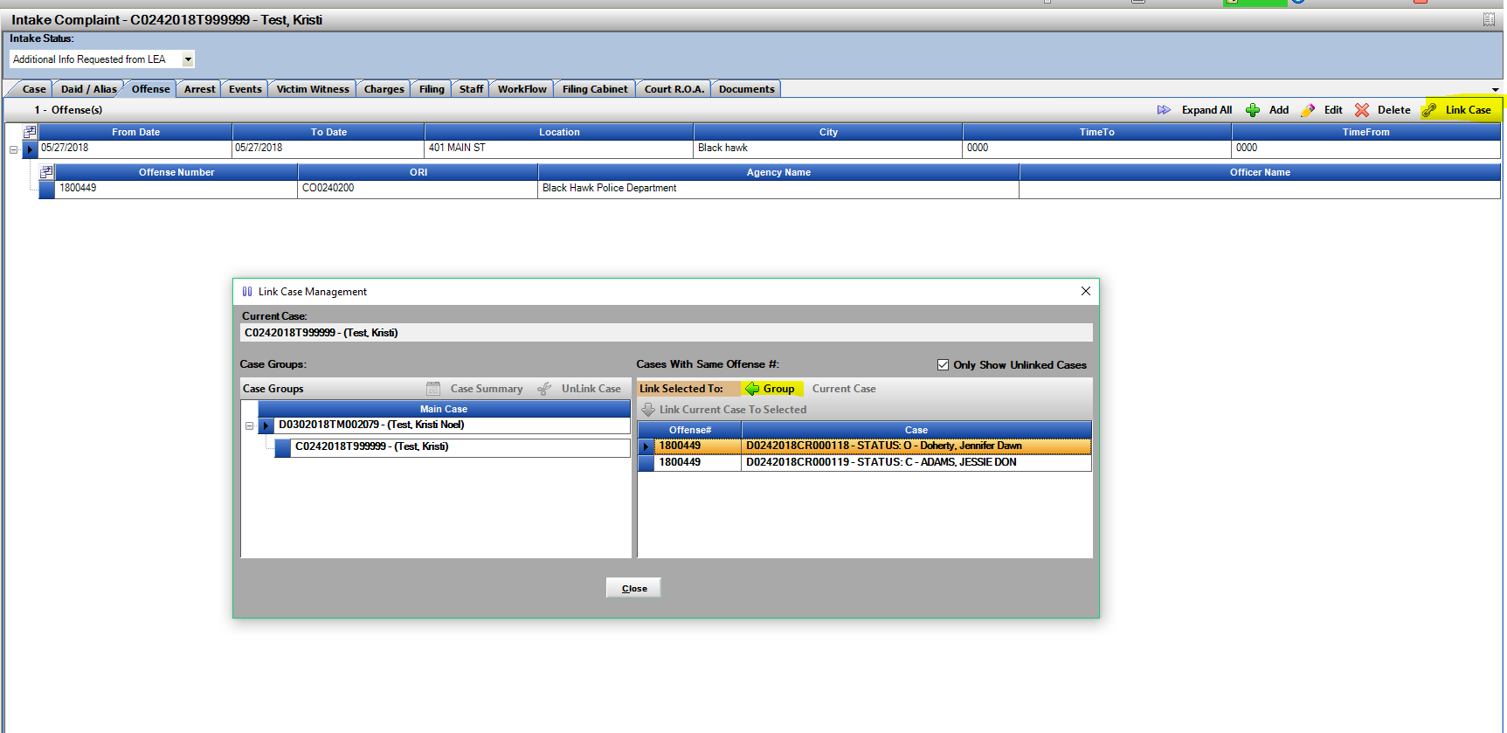Linking of Co-Defendant Cases has been modified to prevent multi-grouping of co-defendants. This is a step towards the linking of Co-Def’s for the File Cabinet. After linking the first 2 defendants together, the Group button will only be enabled. This builds one flat list of all linked cases.

Possible matches are based on matching ORI of filing agency and their Offense Number.

User Task List/ Work-Flow Enhancements

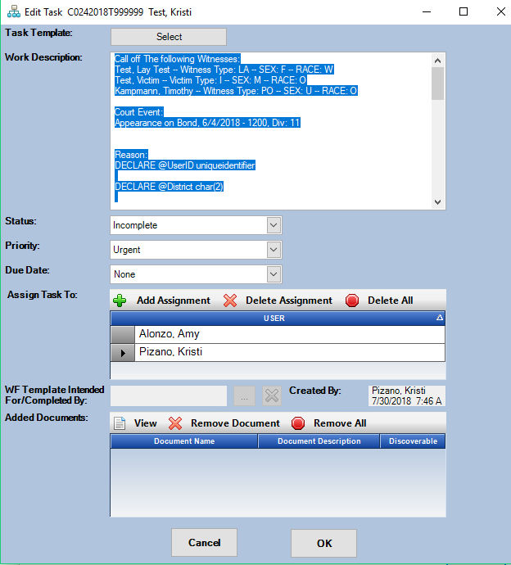

**Add/Edit Task** for Work Flow

Tasks now appear with a larger work description field for the user to see more of the task at once.

Ability to keep the task open at this detail level as you work within Action. The tasks can be minimized, or viewed on another screen as you complete the task.

Exception:

Creating a new task with documents from the file cabinet or from the User Task List with Route File option will not minimize. You will need to first create and save the task, then from the User Task List or from the WF Tab you can Edit the task and then be able to minimize or have open as you work within Action.

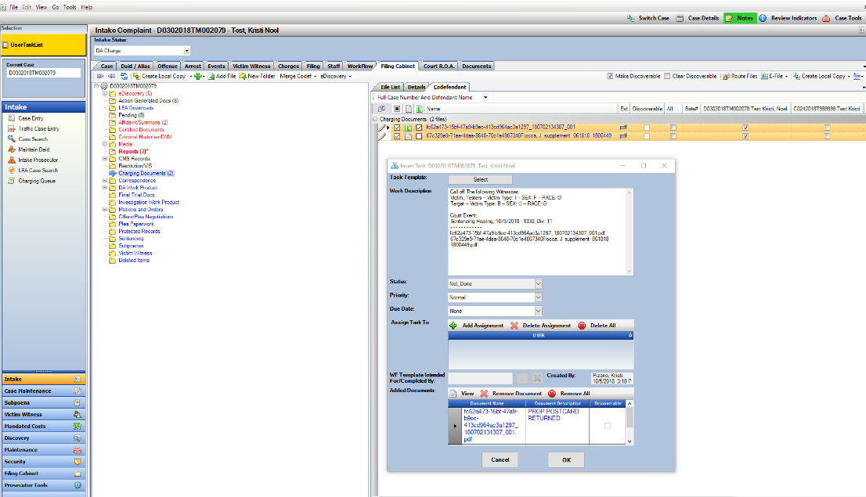

When workflow tasks are minimized, the windows will stack in the Action Icon Tray and can be re-called from there until Saved. If you attempt to close Action when you have pending unsaved notes, it will give you a message reminding you to save.

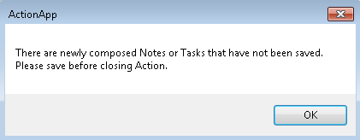

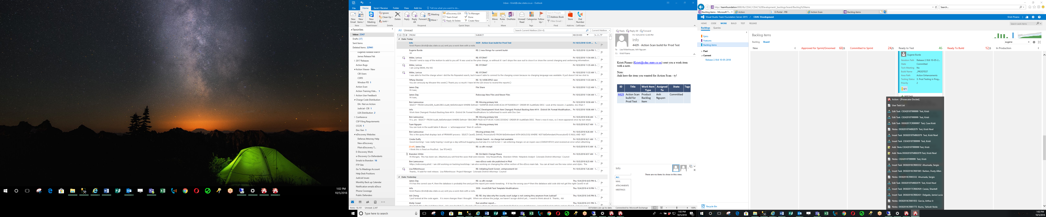

Subpoena Status Screen

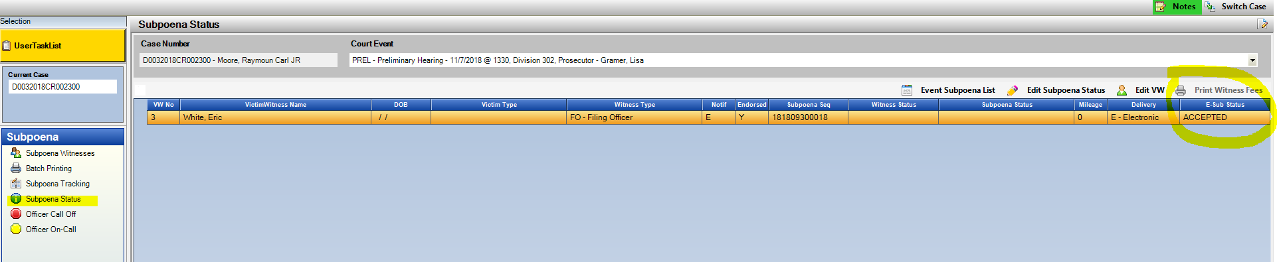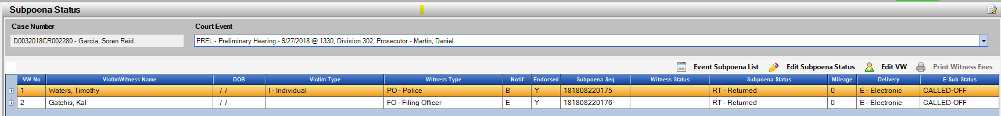Electronic Subpoena Status has been added to the Subpoena Status Screen. This is a read only display field. It will display the various electronic status including: Emailed, Viewed, Accepted, Conflict-Pending, Conflict, Call-Off, On-Call. These same statuses already display on the Event Subpoena List report- but now appear on this Subpoena Status screen for quick user reference. These statuses display the most up to date information based on the officer’s interaction with the e-Sub website or from the Action user using On Call- or Call Off functions.

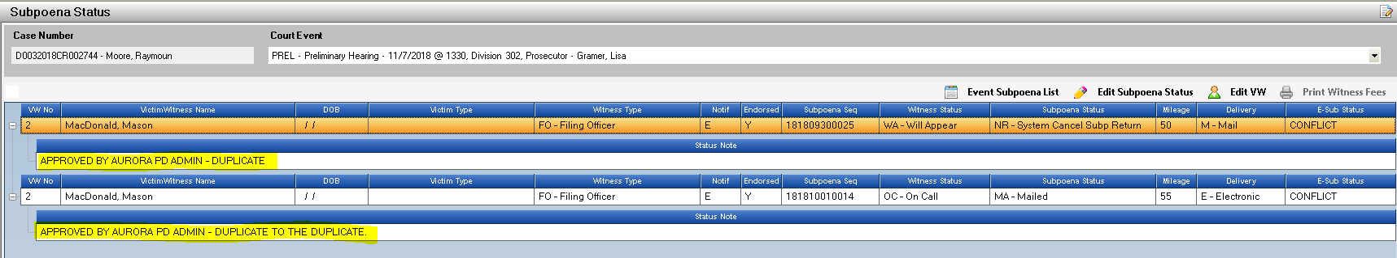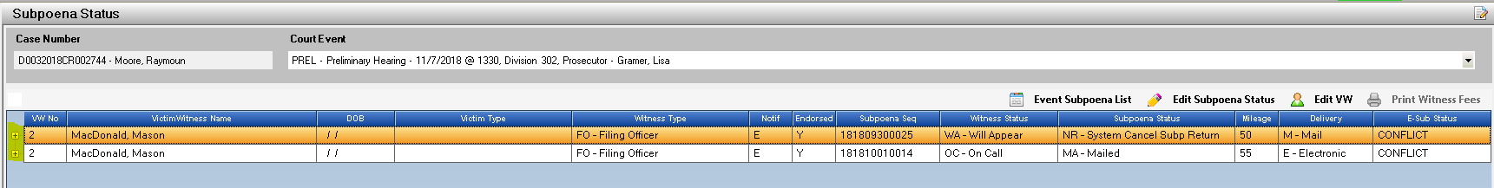If there is a note attached to the electronic subpoena, usually regarding conflicts, you will see a + button next to the row which can be expanded to see the notes.

Delivery Method of the Subpoenas produced is now also displayed on the main grid.

Electronic

Mailed

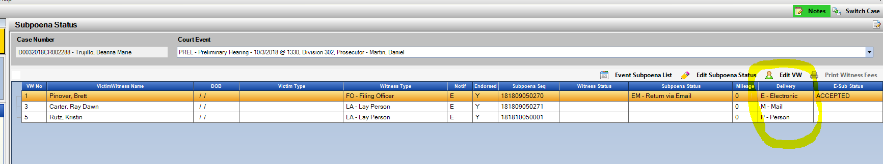Personal Service

Doc. Gen- New Data Variables

For districts currently utilizing Doc. Gen. there are several new Data Variables for this build. *Contact Kristi for questions on Doc. Gen. Trainings.

They include the following:

Case Indicators – All List (located on Case Tab)

Case Indicators- User Selected (located on Case Tab)

Multiple Offense Numbers on a case- User Select (located on Offense/Summons Tab)

Multiple Summons Numbers on a case- User Select (located on Offense/Summons Tab)

Defendant Name – Split to allow specific selection of First, Middle, Last and Suffix. (located on Defendant Tab)

Defendant School- (located on the Defendant Tab)

General School Object (located on the School Tab)

Miscellaneous

1. Bug Fix: Officer On Call corrected to only display Produced Electronic Subpoenas.