Action Enhancement Guide

August 2019 Training Guide



<http://www.CDACweb.com>



**Table of Contents**

1. Prosecutor Tools: ……………………………………………………………………………………………………………… 4
   1. New Case List: Team/Unit Cases
   2. Case Tasking: Add same task to multiple cases at once.
   3. New column selections from field chooser: Team/Unit & Defense Attorney
   4. Docket sorting fix- Sort by Date Event- if same event date/time also group by defendant name.
2. Indicators: …………………………………………………………………………………………………………………………. 7
   1. Display VRA in red.
3. Previous Case List: ……………………………………………………………………………………………………………….. 8
   1. Defendant name added to case number display.
4. Intake: …………………………………………………………………………………………………………………………………. 9
   1. Import VW Officer data from LEA. * District Setting
   2. District Setting: Optional import of VW data from LEA based on ORI.
   3. Co-Def pop-up message on case tab if imported ORI and offense # match existing entry in Action.
   4. Category field moved next to Intake Status under case header.
   5. No-File selection added to Case Type with letter selection.
   6. Update defendant name option on charges if defendant name on case changes.
5. DAID: …………………………………………………………………………………………………………………………………… 15
   1. Power Users – Merge all DAIDs
   2. Create New DAID on case.
   3. Change DAID on case.
   4. Historical tracking of Driver’s License entries.
   5. FBI numbers- allow users to edit records on Case and in DAID Maintenance.
6. Sealing Case: ……………………………………………………………………………………………………………….…….. 23
   1. District Setting: Include “Sealed” in-front of file cabinet folders when case is sealed.
7. Primary Prosecutor: ………………………………………………………………………………………………………..…… 25
   1. Updating Primary Pros will also now update future events if no event action.
8. Noting: …………………………………………………………………………………………………………………………………. 26
   1. Create Work Flow Task from a note. Highlight Note and click on Add Case Task.
   2. Added Column to field selector, Note Reference. This will display victim name for example when a VW letter is generated and auto noting is turned on.
   3. Note Created for Emailing VW letter option. This is generated based on district setting for notes when letters are printed, emailed or batch produced.
   4. Note with a Sub-note type = Sentence will display a warning in Red to users that it can appear on a VW letter. This Sub-note type reserved for additional SE information.
9. Victim Witness: ………………………………………………………………………………………………………………… 30
   1. VW entries:Phone number status (A-Active, I – Inactive) added to expanded view of record.
   2. VW Notification Screen: Display column for email address of witnesses entered.
10. Charges: ……………………………………………………………………………………………………………………………. 31
    1. Charge Description and Charge Title added to all Charge Search display windows.
11. Sentence: …………………………………………………………………………………………………………………………… 32
    1. Option to Copy Existing Sentence to another charge on SE screen.
    2. Sentencing Note warning- now appearing in Red.
12. E-Filing: ………………………………………………………………………………………………………………………………. 34
    1. Default change: All parties in the “Send To” list are selected.
13. Filing Cabinet: …………………………………………………………………………………………………………………….. 35
    1. Copy File Function

Copy Files to other cases within Action.

* 1. Photo Pre-Viewer

View image files within the file cabinet.

1. D18 Metrics Screen: ……………………………………………………………………………………………………………. 42
   1. District created for tracking internal processes-currently only available for D18.

Includes: Supervision Status and Defense Attorney Withdrawals.

1. Doc Gen Variables: ……………………………………………………………………………………………………………….. 44
   1. VW Race and Sex Variables Added
   2. Co-Defendant Case Status Added
2. Miscellaneous …………………………………………………………………………………………………………………….. 45
   1. Bug Fixes

Prosecutor Tools

1. **Team/Unit Case Listing**

Prosecutor Tools now includes a case listing by Team/Unit. Any Teams/Units that your district is currently using as a variable to distinguish particular cases can now be view here. This displays Open, Re-Open and Pending cases on this list. *note Team/Unit docket will be coming out in our next release. The Teams/Units can be added to by the request of your district. This field is found on the Case Tab within your cases.

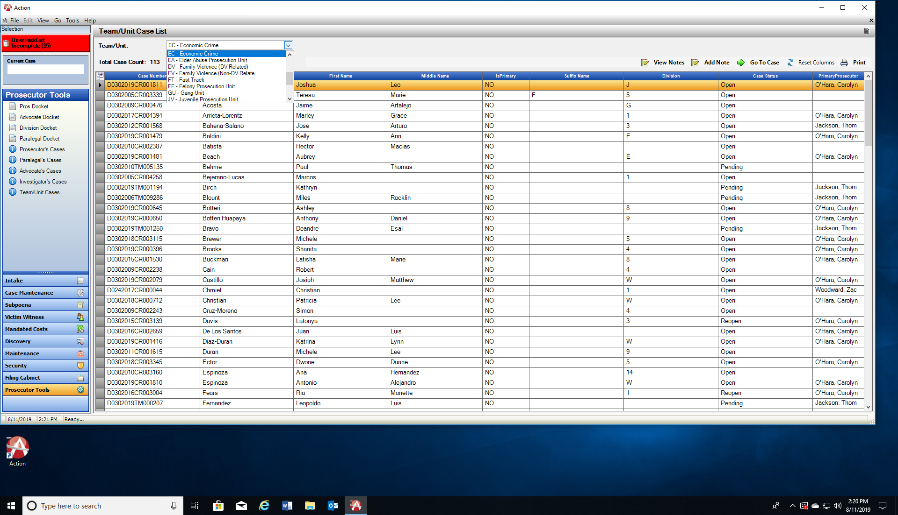

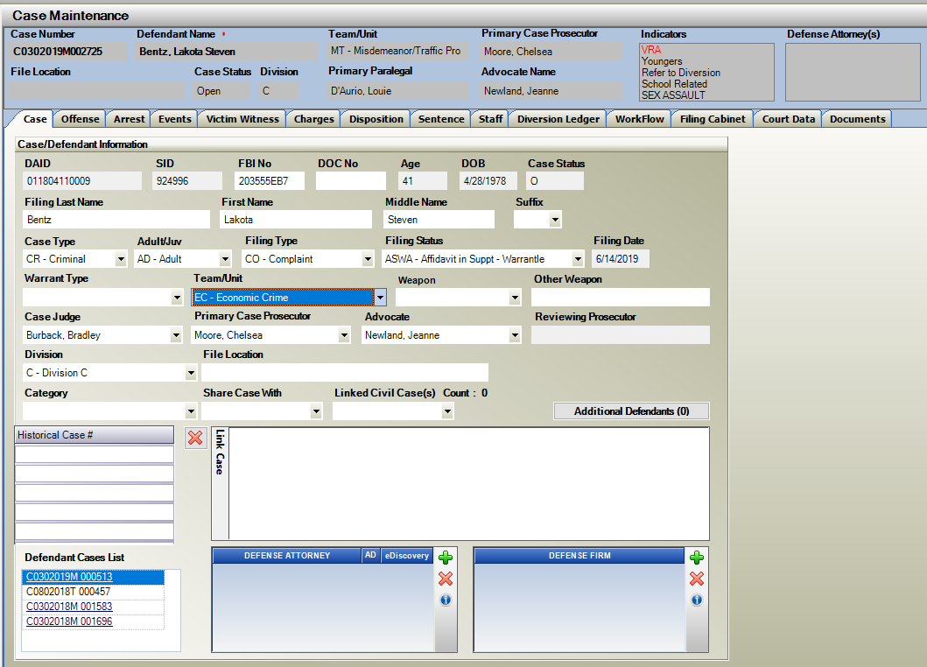

1. **Work Flow Tasking to Multiple Cases**

Case Tasking to Multiple Cases from Docket Views in Prosecutor Tool. Users can now multi-select (highlighting cases) that they wish to add the same Work Flow Task to.

After highlighting click on Add Task. The cases selected that appear on the form will each have the same work flow task added to it. This is same functionality that is currently available for “Add Notes”.

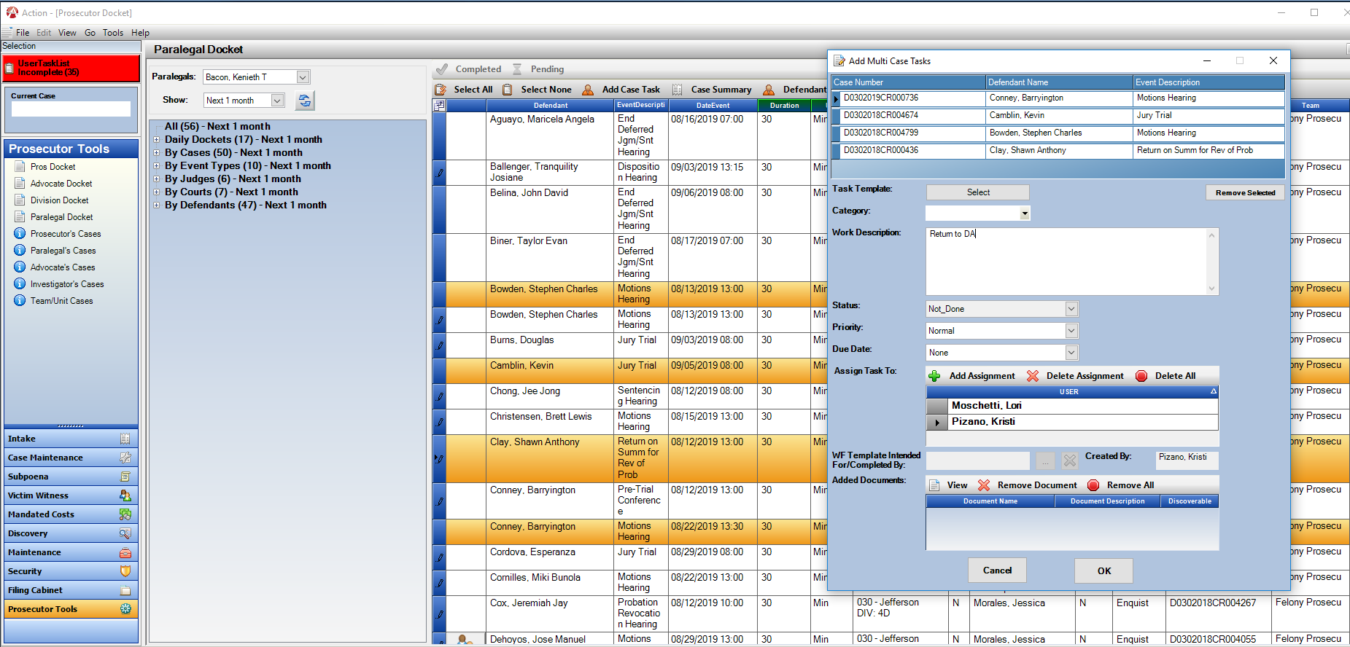

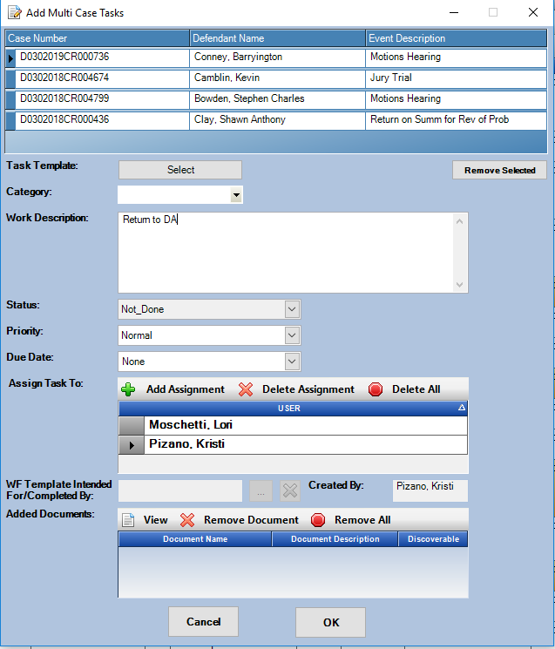

1. **Prosecutor Tools – Field Selectors**

New column added to field selector for Team/Unit. This can be added to any of the docket selections. Another new column added is for Defense Attorneys. This will display the defense attorney listed on the event of the case you are viewing on the dockets. For both options click on the field selector. These displayed columns are users specific and will retain until the Re-Set column button is selected or removed by the user.

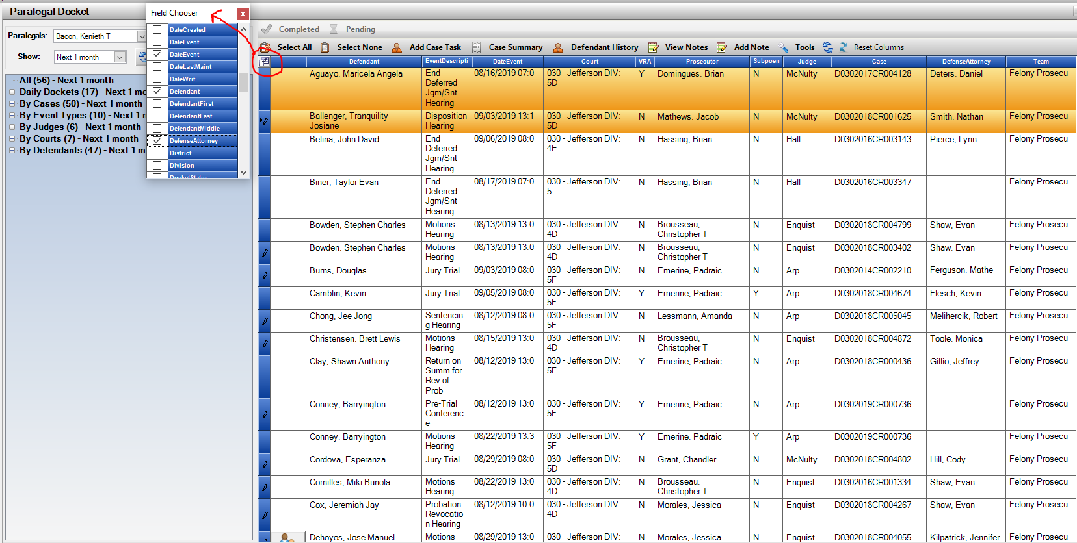

1. **Docket Sorting**

If sorting on the Date/Event column if the same date and event time it will now further sort alphabetically by Defendants last name.

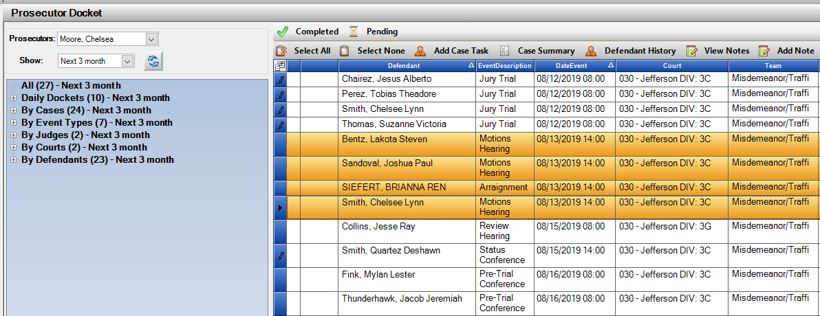

Case Indicator

* + - 1. **VRA Indicator display in RED**

Districts that have a case indicator of VRA will now appear in Red and will default to the top of your case indicator list for easy visual reference to users. Please contact CDAC to have VRA added for your district if you currently do not have this and would like this listed as a user option for your cases.

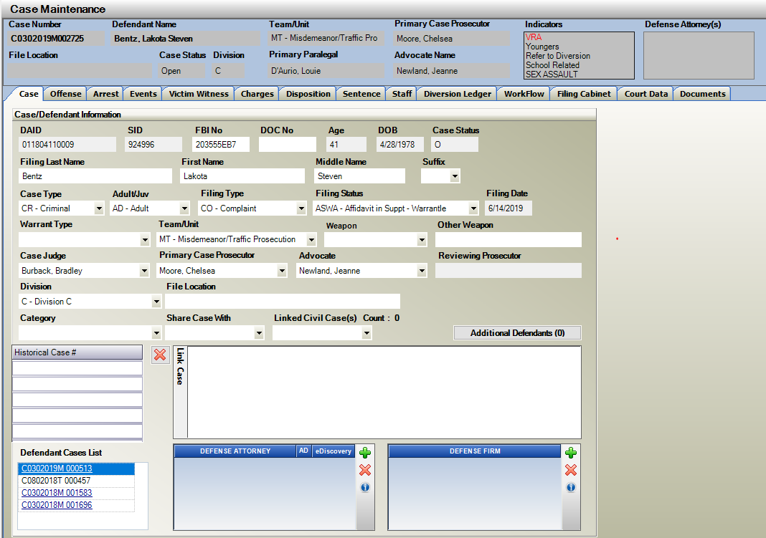

Previous Case List

1. **Previous Case List**

Previous Cases that you have just accessed in Action now also display the Defendant’s first and last name for easier identification.

Click on File and then on Prev Cases.

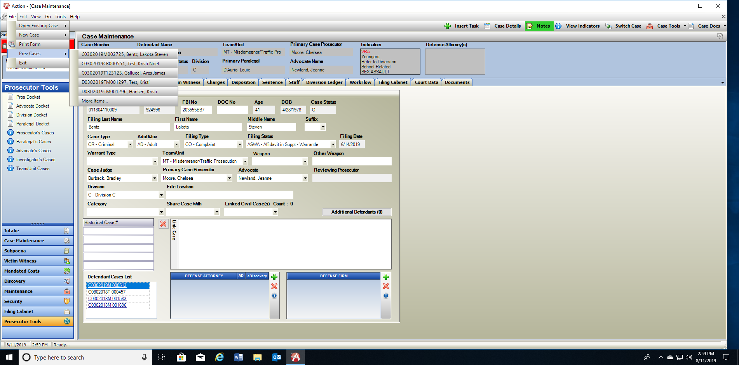Click on More Items to see longer display of cases. Click on that case to launch it from this view.

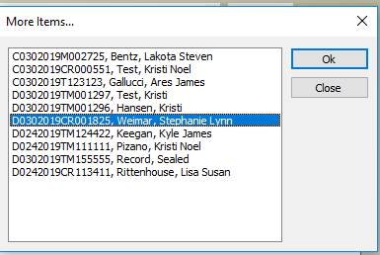

Intake

1. **Import LEA Officer Data**

LEA data now includes Officer entries for the VW Tab. If you district is importing LEA VW Data, this additional data will also come into your case when you use “Begin Case” from the LEA search screen. Different agencies will have different information sent based on their RMS entries. If they are entering Officers, this information will come through on your case VW tab. The officers will default to a witness type = PO; their agency ORI will also default and we attempt to match the officer name sent with an officer from your current officer table. If there is a match we will connect. This will then keep your officer entries updated correctly for eSubponea and officer tables with less user editing.

*Have users add this new column **“Officer Link”** to the **VW tab** on a case. This will show users quickly if we were able to match an officer record sent, or if they should edit the record, review and see if they can find a match in the officer table. Use the field selector to add this column on the VW tab.

1. **\*\*\*New District Setting – Please contact CDAC to have enabled for your District \*\*\***

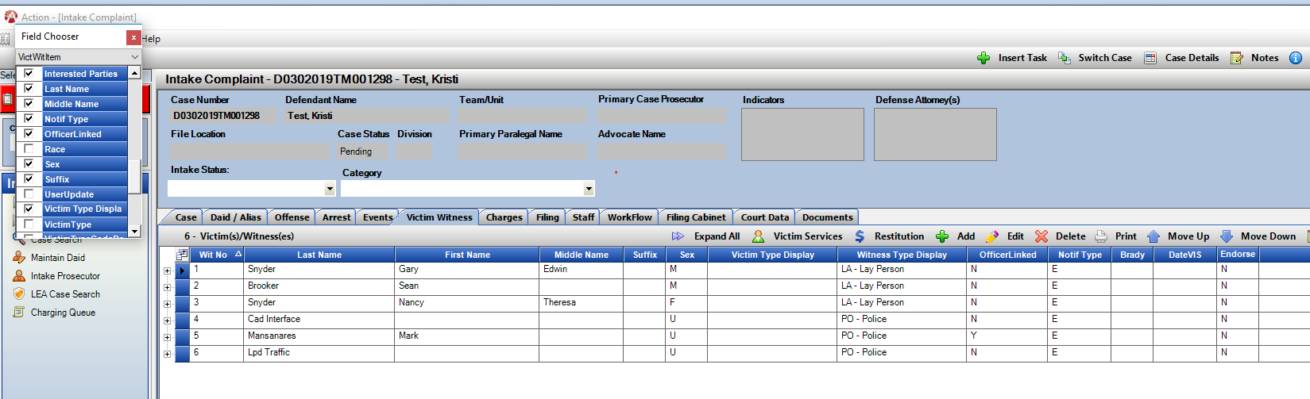New Setting created so that districts can bring in LEA VW data based on ORI’s. If your district has some agencies that have better VW data and others that are not, we can customize a list to only bring in VW data from the ORI’s that you indicate. Contact CDAC to have this set-up.

Click and Edit any unlinked officer records. Search for the officer in the officer drop down connected to that ORI. Any bad records imported can also be deleted out.

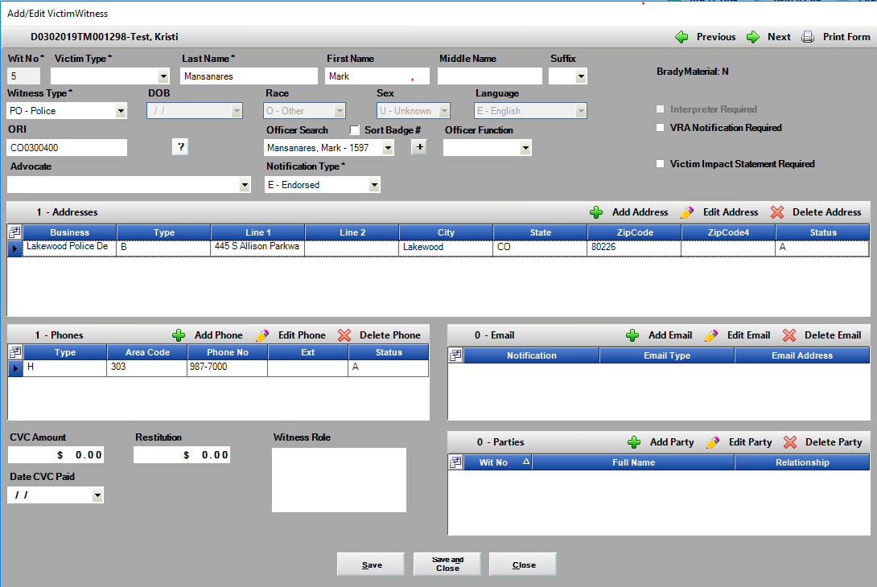Linked Officer Record

Unlinked Officer Record

This is an example of bad data sent through, this record can be deleted out.

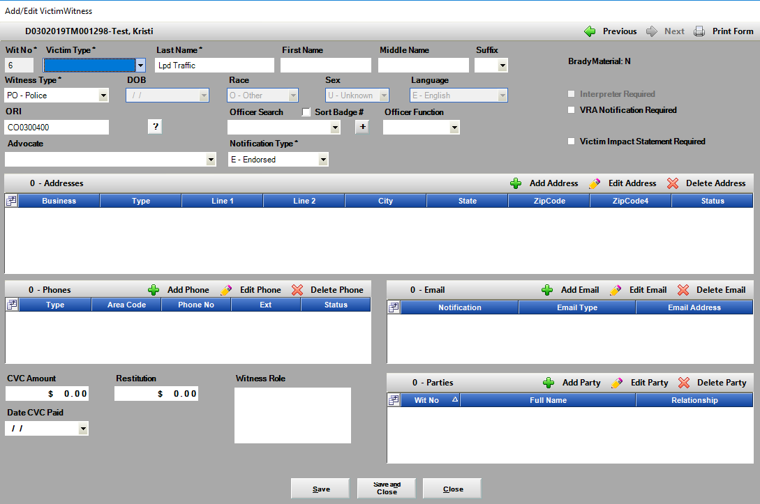

1. **Co-Defendant Pop-Up Notification**

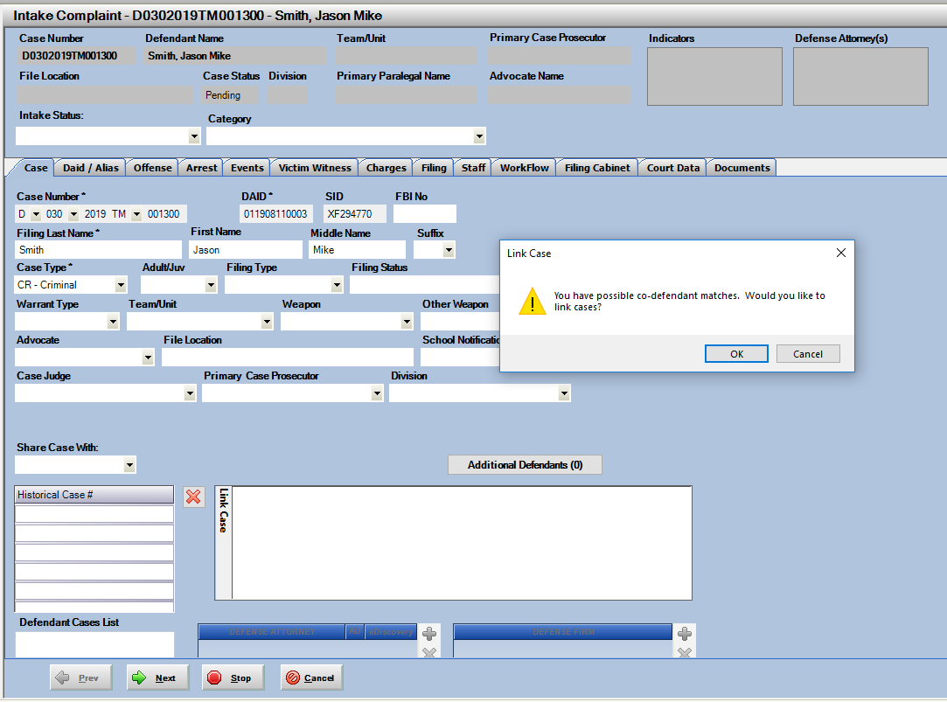On new cases started from LEA where offense data is populating in with the case, there is now a pop-up that will appear for users as they are starting an Action case. This is to help identify co-def’s based on the Agency Offense Number and Agency ORI. If there is a match within Action a pop-up notifying the user will appear on the Case Tab as they begin the secondary case after entering case number and defendant name. Linking can still be handled on the offense screen- but this provides an immediate notification to users.

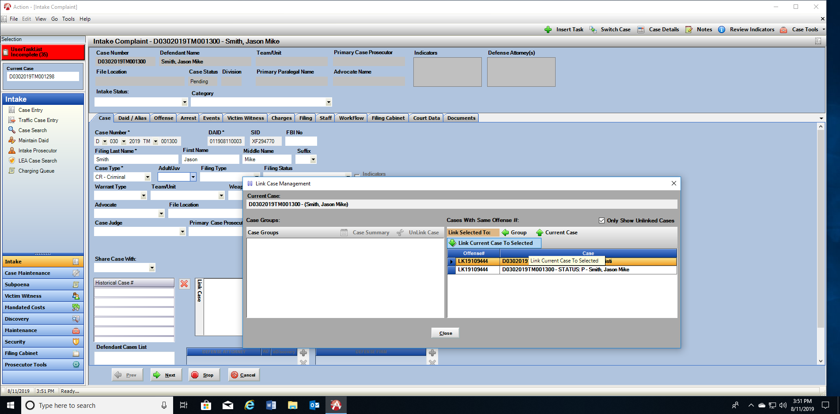

1. **DA defined Category for LEA cases**

Moved position on the Case Tab for easier user reference. This is now moved next to the DA Intake Status Column.

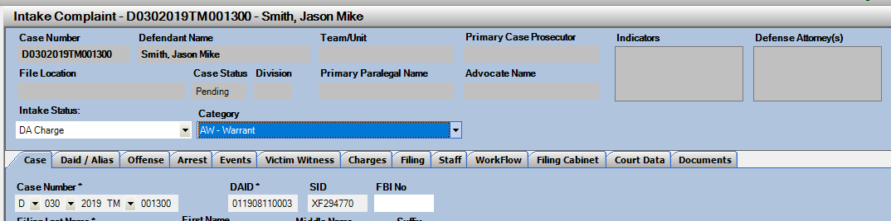

1. **No-File w/Letter Selection**

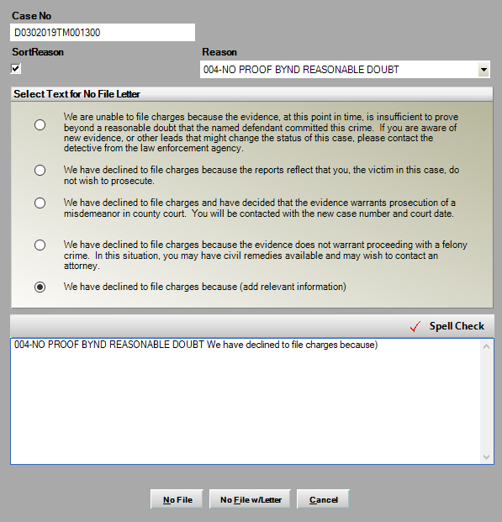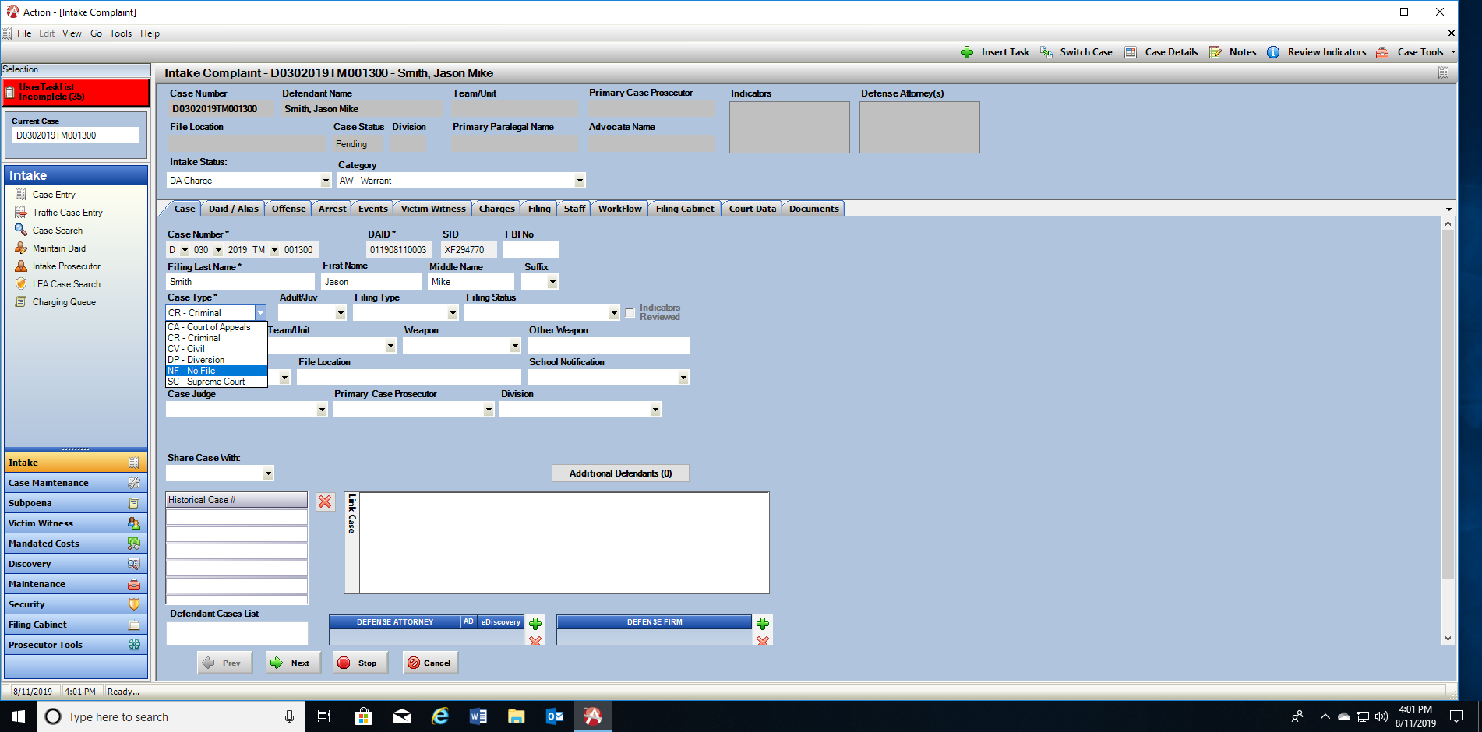No-Filing a case while in Intake has been expanded for user so that they can simply change the Case Status on the Case Tab to No-File. When selected this will act like No-File Selection under Case Tools, with option to no file with letter and will correctly update the case status to No-File.

1. **Option to update defendant name on existing charges if it changes on case.**

In Intake if the case was set-up and charged, and then the defendant name changes on the Case Tab users will have an option to Update the name within the charges to the name that was changed.

Users enter a new name or edit in the Last Name, First Name or Middle Name field when they tab from any of these fields- it is detected that it’s a change from how the name appears within the charges. User will see a pop-up asking if they want to update the name. Click on Save after each name field if the entire name is changing. Example – change last name, tab out and a pop-up will appear asking user as seen below. * Note this is just on cases with a Pending status in Intake.

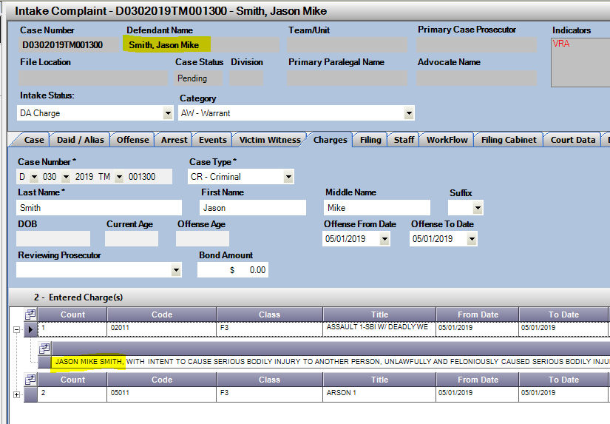

Example:

Charged as Jason Mike Smith

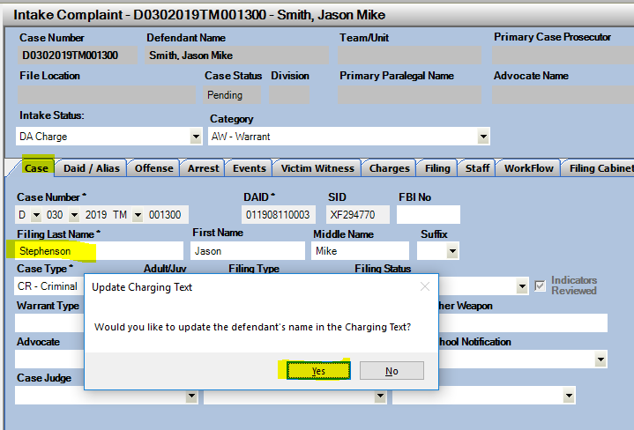Name changes on Case Tab. Click on Yes after tabbing from the field. Each name field will prompt the user if changed.

View charges on Charges Tab to see updated Defendants name.

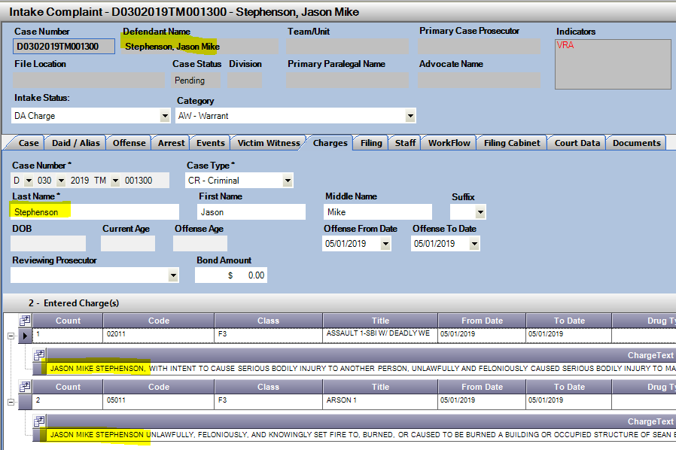

DAID: Merging

1. **Power Users Merge DAIDs across state access**

Merging DAIDs across the state can now be done by Power Users. The restriction to only merge within a district has been removed for users set up as a power user function. CDAC will re-direct users with Merge DAID requests back to their power users for updating.

When multiple DAIDs reported:

1. Click on Maintain DAID option and then on Merge DAIDs.
2. Enter the first DAID and click on Load to see details.
3. Enter the second DAID and click on Load to see it’s details.
4. Use the Select button next to either DAID to keep as the assigned DAID, the unslected DAID is deleted. The cases associated to the DAID being removed are added the one selected.
5. Users can highlight fields on either DAID and Right Click – option to “Use” is displayed. Click on Use to have this field information kept in the DAID that was selected.
6. Base keeping a DAID on the one with a valid SID number. These will always begin with a number instead of a letter. If no valid SID is attached, then user can decide which DAID to preserve.

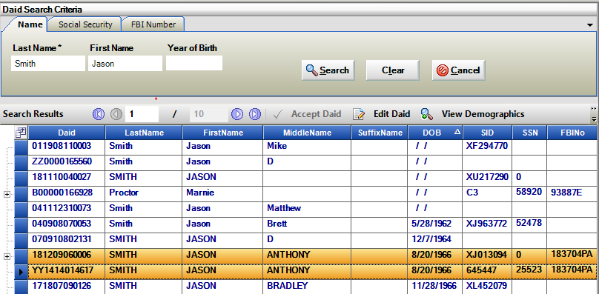Identified multiple DAIDs for same Defendant

DAID Maintenance/ Merge DAID selection

Enter DAID 1- Load

Enter DAID 2- Load

Select DAID to keep, this appears below in Merged DAID. Update information from both DAIDs if desired through right click selection- click on “Use”.

Click on Save.

The Unselected DAID is deleted and all cases under that DAID are moved to the selected one. This will update the Defendant Case List in all cases this ties these cases to that view on the Case Tab.

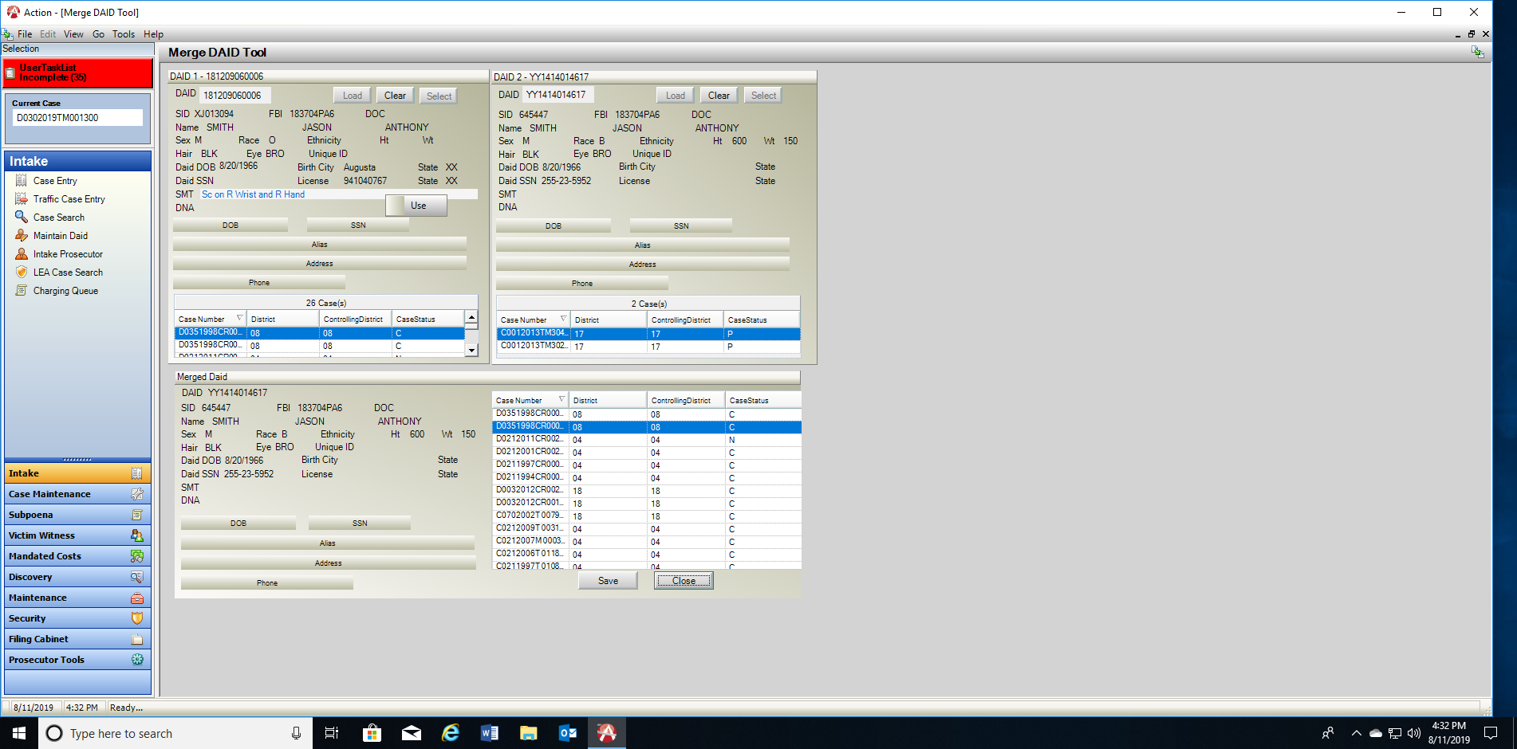

DAID: Changing or Creating New

**Change or Create New DAID for an existing case in Action.**

If a user has started a case within Action then realizes that the DAID they had attached to is not correct, they can now have the system either Change the DAID to an existing correct DAID or have the system create a new DAID for this case.

*Note – whether changing or creating a new DAID users will need to access the DAID that was originally attached to their case to clean up the DATA. When a DAID is first attached the new name, dob and other demographic information updates. If you had selected an incorrect DAID this information typed in by the user is now incorrect to the original DAID and needs to be removed/cleaned up. Please note or reference the original connected DAID so it can be re-accessed and updated.

1. **Changing a DAID to another existing DAID**

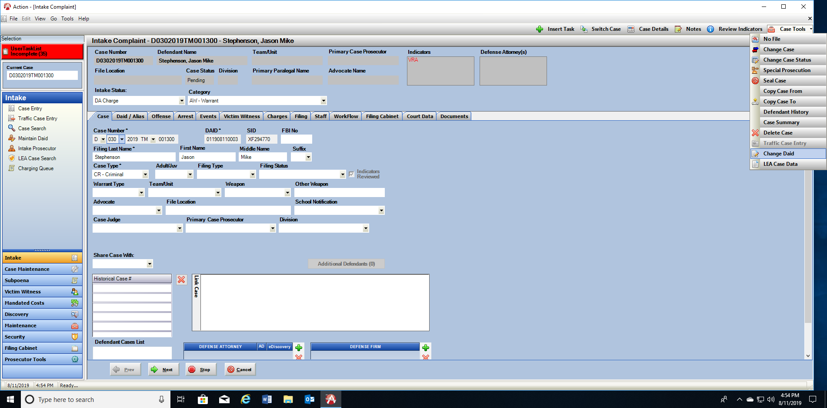From your Action Case, click on the Case Tools drop down menu. Select “Change DAID”

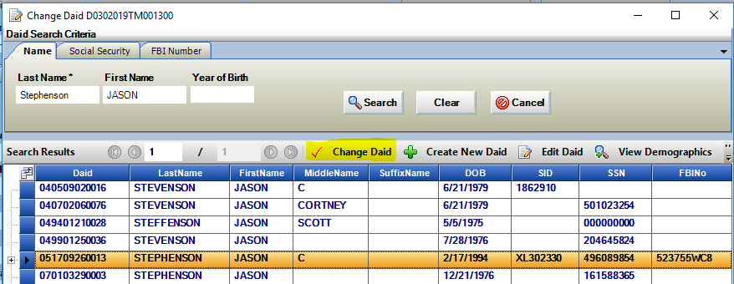DAID Search window appears, conduct new search to see if there is a valid existing DAID for the defendant. If users find a match, highlight the correct DAID on screen and click on “Change DAID” button.

Pop-up confirming change 🡪 Select Yes.

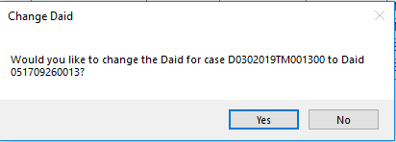Case DAID will then be changed, the DAID name is also updated becoming the default Case Defendant Name on the Case Tab.

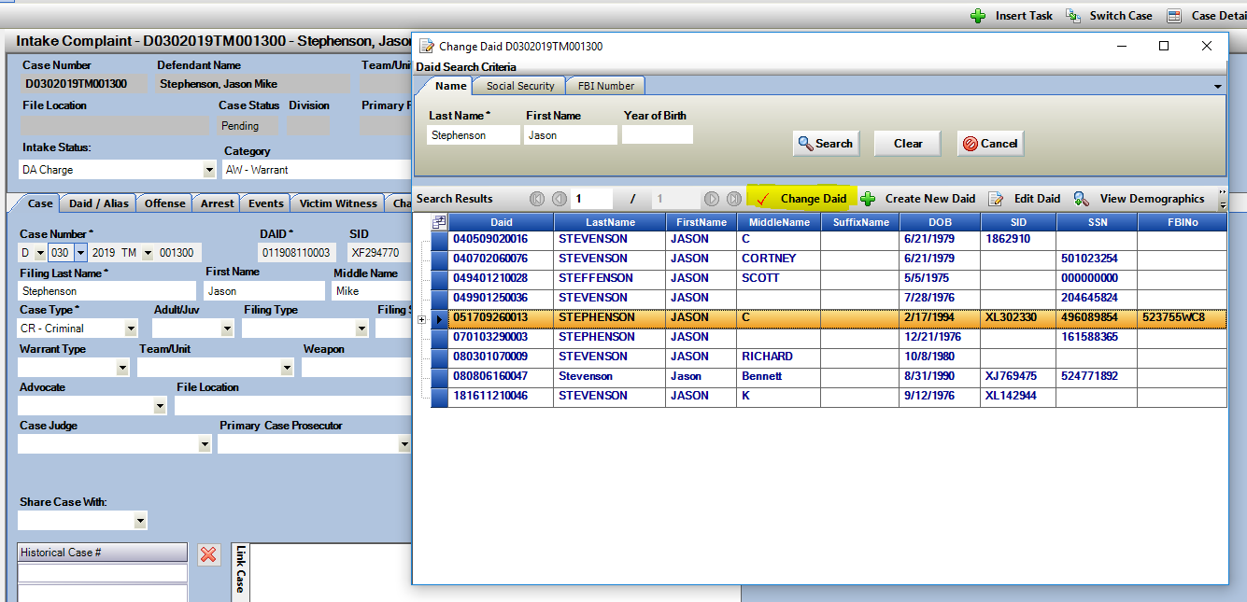

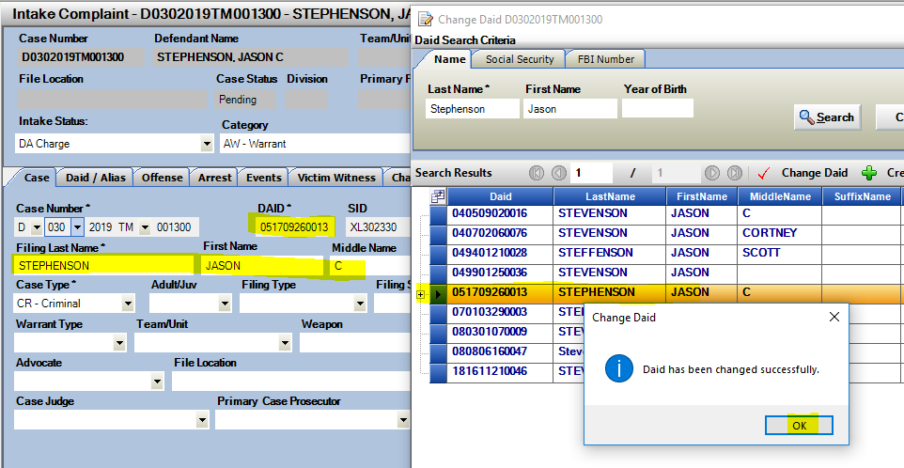Selected DAID and Name then update on case.

1. **Creating a New DAID**

If a user has started a case within Action then realizes that the DAID they had attached to is not correct, they can now have the system either Change the DAID to an existing correct DAID or have the system create a new DAID for this case.

*Note – whether changing or creating a new DAID users will need to access the DAID that was originally attached to their case to clean up the DATA. When a DAID is first attached the new name, dob and other demographic information updates. If you had selected an incorrect DAID this information typed in by the user is now incorrect to the original DAID and needs to be removed/cleaned up. Please note or reference the original connected DAID so it can be re-accessed and updated.

**Click on Change DAID**

From your Action Case, click on the Case Tools drop down menu. Select “Change DAID”

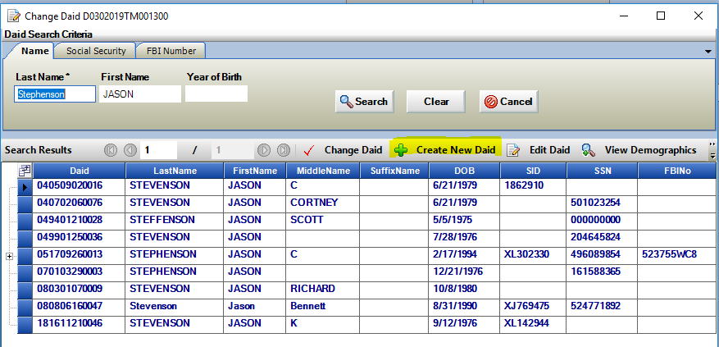DAID Search window appears, conduct new search to see if there is a valid existing DAID for the defendant. If there is no current match to the defendant you are looking for, then click on “Create New DAID” button. Note this only appears after a name search has been run. A new system generated DAID is then applied to the case. User must type in Defendant Name on the Case Tab of the case for this new record.

New DAID is generated, and Filing Names and demographics need to be entered by the user. The cursor will default back to the Filing Last Name* field for entry.

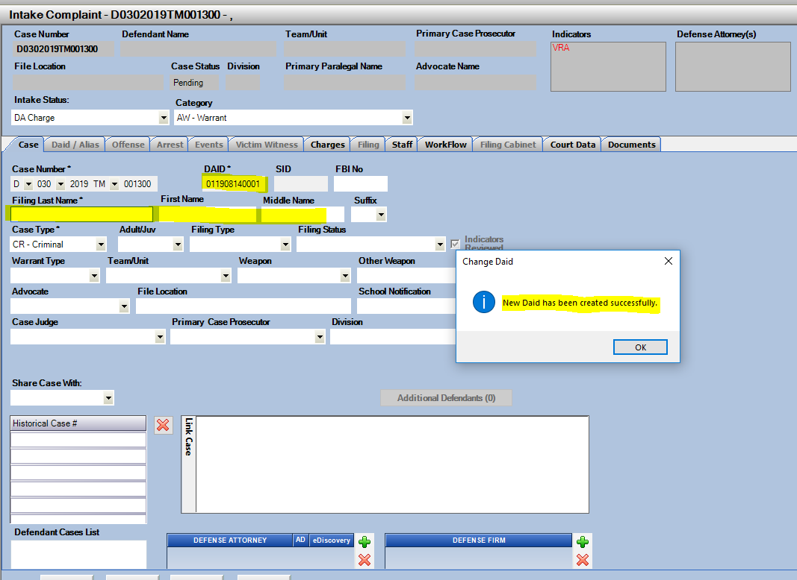

DAID: Driver’s License Tracking

1. Entering a new DL number on the DAID/Alias tab of a case while in Intake will add the DL to the defendant’s DAID record for historical tracking purposes. Additional DL numbers can be added directly to the DAID as well by going to Maintain DAID and to the DL tab. Click on Add to add new records, select and click Promote to make an entered record the main one for the defendant.

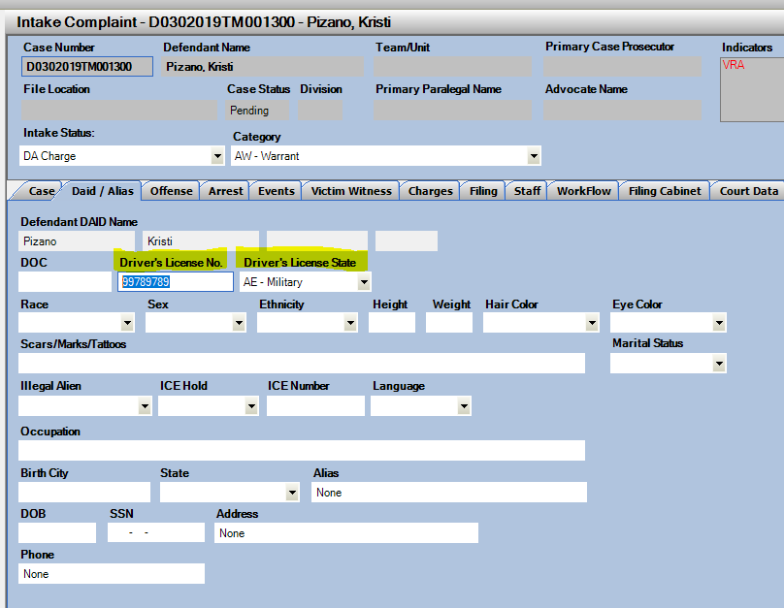

Maintain DAID

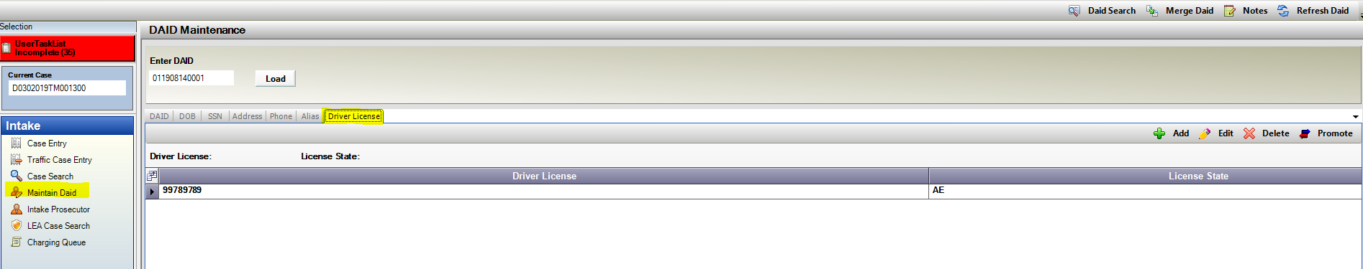

DAID: FBI Number

1. 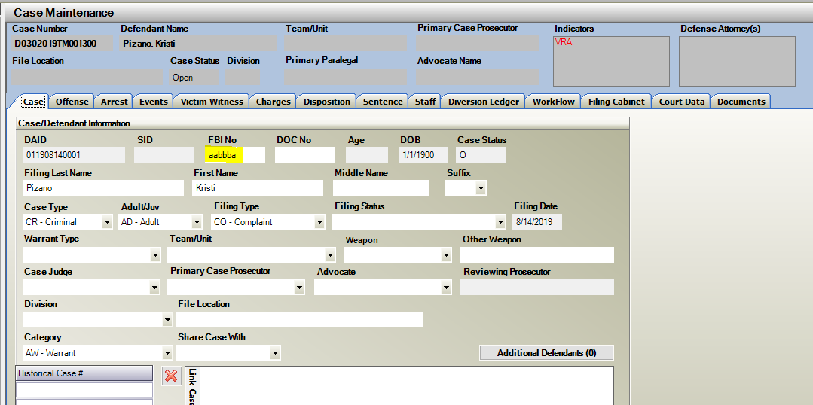FBI number connected to a DAID record can now be entered and edited on cases. This can be updated directly on the case on the Case Tab FBI No field. This can also be updated through DAID Maintenance. FBI Numbers can be confirmed through CCIC/NCIC or through the courts entries.

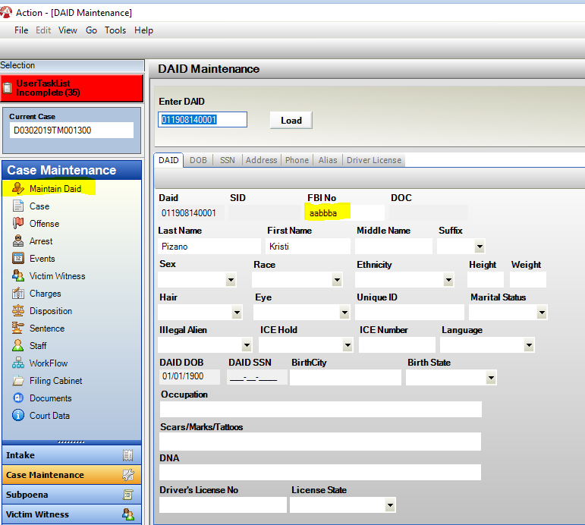

Sealing Cases

1. New District Setting option for districts to include the word “Sealed Case” in-front of the filing cabinet folders when a case has been Sealed within Action.

*Please contact CDAC to have this setting turned on for your district.

Process to Seal Cases

Case Tools 🡪 Seal Case

Case Status updates to: Sealed

File Location updates to: Sealed Case

Defendant Filing Name updates to: Record, Sealed

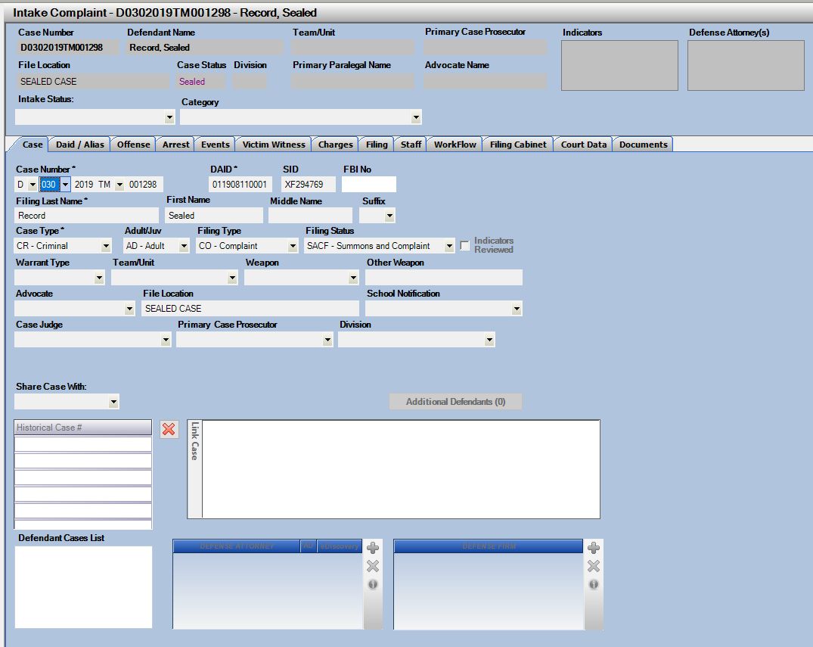New: Filing Cabinet Folder Names update with: Sealed Case prefix

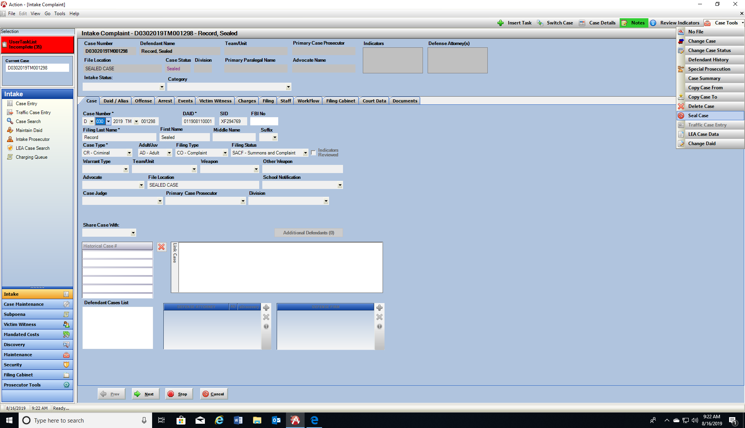

This does not lock down or prevent any activities within the filing cabinet, but acts as a visual aid to users that this case is Sealed Status.

CDAC can Unseal cases if they have been sealed in error*

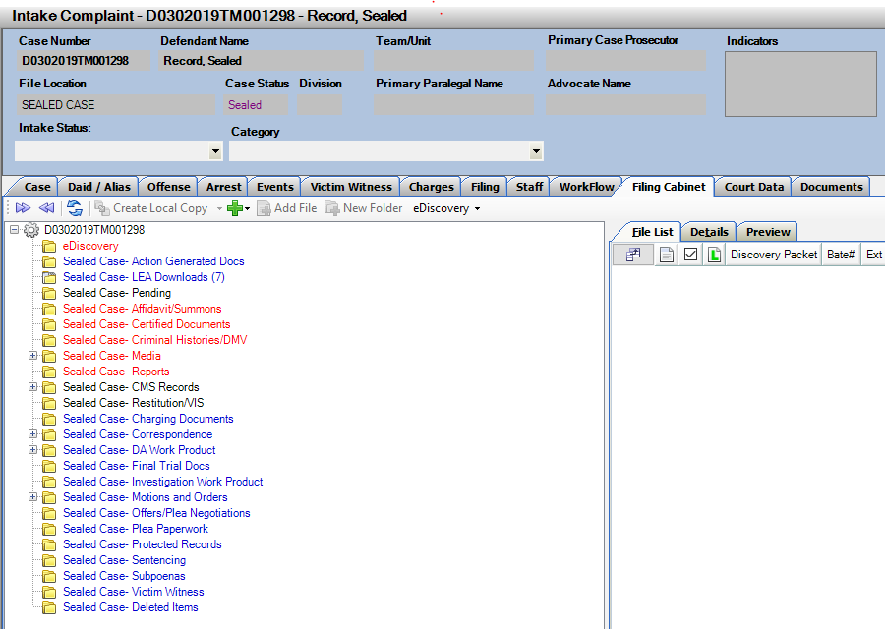

Primary Prosecutor – Update Future Events

1. Primary prosecutor field has been updated so that when this is changed within Action, it will also automatically update the event prosecutor on any future events that do not have event actions entered. Future events defined as today and any future date.

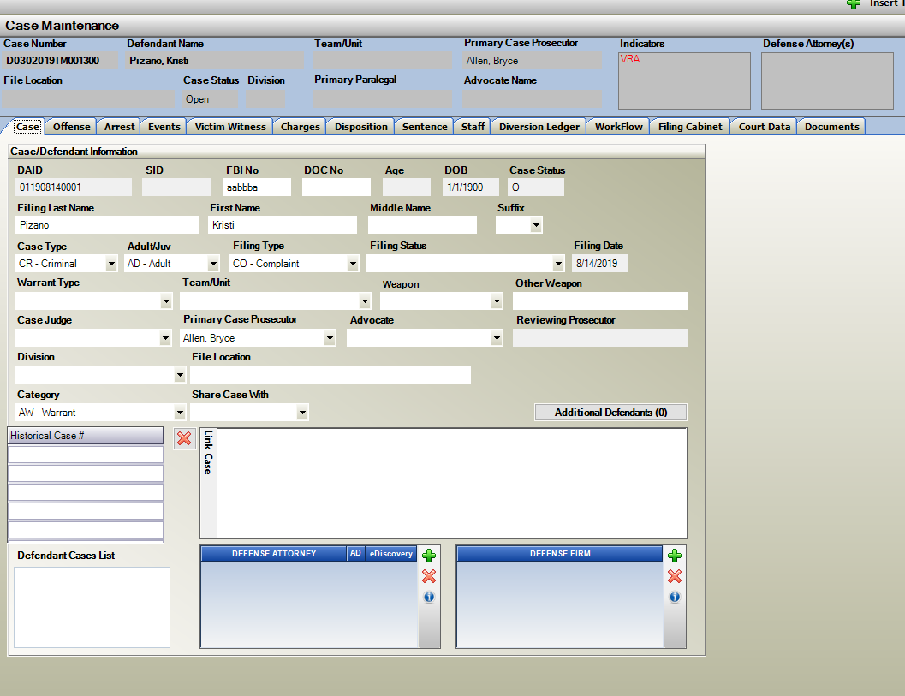

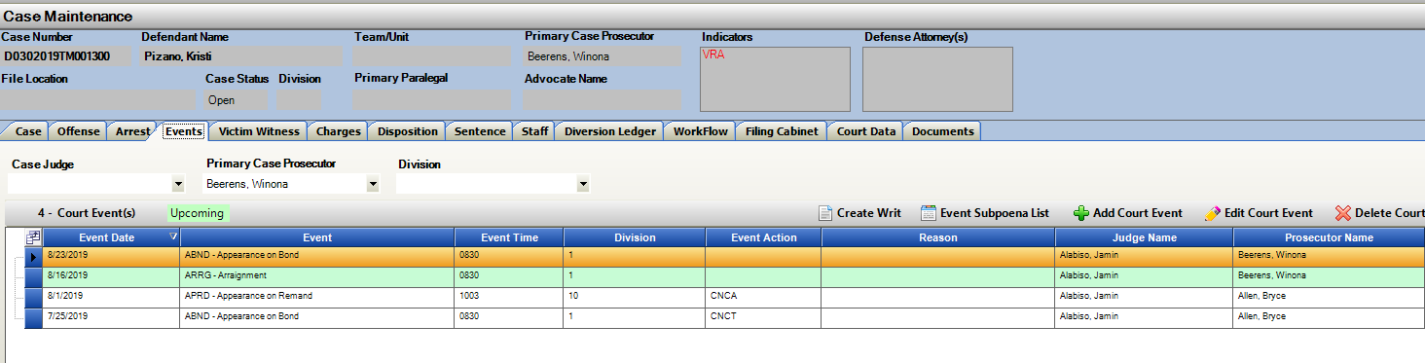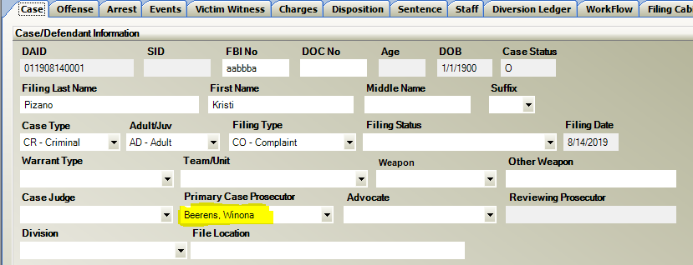

Noting- Create Work Flow task from a Note

1. Highlight a Note within a Case and then then click on Add Case Task. The Note Type, Note Sub Type, Subject, Note Text and Author all appear in the Work Description of the work flow task.

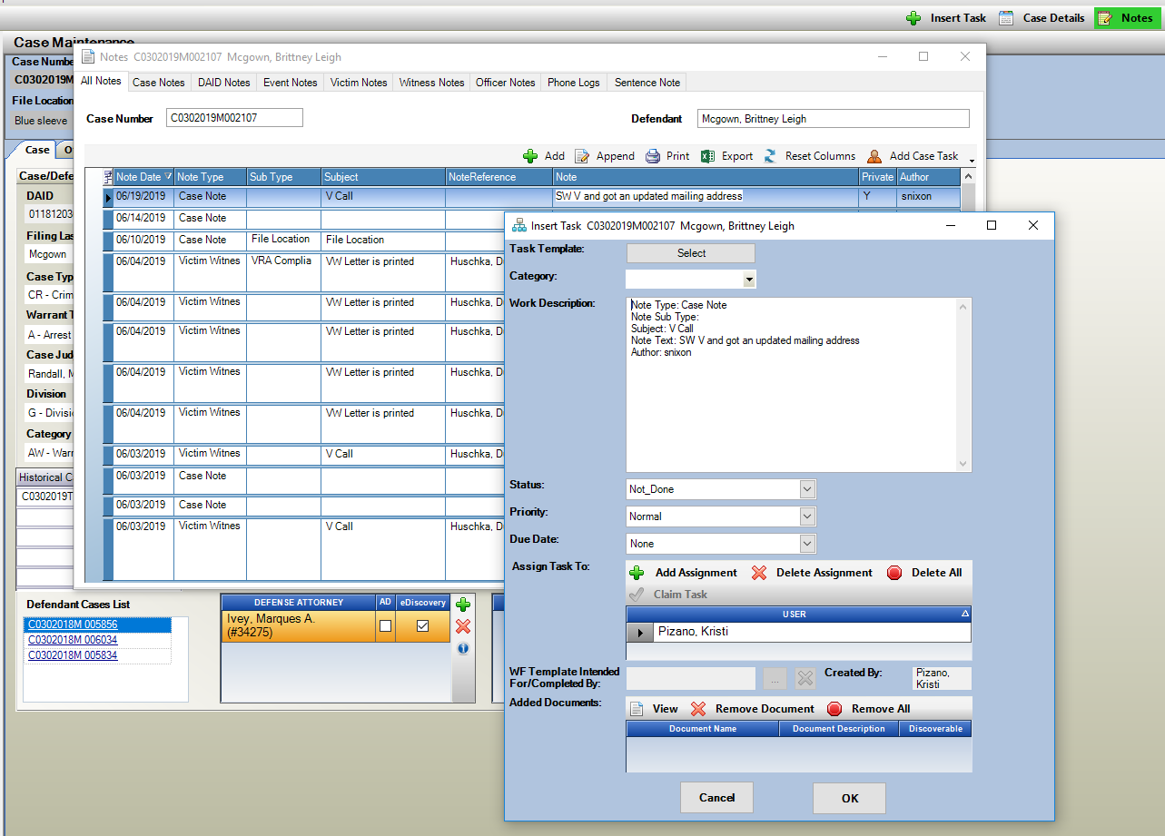

Notes: New Column – Note Reference

1. Note Reference is now a column that can be added to the Noting Display. Click on the field selector to add this. This will display Victim/Witness Names, Events etc. based on the type of note entered. This is to provide the user with further detailed information about the note that was entered, or auto-generated from Action.

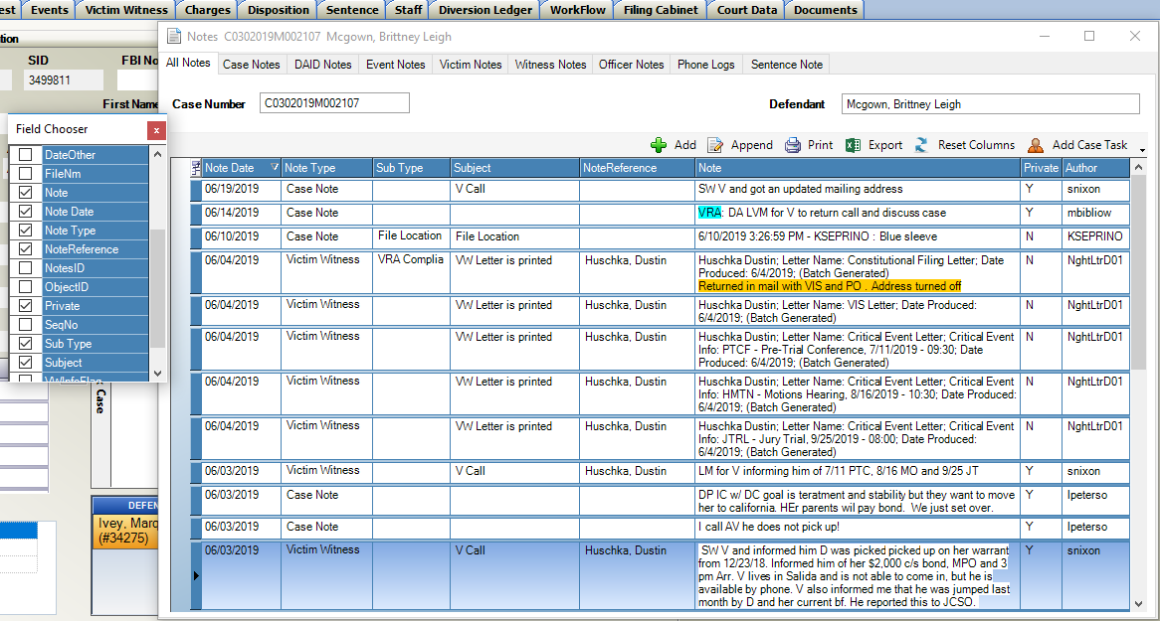

Notes: Create Note when a VW letter is Emailed

1. Existing functionality to email VW letters, now includes the option to have an Auto-Note generated when processes. This is a District Setting for VW Letters, when produced now through printing or batch to have a VW Note created when a letter is created.

*Contact CDAC to turn on Auto-Noting if not already enabled for your district or for further information regarding the email VW letter process.

After emailing the VW letter the note if the setting is on will appear as below.

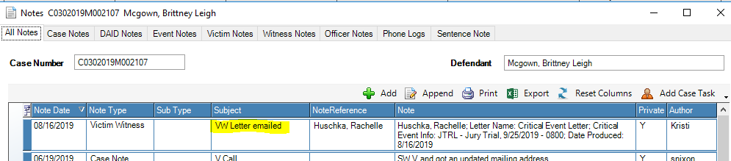

Notes: Sentence Note Sub Type

1. Note Sub Type: Sentence now displays clearly to the user in Red as a warning that they are entering a note that could display on a produced VW letter. This Note Sub Type was designed for additional Sentence information to be shared with Victims and Witness.

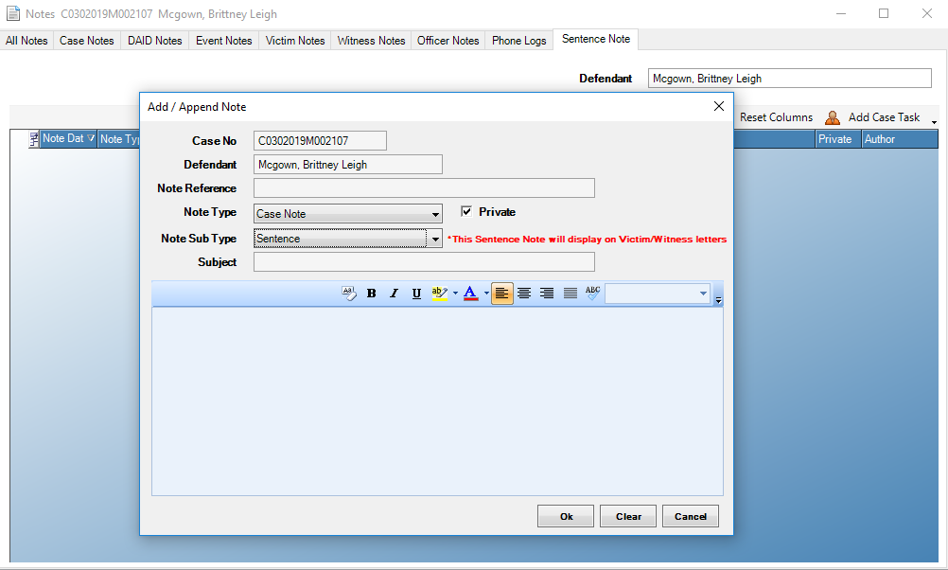

Victim Witness Tab: Phone Number Status

1. Victim Witness Tab within a Case now has the Phone Number Status also added to the Expanded View of VW information. Click on Expand within this screen and then note new field shown below to help indicate quickly to users the status of the phone numbers entered.

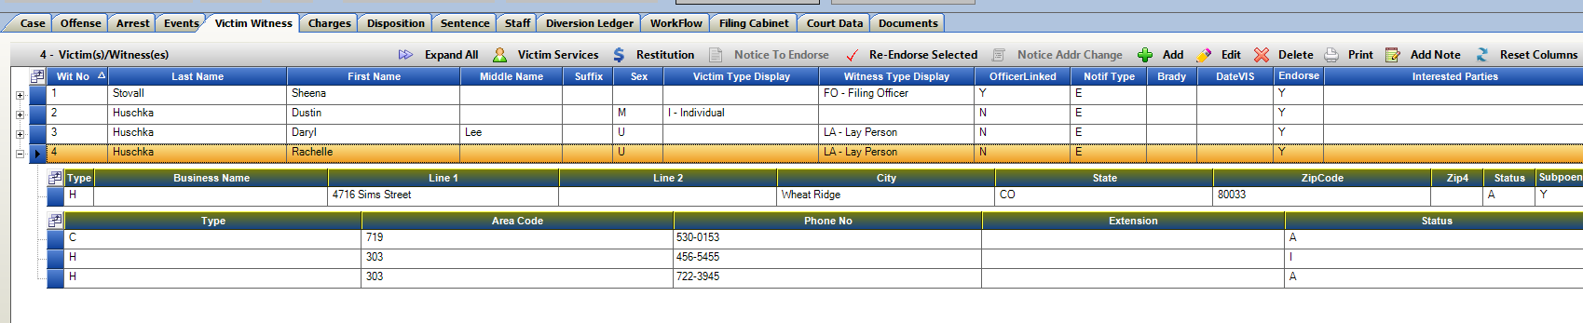

1. Victim Witness Notification Screen-

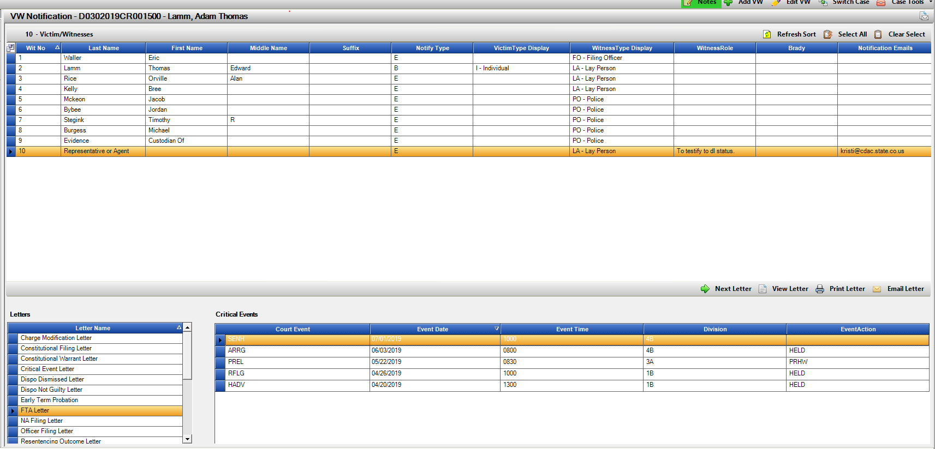Column displaying the witnesses email address has been added to the main display. If a district is using the feature to email letters, this will make selecting entries which have an email entered for notification purposes easy to identify.

Charges Tab: Charge Title and Description

1. Adding, Editing or Amending Charges within an Action Case will now display both the Charge Title and the Charge Description. This will help provide users with further information regarding the charge they are selecting.

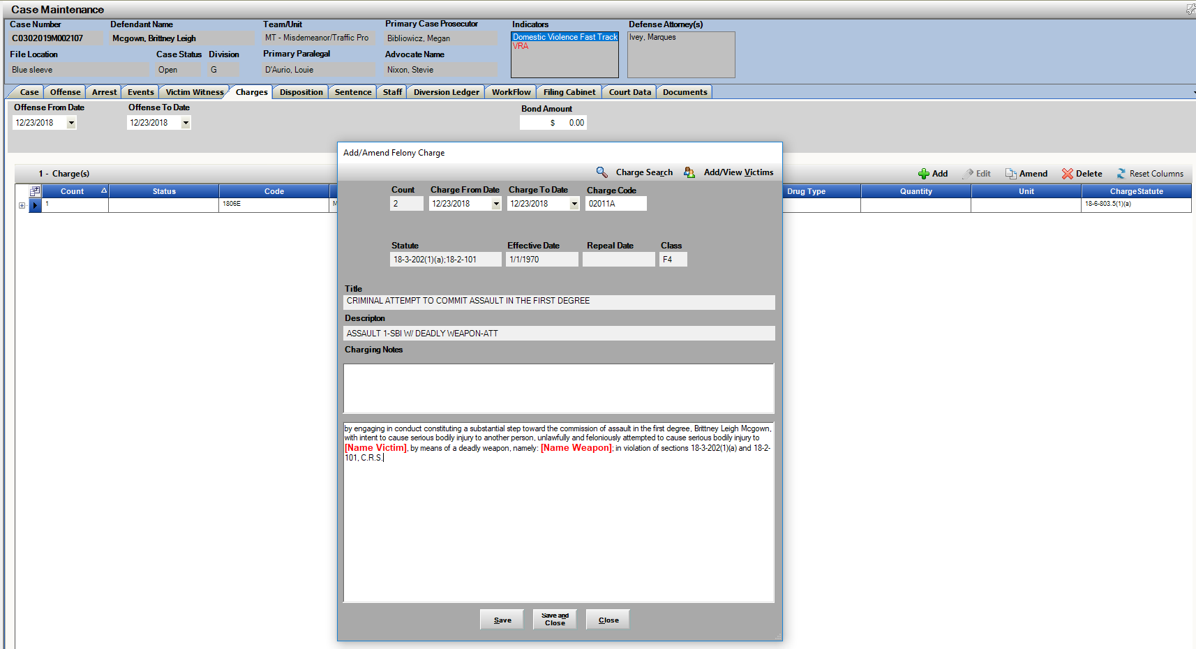

Sentence Tab: Copy Sentence to another Charge Option

1. Users can now select to copy an existing Sentence to another guilty associated charge within a case. The receiving charge cannot have current Sentence information already attached.

To Copy:

1. Highlight the Sentence entered and click on Copy Sentence button.
2. Copy Sentence Window appears, select charge that you want to copy this Sentence to within the case with Check box, user can select multiple charges.
3. 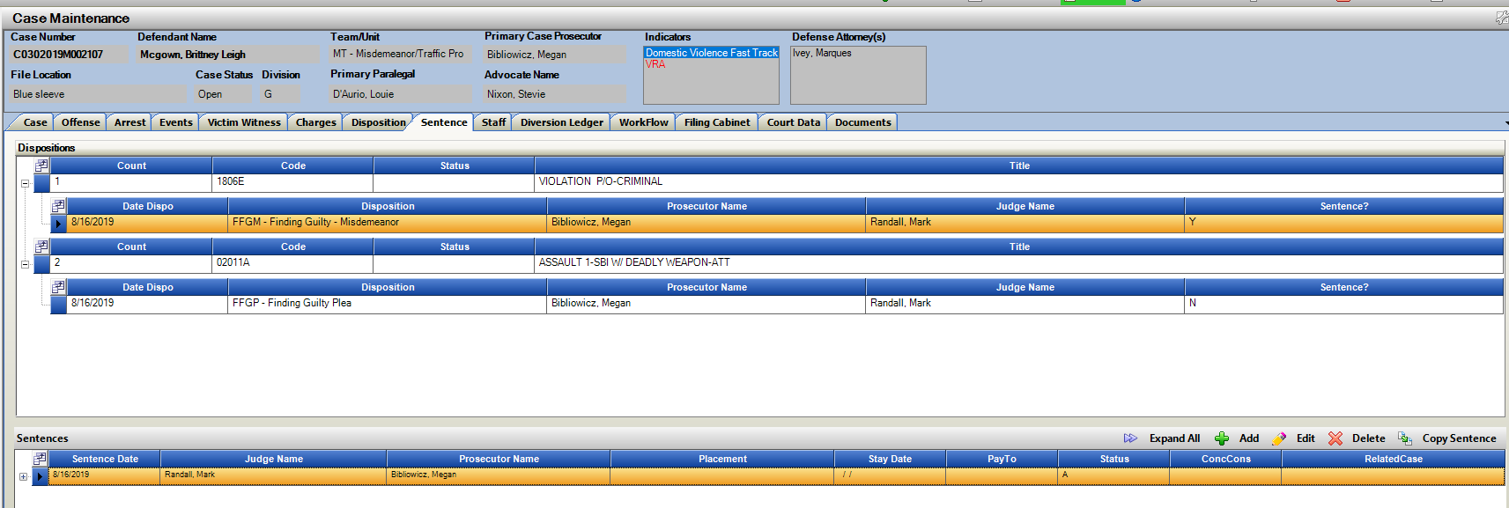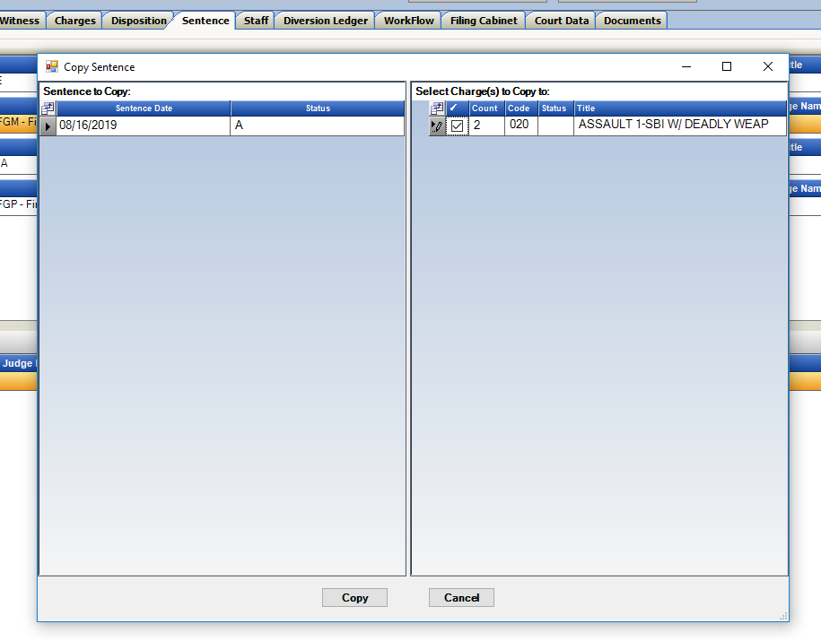Click on Copy.

Sentence: Display Sentence Note Warning Message in Red

1. Sentence Tab within Action; When adding or editing a Sentence the previous note warning users that the Sentence Note can display on VW notification letters has now been updated in RED for clearer visual aid as to the entry on this form. This was designed for further sentence penalty or condition notes.

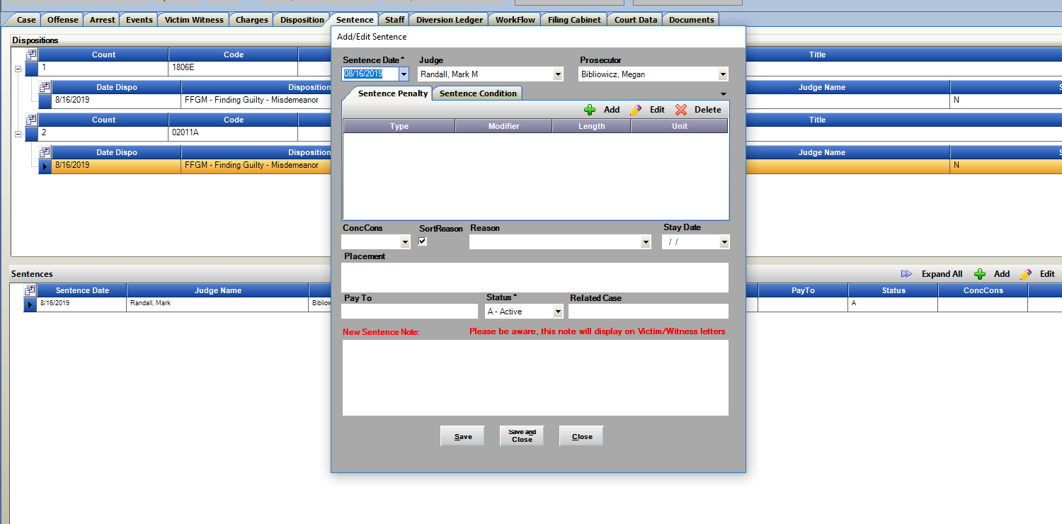

E-Filing: “Serve To” Auto Checked

1. E-Filing forms within Action will now default with all parties in the “Serve To:” list auto checked. Users can Un-check the ones they do not wish to electronically serve. This is to help streamline the process of e-filing with less clicking on this form.

Just as a reminder- this list defaults only with parties entered by the Court Clerks on this case. It is not connected to any Action entries.

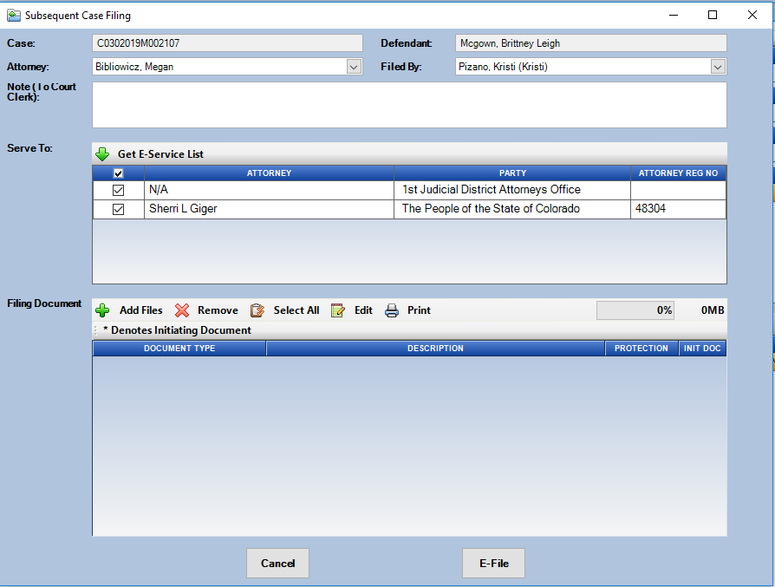

Filing Cabinet: Copy File Option

1. Copy Files is now an option within the Filing Cabinet. This will let users select and copy files to another case within Action. This is to stream line the process so a local copy does not need to be made and then added to the other cases.

Usage:

Example of functionality would be if you needed to copy selected files from a defendant’s case to their other open cases if they are connected, or to other defendants that may have a related case but are not co-defendants or linked cases within Action.

Process:

1. Highlight multiple files within the file cabinet using the selection checkbox column or by using short cut keyboard keys. Hold down Ctrl and mouse click on different documents for example. Hold Shift and make a selection of files displayed.
2. Click on Copy File.
3. Search for Case you want the selected files to copy to.
4. Click on Copy

Restrictions of functionality:

1. If cases are linked as Co-Defendants in the File Cabinet- access Copy Files from the **File List** **Tab.** This is not available from the Co-Def Tab to ensure you are making a copy of a file that exists on the case you are reviewing.
2. We prevent copying of Discovery packets under the eDiscovery folder from one case to another as those need to be created within each case.
3. We prevent copying of files that are in the LEA Downloads folder and not yet downloaded. Download and move these first to a specific default folder and then you can make a copy to another case.

Select Files that you would like to copy.

Enter case number on search for the case that you want these files copied to.

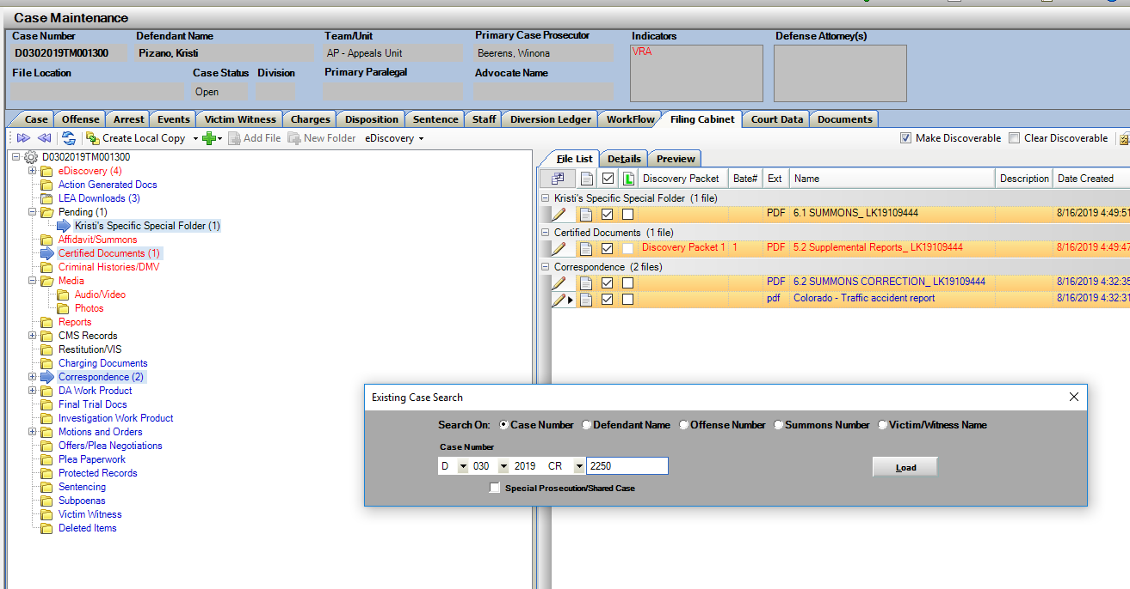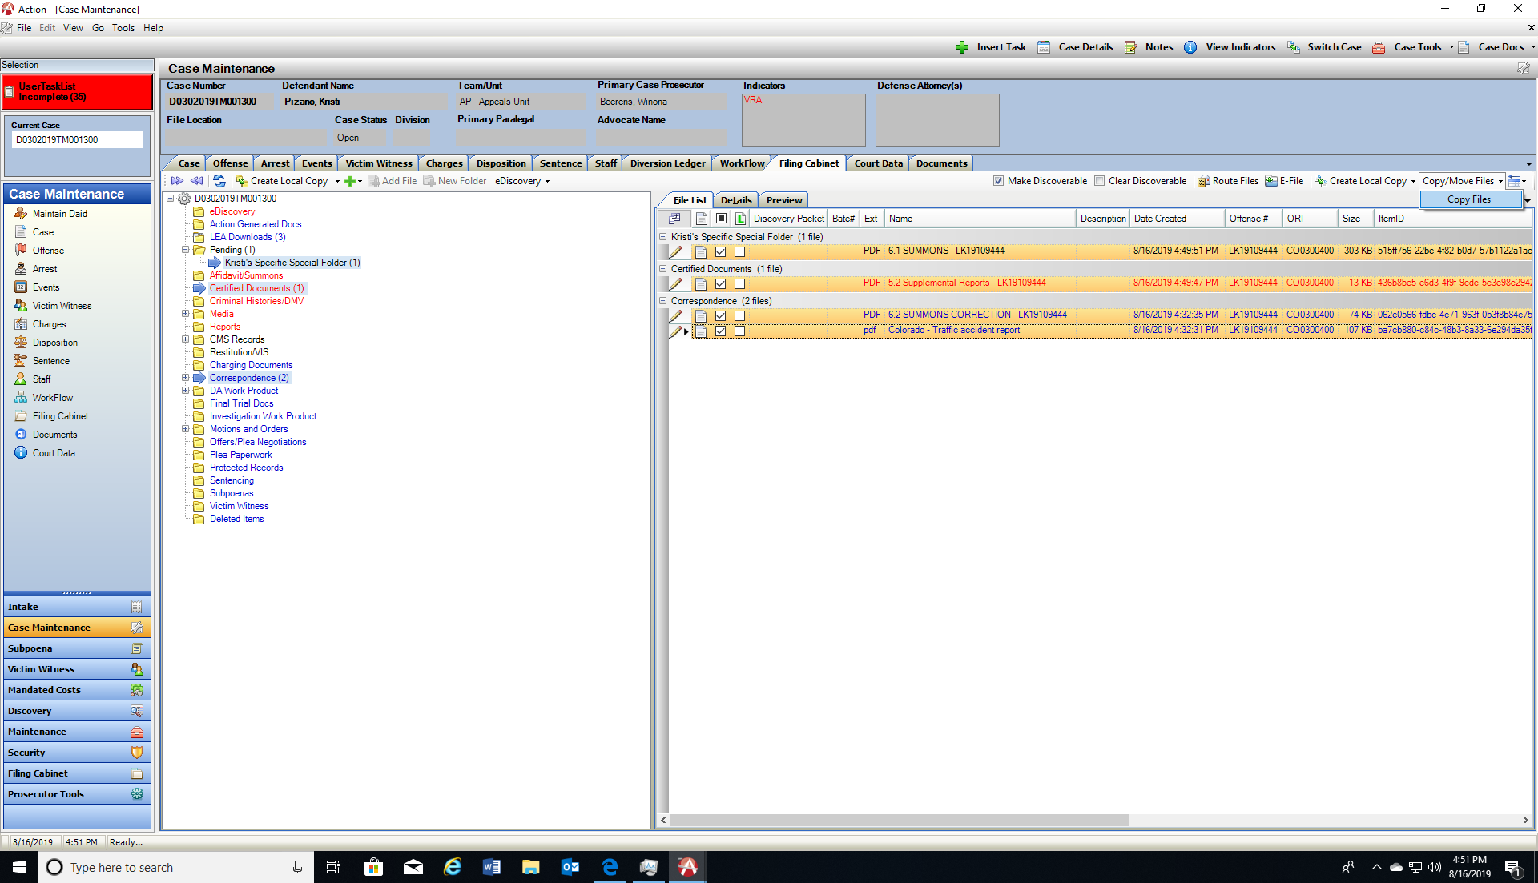

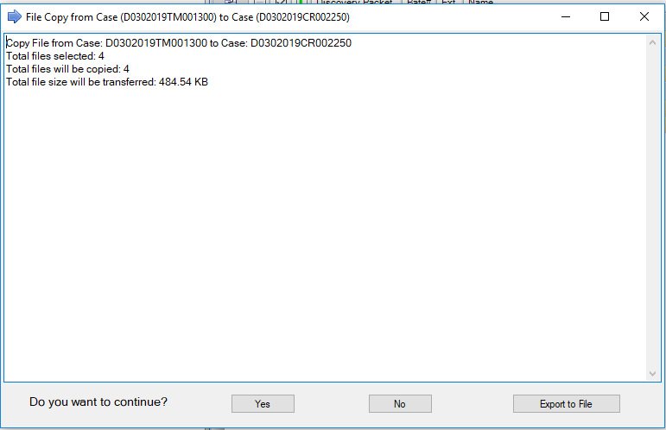File Copy window appears with details on the copy function. This shows the cases that it’s being copied from and to, the total files selected and the total file size. Click on Yes to Continue with the Copy, Click No to cancel the process or click on Export to File to create a local copy of the files selected.

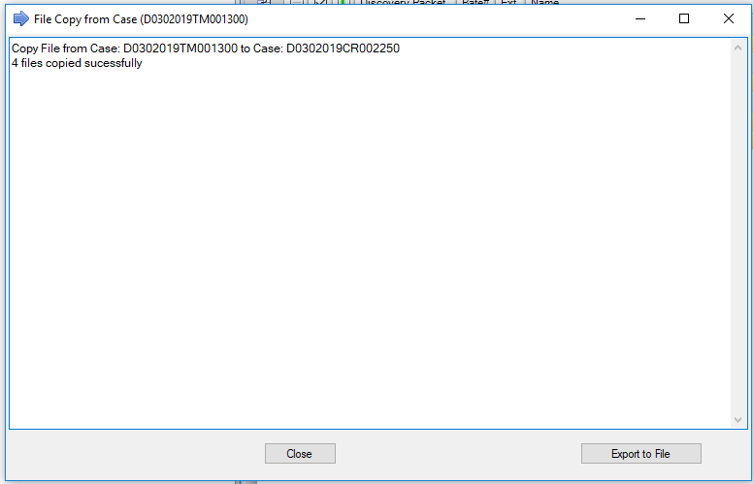Export Option will keep same selection window open, so a user can export to File first and then make the copy to the other case if needed.

The Folders and files that where copied now appear in the new case.

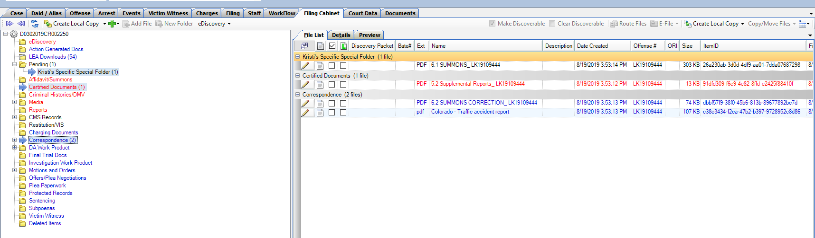

To view a file history which includes if it was copied from another case:

1. Highlight File
2. Right Click and select Advanced Options
3. Under Available Operations select: Document History
4. 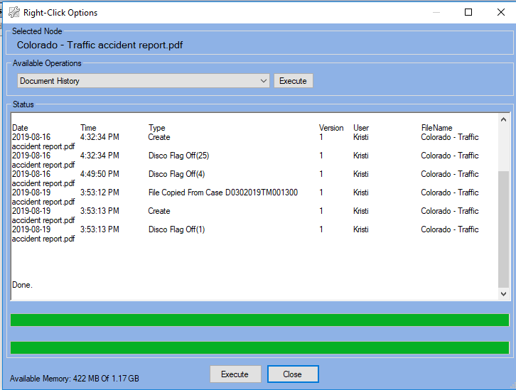Click Execute

Filing Cabinet: Image Viewer

Image Previewer is now available within the file cabinet. A New Tab “Preview” is displayed within each case. This will display a view of the image files within the case without having to open each file.

Functionality:

Highlight a folder(s) and selected files from the file list tab, then click on “Preview” tab. This will display the image if it’s an image file. If it is not, then no preview is available. Users can select files from this view as in the file list and can make discoverable, send as work flow items etc. Same functionality that exists if you were working on the file list tab.

Display Options:

View Page

Items Per Page

Preview Image Size on a slider

Selected Item count- To select multiple items use CTRL and mouse click, or Alt A for all items. Same functionality as within the file list for selecting files.

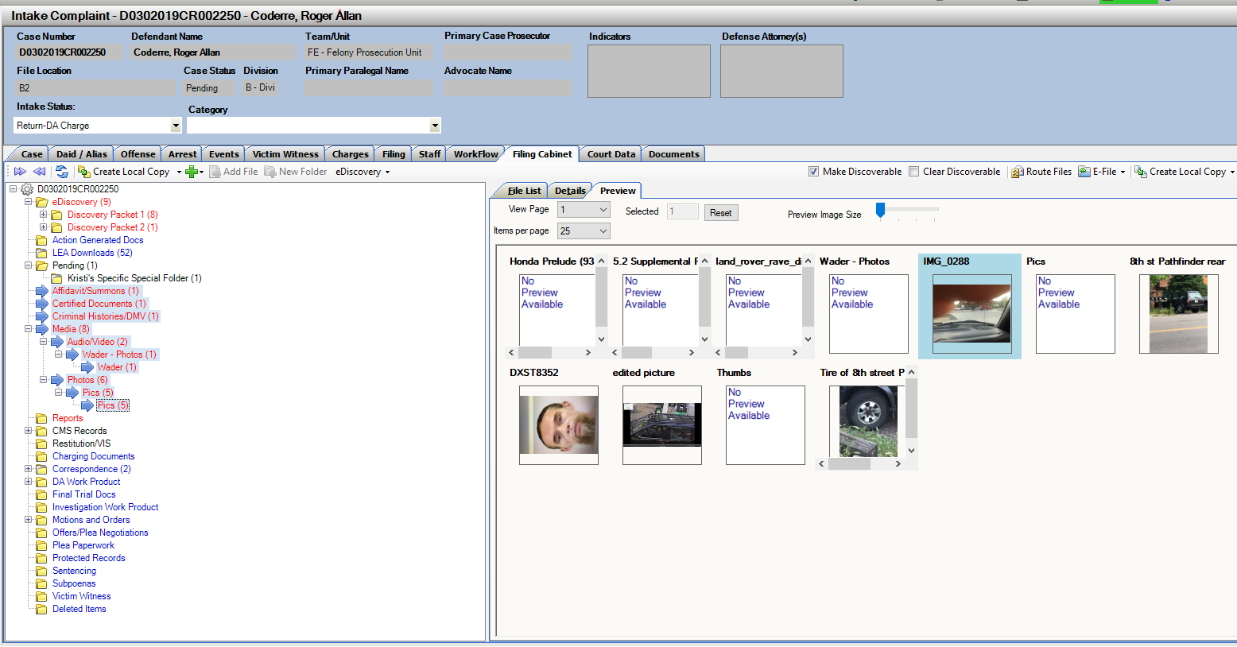

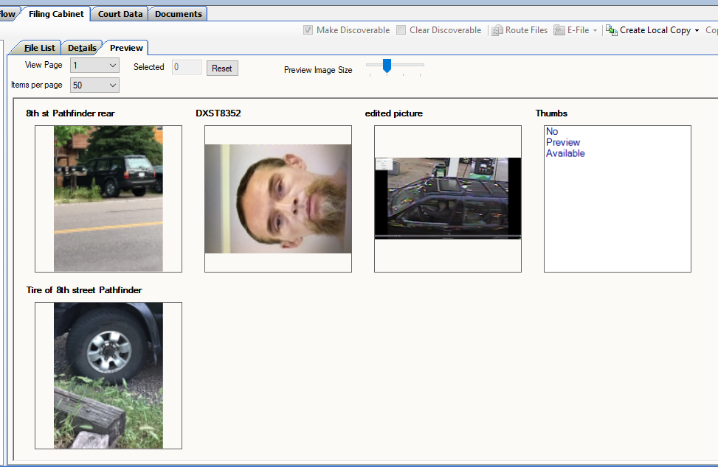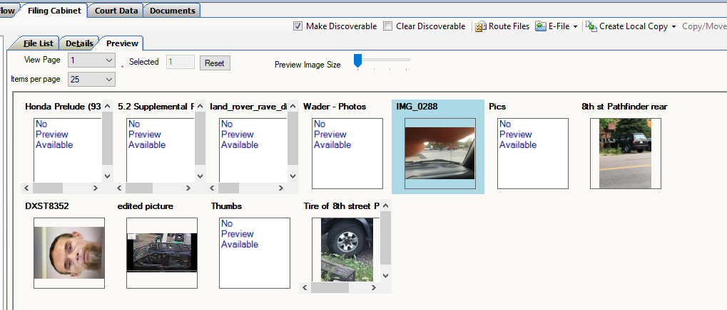

Selected Item count displayed, click on Reset to unselect.

Select by using Ctrl and mouse click, Alt A for all etc.

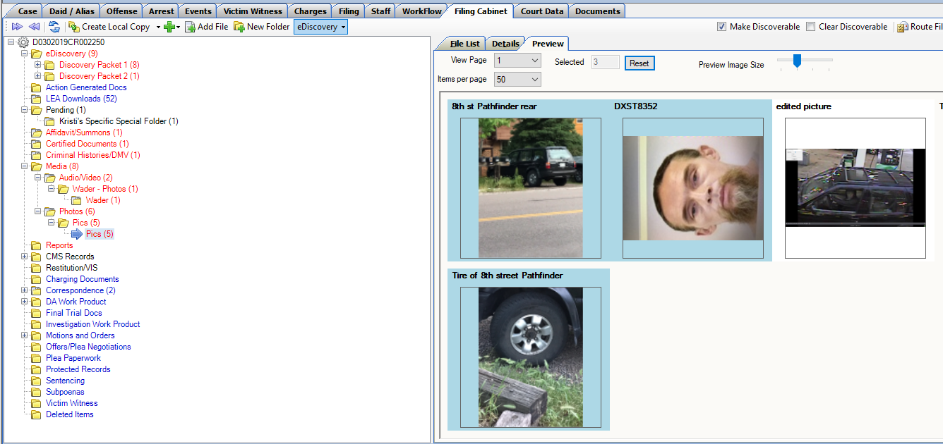

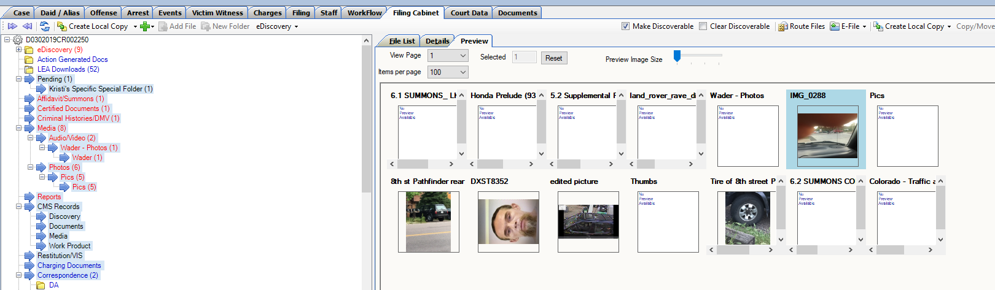Select Multiple folders in a case and preview all images.

D18 Metrics Screen

Tracking Screen designed by D18, this is currently only available for D18. If others are interested in this functionality, please contact CDAC.

This option is accessible under Case Tools drop down menu from both Intake and Case Maintenance. Select Case Metrics.

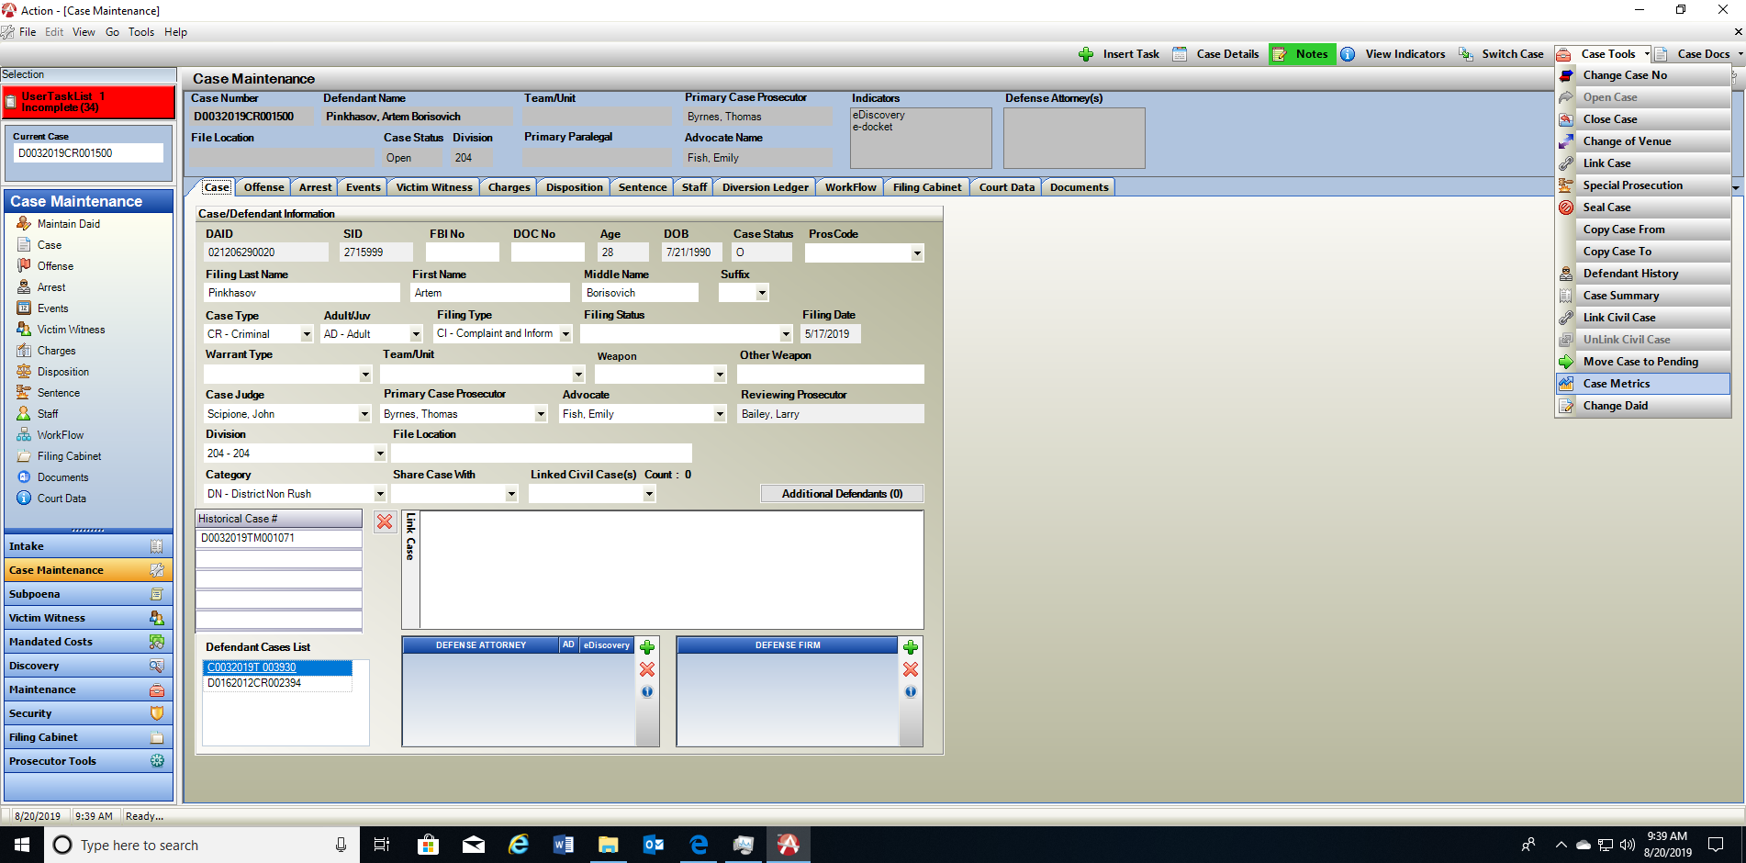

Supervision Status – Add Status, Edit Status and Delete entered Status.

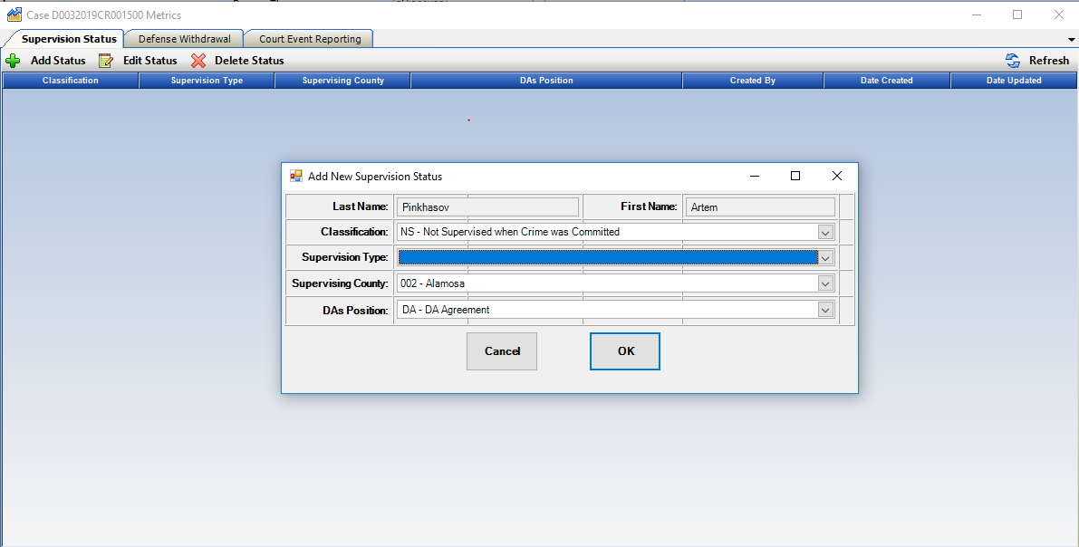

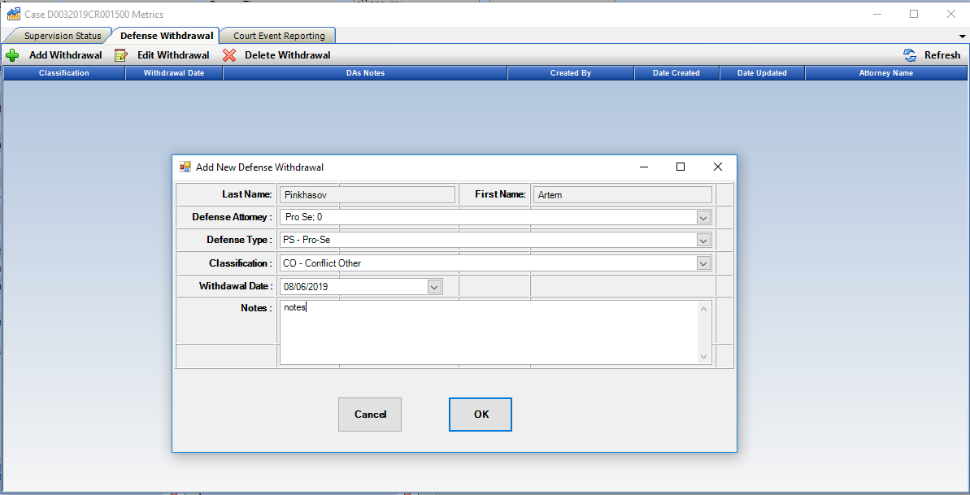Defense Withdrawal- Add Withdrawal, Edit Withdrawal and Delete Withdrawal entries.

Court Event Reporting- for future release.

Doc Gen Variables

1. VW Race and VW Sex have both been added as new Doc Gen Variables. If these fields are used on your VW entries within cases they can be used now as part of creating documents.

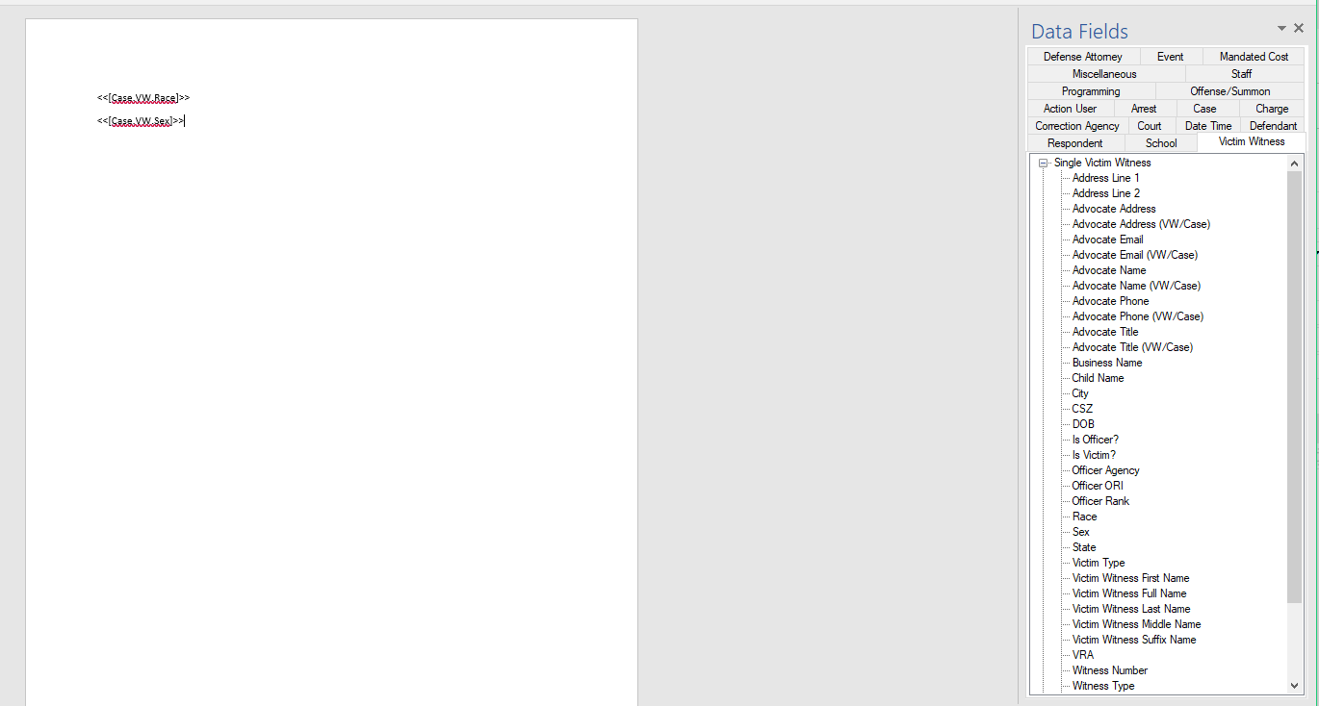

1. Co-Defendant Case Status Variable has also been added to the Co-Defendant and Co-Defendant List Variables under the Case Tab.

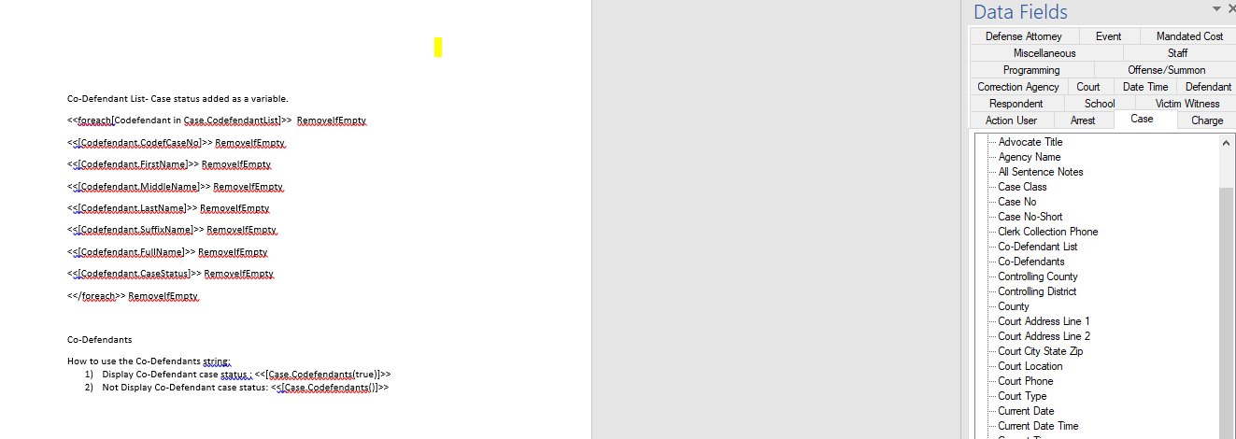Co-Defendants

How to use the Co-Defendants String with Status:

1. Display Co-Defendant case status : <<[Case.Codefendants(true)]>>
2. Not Display Co-Defendant case status: <<[Case.Codefendants()]>>

Miscellaneous

1. Allow Mandated Cost Entries to have negative numbers entered.
2. LEA received notes are updated to reflect the “Author” of the note as LEA instead of the Action user that began the case.
3. DAID search results – sort updated so when a column is sorted, it’s sorting correctly.
4. Fix for Prosecutor Tools- Dockets- update to reduce issue of users not being able to add events to their external calendar.
5. Fix on Offense Screen, issue when multiple offenses were entered on a case.