Action Enhancement Guide

February 2019 Training Guide



<http://www.CDACweb.com>



**Table of Contents**

1. Intake: ……………………………………………………………........…………………………..………. 4
   1. Case caption added to all Intake cases.
2. Intake: Initiating Events Screen…………………………………………………………………..… 5
   1. Case will re-populate onto the Initiating Event Screen if case is deleted

from Action.

1. Intake: LEA Search Screen …………………………………………………….………………………… 6-7
   1. User specific column selections for customized view.
   2. Cases started from LEA will now remove duplicated VW entries.
   3. Setting to allow LEA to import VW names but not VW addresses.
   4. Sealing case process, will not re-populate the case to the LEA search.
2. File Cabinet: LEA Folders ………………………………………………………………………………… 8
   1. LEA can now utilize folders for organizing their files in the portal. These

folders can now be moved with their contents to the Action file cabinet.

1. Court Data: ……………………………………………………………………………………………….…… 9-11
   1. Court Data Tab now replacing ROA Tab within Action Cases.
   2. Court Data Tab- Contains ROA information and Minute

Orders/Events from Judicial.

1. Work Flow: ……………………………………………………………………………………….…………… 12-14
   1. User Task List- Button Color Update.

Red = Urgent, Yellow = Elevated, Green = Normal, Gray = no new tasks.

* 1. User Task List- Button – add display of number of Incomplete Tasks.
  2. User Task List- Custom Column selection per user.
  3. User Task List- Separation of “Created by” and “Created on” columns.
  4. User Task List- Group by “Case View” sorting correctly.
  5. Work Flow Tab- Add Re-Assign button to this tab for quick updating.

1. Prosecutor Tools: …………………………………………………………………..………………………… 15-16
   1. Prosecutor Docket Options to Check off/ Complete an Event on docket.
   2. Custom Column Selection per user.
   3. Advocate Case Listing.
   4. Multi-Notes added to Prosecutor, Advocate and Paralegals Case Listings.
   5. Add Note/ View Note added to right click menu option.
2. Charging: ……………………………….……………………………………………………………………… 17
   1. Update to display all valid charge codes based on charge date range

when selected.

1. Dispositions …………………………………………………………………………………………………… 17
   1. Update for users to delete dispositions if needed.
2. Sentences …………………………………………………..…………………………………………………..… 18-19
   1. Allow users to enter Sentence Notes from a received or user

entered sentence.

1. Brady Officer Maintenance ……………………………………………………………………………… 20
   1. Removing a Brady flag on an officer entry will need to be requested of

CDAC.

1. Subpoena Process …………………………………………………………………………………………… 21
   1. Option to Re-Flag all VW from the previous event on the case.
2. E-Subpoena Agency ………………………………………………………………………………………… 22
   1. Enable only Power Users to add new officer entries to agencies set-up

for electronic subpoenas.

1. Delete Case Message ……………………………………………………………………………………… 23
   1. Delete message warning for Power users when deleting cases out of

Action.

1. Doc Gen: New Data Variables ………………………………………………………………………... 24-29
   1. Date Selection for future or past dating.
   2. Defendant ICE number variable.
   3. Current Display of Charges for users selection include Dispo and SE.
   4. Offense and Summons List Selections.
2. Miscellaneous ………………………………………………………………………………………………. 30
   1. Bug Fixes

Intake: Case Header

**Intake:** Case Header added to the Intake Case view so that all the case information can be easily seen while a case is still in the Intake Process.Case Status, Indicators etc.all viewed from any tab.

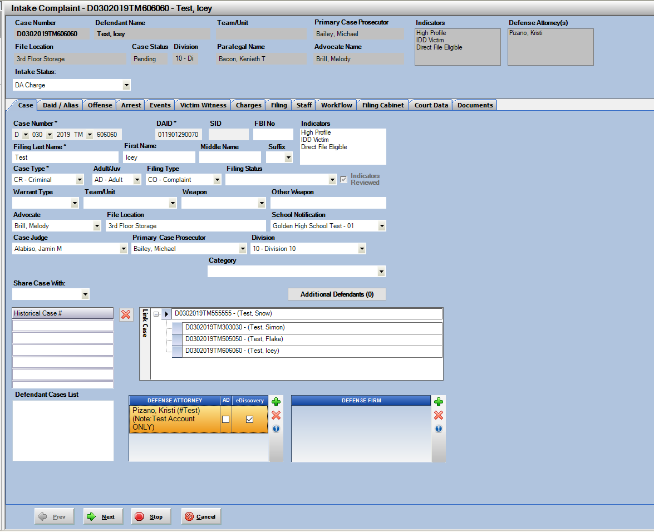

Intake: Initiating Event Screen

**Initiating Event Screen:**

This is the screen that shows cases sent by Judicial so that Action users can attached and begin a case with. We have made an update so that if a user starts a case received by Judicial and then later deletes that case from Action- the record will automatically re-populate to the Initiating Event screen so it’s available again to connect to if needed.

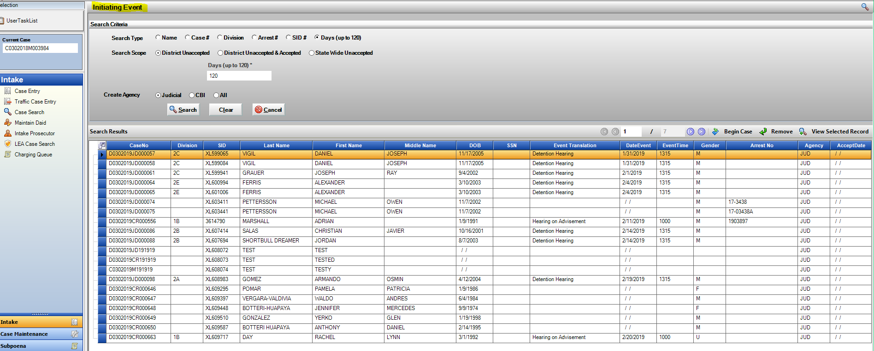

Intake: LEA Search Screen

1. 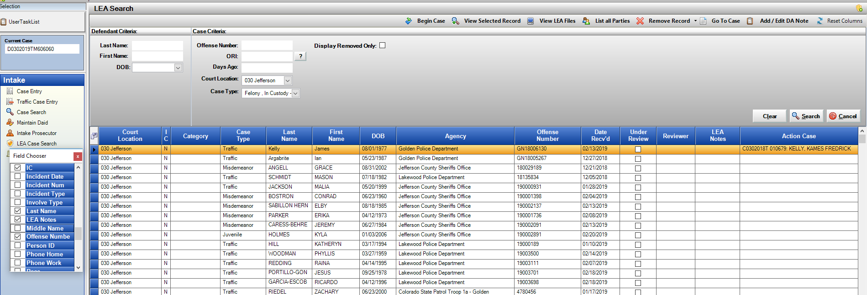User Specific Columns Selections for custom view per user. Add and remove columns using the field chooser or rearrange columns by dragging and dropping column headers to different positions, the selections are then preserved per user. Click on Re-Set Columns to set grid back to the defaulted view.
2. ***New District Setting – Please contact CDAC to have enabled for your District ***

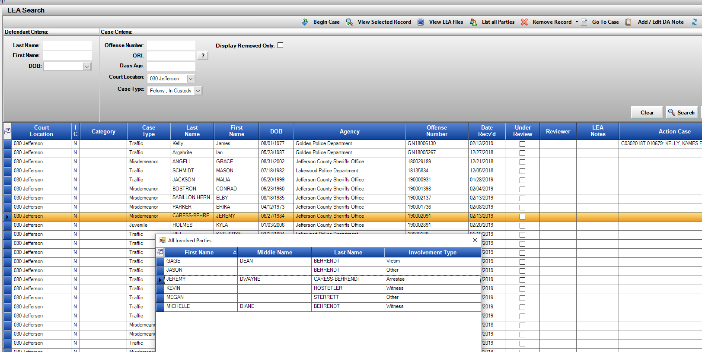Setting that would allow VW names to come into the VW Tab within Action when the case is created but would not bring in the addresses associated with them. This was requested as some LEA are not providing good address information and it takes longer to edit information received then to just manually enter it. Let us know if you would like this turned on.

1. 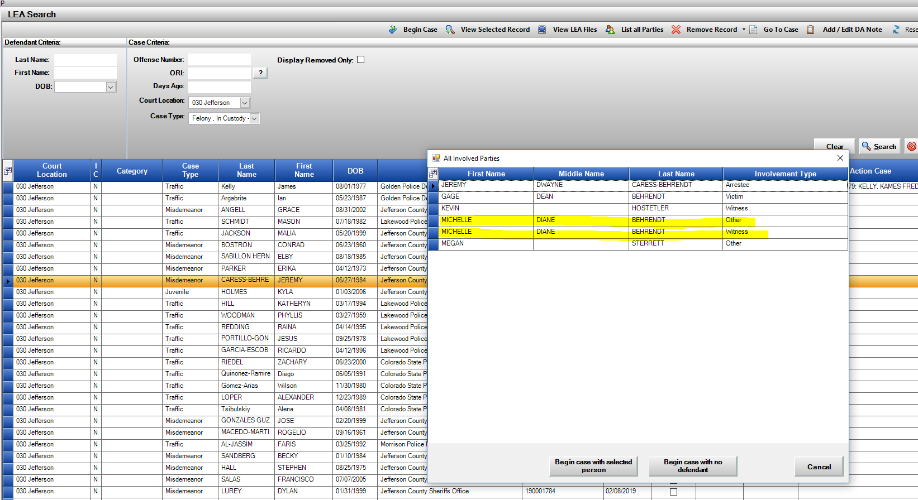Automatic merging of LEA witnesses received. If LEA sends over duplicated involved parties, we will match and merged into one record on the VW tab when the case is started. If addresses are different on each record they will both then be added to the VW entry.

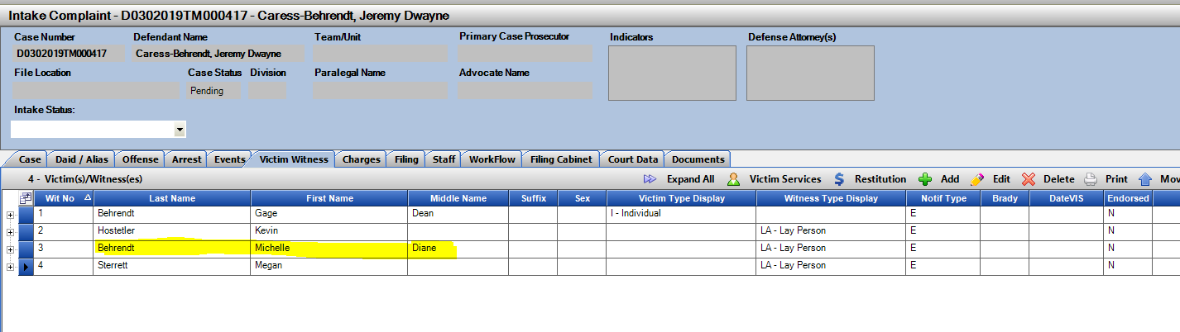

1. Sealed Cases will no longer re-populate onto the LEA search screen. When cases are sealed in Action the name changes to Sealed Record, this was then re-populating the LEA case on the search screen as the names no longer matched what was in Action. This has been updated so if a case has been sealed, it will not re-populate the main search screen.

File Cabinet: LEA folders drag and drop into Action case

Law Enforcement can now start utilizing a folder structure with the eDiscovery Portal. If they are using these folders, when the case is submitted to the DA’s office the folder and its contents are then displayed in the LEA Downloads folder within Action’s file cabinet.

Functionality:

This enhancement allows users to now drop and drag a folder and all its contents received by LEA into the file cabinet. It can be moved into any position. Note- the files need to be downloaded first before the folder can be moved. This helps streamline the process so individual files don’t have to be moved when received.

View LEA Files View: files can be individually downloaded before starting an Action case.

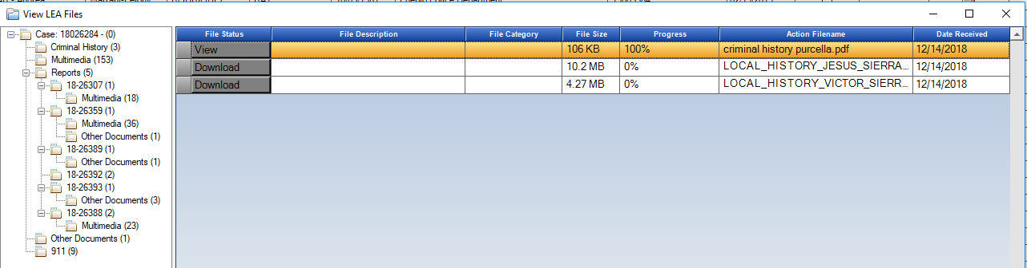

View LEA Downloads in an Action Case:

After downloading files, drag and drop entire folder from LEA to any location within the file cabinet. The folder name plus all content is moved.

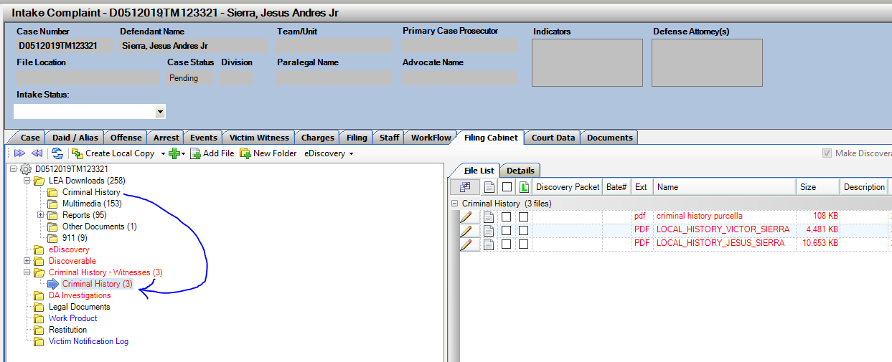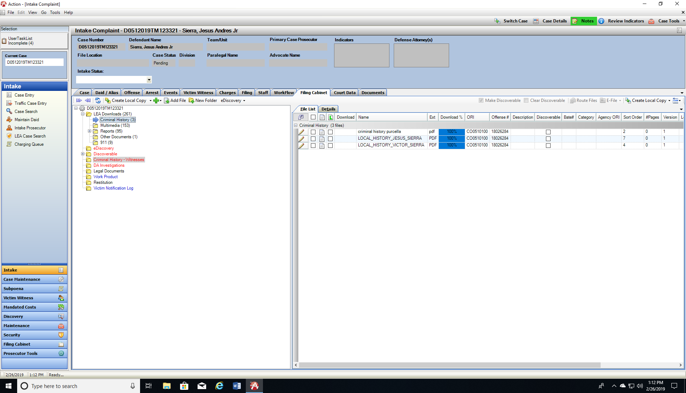

Court Data: ROA and Minute Orders/Events Displayed

Court Data tab now replaces the prior ROA tab within Action Cases. This Court Data tab displays the ROA information plus the Case Minute Orders/Events from Judicial.

Users will see 2 tabs on the Court Data tab one for each. Users have the ability to use the “Pop Out” function where the Court Data becomes a separate moveable window so it can be viewed while continuing to work in other areas of Action.

**ROA View:** Enhancement- Users can now double click on a row to open the file instead of only the Get Document button.

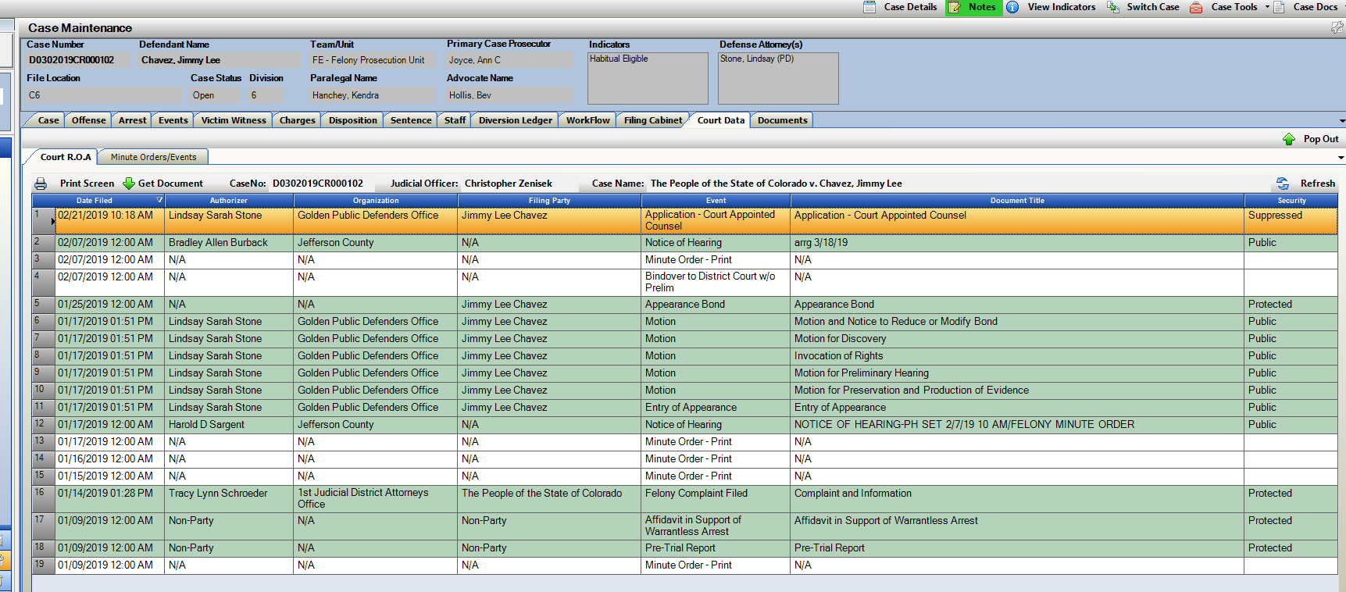

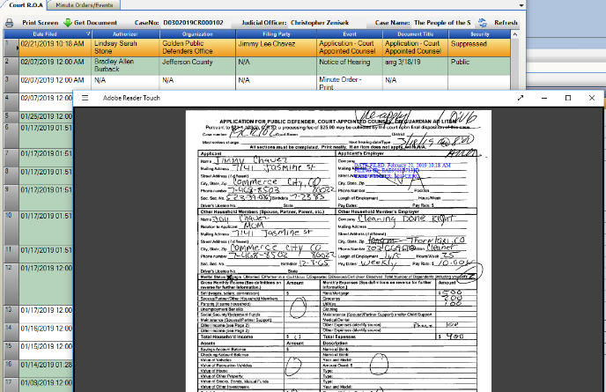

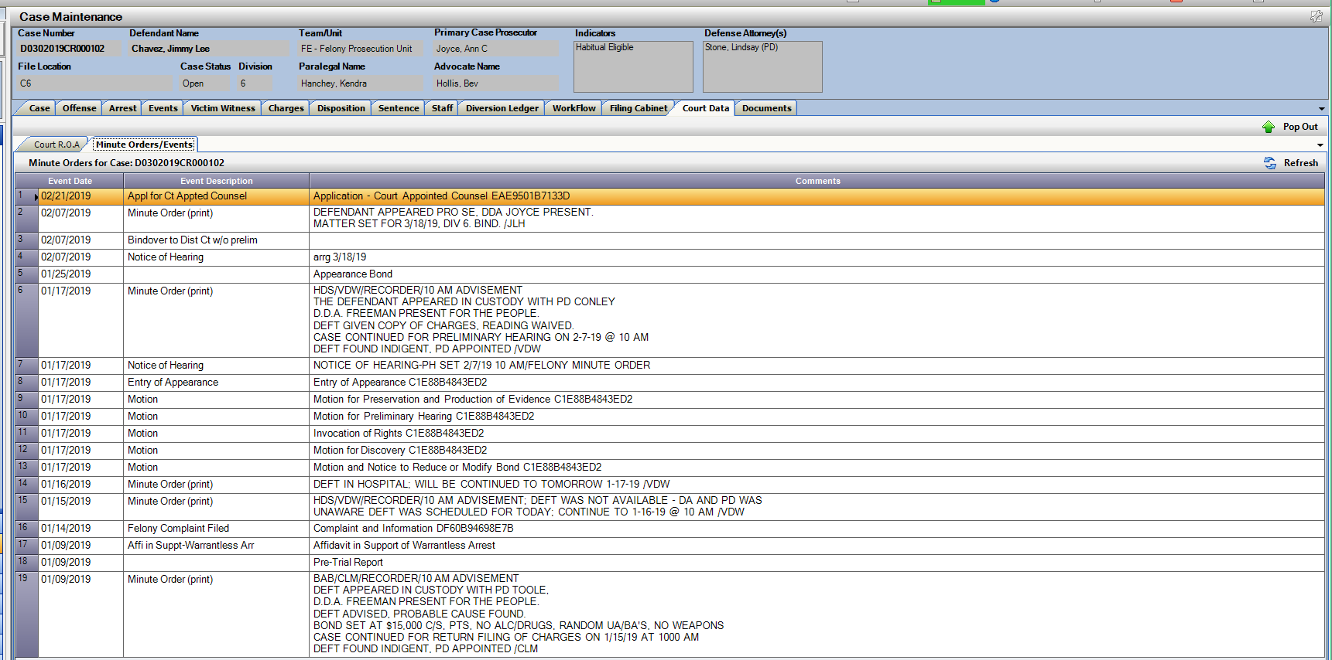**Minute Orders/Events View:** New view of Judicial Minute Orders within Action. These are the same minute orders seen in Court Data Access or within the CICJIS C.O.P.’s program. Now these have been made available within Action cases, or from Prosecutor Dockets- Right Click Menu Option- so that while in docket these can easily be accessed and viewed.

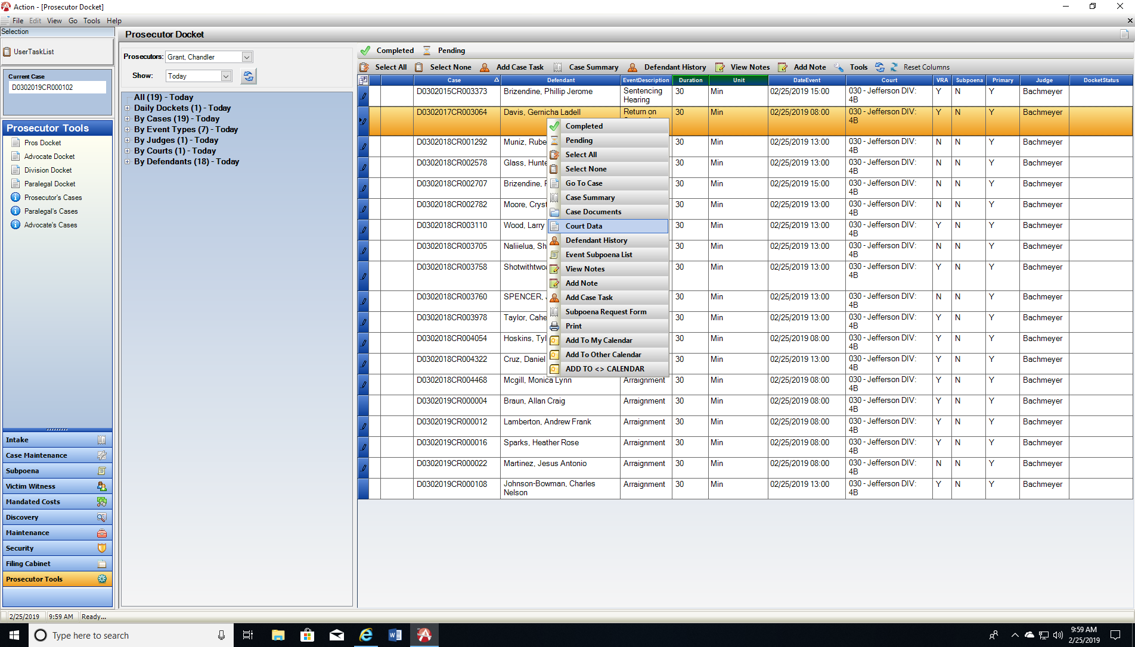

Use the “Pop Out” button and the form will display in a new window allowing the user to keep it open while continuing work within Action. When minimized they will stack behind the Action Icon in your computer menu tray.

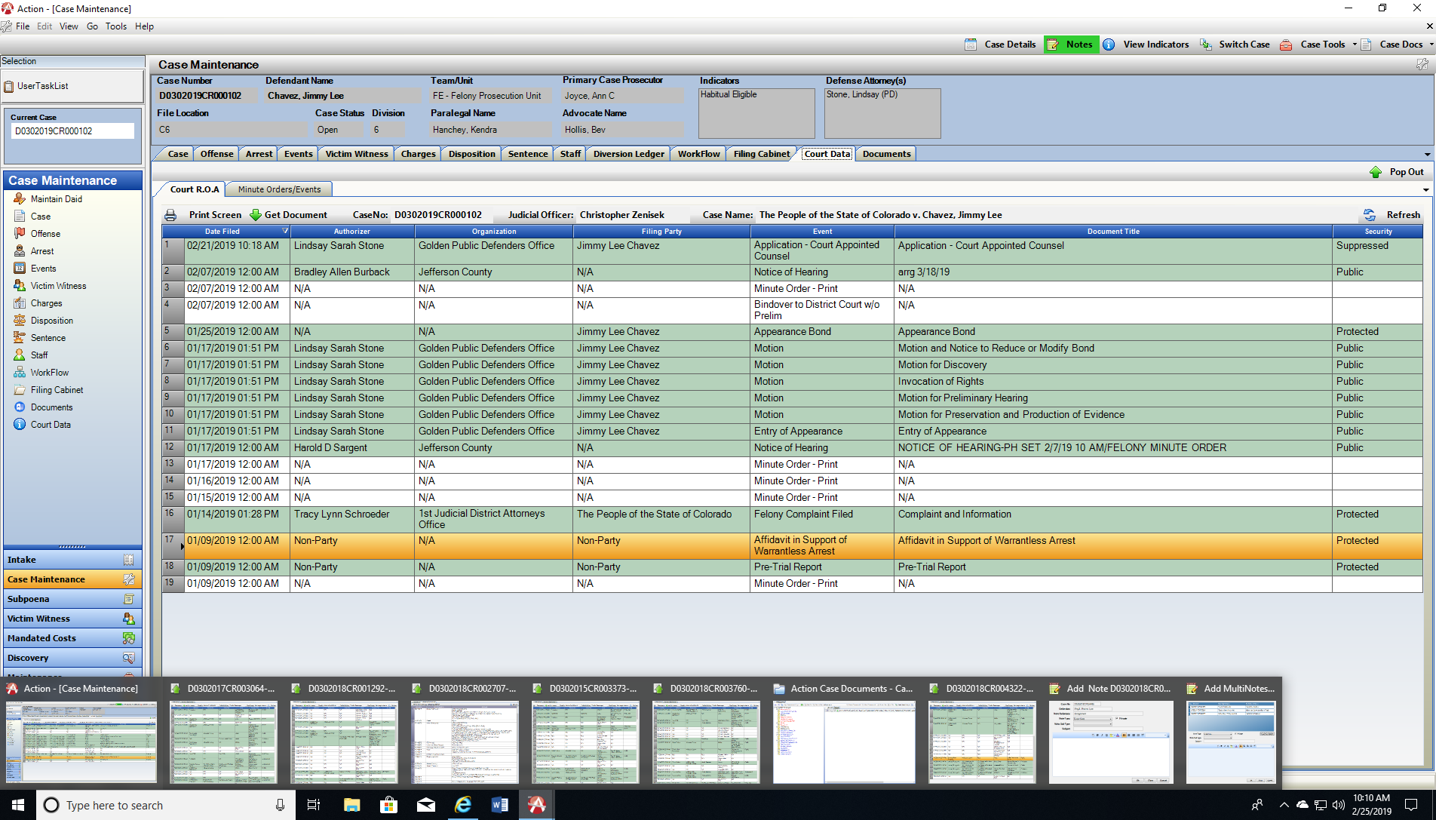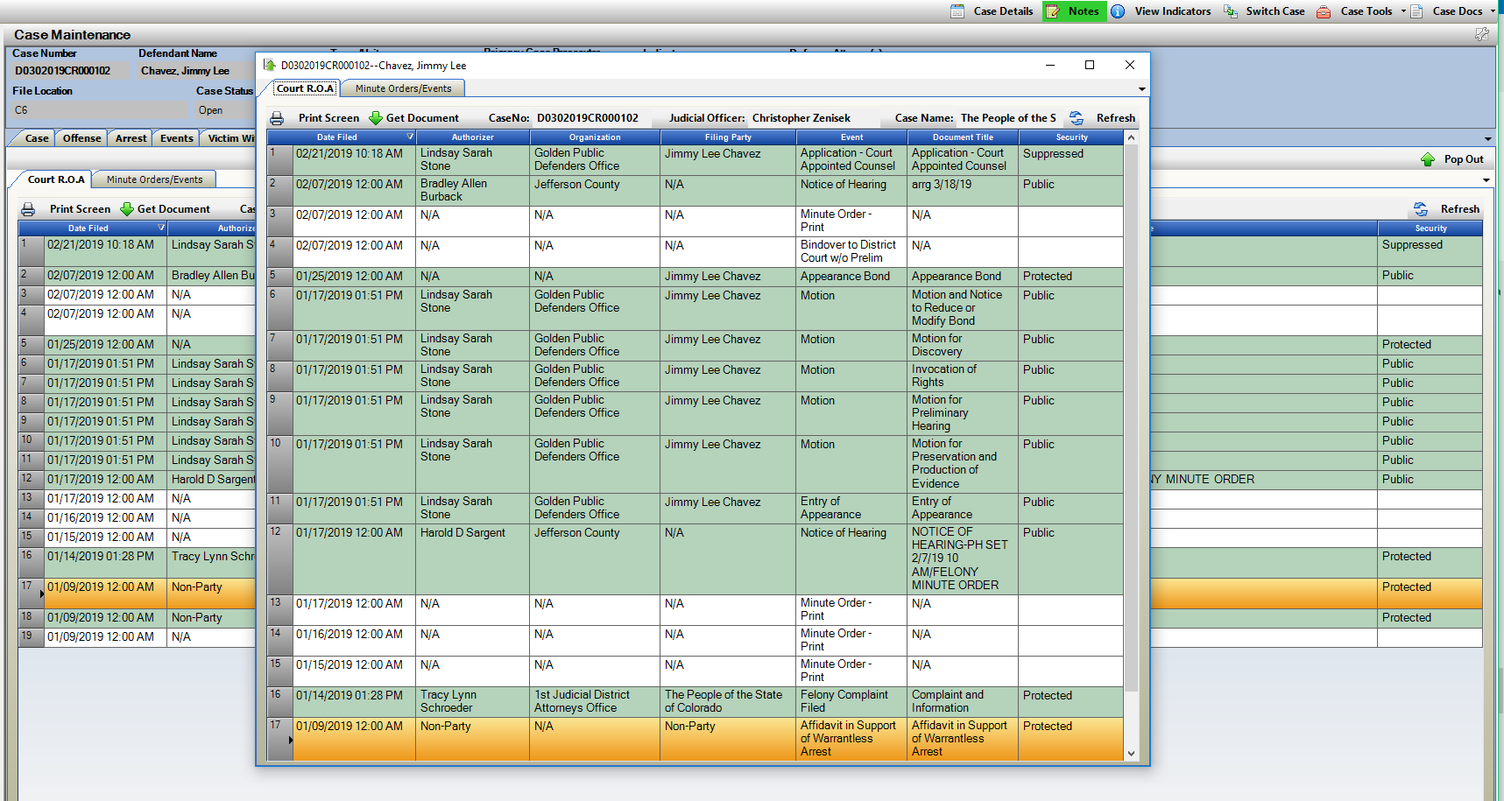

Work Flow/ User Task List- Enhancements

1. User Task List: User Task List Button color change for visual indicator of status of tasks.
   1. Red = Urgent Task
   2. Yellow = Elevated Task
   3. Green = Normal Task
   4. Gray = No new tasks, no urgent or elevated pending.
2. User Task List: Display Count of Total Incomplete Tasks per User
   1. Display of Total Incomplete Tasks is now added to the User Task List button for quick visual update of these pending tasks.
   2. Continued display count of “Un-Viewed” tasks so that when a new task is assigned it is also shown.
   3. Note: This is NOT counting Follow up tasks, only Incomplete Status.



Count of Unviewed Tasks

Count of Incomplete Tasks (x)







1. User Task List: Customization of columns/order per user.
   1. Drag and drop columns and use of the field selector to customize your view of the User Task List.

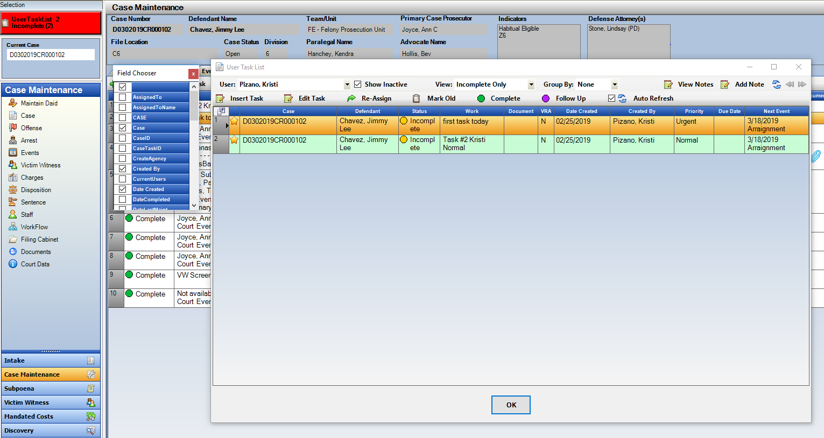

1. User Task List: Separate Columns “Date Created” and “Created By”.
   1. 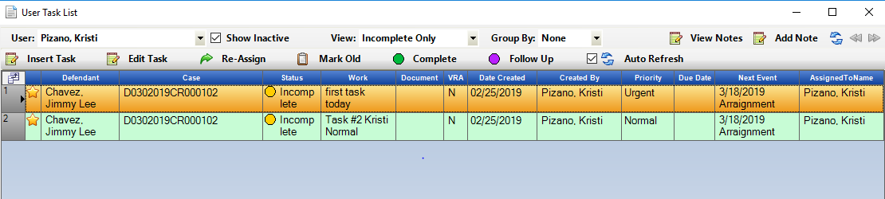These columns are now separated so users can now sort on either column specifically.
2. User Task List: Group by “Case View” is now sorting correctly, it was previously re-sorting when the screen was refreshed with new tasks.

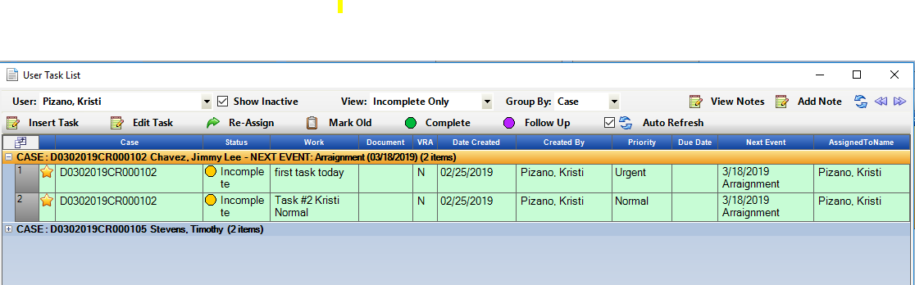

1. Work Flow Tab: Reassign Button added to this tab for quick updating from the case.
   1. Highlight specific task(s), click on Re-Assign, select the user to send task to. This will remove the current Assigned to user(s) and add in the user(s) selected.

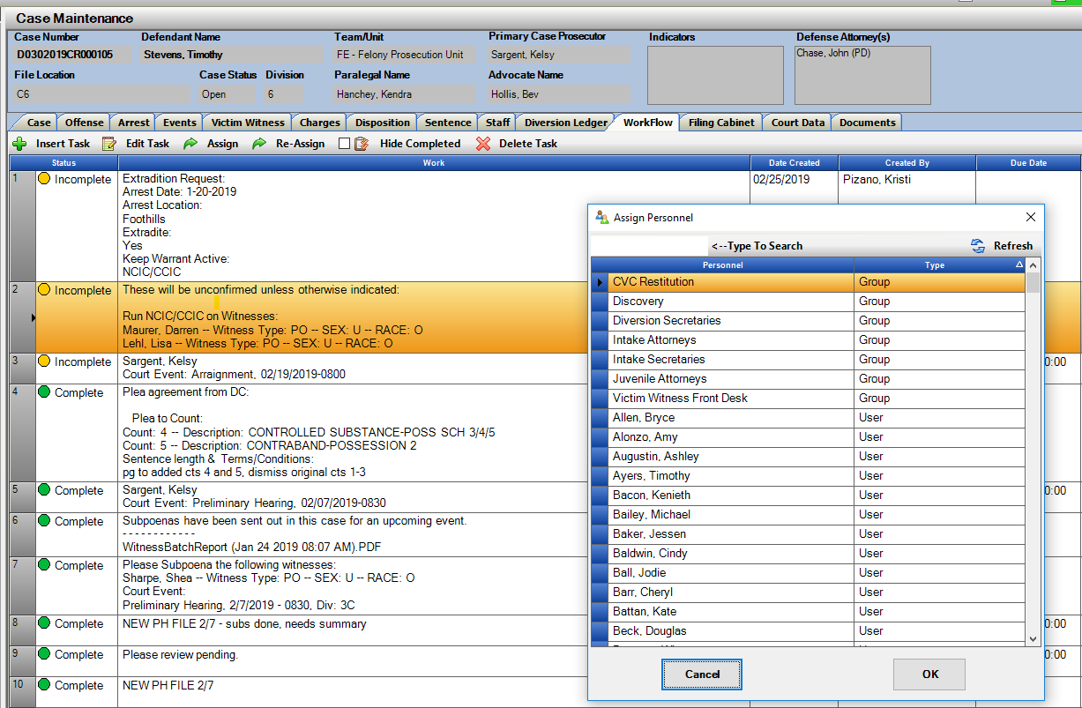

Prosecutor Tools

1. **Prosecutor and Division Docket- Mark as Complete**.

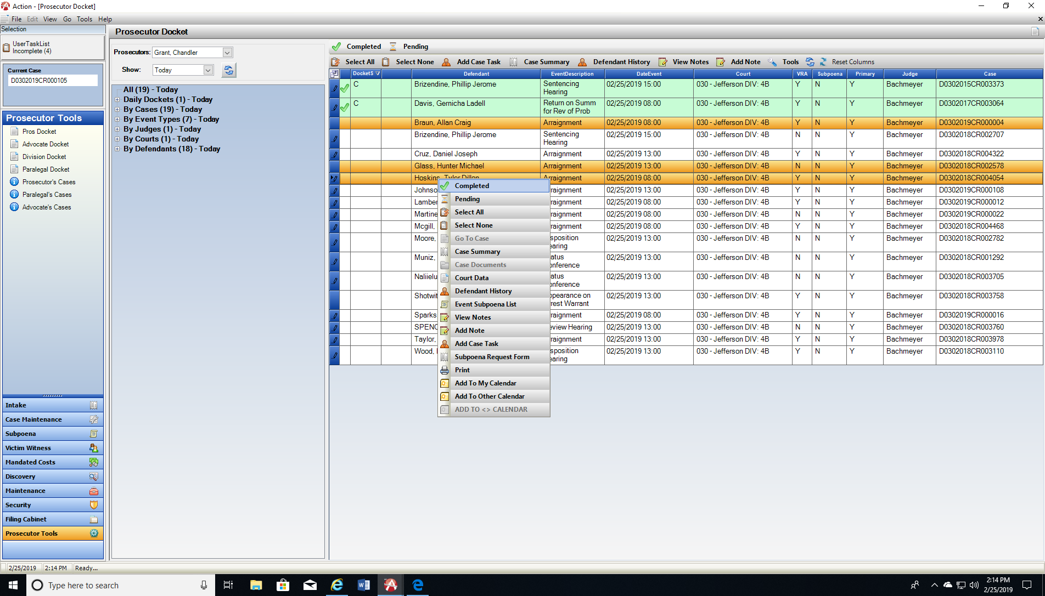Prosecutor and Division Dockets now have a tool to mark off events as they are heard in court. Highlight a singular row or multiple rows then click on Complete above or access from the Right Click Menu. This changes the row color green indicating the hearing occurred. If a row(s) is marked in error re-highlight and click on Pending. This changes the row color back to white.

1. **Prosecutor Tools – Field Selector** for users to customize their docket and case listings views. Click on the field selector button from any of the views. Add and Remove columns to be displayed. Re-arrange your columns based on individual preference.

*Note Add Column Docket Status to use to sort Complete Events in view above *

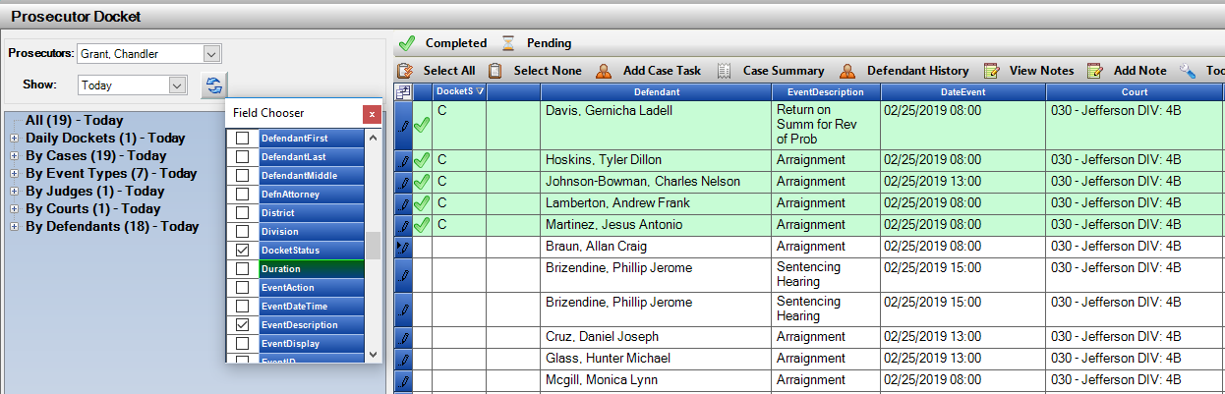Each Docket has its own sort, so each is customizable based on user preference.

1. **Advocate Cases List- View of all cases currently assigned to each Advocate**.
2. Cases on list are in Open, Re-Opened or Pending Case Status.
3. Columns are user customizable with the field selector as well.

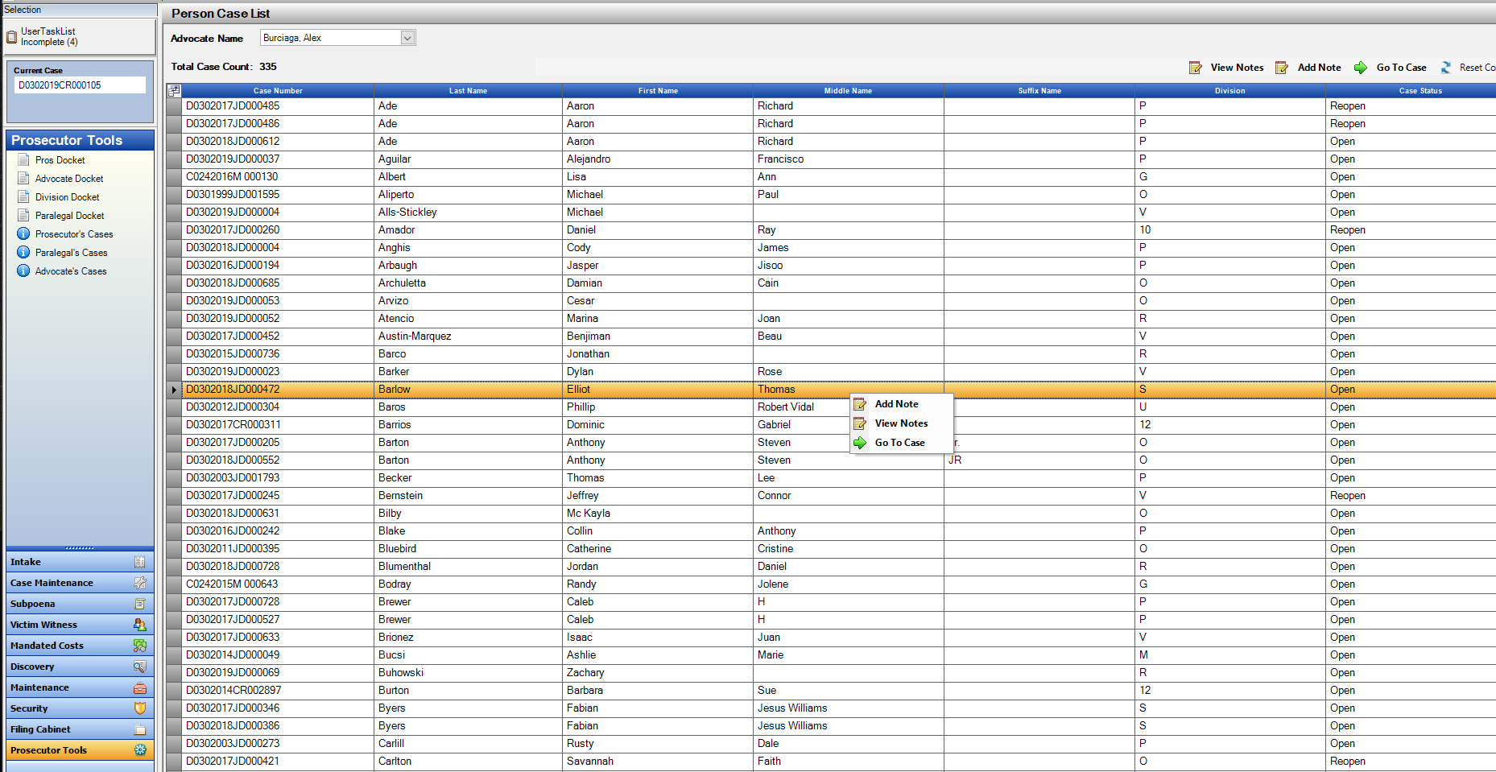

1. **Case Lists- Multi-Add Noting and Right-Click Menu**
2. All of the Case Lists under Prosecutor Tools now have the ability to allow a user to multi-select rows and click Add Note to add the same note to all selections at the same time. Previously this was just on the Docket Options.

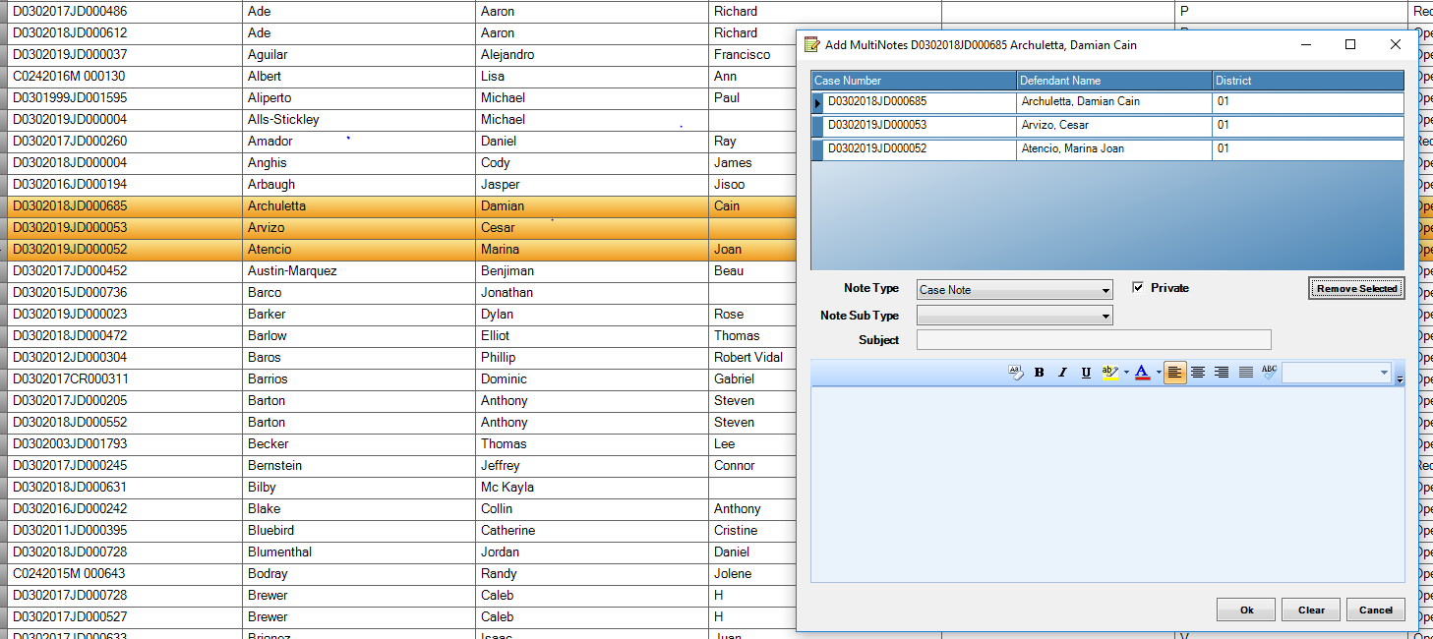

1. Case Listings also have the added Right-click Menu for options to View or Add Notes or Go to Case.

Charges

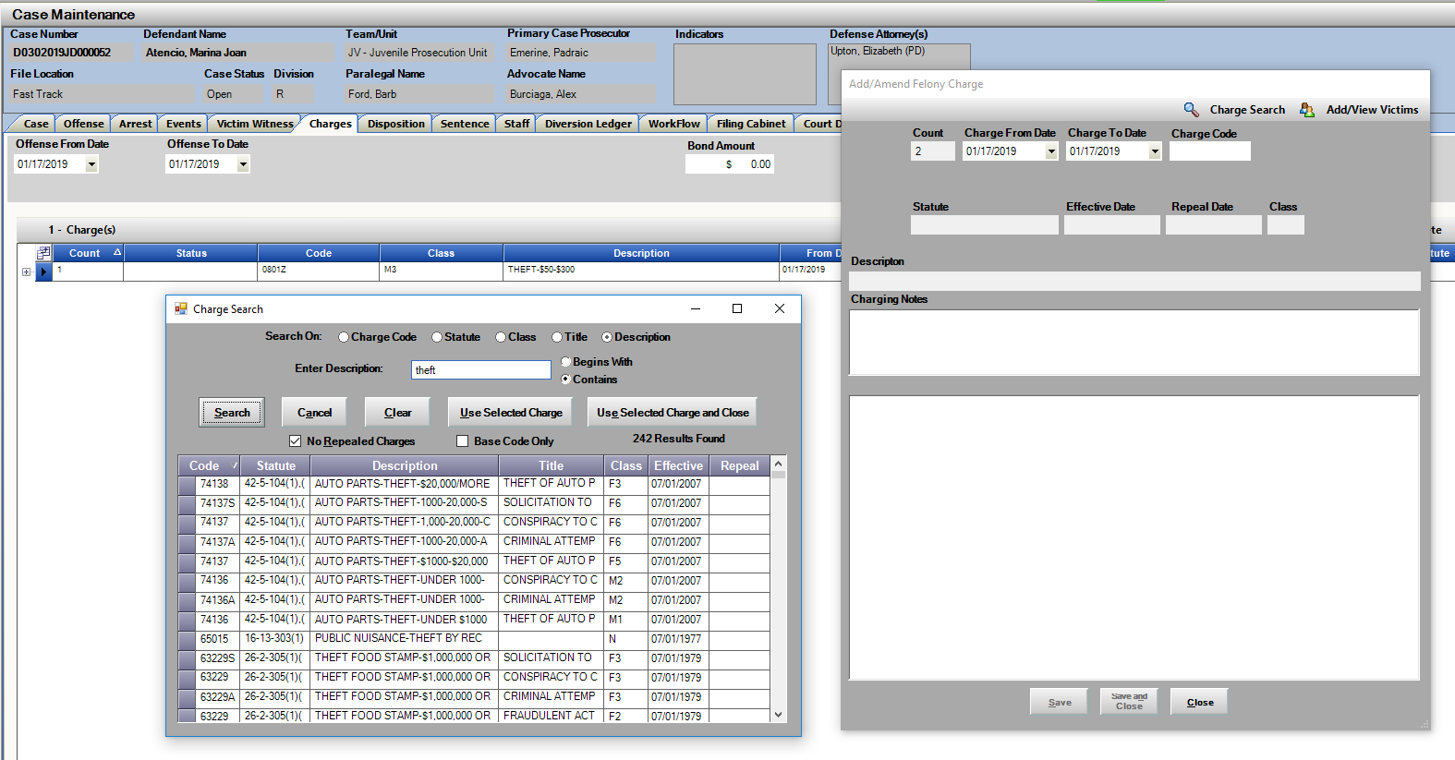Update to Charges so that when the Charge Search is used. The returned Valid charges in the view are based on the Charge Specific Range. Continue to un-check “No-Repealed” to view repealed charges if needed.

Dispositions

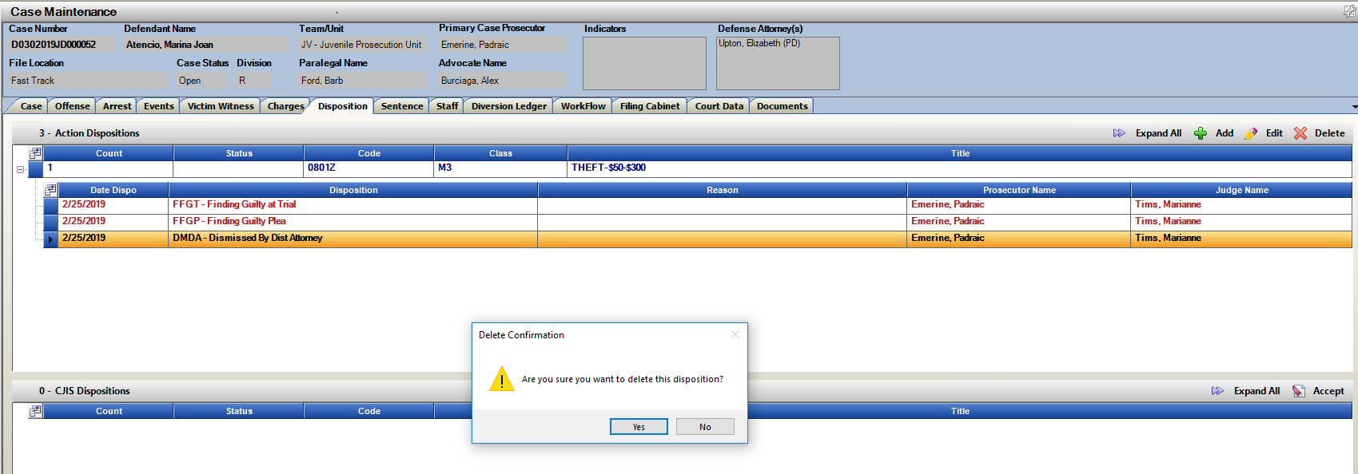Update to Dispositions to allow users to delete dispositions as long if there is a guilty disposition entered for any charge that has a Sentence attached already. If Sentence was incorrect, then delete SE record first and then the Disposition can be removed.

Sentence Notes

Sentences received by Judicial and/or entered by users can now have a SE note added to the Noting function of the case directly from the Sentence screen.

**Note; Sentence notes entered appear on produced VW Notification Letters, these notes are to supplement the Sentence conditions/terms. Not to be used to describe the event etc.

**Functionality:**

From the Sentence Tab – Add or Edit an existing Sentence to a charge. Type your Note into the Sentence Note Field. When the Sentence is saved, that note gets saved to the Notes within the Action case which appear on the Sentence Tab.

The note is not saved directly to the Sentence, so once saved it’s only viewable under the Noting Option on the case- on the Sentence Tab.

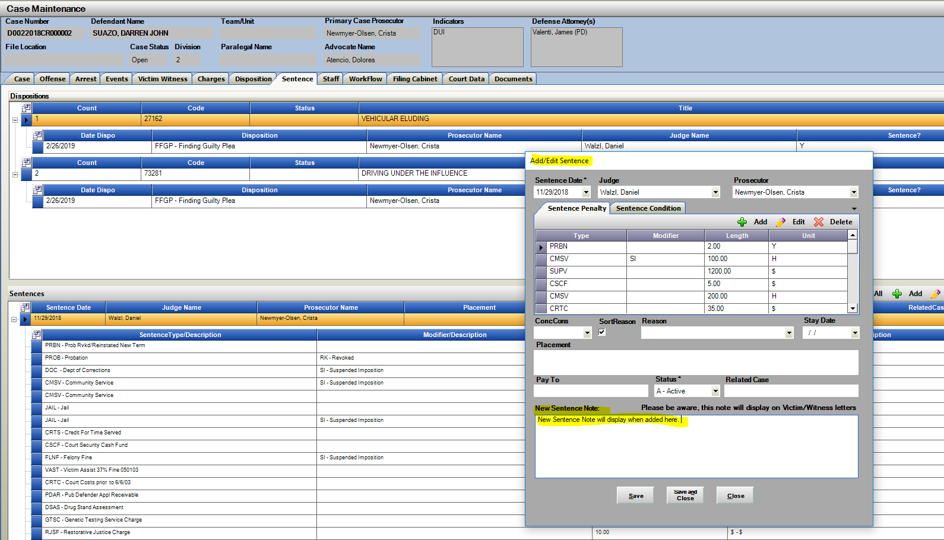

Setence Note added:

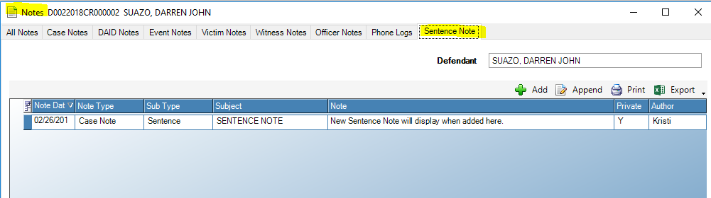

Note appearing on the VW Notification Letter:

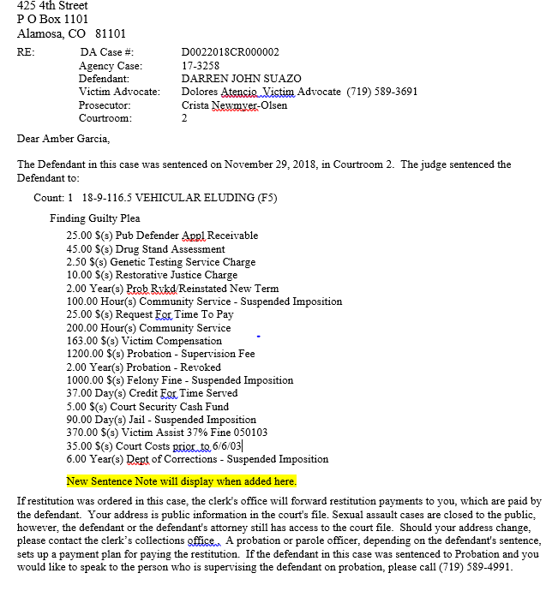

Brady Officer Maintenance

Update to require CDAC to uncheck any officer currently marked with the Brady Material check box on the officer’s entry.

As some LEA agencies are shared across districts and criteria for identifying officers as “Brady” may be different, locking down the removal of a Brady flag has now been introduced.

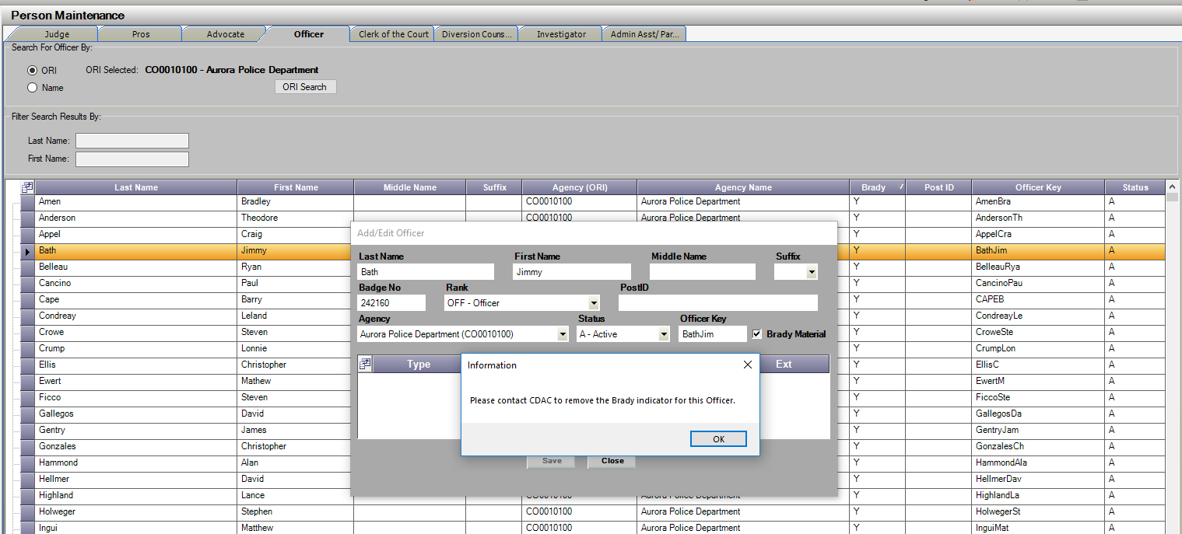Power Users can still update officers in the Maintenance Tables as being Brady with the use of the Brady Material check box. To have one removed please contact CDAC if necessary. An information message is shown to the users when they attempt to remove the flag as shown below.

Subpoena Production: Re-flag prior Witnesses

New button created to re-flag the same witnesses from the prior event on the same case for quick re-selection process. This flags the same

**Functionality:**

Subpoena Screen, previous subpoenas must have already been selected and sent on a prior event for the case. Click on Select Previous Event Witnesses and they will be selected – flagged automatically. User still must select Print Immediate or Add to Batch and Print from Batch to generate the selected Subpoenas.

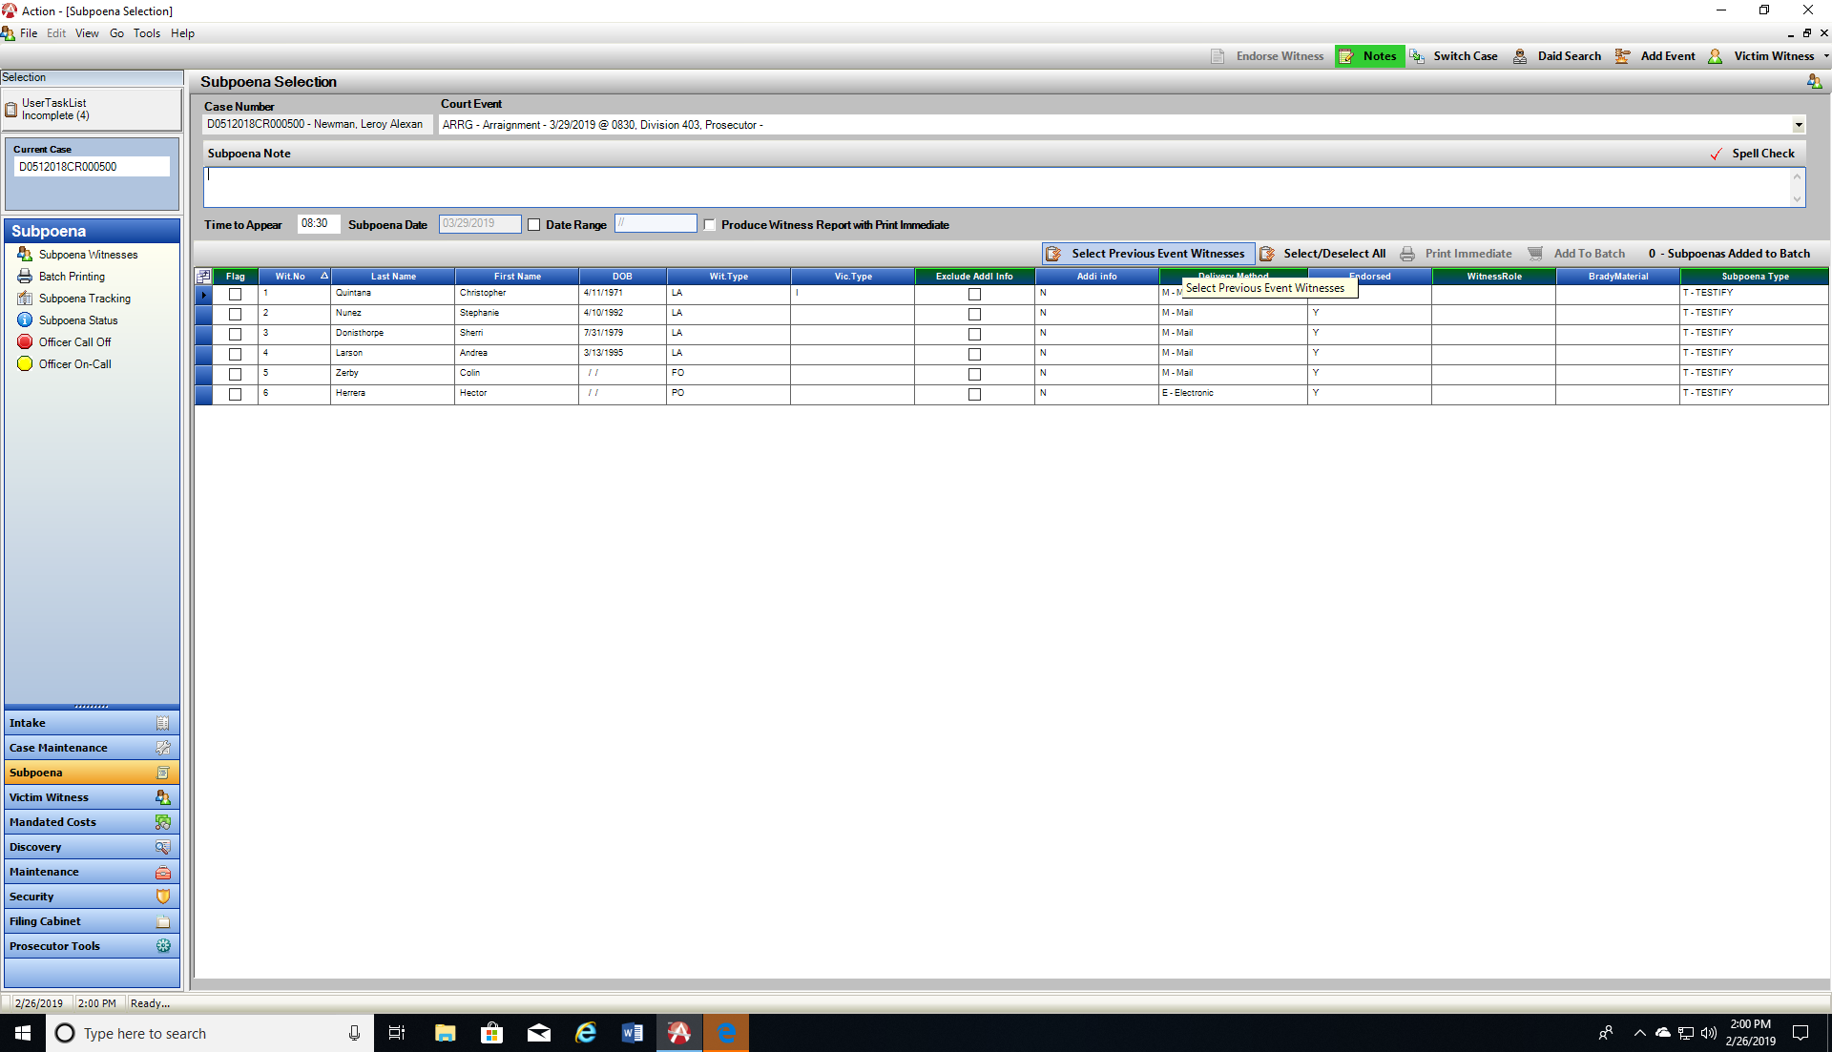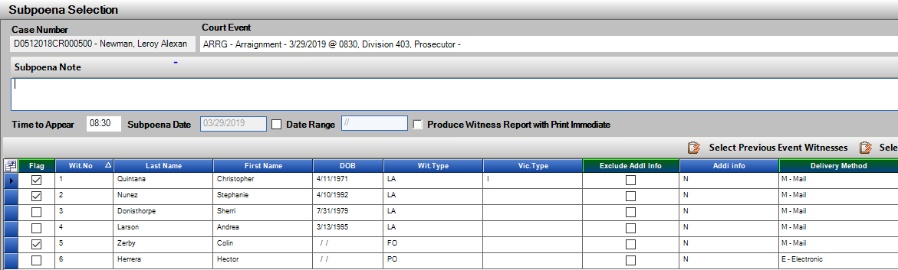

e-Subpoena Agencies: Restriction to Add New Officers

Restriction has been added to Action to prevent users from adding new officers to Agencies that are set-up for electronic subpoenas. This is to help prevent duplicate officer entries and to have the officer’s set-up correctly by their agency admins so that they have the correct credentials for e-Subpoenas.

Power Users can still add in new officers from the Maintenance tables if needed for a quick entry, but preferred entry is done from the Admin in the agency. Their entries populate our officer tables.

**Functionality:**

Add officer (+) button on multiple screens is now disabled if the agency that first selected by ORI is set-up for electronic subpoenas.

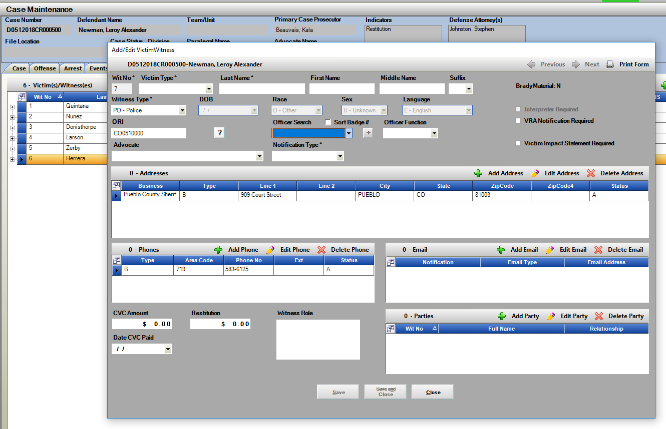

Delete Case: Warning message to Power Users

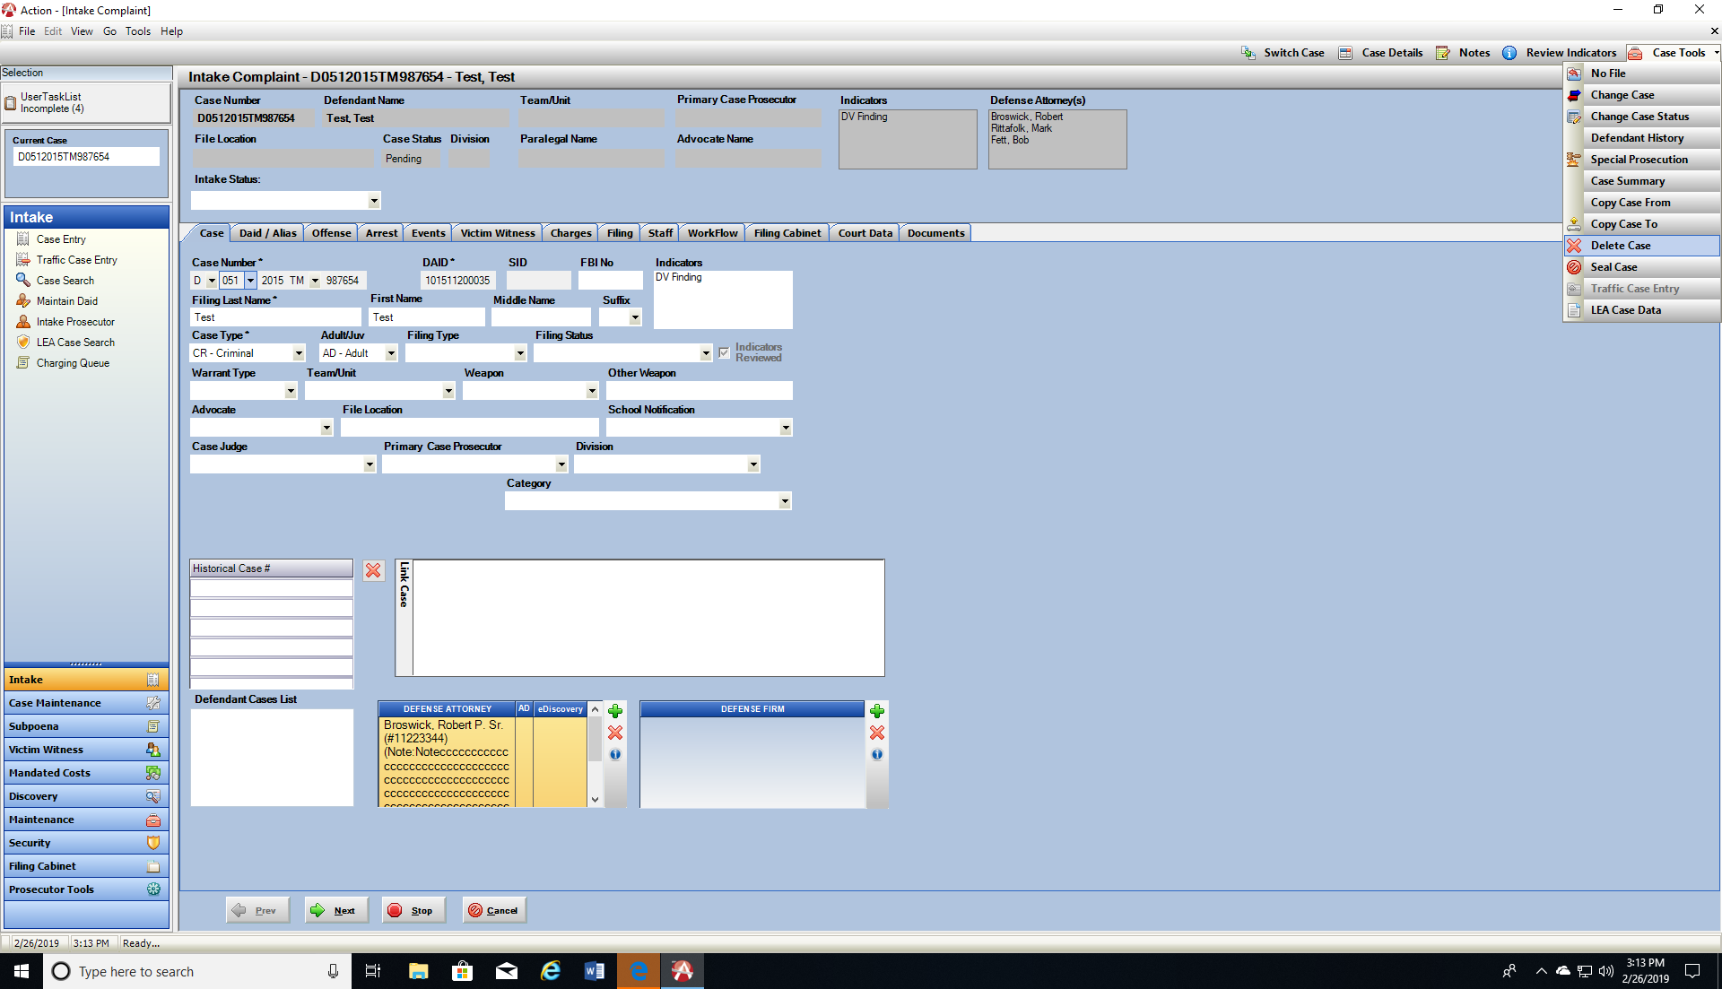Power users have the ability to delete created cases in Action while in the Intake Process. The associated confirmation of deletion message has been added to for an additional reminder of deleting files in the file cabinet first associated to that case, and also to check if that case was set up as a Co-Def within Action File Cabinet. Both of these can have side effects if not checked and handled first before case is deleted. Contact CDAC with any questions.

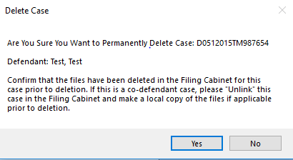

Doc. Gen- New Data Variables

For districts currently utilizing Doc. Gen. there are several new enhancements for this build. *Contact Kristi for questions on Doc. Gen. Trainings.

Update includes the following:

1. Date Selection variables for future or past dating.
2. Defendant ICE number variable.
3. Current Display of Charges for User selection will now include view of Disposition and Active Sentence for better user selection during document creation.
4. Offense and Summons List Selections

See following pages for documentation on each that can be added to work space to test new variables.

**New Doc Gen Variables**

**Date Selection Variables:**  Added options so a past or present date can be displayed within the document if selected.

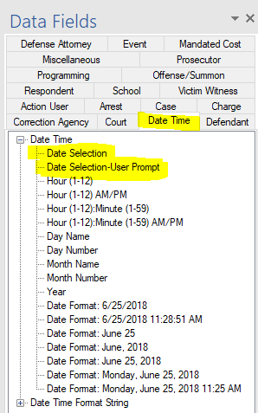**Location**: Date Time Tab

1. **Date Selection**

Define the date in the (0) 0 = current date; replace 0 with 1, 2 etc. for that many days in the future, or use (-1) for previous days-and it will back that many day’s and populate.

Examples:

<<[Case.DateSelection( **0** ).ToString(“d”)]>>; current date

<<[Case.DateSelection( **5** ).ToString(“d”)]>>; 5 days in the future from today

<<[Case.DateSelection( **-7**).ToString(“d”)]>>; 7 days in the past from today

1. **Date Selection-User Prompt**

User defines the date on a pop-up while document is generated. Same function where 0 = Current Date; 1, 2 etc. for that many future days, and -1, -2 etc. for amount of previous days.

Example:

<<[Case.DateSelection(Case.SetUserText(“Date Selection”)).ToString(“d”)]>>

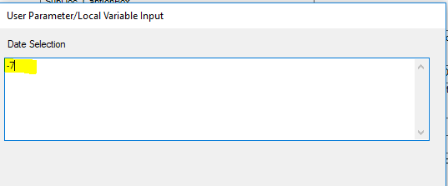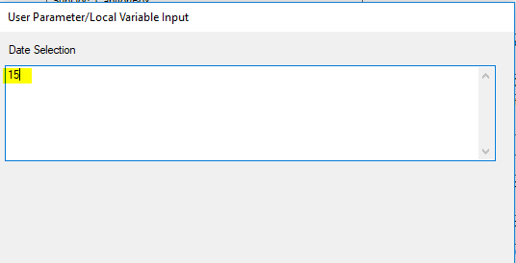

**Defendant ICE Number Variable.**

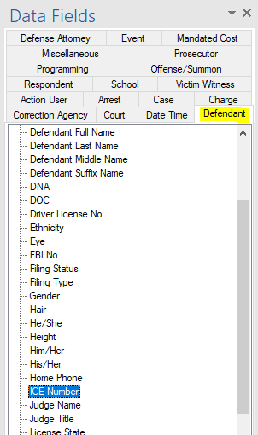**Location:** Defendant Tab

1. ICE Number

<<[Case.Defendant.ICENumber]>>

**User Display when prompted to select charges when producing a document now includes showing the the connected Disposition and Active SE column so they can select the charge intended.**

**Location:** Charges Tab

1. Display of Charges with Dispostion and Active Sentence for Users to select from when using the charging variable.

<<foreach[Charge in Case.ChargeSelection]>> RemoveIfEmpty

<<[Charge.ChargeCount]>>, Charge Code: <<[Charge.ChargeCode]>>, Charge Title: <<[Charge.Title]>>, Disposition: <<[Charge.Dispo]>>

<</foreach>> RemoveIfEmpty

When Document produced- User See’s the following

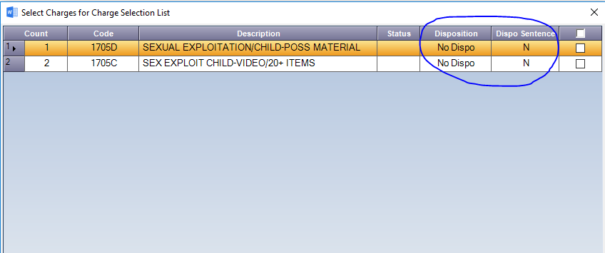

**Offense List and Summons List Selections by User**. Added option so users could select the offense/summons number desired if more than 1 has been entered onto an Action case.

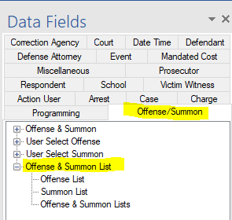

Location: Offense/Summon Tab

1. Offense List

<<foreach[Offense in Case.OffenseSummonList]>> RemoveIfEmpty

<<if[Offense.OffenseAge > 0]>><<[Offense.OffenseAge]>><</if>> RemoveIfEmpty

<<if[!Offense.IsDateFromNull()] >><<[Offense.DateFrom.ToString(“MM/dd/yyyy”)]>><</if>> RemoveIfEmpty

<<if[!Offense.IsDateToNull()] >><<[Offense.DateTo.ToString(“MM/dd/yyyy”)]>><</if>> RemoveIfEmpty

<<[Offense.FullLocation]>> RemoveIfEmpty

<<foreach[OffenseNo in Offense.OffenseNumberList]>> RemoveIfEmpty

<<[OffenseNo.Number]>> RemoveIfEmpty

<<[OffenseNo.AgencyORI]>> RemoveIfEmpty

<</foreach>> RemoveIfEmpty

<<if[Offense.NumberOf() == Case.OffenseSummonList.Count]>> RemoveIfEmpty<</if>>

<</foreach>> RemoveIfEmpty

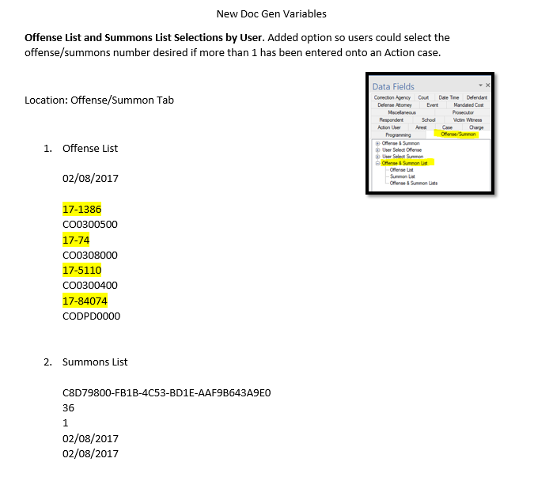

1. Summons List

<<foreach[Offense in Case.OffenseSummonList]>> RemoveIfEmpty

<<[Offense.OffenseID.ToString().ToUpper()]>> RemoveIfEmpty

<<if[Offense.OffenseAge > 0]>><<[Offense.OffenseAge]>><</if>> RemoveIfEmpty

<<[Offense.SeqNo]>> RemoveIfEmpty

<<if[!Offense.IsDateFromNull()] >><<[Offense.DateFrom.ToString(“MM/dd/yyyy”)]>><</if>> RemoveIfEmpty

<<if[!Offense.IsDateToNull()] >><<[Offense.DateTo.ToString(“MM/dd/yyyy”)]>><</if>> RemoveIfEmpty

<<[Offense.TimeFrom]>> RemoveIfEmpty

<<[Offense.TimeTo]>> RemoveIfEmpty

<<[Offense.Accident]>> RemoveIfEmpty

<<[Offense.Injuries]>> RemoveIfEmpty

<<[Offense.Location]>> RemoveIfEmpty

<<[Offense.FullLocation]>> RemoveIfEmpty

<<[Offense.City]>> RemoveIfEmpty

<<[Offense.State]>> RemoveIfEmpty

<<foreach[SummonNo in Offense.SummonNumberList]>> RemoveIfEmpty

<<[SummonNo.Number]>> RemoveIfEmpty

<<[SummonNo.AgencyORI]>> RemoveIfEmpty

<<[SummonNo.OfficerName]>> RemoveIfEmpty

<<[SummonNo.AgencyName]>> RemoveIfEmpty

<<[SummonNo.AgencyAddressLine1]>> RemoveIfEmpty

<<[SummonNo.AgencyAddressLine2]>> RemoveIfEmpty

<<[SummonNo.AgencyCSZ]>> RemoveIfEmpty

<<[SummonNo.AgencyState]>> RemoveIfEmpty

<<[SummonNo.AgencyCity]>> RemoveIfEmpty

<<[SummonNo.AgencyZipCode]>> RemoveIfEmpty

<<[SummonNo.AgencyFullAddress]>> RemoveIfEmpty

<</foreach>> RemoveIfEmpty

<<if[Offense.NumberOf() == Case.OffenseSummonList.Count]>> RemoveIfEmpty<</if>>

<</foreach>> RemoveIfEmpty

1. Offense & Summons Lists

<<foreach[Offense in Case.OffenseSummonList]>> RemoveIfEmpty

<<[Offense.OffenseID.ToString().ToUpper()]>> RemoveIfEmpty

<<if[Offense.OffenseAge > 0]>><<[Offense.OffenseAge]>><</if>> RemoveIfEmpty

<<[Offense.SeqNo]>> RemoveIfEmpty

<<if[!Offense.IsDateFromNull()] >><<[Offense.DateFrom.ToString(“MM/dd/yyyy”)]>><</if>> RemoveIfEmpty

<<if[!Offense.IsDateToNull()] >><<[Offense.DateTo.ToString(“MM/dd/yyyy”)]>><</if>> RemoveIfEmpty

<<[Offense.TimeFrom]>> RemoveIfEmpty

<<[Offense.TimeTo]>> RemoveIfEmpty

<<[Offense.Accident]>> RemoveIfEmpty

<<[Offense.Injuries]>> RemoveIfEmpty

<<[Offense.Location]>> RemoveIfEmpty

<<[Offense.FullLocation]>> RemoveIfEmpty

<<[Offense.City]>> RemoveIfEmpty

<<[Offense.State]>> RemoveIfEmpty

<<foreach[OffenseNo in Offense.OffenseNumberList]>> RemoveIfEmpty

<<[OffenseNo.Number]>> RemoveIfEmpty

<<[OffenseNo.AgencyORI]>> RemoveIfEmpty

<<[OffenseNo.OfficerName]>> RemoveIfEmpty

<<[OffenseNo.AgencyName]>> RemoveIfEmpty

<<[OffenseNo.AgencyAddressLine1]>> RemoveIfEmpty

<<[OffenseNo.AgencyAddressLine2]>> RemoveIfEmpty

<<[OffenseNo.AgencyCSZ]>> RemoveIfEmpty

<<[OffenseNo.AgencyState]>> RemoveIfEmpty

<<[OffenseNo.AgencyCity]>> RemoveIfEmpty

<<[OffenseNo.AgencyZipCode]>> RemoveIfEmpty

<<[OffenseNo.AgencyFullAddress]>> RemoveIfEmpty

<</foreach>> RemoveIfEmpty

<<foreach[SummonNo in Offense.SummonNumberList]>> RemoveIfEmpty

<<[SummonNo.Number]>> RemoveIfEmpty

<<[SummonNo.AgencyORI]>> RemoveIfEmpty

<<[SummonNo.OfficerName]>> RemoveIfEmpty

<<[SummonNo.AgencyName]>> RemoveIfEmpty

<<[SummonNo.AgencyAddressLine1]>> RemoveIfEmpty

<<[SummonNo.AgencyAddressLine2]>> RemoveIfEmpty

<<[SummonNo.AgencyCSZ]>> RemoveIfEmpty

<<[SummonNo.AgencyState]>> RemoveIfEmpty

<<[SummonNo.AgencyCity]>> RemoveIfEmpty

<<[SummonNo.AgencyZipCode]>> RemoveIfEmpty

<<[SummonNo.AgencyFullAddress]>> RemoveIfEmpty

<</foreach>> RemoveIfEmpty

<<if[Offense.NumberOf() == Case.OffenseSummonList.Count]>> RemoveIfEmpty<</if>>

<</foreach>> RemoveIfEmpty

Miscellaneous

1. FBI field label on DAID Search Screen was cut –off now fixed.
2. Removed calendar option for date filed on the Case Tab as this is auto-populated.