Action Enhancement Guide

June 2019 Training Guide



Training Materials can be found on our website on the Action Page

<http://www.CDACweb.com>



Table of Contents

1. Prosecutor Tools: ……………………………………………………………………………………………………….. 4-5
   1. DA Investigators cases list option.
   2. Print function added to case list options.
2. Staff Tab …………………………………….……........………………………………………………….…………….. 6
   1. Primary Paralegal checkbox to denote primary if there are multiple

Paralegals entered into this staff entry per case.

1. Indicators: …………………………………………………….……………………………………………………….. 7
   1. Increase case indicator window size.
2. Work Flow: ………………………………………………………………………………………………………………… 8
   1. Insert a new WF task for the case without going to Work Flow tab.
3. Work Flow: …………………………………………………………………………………………………. 9-10
   1. User option to claim a WF task when it is assigned to a group or

multiple users.

1. Work Flow: …………………………………………………………………………………………..………………... 11-12
   1. District specific categories to help identify the tasks for users.
2. Intake: Initiating Events Screen…………………………………………………………………..… 13
   1. Option to view the removed cases, if user needs to re-access.
   2. Offense Number and ORI added to main view of grid.
   3. Offense Information added to details screen.
3. Intake: LEA Search Screen ……………………………………………………………………….…… 14
   1. Remove multiple records at once from this screen.
4. Intake: Seal Case ….…….…………………………………………………….…………………………. 15
   1. Sealing a case while in Intake status, will keep case in Intake.
5. Court Data: ……………………………………………………………………………………………….…… 16-17
   1. Additional Court Data displayed including history information and

financial summary.

1. Notes: …………………………….……………………………………………………………………………….……….… 18
   1. Noting now includes user preferences for selected columns and order.
2. Notes: Multi-Note………………………………………………………………………………………………………... 19
   1. Victim/Witness Tab, highlight multiple witnesses and click add note

to add same note to all selected.

1. Copy Case: ……………………………………..…………………………………………………………………… 20
   1. Option to retain count number when copying charge from and to

cases without automatically being renumbered.

1. Miscellaneous/Bug Fixes……………………………………………………………………………………………. 21
   1. User Task List: Fix for list resorting from selected highlighted row when refreshed.
   2. Traffic Case Entry: was allowing bad data in Offense/Summons

and ORI fields. This now has been validated before moving on case entry.

* 1. Prosecutor Dockets: Save state of the grid and sort when rows are marked as completed.
  2. Subpoena Status Screen: Restrict users from modifying location field on electronic subpoenas to retain integratory of information.

Prosecutor Tools

**Investigator Case List**

DA Investigators now have an option to view all cases assigned to them within Action. This displays Pending, Open, or Re-Opened Cases that have been assigned to them within the Staff Tab on an Action Case.

Screen Options:

View or Add Case Notes

Go to Case

Print list

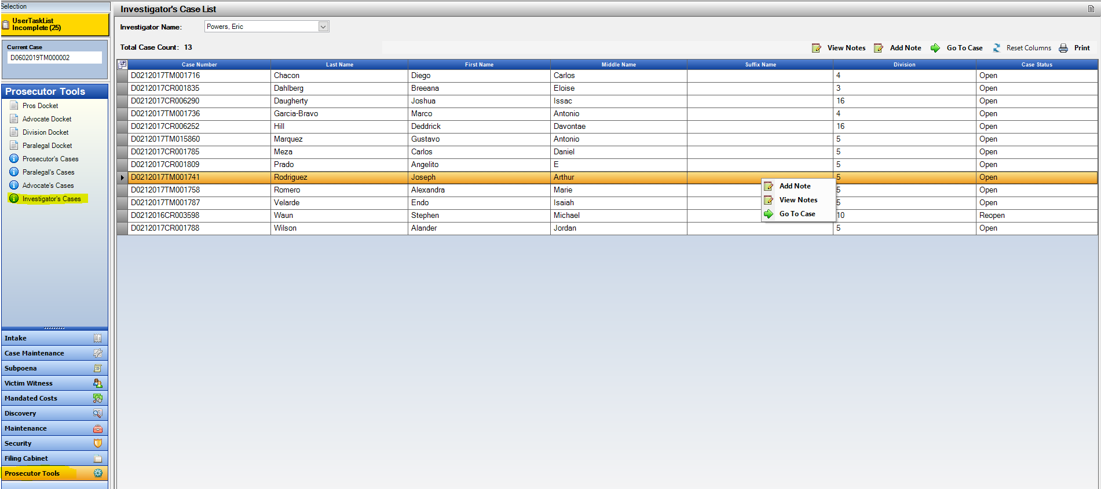Sortable Column Headers

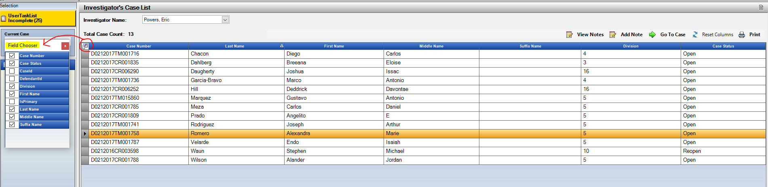Field Chooser, for columns displayed and column order is user specific.

Prosecutor Tools

**Case List Print function**

Print option is now added to all of the Case Listing options within Prosecutor Tools. This will print based on your current view- you can sort the column headers first and then on print.

*This is a great view of what is currently assigned to specific users before requesting batch changes.

Prosecutors Cases

Paralegals Cases

Advocate Cases

Investigator Cases

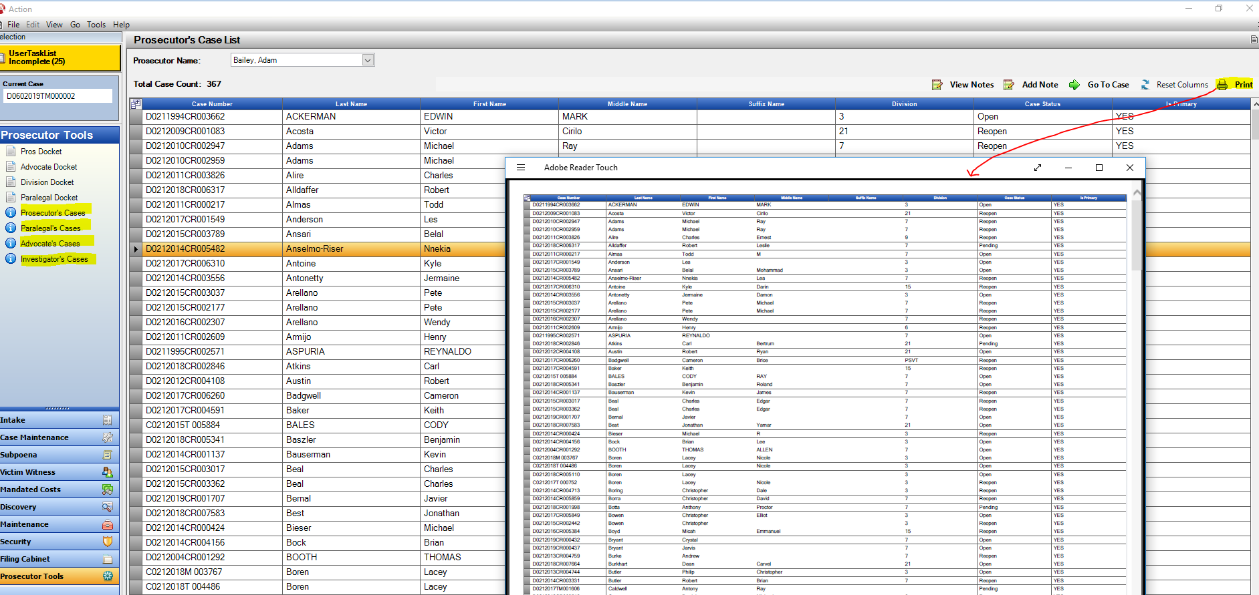

Staff Tab: Primary Paralegal

**Primary Paralegal case designation**

Primary Paralegal/Admin Assistant designation has been added to the staff tab. This will allow multiple entries but also gives the option to denote one as Primary- the one selected as primary then will appear in the case header.

Note* Handling of prior entries: CDAC will update current paralegal as primary on cases. If multiples the one currently appearing in the Paralegal Name field in the case header is selected.

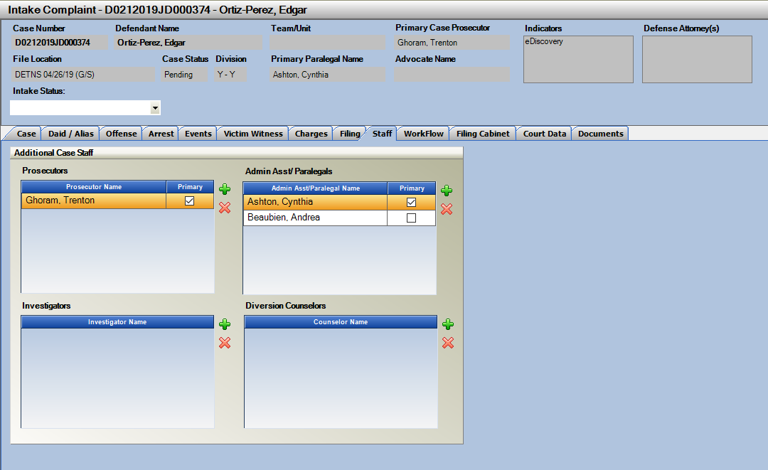

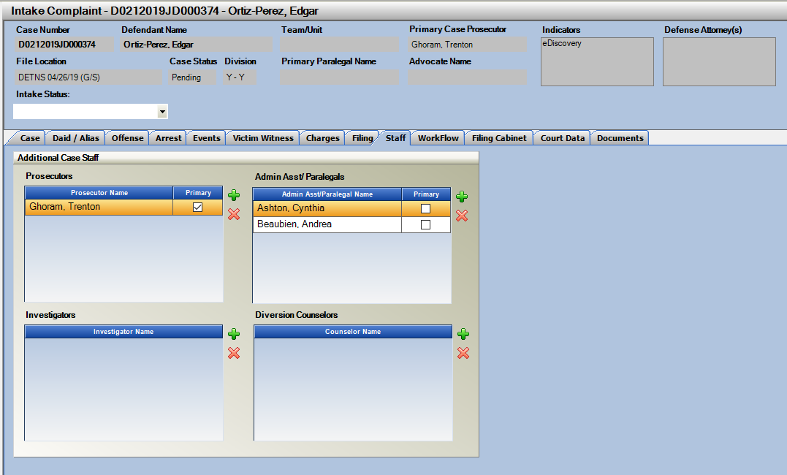

Indicator List

**Indicator List**

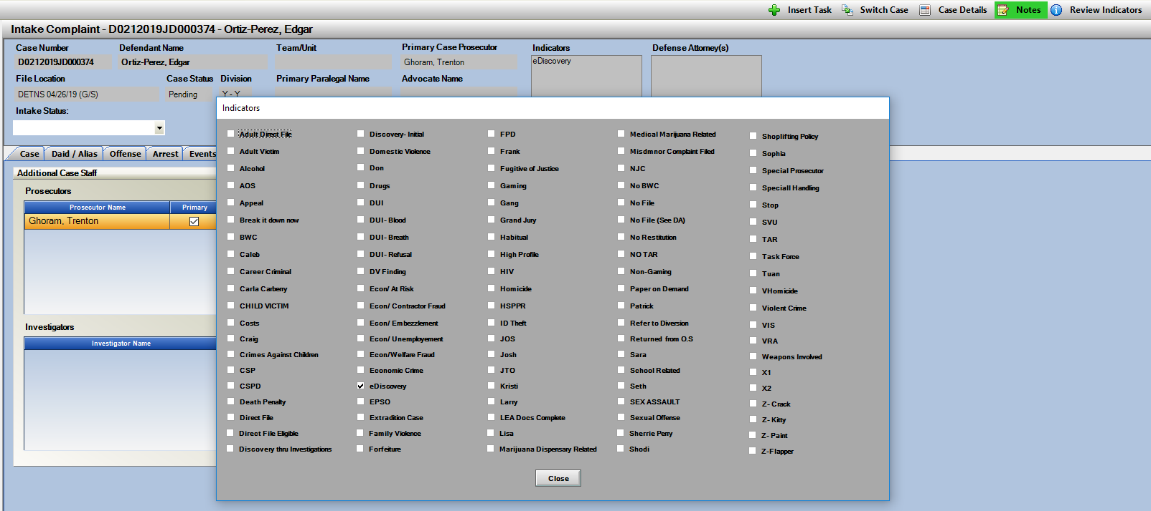Increase to Indicator display window. This was previously cutting off at 80 entries now increased to 100. These indicators are district specific for tracking/reporting and notification of specific things related to the case that also appear in the Indicators box on the case header.

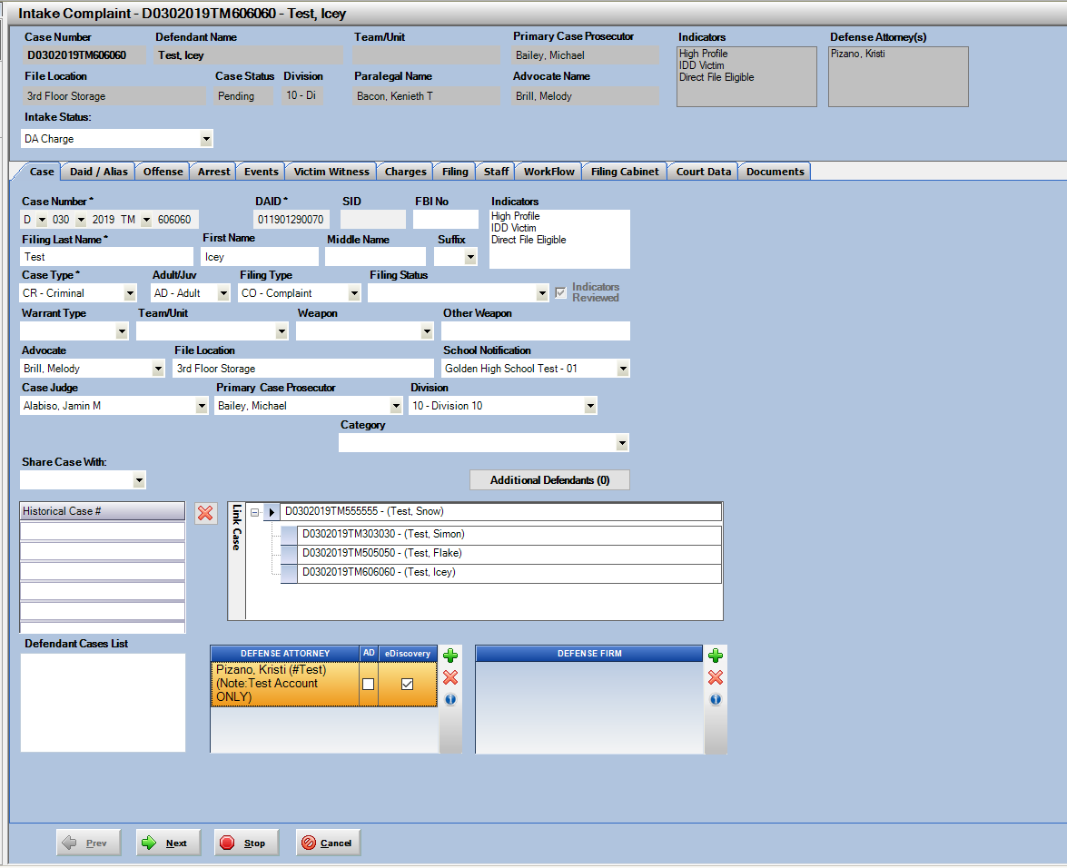

Work Flow: Insert Task

**Insert Task on Main Case Header**

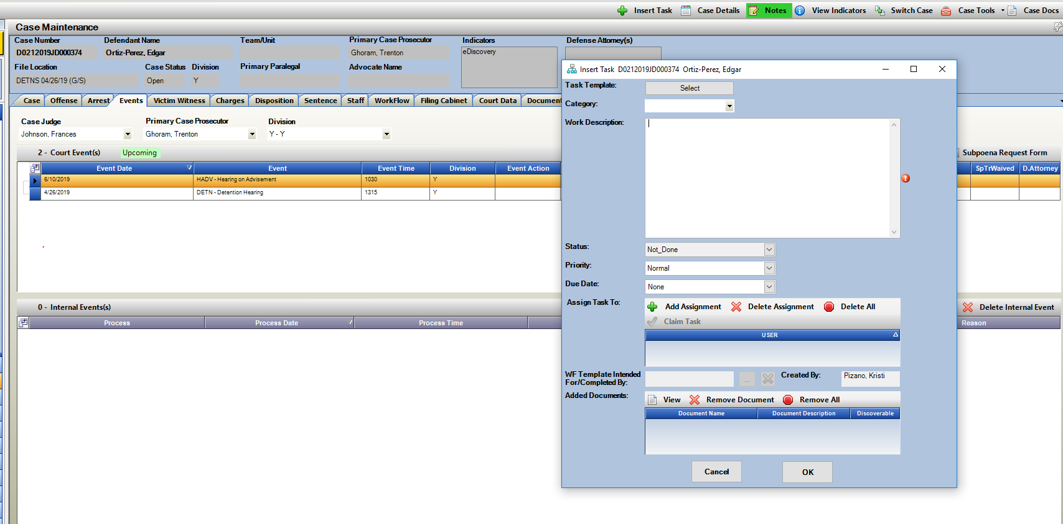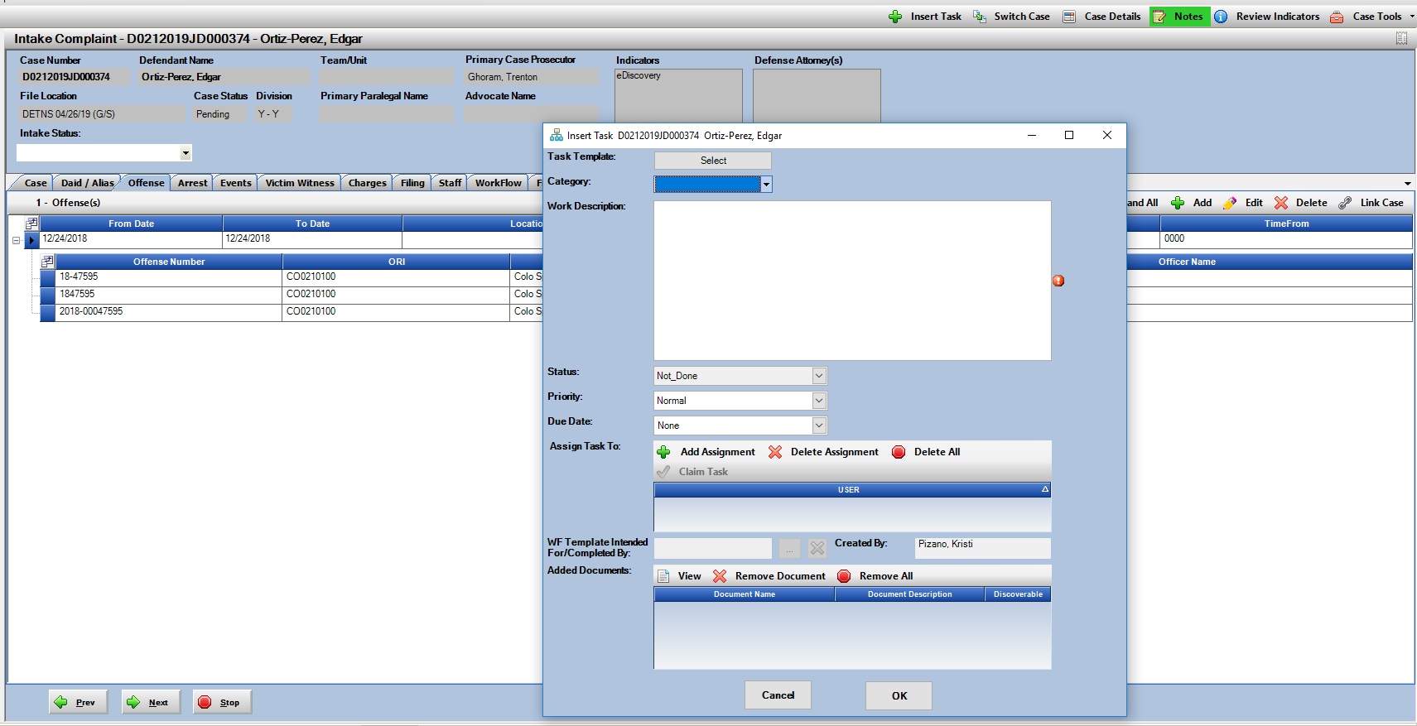Create new Work Flow tasks from anywhere within your Action case. Insert Task now on the Main Case form on Intake and Case Maintenance Cases.

Work Flow: Claim Task

**Claim Work Flow Task Option**

Work flow tasks can now be claimed by one of users the task is assigned to. This comes into play when you have a task that was sent to multiple users or a group. This function allows the one claiming it to stay as the assigned user, while other users assigned are then removed from that task. This is to help with users overlapping efforts on common tasks.

User Tasks List:

Use the field selector to add in the column Assigned to Name- this will show you all of the users assigned to a Task.

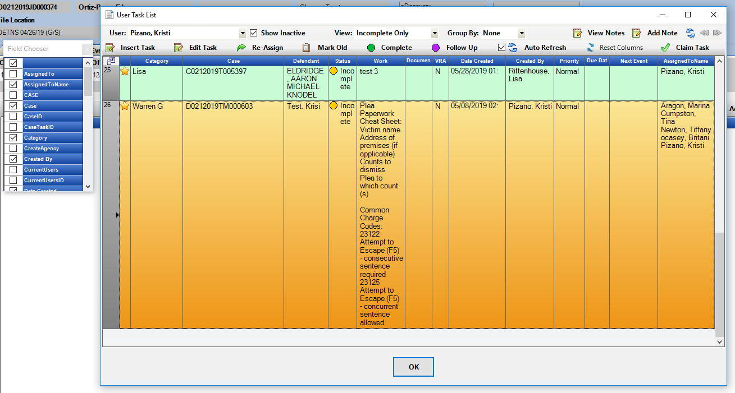To claim a task, highlight the task row and click on Claim Task button, or Open the task and click on Claim within it.

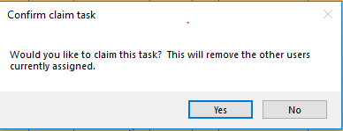

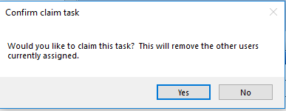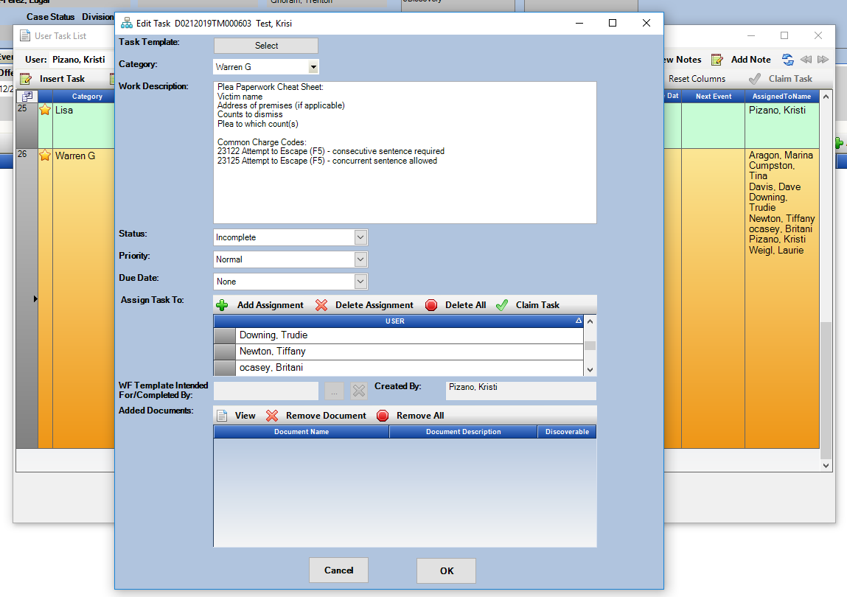

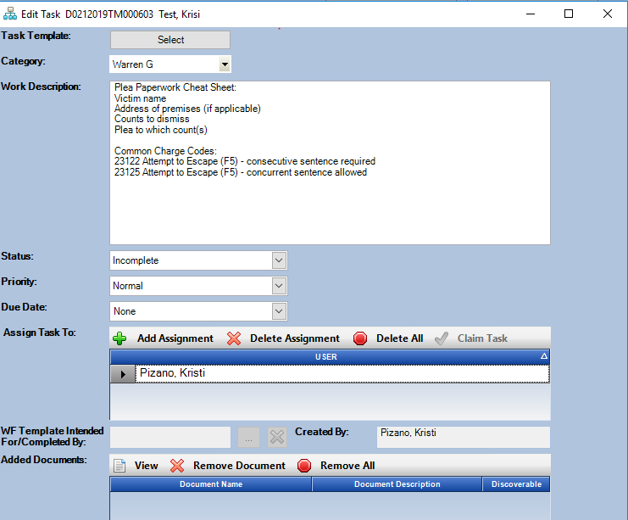

Work Flow: Categorize Tasks

**Work Flow – Categories**

Each District can now have CDAC create Work Flow Categories. These Categories become selectable as part of the task allowing for prioritizing by Category for users.

Examples:

Plea Paperwork

VW Notification

Writs

(anything you want to classify a task by)

Please send your district list to [Kristi@cdac.state.co.us](mailto:Kristi@cdac.state.co.us)

These categories can then be selected on the User Task List- Category Column, or from within a Task.

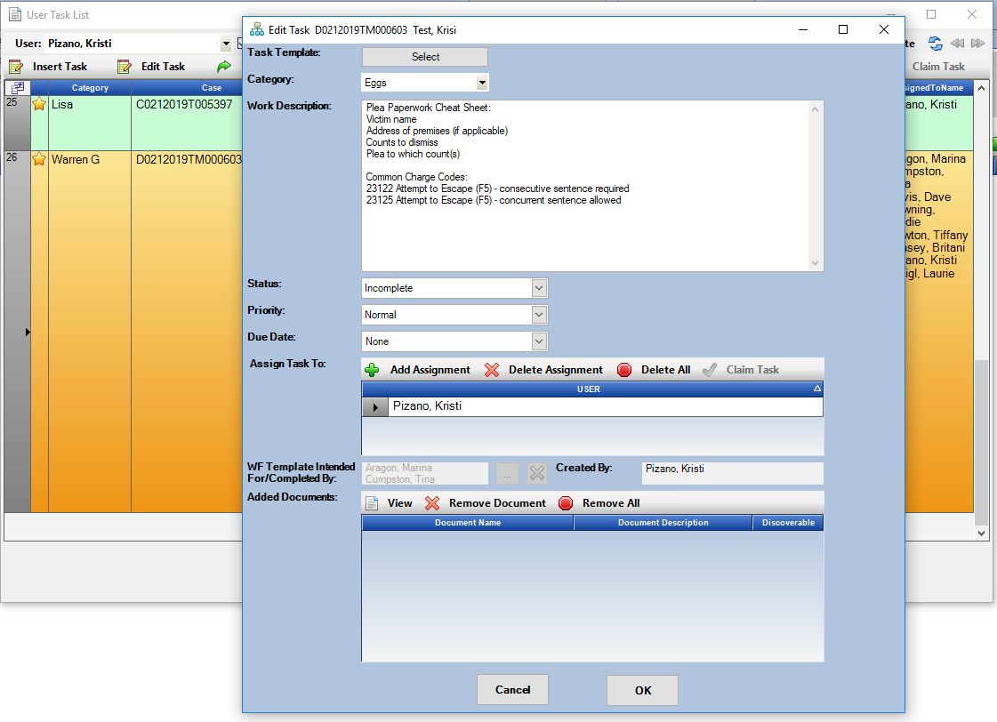

On the user task list there is also an option to **Group by Category**. This will let the users see all of the tasks currently assigned to them by category. Expand each grouping by clicking on the plus button. If no Category is assigned to tasks they group together at the top of the list. They are listed alphabetically.

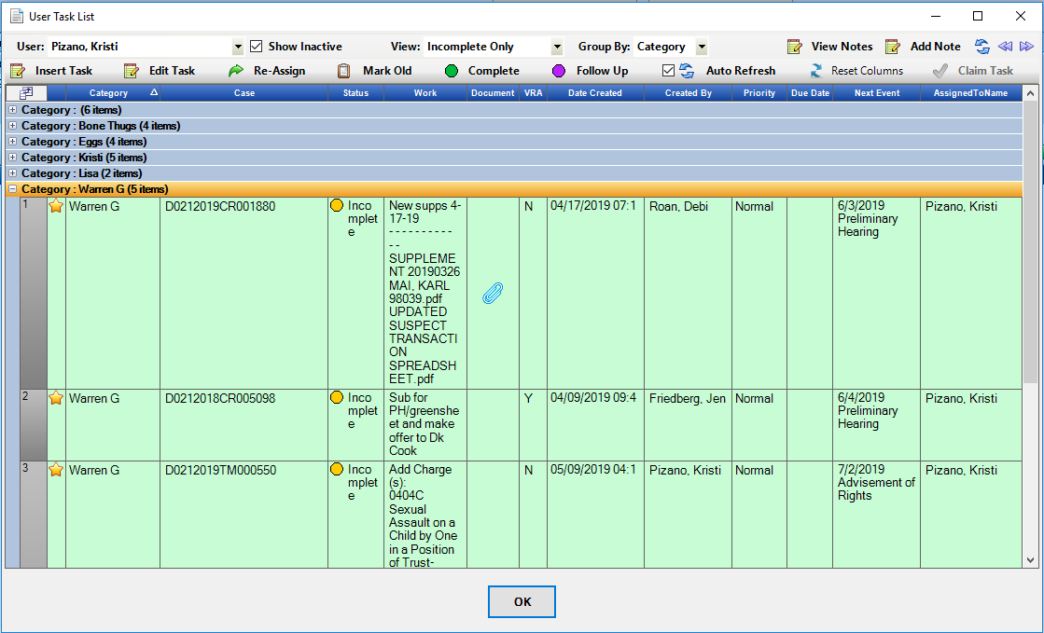

Intake: Initiating Event Screen

**Option to View Removed Cases**

Users were previously given the option to remove cases from this screen that they would not be starting within Action. There is now an option to view those removed records and re-access if they were removed by a user by accident. Enter Specific Variables to search on and then click on Display Removed only checkbox then on search.

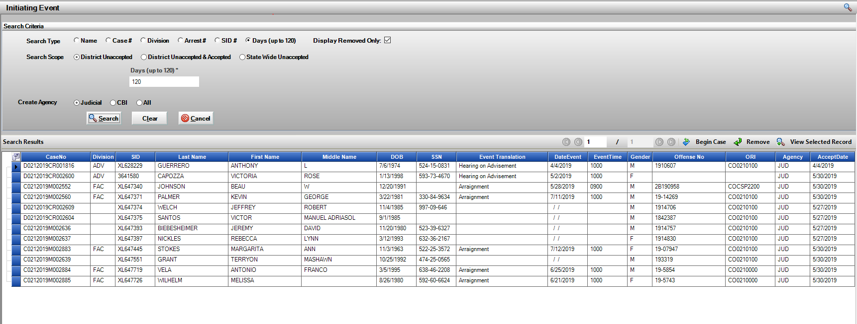

**Offense Number and ORI added to Main Grid to match up records easier, also added to Details when View Selected Record is selected.**

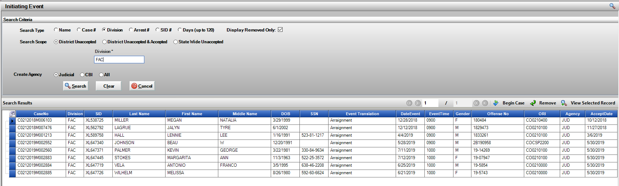

Intake: LEA Search Screen

**Remove multiple Records at once**

User can now highlight multiple rows on the LEA search screen and select a removal reason for all, instead of removing one at a time. Use Ctrl or Shift on your keyboard to multi-select rows and then select Removal Record reason.

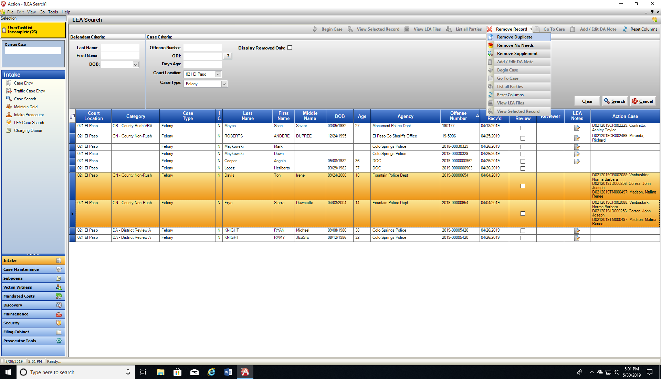

Intake: Sealing Case

**Intake cases can now be sealed and will remain within Intake.**

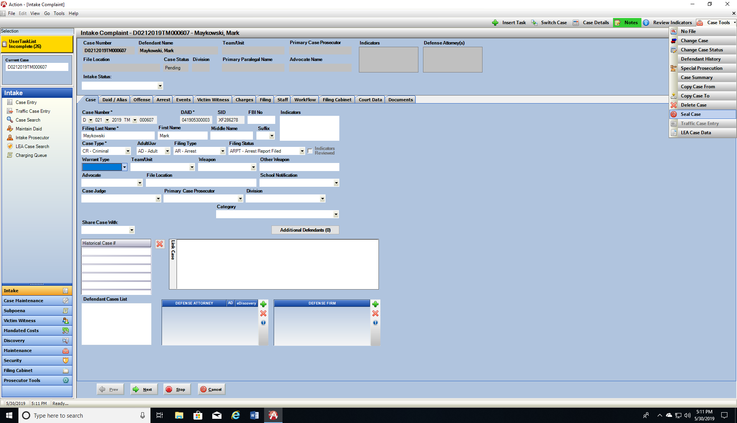Select Seal Case from the Case Tools drop down selection. Defendant Name on case changes to Record Sealed, Case status is still updated to Sealed, but case will remain in Intake.

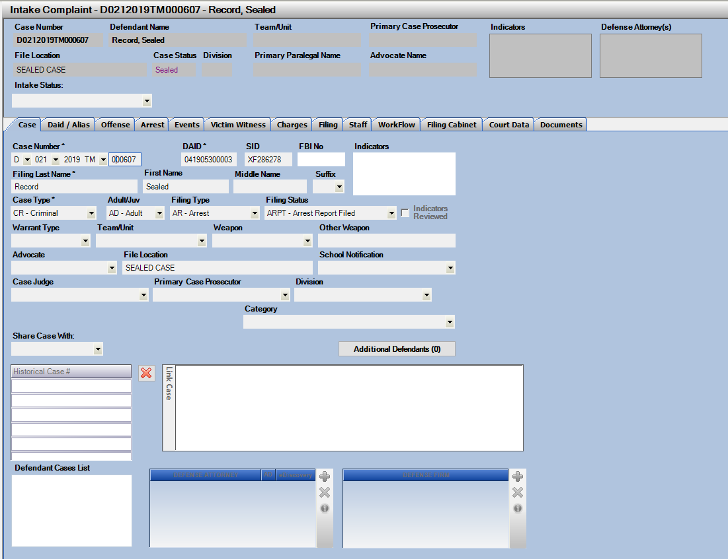

Court Data: History and Financial

**Court Data – New tabs displayed with additional CICJIS case information.**

New Tabs: Case Summary, Participants, Charges/Dispositions/ Hearings/Trials Bond and Financials. Pop-Out function as well so window can be viewed while working within Action.

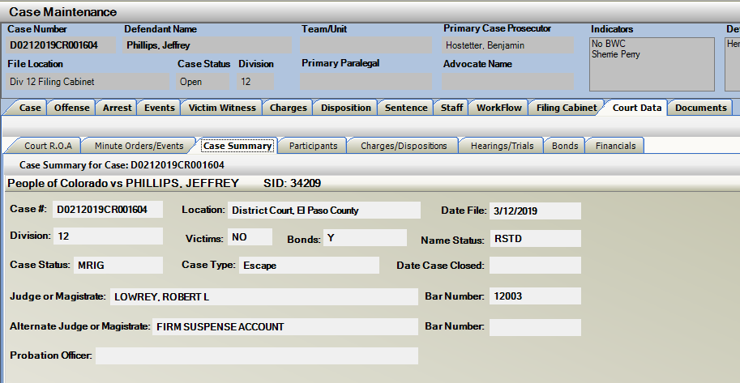Case Summary

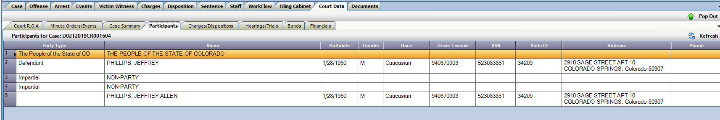Participants

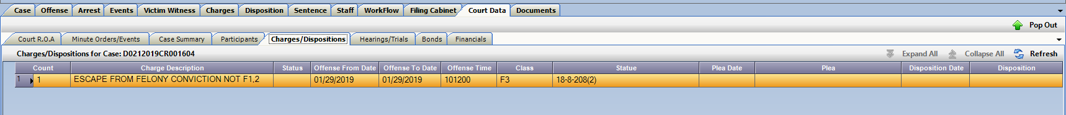Charges/Dispositions

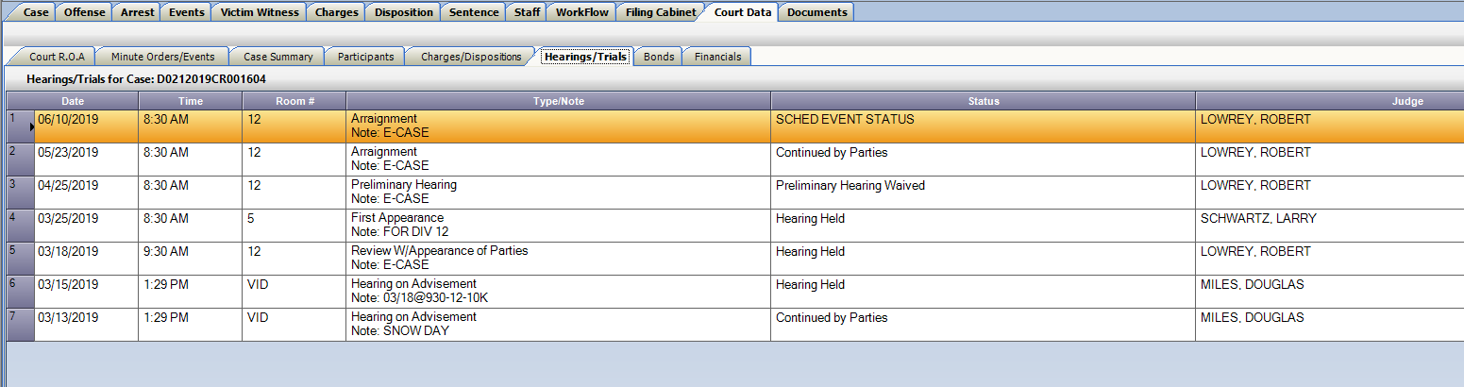Hearing/Trials

Bonds

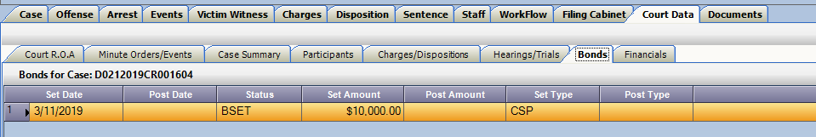

Notes: User Preference

**Notes: User Preference added for displayed columns and column order.**

Notes can now be customized per user, using the field selector shown below. Choose your columns, and then the order of the columns by clicking a column header and dragging to a new position on the displayed grid if desired. Use the re-set columns button to return to the default view.

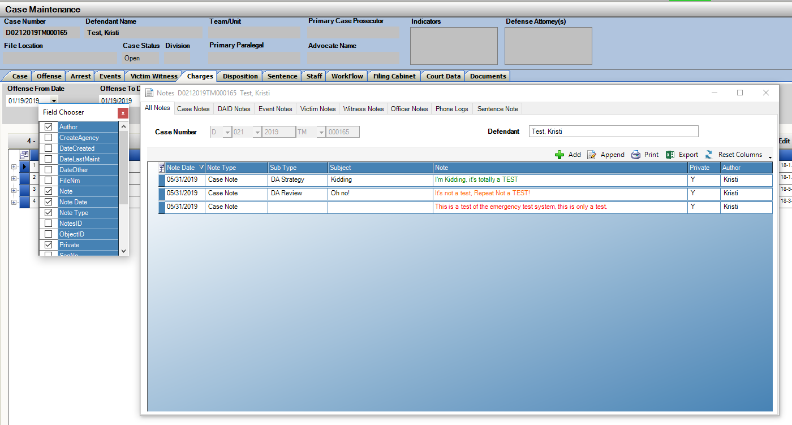

Move column positions- this will retain per user until you click on Reset columns

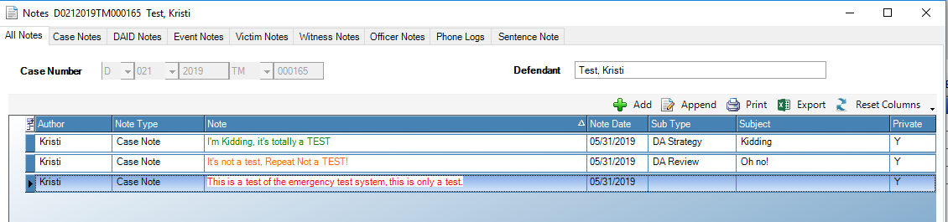

Notes: Add same note to multiple Victims/Witnesses

**Multi-Select Victims/Witnesses and Add Same Note to those selected.**

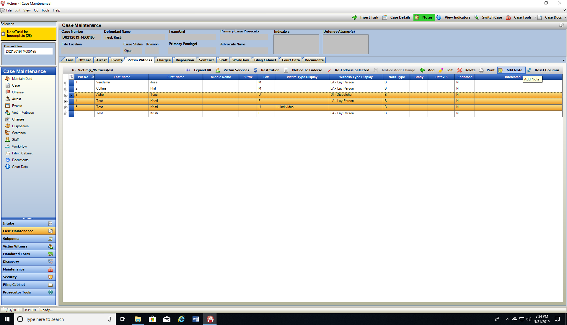Multi-Select victims and witnesses from the Victim Witness Tab on any case and then click on Add Note. The note entered, will then appear as separate notes for each of the individuals selected.

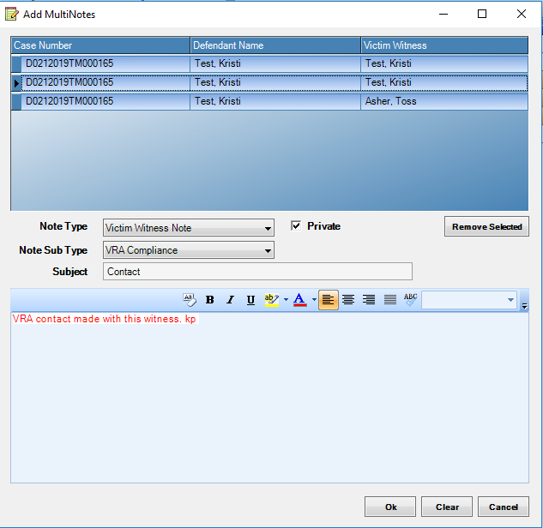

Copy Case: Retain Count Number Option

**Exporting and Importing Charges between cases now has additional option of retaining the count number from the case selected.**

This function is important especially for Indictment cases where count numbers are shared between co-defendants. This will allow you to copy and retain the count number that may not be in sequential order from one case to another. This eliminates the need then to re-number all counts once copied.

If the case you are copying charges to already has charges with same count number, they are added as the next sequential number.

Copy To, Copy From and Link Case Options- there is an additional checkbox displayed that is auto defaulted as flagged: Keep Charge Count

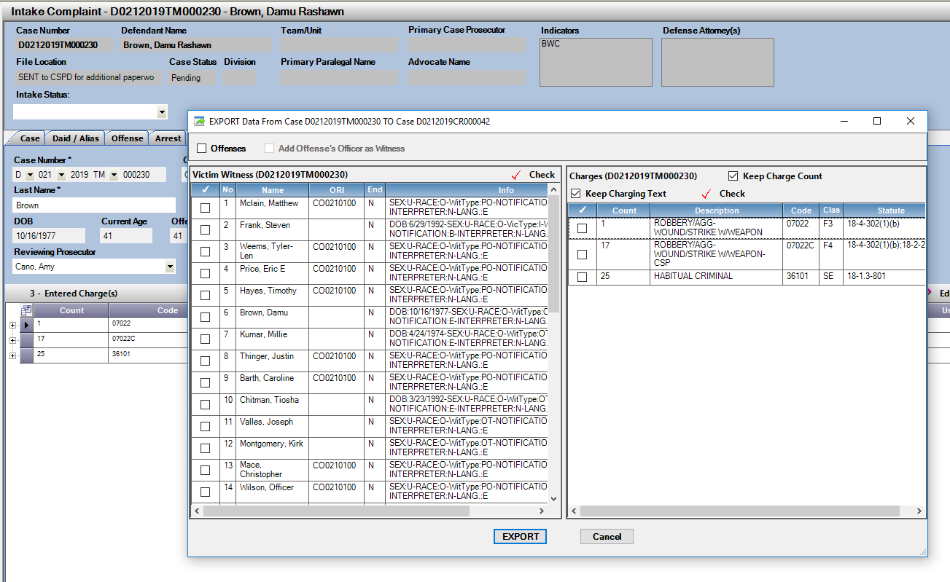

Miscellaneous/ Bug Fixes

1. User Task List: Fix for resorting from selected highlighted row when refreshed.
2. Traffic Case Entry: was allowing bad data in Offense/Summons and ORI fields. This now will be validated before moving on case entry.
3. Prosecutors Dockets: Save state of the grid and sort when rows are marked as completed.
4. Subpoena Status Screen: Restrict Users from modifying location field on the electronic subpoenas to retain integratory of information.