Diversion Case Screening and Juvenile Data

**Purpose**: Action integration to a new external Diversion system.

**Diversion System Official Live Date:** August 1, 2020

*Please contact your Diversion Director for when district users will start utilizing this process from Action.

**Functions:**

1. Send Case to Diversion from Action.
   1. New Diversion System will be populated with Action case data when sent to them. This will not remove the case from Action.
   2. Case Type and Filing Type will automatically be updated to Diversion when case is sent.
   3. Internal Event will be auto generated showing case was sent to Diversion.
2. Juvenile Case Data Display created to capture screening information required for data collections per SB 19-108.

**Access Functions:** Case Tools Drop Down from within an Action Case.

1. Diversion Send Case
2. Juvenile Data
3. Note: Case Tab Adult/Juv field must be set to Juv.

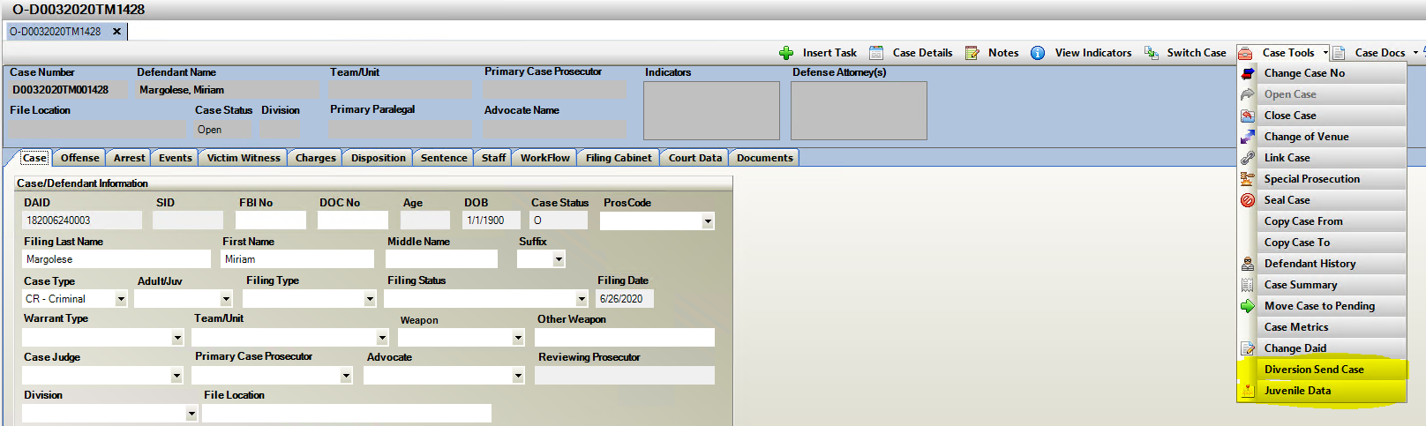

**Diversion- Send Case**

1. Diversion Send Case when selected opens a “Refer to Diversion” screen where a user must enter information to Diversion regarding the case sent. This appears within the Diversion System, not within Action. Enter note information and click on “Send”. This is a required entry text can be determined by your internal practice. These cases appear within the Diversion System as a “Pending Case” for review with this note attached.

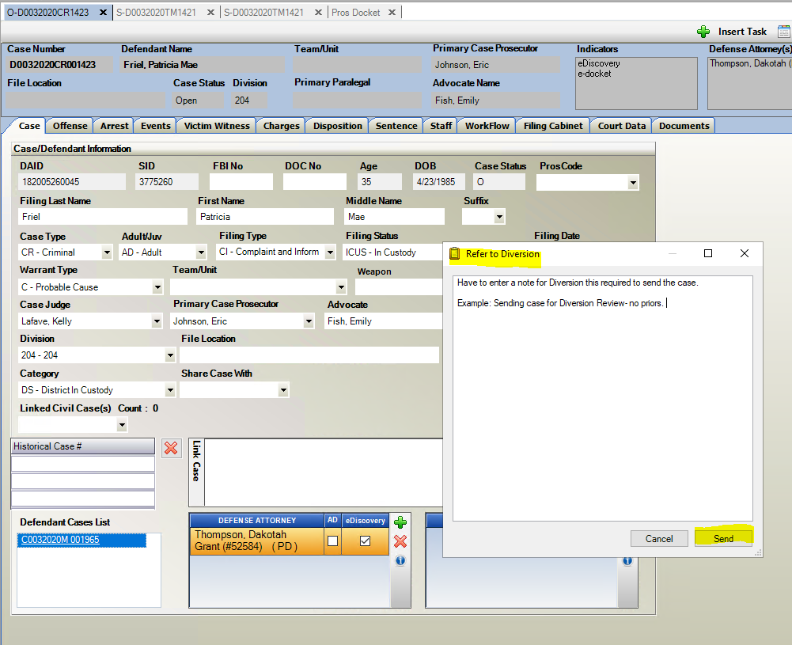

1. 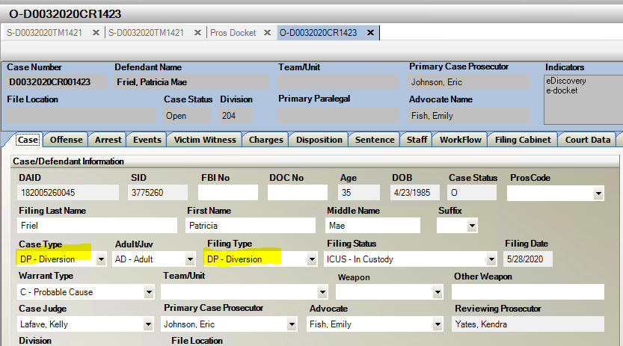Case Type and Filing Type both Auto Update to Diversion
2. Internal Event is Auto Generated tracking that the case has been referred to Diversion.

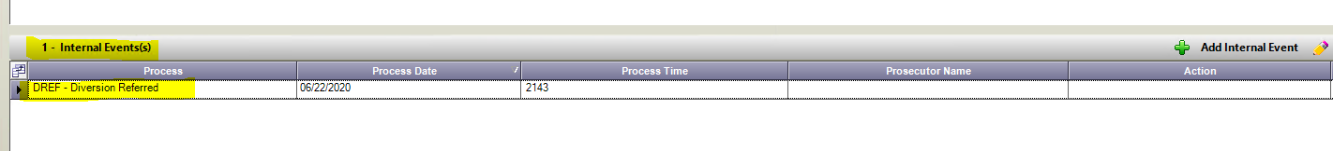

Juvenile Data Collection

Per SB 19-108

**Juvenile Data Collection**

**Purpose:** Capture State-Required Diversion Screening

1. Select Yes/No if Screening was completed.
2. If Yes = Go to Screening Completed Section and enter the Tool Score.
3. If No= Go to the Screening Not Completed
4. Screening Not Completed
   1. Enter Reason either Excluded from Screening by the Statute or Other.
   2. If Other is selected, then enter the other reason why it was not completed.
5. Child Welfare Involvement (per. Local Definition of Cross-over Youth)-check box based on local interpretation.
6. Pending D&N Case can also be selected if Child Welfare Involvement has been selected.

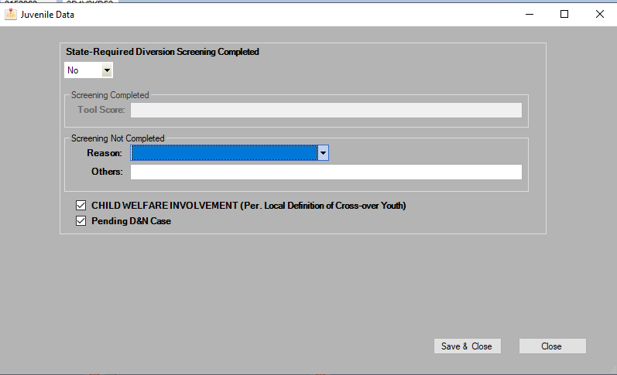**Location:** Case Tools Drop down menu- Juvenile Data