Action Enhancement Guide

June 2020 Training Guide



<http://www.CDACweb.com>



**Table of Contents**

1. Multiple Open Cases in Action: ………………………………………………………………………………………… 3
2. Prosecutor Tools: New Team/Unit Docket:………………………………………………………………………… 10
3. E-Filing e-Service List: ……………………………………………………………………………………………………….. 11
   1. Uncheck DA and DA Office
4. Discovery- Media List: ………………………………………………………………………………………………………… 12
5. Event Screen – eSub details: ………………………………………………………………………………………………… 13
6. Send Case to Diversion …………..………………………………………………………………………………………………. 15
7. Juvenile Data Collection Related to SB 19-108 ………………………………………………………………………….16

Multiple Open Cases in Action

**Purpose**: Created so that users with this mode can have many cases viewable at once within Action.

**Modes:**

1. Single Mode (Default)- Loads one case or process at a time.
2. Multi-Tab mode is User Selected, this enables viewing multiple cases on separate tabs within Action.

**Selecting Multi-Tab Mode-** When you log into Action you will see a new check-box in the upper right hand corner labeled “Multi-Tab Mode” check this box to enable this function.

Users can check, un-check this box at any time during their active session in Action.

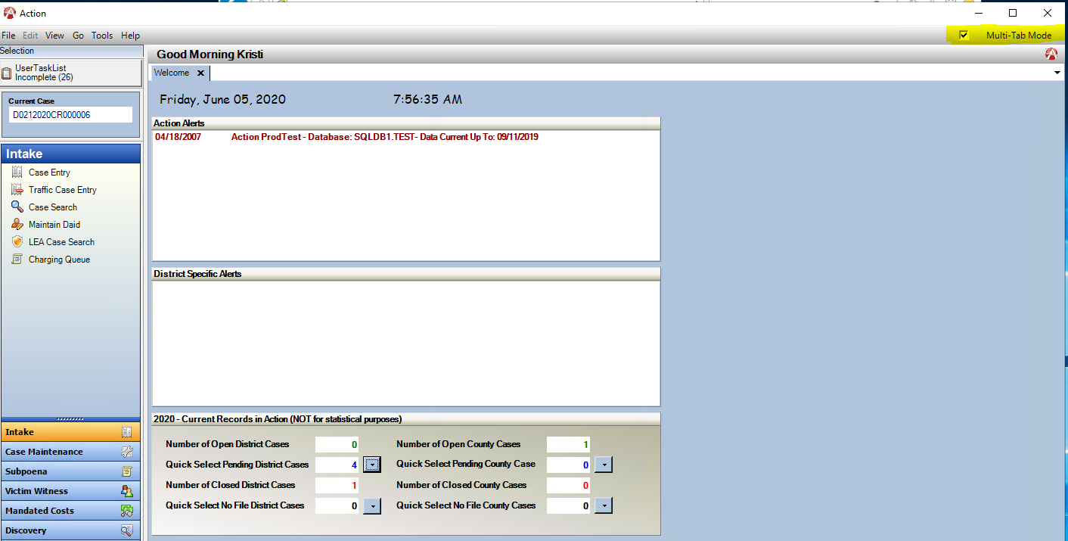

**Multi-Tabs- Labeled with Case Status followed by the Case Number.**

Case Status: O= Open

P = Pending (Intake Case)

R= Re-Opened

N= No-Filed

S= Sealed

Examples:

O-D0032019CR520

C-D0032010CR611

P-D0032020TM001564

**Tab Tips:**

1. The Tab that is highlighted in Blue indicates the viewing Tab.
2. New Tab’s open to the Right hand side.
3. Tabs can be closed by clicking on the X on the Tab.
4. All Tabs can be closed by Right Clicking on one of the Tabs selecting: Close All
5. Depending on Process, some functions close the case tab automatically these include:
   * 1. Seal Case
     2. Change of Venue
     3. Special Prosecution
     4. Delete Case (from Intake)
     5. Refer a case to Diversion (new functionality).

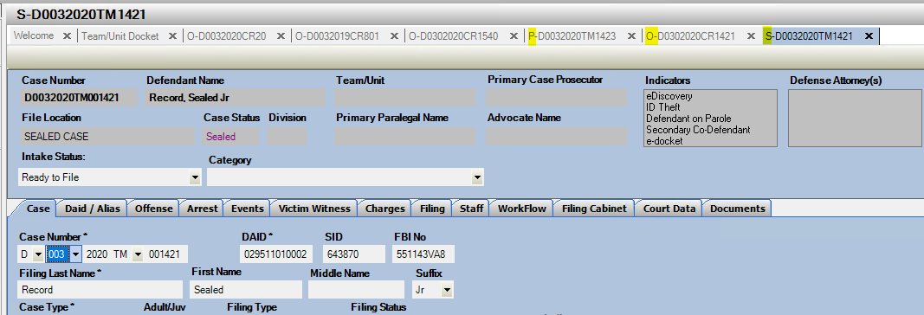

**Special Functionality with Multi-Tab Mode**

1. **Pop-In/ Pop-Out Selections**
2. Dockets

Dockets under Case Tools will open in their own window not on a new tab. This is so user can have this open separately while Action cases are also open and can view on different screens. User have the option “Pop In” the screen- adding as a tab. Users also have the option to “Pop Out” that tab to a window again as well. This is per Action session to accommodate different usages of these dockets. (This section applies to Single and Multi-Mode).

1. User Task List

User Task List will continue to open in its own window with the added option as above in (A) with the “Pop In” and “Pop Out” Options. (This section applies to Single and Multi-Mode).

1. **Intake Processing**
2. Intake Process includes Case Entry, Traffic Entry and LEA Case Search.

When a case is started from Intake the process goes through the first three screens before allowing the user to start another Intake case, these screens include: Initiating Event Screen, LEA Case Search and DAID Search.

After the case has gone through these initial screens and the case tab opens then another Intake case can be started. This process is by design to lock down starting a case to prevent duplicated cases from being created by different users at the same time.

1. **Split Screen Horizontal or Vertical Viewing**
2. Users can view 2 cases or processes at the same time on the same screen with the split screen mode. Select New Horizontal or Vertical Tab Group from Right Clicking on a Case Tab.
3. Users can drag and drop a tab from one view to the other.
4. Users can move back a separated tab back to the Previous Tab Group or Close that specific Tab Group. This is a Right Click Option once in split view mode from a Case Tab. – **Note- Close all will close everything in Both Split Screens!**

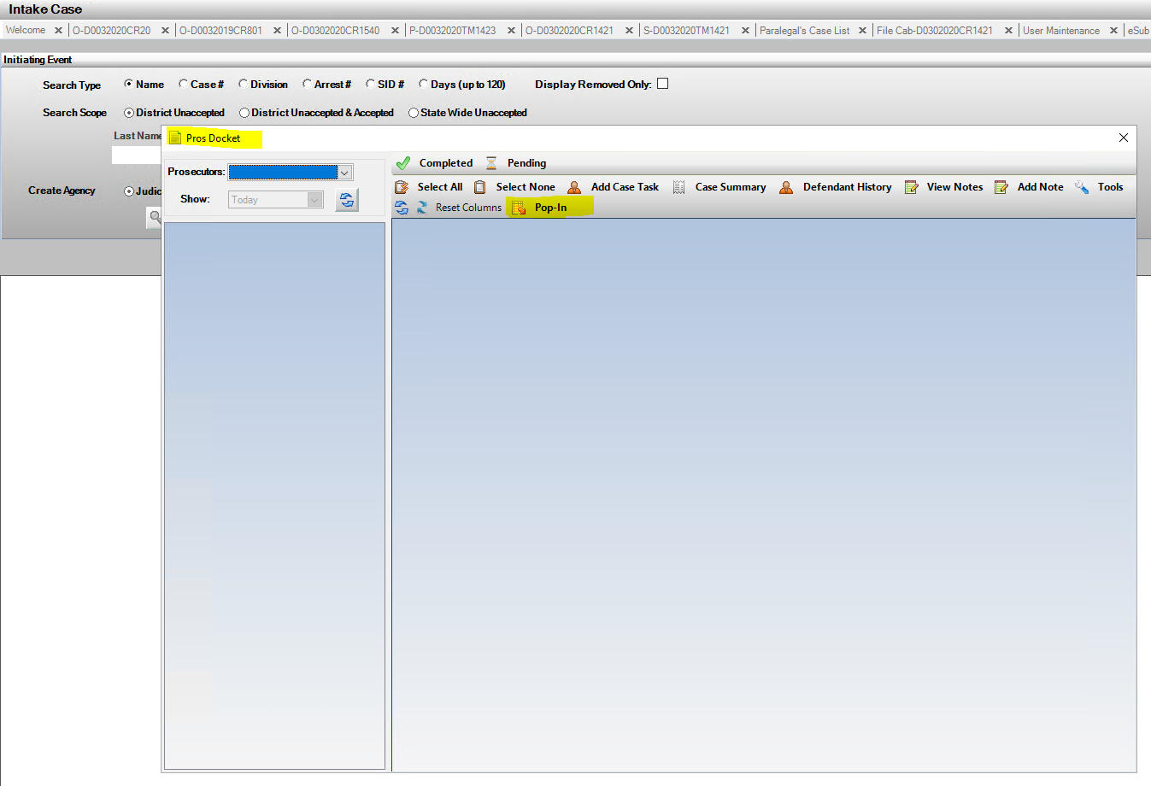#1. Docket Example

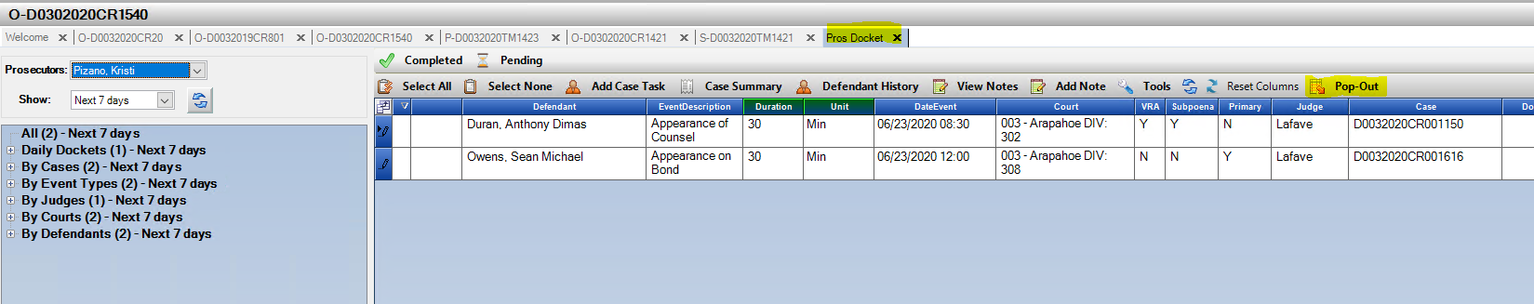

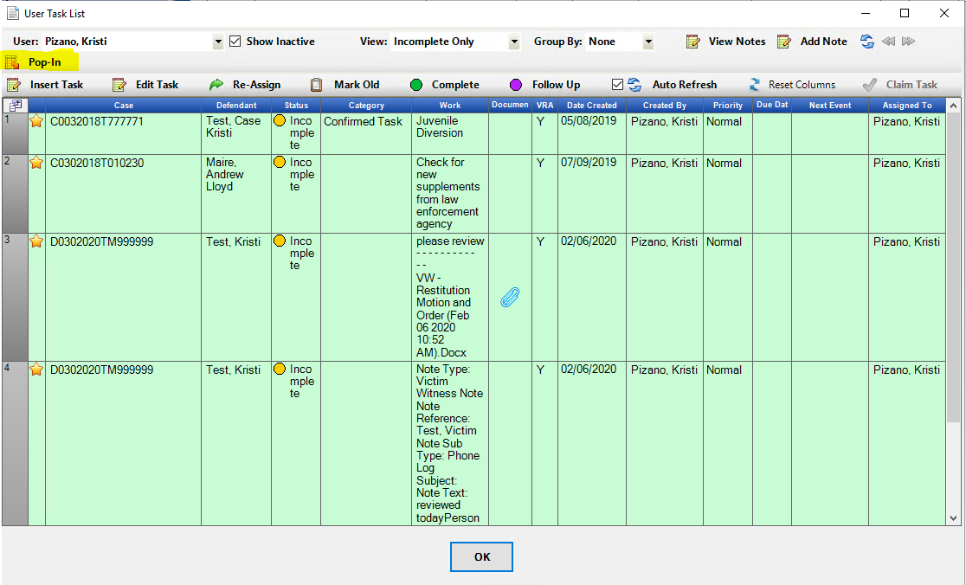#2. User Task List Example

Intake Example

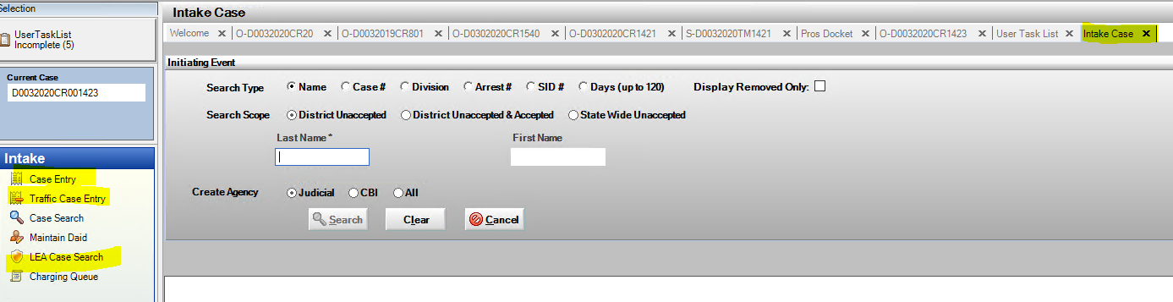

#3. Split View- Vertical/ Horizontal Tabbing Option Examples

*Note Users can open multiple horizontal or vertical views in the same screen, of course visibility is than reduced; two is recommend.

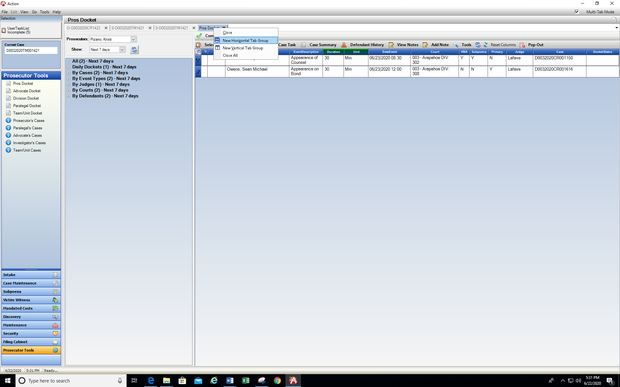

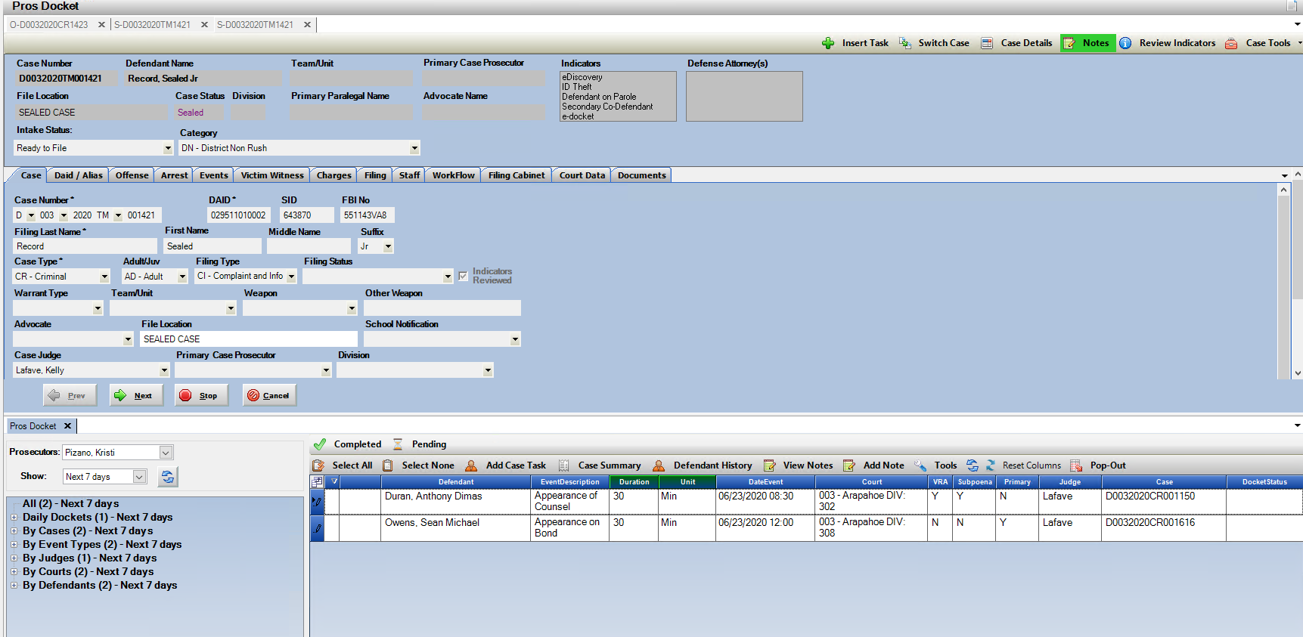

Vertical View Example

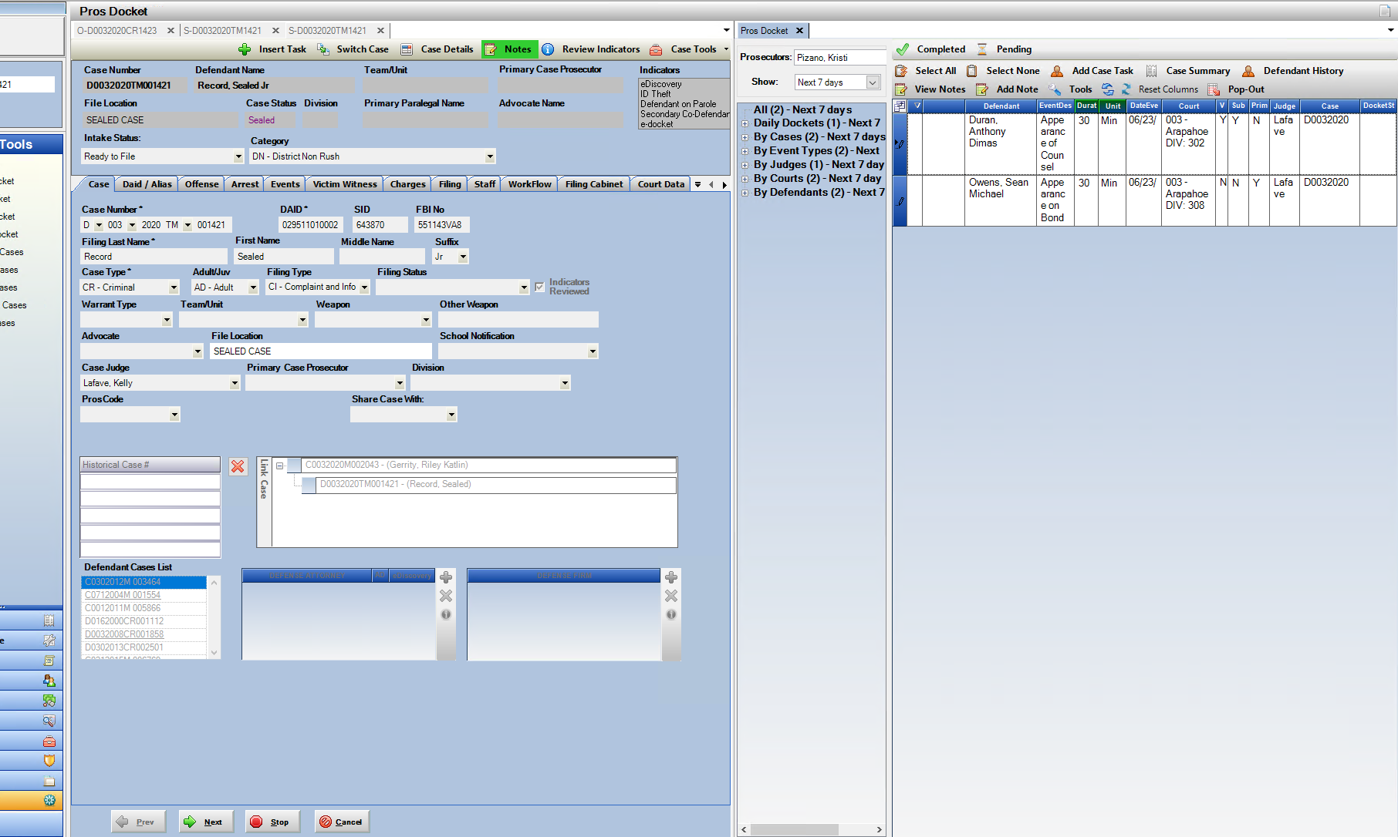

Prosecutor Tools

1. **Prosecutor Tools – New Team/Unit Docket**

New Docket Option created based on a case being associated with a Team/Unit in your district. The Team/Unit field is located on the “Case” tab. When selected on a case, this will translate to this docket view. CDAC can add Teams/Units per District Request

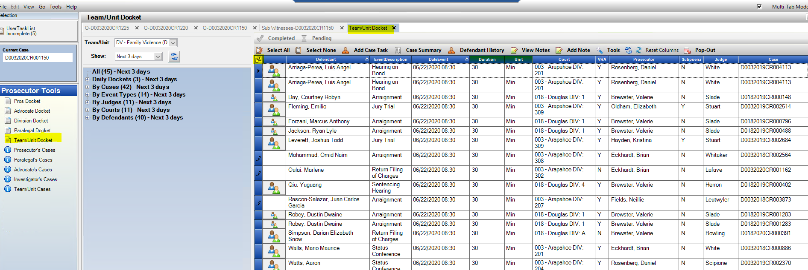

E-Service List for e-Filing

* + - 1. **E-Service list for E-Filing- adjustment**

The E-Service list for e-Filings is now only defaulting to check the other parties listed by the court, removing the auto check for the DA’s Office and DA listed attorney.

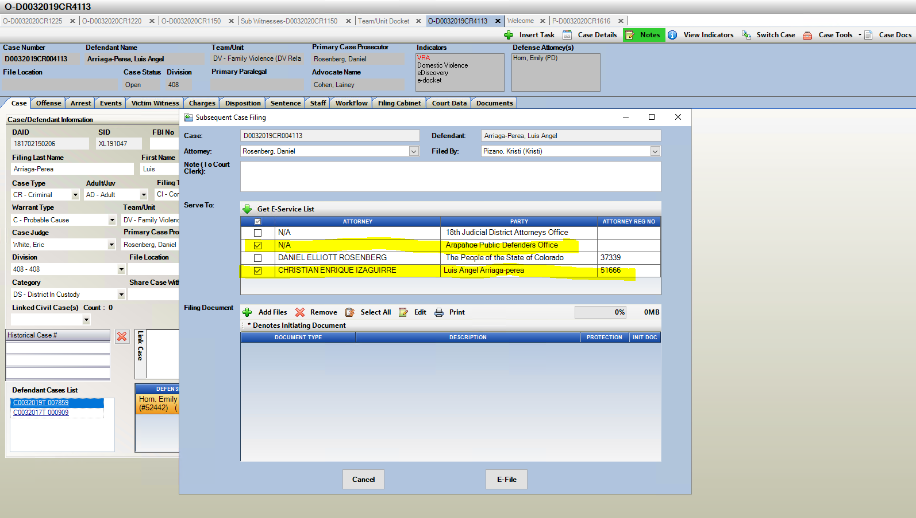

File Cabinet: Media List

1. **Media List created for physical discovery reference in File Cabinet.**

The Media List that is sent to defense referencing physical media has been updated to reflect the entered Media name, even if the district has the setting to display only bate-stamped numbers to defense. This was updated to reference the bate-stamp number and the original file name together.

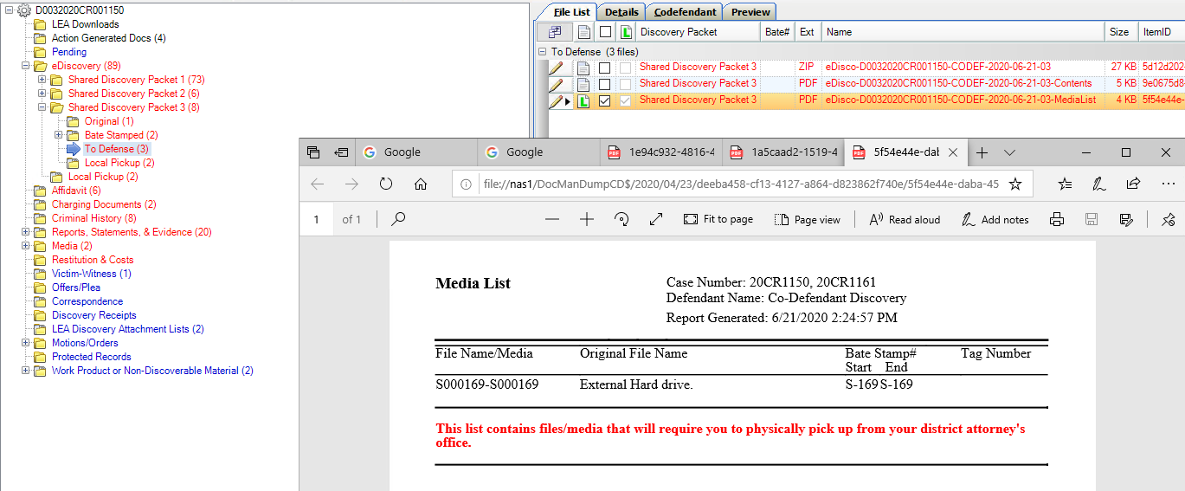

Event Screen Tab

1. **eSubpoena Information added to the Event Screen.**

Update to the Event tab, to include eSub information. eSub Status and Status Date are now also added to the existing Subpoena Grid. This will assist in subpoena referencing from this screen. When there is a (+) button next to a court event it can be expanded to see which subpoenas have been generated. This offers more information from this quick view for eSub information now. The Delivery Method shows if the Sub was produced electronically, mailed or had personal service.

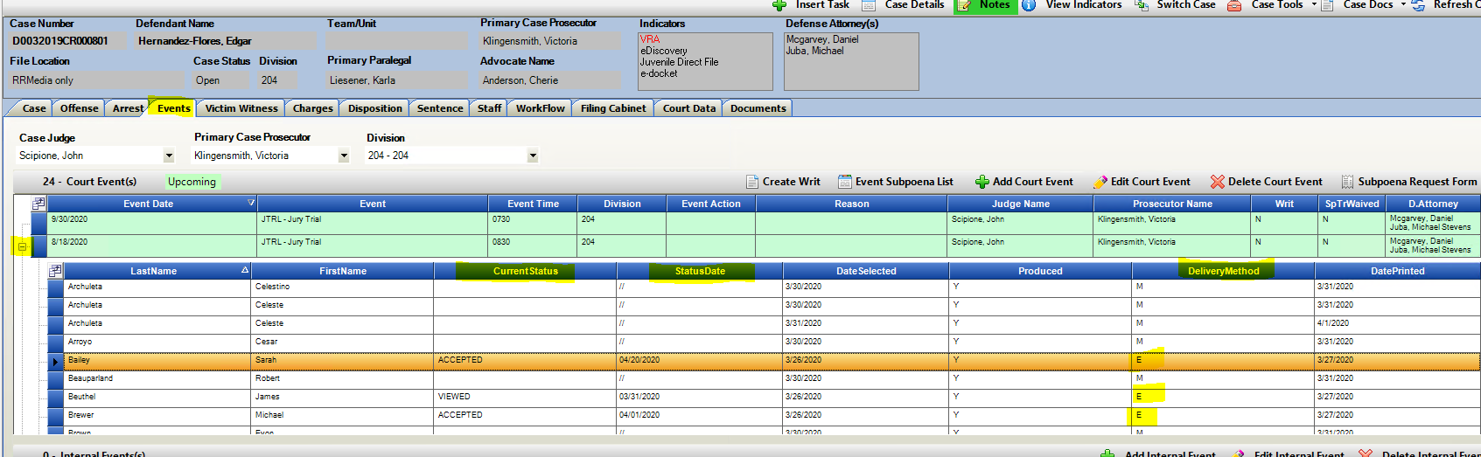



Diversion Case Screening and Juvenile Data

**Purpose**: Action integration to a new external Diversion system.

**Diversion System Official Live Date:** August 1, 2020

*Please contact your Diversion Director for when district users will start utilizing this process from Action.

**Functions:**

1. Send Case to Diversion from Action.
   1. New Diversion System will be populated with Action case data when sent to them. This will not remove the case from Action.
   2. Case Type and Filing Type will automatically be updated to Diversion when case is sent.
   3. Internal Event will be auto generated showing case was sent to Diversion.
2. Juvenile Case Data Display created to capture screening information required for data collections per SB 19-108.

**Access Functions:** Case Tools Drop Down from within an Action Case.

1. Diversion Send Case
2. Juvenile Data

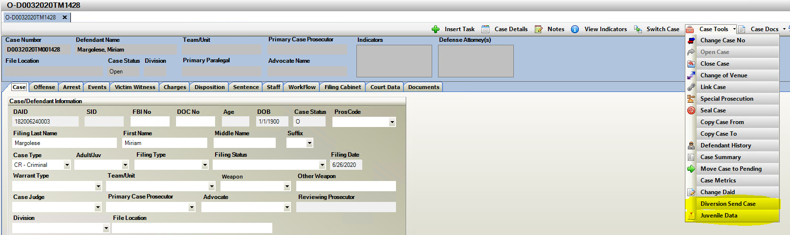

**Diversion- Send Case**

1. Diversion Send Case when selected opens a “Refer to Diversion” screen where a user must enter information to Diversion regarding the case sent. This appears within the Diversion System, not within Action. Enter note information and click on “Send”. This is a required entry text can be determined by your internal practice. These cases appear within the Diversion System as a “Pending Case” for review with this note attached.

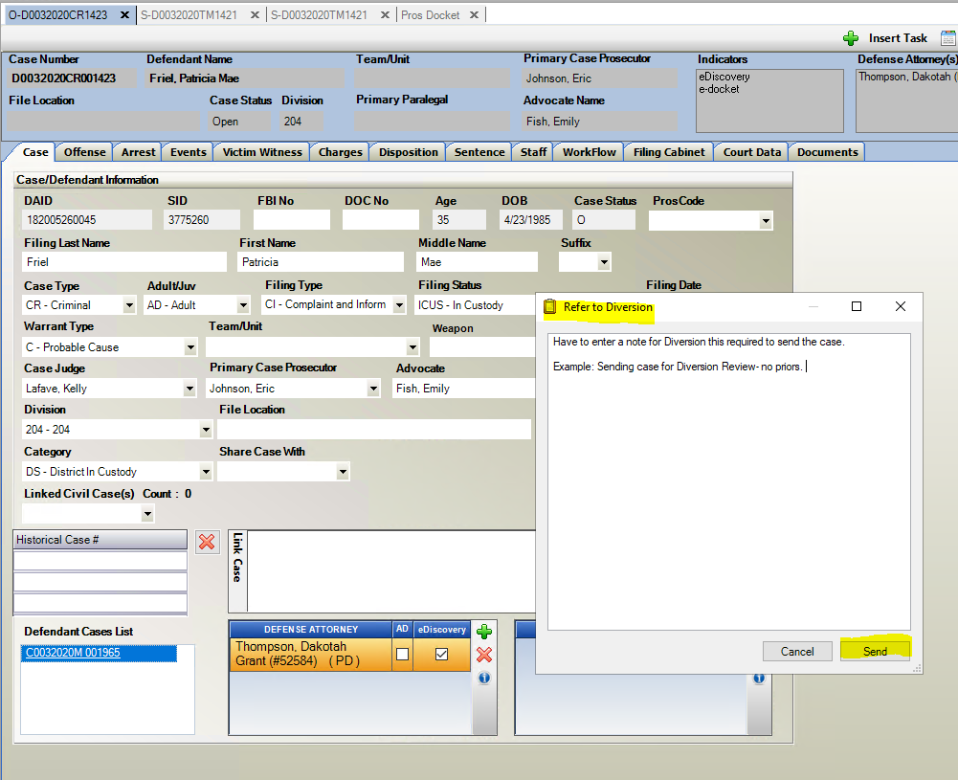

1. 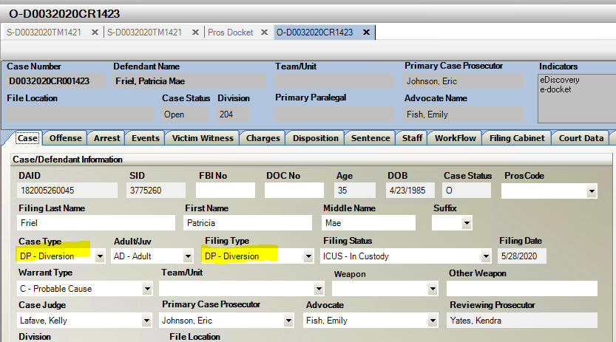Case Type and Filing Type both Auto Update to Diversion
2. Internal Event is Auto Generated tracking that case has been referred to Diversion.

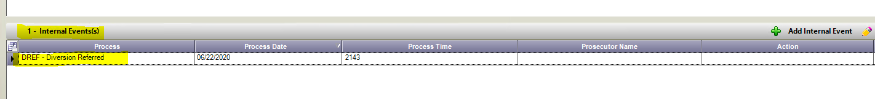

Juvenile Data Collection

Per SB 19-108

**Juvenile Data Collection**

**Purpose:** Capture State-Required Diversion Screening

1. Select Yes/No if Screening was completed.
2. If Yes = Go to Screening Completed Section and enter the Tool Score.
3. If No= Go to the Screening Not Completed
4. Screening Not Completed
   1. Enter Reason either Excluded from Screening by the Statute or Other.
   2. If Other is selected, then enter the other reason why it was not completed.
5. Child Welfare Involvement (per. Local Definition of Cross-over Youth)-check box based on local interpretation.

**Location:** Case Tools Drop down menu- Juvenile Data

