Action File Cabinet Co-Defendant Discovery Processing
Functionality: Action Electronic File Cabinet Option for Linking Co-Defendants for Processing Electronic Shared Discovery.
This functionality will allow users to link co-defendant cases within the File Cabinet. This process works by auto-sharing discoverable files added into one case into all of the other linked co-defendant cases. When cases are linked the users will see a new Tab within the File Cabinet named: Co-Defendant. This Tab will show in a column view all of the linked cases in the file cabinet. Any files added to a case that are marked as being Discoverable “Red” will automatically be associated with each linked case. If files are added as Work Product or Non-Discoverable they are not added automatically to the other cases, but users are able to share that document into the other cases if they would like. These generated Discovery Packets on linked cases will be identified as “Shared Discovery Packets”- referencing more than one case is linked and sharing discovery. The Bate-Stamp number references on created Shared Discovery Packets will display with a preceding “S” before the bate-number to identify a Shared Packet- example “S1-S4”. The cases linked when the bate-stamp process is done will be displayed on the footer of the discovery- example 18CR101, 18CR102.
In conjunction with this Co-Def functionality, if your District receives files from LEA electronically this process will “De-Dup” any duplicated files between linked co-defendants. As these files are shared, if you delete the file it’s removing it from all of the others, if the file is re-named it’s renaming it across all linked cases. Take this into consideration before deleting any case from Action or asking CDAC to delete cases on your behalf.
This new functionality requires Districts to be set-up by CDAC as there are several permissions options that you can decide how to have set-up. These permissions can be for the District or set-up for Specific Users.

Table of Contents
- District Setting Options....................................................................................... Page 2
- Basic Steps Overview.…………………………………………………………………….……….……... Page 2
- Co-Defendant Linking Process for File Cabinet.………………………………………….…... Page 3-5
- Copy Existing Discovery Packets to Linked Co-Def Cases……………………………….… Page 6-10
- Convert Existing Single Discovery Packets to Shared Discovery Packets………….. Page 11-15
- DA Discovery Summary- Tracking Converted and Deleted Discovery Packets….. Page 15-16
- Shared Prosecutor PDF …………………………………………………………………………………… Page 17
- Unlink accidently linked Co-Def Cases in File Cabinet …………………………………….. Page 18-19
- Deleting Discovery Packets and Files in the File Cabinet- Warnings ………………… Page 20

District Options for Co-Defendant Functionality- Contact CDAC to have turned on.
- Setting: Functionality to allow Co-Def processing in the File Cabinet.
- Setting: District or Limit per user; Link Co-Defendants in the File Cabinet.
- Setting: Ability to “Unlink” a case in the File Cabinet when cases have been accidently linked.
- Setting: District or Limit per user; Copy existing Discovery Packets from one Co-Def. case to another linked Co-Def case.
- Setting: District or Limit per user; Convert existing Single Discovery Packet from one Co-Def. case to another linked Co-Def case.

What to Know:
- Your District needs to determine how to proceed using Co-Def Functionality in the File Cabinet. Our recommendation is to use the functionality day forward on your new Co-Def cases, and then on specific older cases that would benefit from the new option of sharing packets. It’s not limited to this but feel free to contact us for any support questions.
- Linking cases in the file cabinet is a separate user driven 2nd step after linking Co-Def cases within Action. Both steps must be done in order to share files within the file cabinet.
- Generated Discovery Packets in Co-Def Linked cases are called- Shared Discovery Packets. Bate-Stamps on these Shared Packets use a “S” along with the bate-number to identify it as part of a Shared Discovery packet. You may have questions on this internally and from defense when you start using the process that you will need to disclose or provide information on.
- If your Districts receives and uses LEA files from law enforcement, it’s important to remember that these files are “De-Duped” on linked cases.
- There is one file reference on your server, but through Action the same file is displayed from all of your linked cases for Discoverable files (RED). When you edit this document or change the file name- it’s changing it across all linked cases. Benefit is less used storage on your servers due to duplicated files in each linked case.
- User Specific ability to “Un-Link” cases when accidently linked in the File Cabinet. This process will separate files out based on which case the file was added/downloaded into.
- Copy Function of Discovery packets ensures that the Bate-Stamp order remains in place across multiple Co-Def’s that do not have existing packets.
- Convert Function- allows users to convert a processed Discovery Packet to a Shared Discovery Packet. This is to be used per case bases as needed by users with these set-up permissions.

Basic Steps Overview
- Link Cases in Action.
- Link Co-Defendants within the File Cabinet.
- New Co-Defendant Tab appears within the File Cabinet.
- Add files to a Discoverable Folder, these are now shared across all connected co-defendants automatically.
- Produce Discovery – Creates “Shared Discovery Packet” referencing all connected co-def. cases and lists their case number on the Bate- Stamp footer. Bates are referenced by a preceding “S” All connected cases are completed- created/bate-stamped/uploaded at same time.
Co-Defendant Linking and Processing Shared Discovery

- Step 1: Link Cases in Action
Link your Action cases as co-defendant on the Offense Screen in Intake cases with current process, from the Link Case Option in Intake or the Link Case option under Case Tools. This creates a Co-Def connection that appears on the Case Tab with your Action Case.
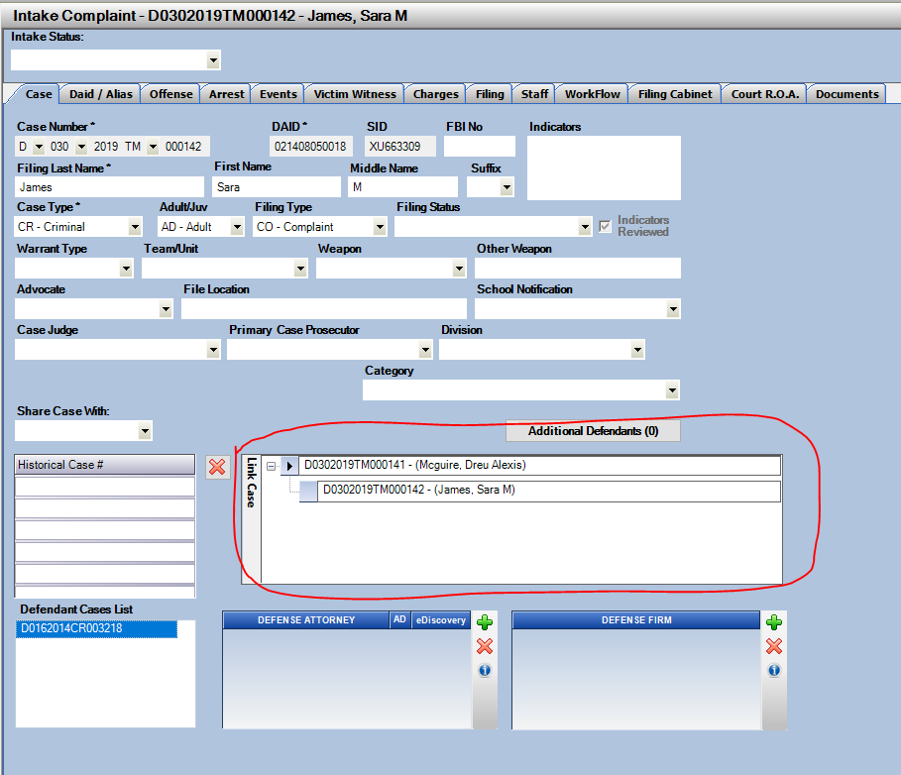

- Step Two: Link Co-Defendants within the File Cabinet. With the User setting turned on. Users will see a “Link Co-Def.” button appearing in the File Cabinet.
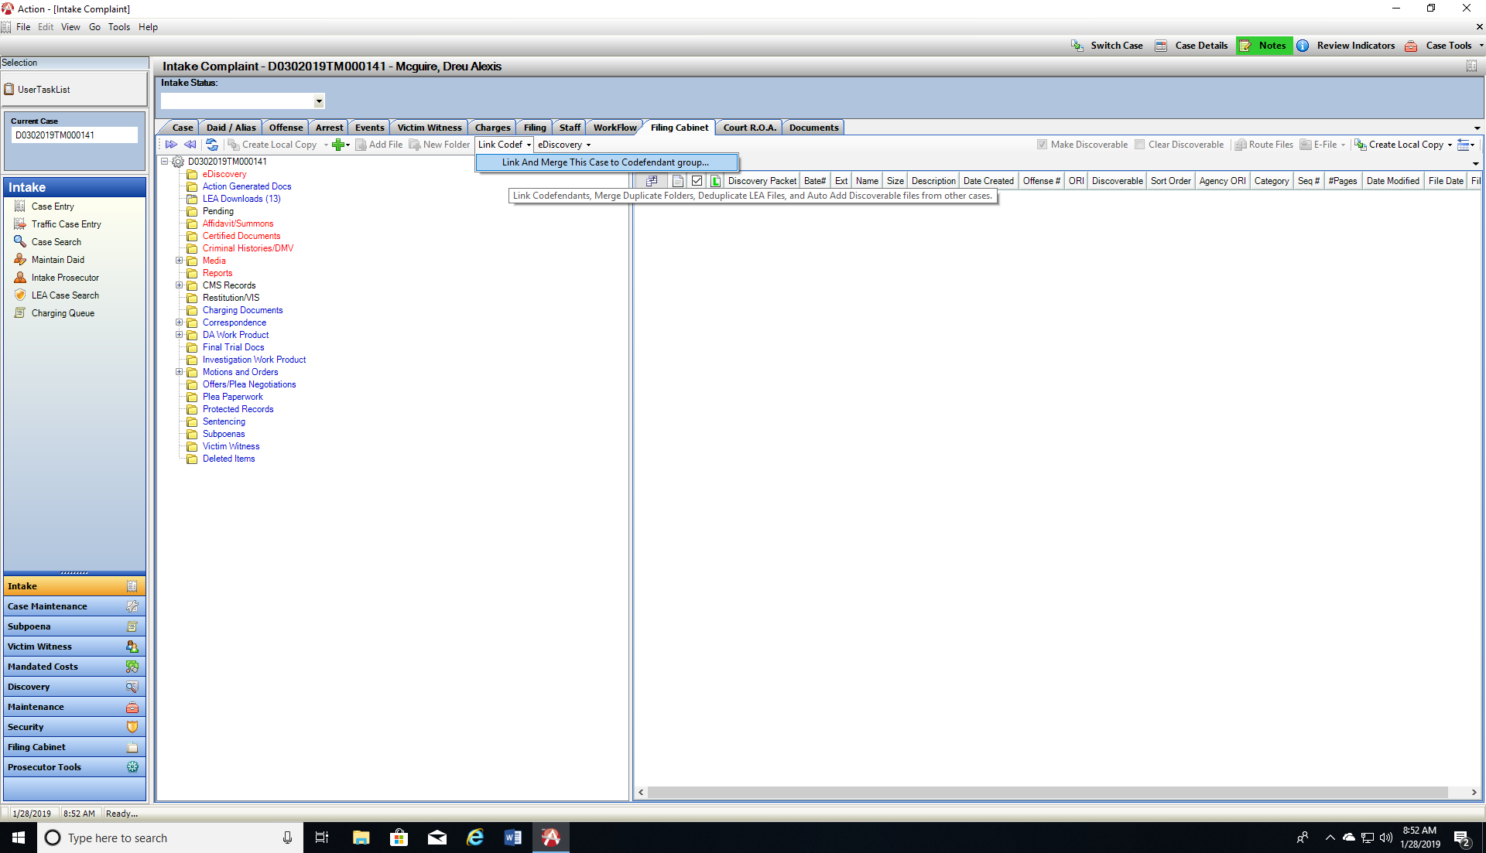
Click on this to Link your co-defendant case in the File Cabinet.

Message Box Opens giving you information regarding the Case you are merging and existing Co-Defendant’s already linked- confirm and let the process run. Then close out of the window.
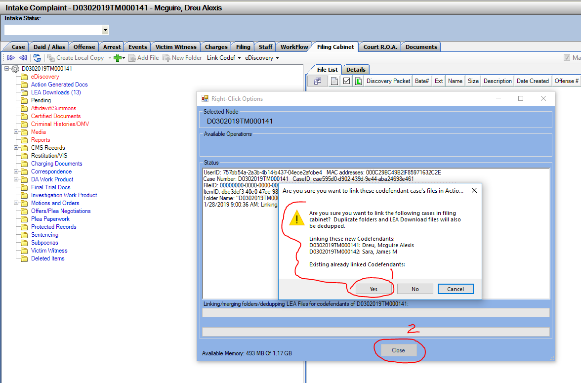

- Step Three: After linking you will see a new Co-Def Tab appearing in the File Cabinet.

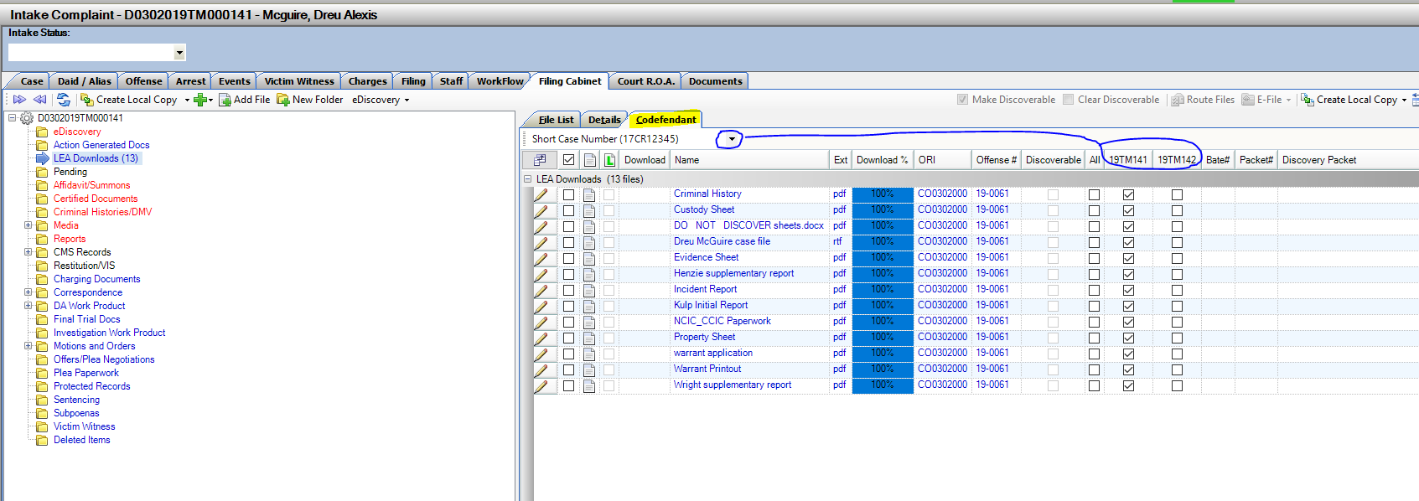
This is the Defaulted View for linked Co-Def Cases within the File Cabinet. Co-Defendant Tab shows a column for each linked Co-Def case. You can select the format in which to display these cases from this drop down.

- Step Four: Add Files to a Discoverable folder (RED) or make files Discoverable.

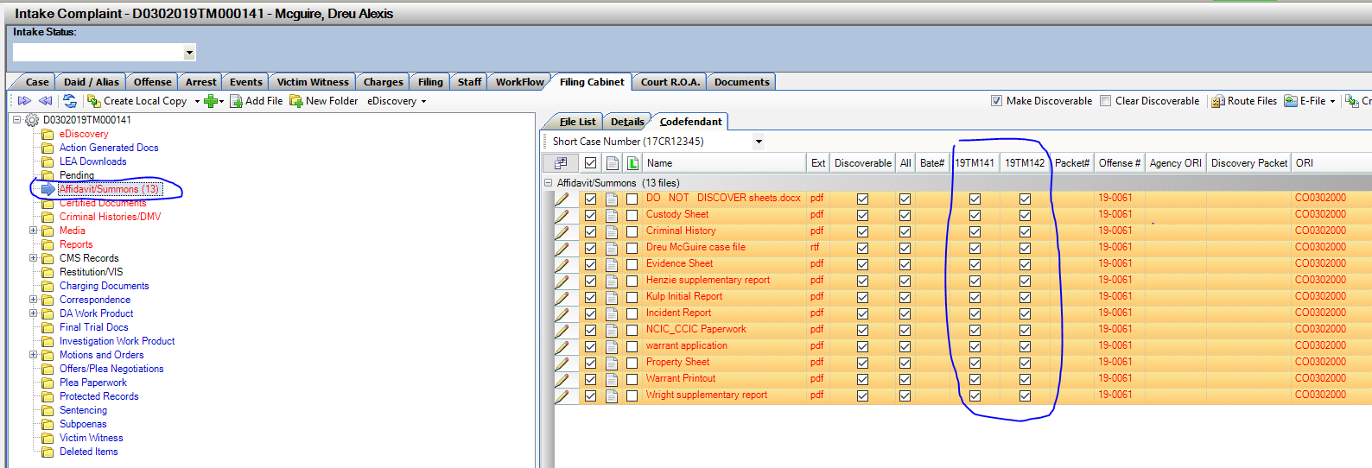
When you do this the files are then automatically associated with all linked Co-Def cases in the File Cabinet. Reference the Check Box under each Case Number listed and the corresponding file. There is one file on your server, but pointed to both cases. You can access and see this file from all linked Co-Def Cases.

- Step Five: Produce Discovery; Express Method or Step Process with Create, Bate-Stamp and Upload.

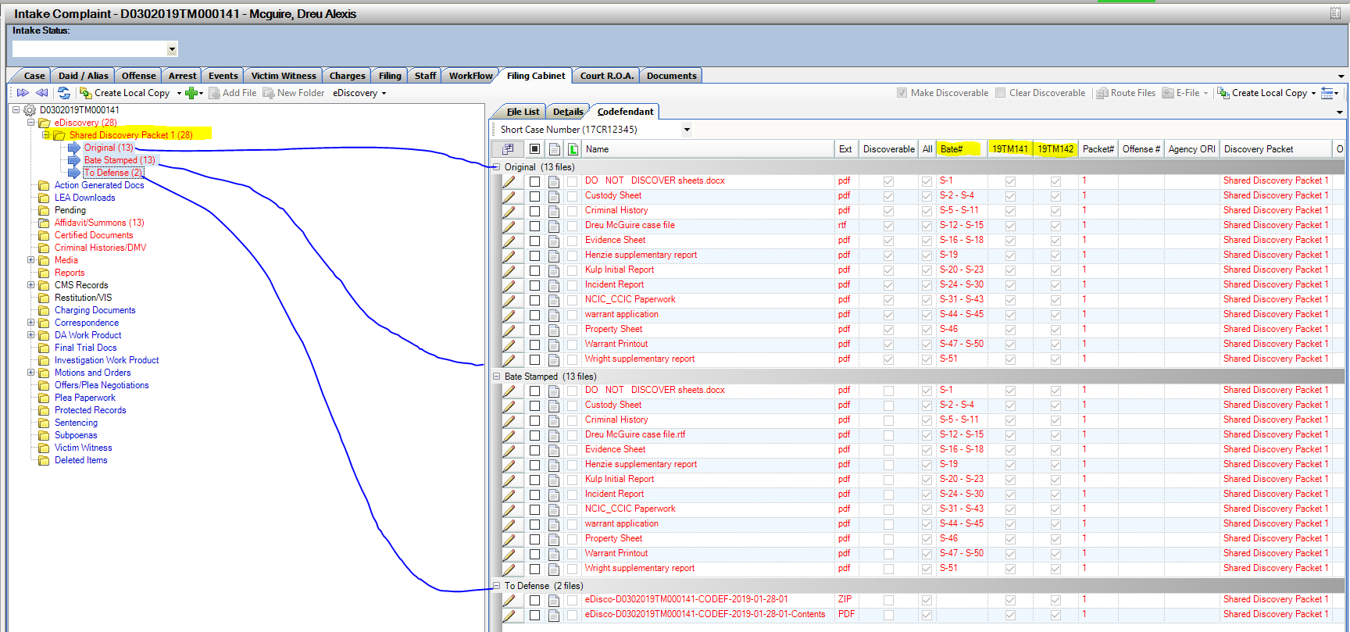
The system will generate a “Shared Discovery Packet” across all linked cases in the file cabinet. This means that it will be uploaded for defense on all cases. If defense has not yet entered on a specific case, when you do enter them they will have access then to any previously uploaded discovery.

Copy Existing Shared Discovery Packet to Newly Added Linked Co-Defendant

Functionality: Copy Single and Shared Discovery Packets to linked Co-Defendant Cases, this will ensure that order and bate-stamp reference are identical between co-defendants.
Setting: Setting per user to use Copy in File Cabinet.
Example Case Scenario– There are 3 Co-defendant cases linked and they each have Shared Discovery Packets 1 and 2 that were generated in them. There is an Added 4th Co-defendant now created in Action.

- Link the new co-defendant in the File Cabinet with the Link Co-Def button.

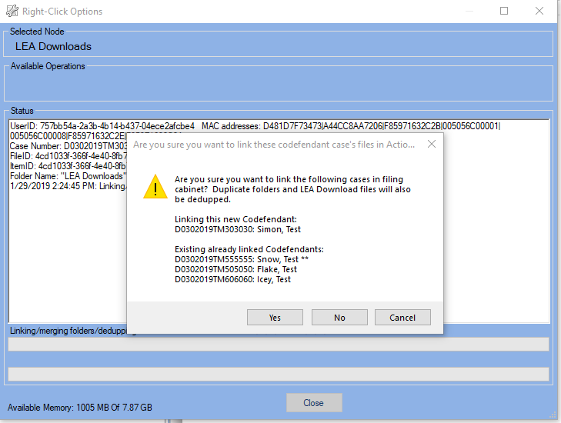

- Existing Discovery Detected

The system see’s there are discovery packets on the linked cases in the file cabinet.
Select Yes to Launch the Shared Discovery Manager or No to not share Discovery to this new linked case. This option can be re-selected from the case (Right Click menu option) if you click no at this time.

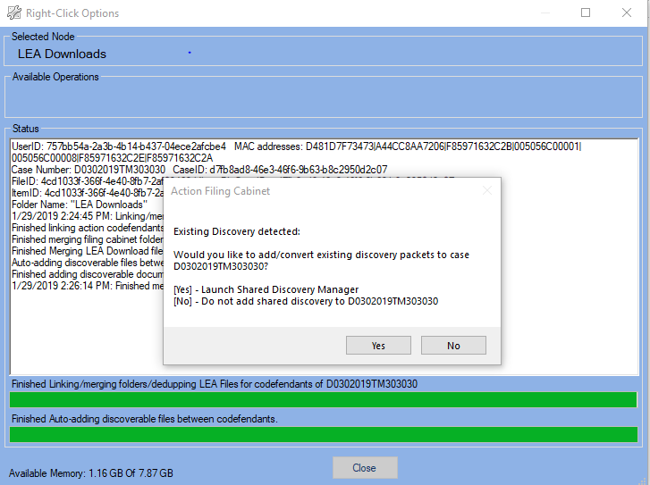

- Shared Discovery Manager

This screens lets you see existing discovery packets on all linked co-defendant cases and gives the users permissions to copy the existing packets to the newly added co-defendant case. This retains the same file order, bate-numbers for consistency between filings.
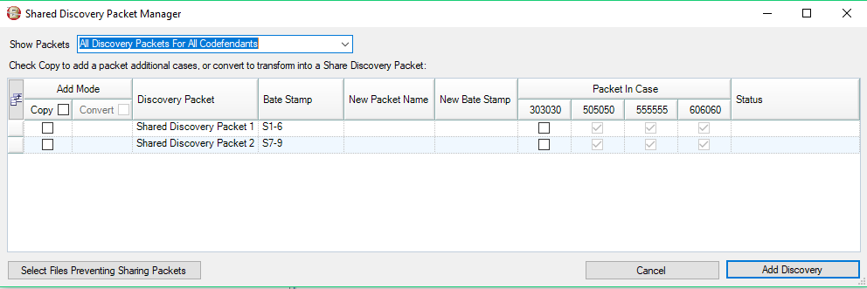
This screen is prompted to open by the user after linking a new case, as shown above, if there is existing discovery. It can also be accessed by the Right Click Menu Option from a highlighted folder in the File Cabinet.
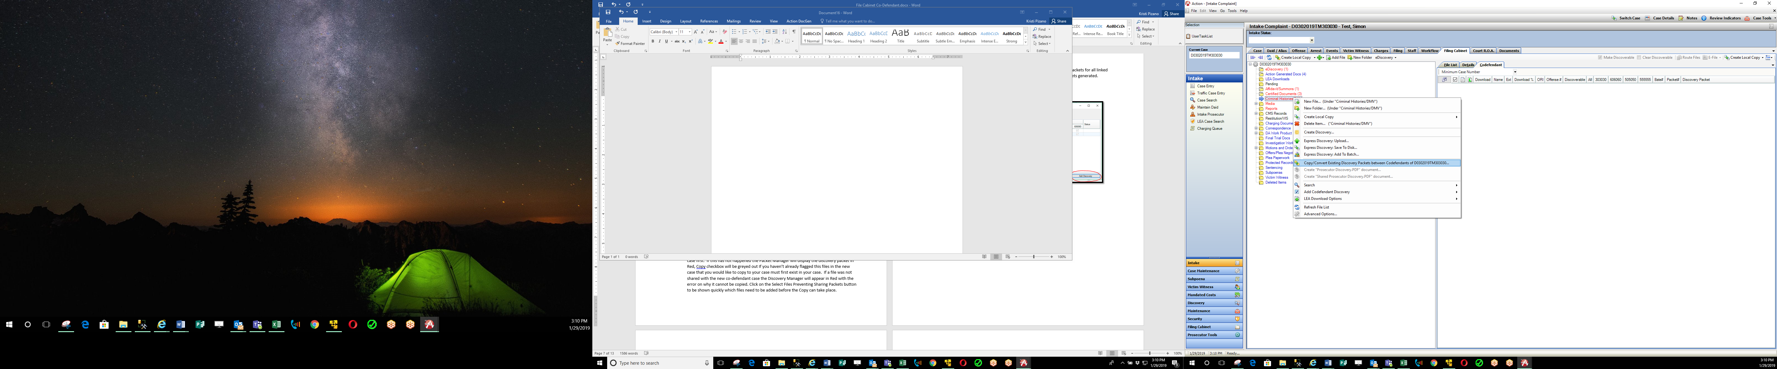

What to know:
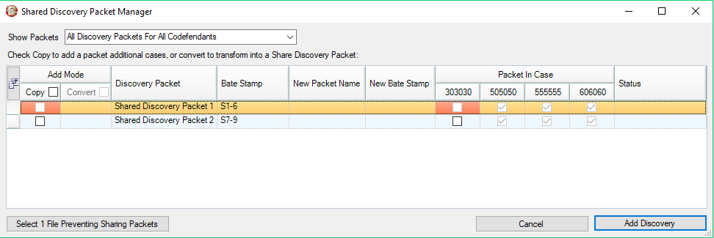
The files in the discovery packet that you would like to copy need to exist in the new case first. If this has not happened the Packet Manager will display the discovery packet in Red and the “Copy” checkbox in that row is disabled. Click on the Select Files Preventing Sharing Packets button to be shown quickly which files need to be added before the Copy can take place.

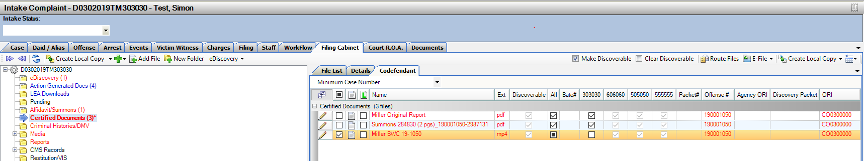
The Highlighted file below shows it was not added to the current case, and is needed to copy the discovery packet. Click on the checkbox adding it to this case and then go back to the Packet Manger to complete the Copy process of the Discovery packets.

- Copy Packets

Click on the Copy checkbox for each packet and then click the cases you want to add the packet to. In this example we are adding both Shared Discovery Packets to the new Co-Defendant. The greyed out checkboxes under the other case numbers are showing you that the packet has already added and processed as part of that case. Click on “Add Discovery” button to Copy the selected packets to your case.
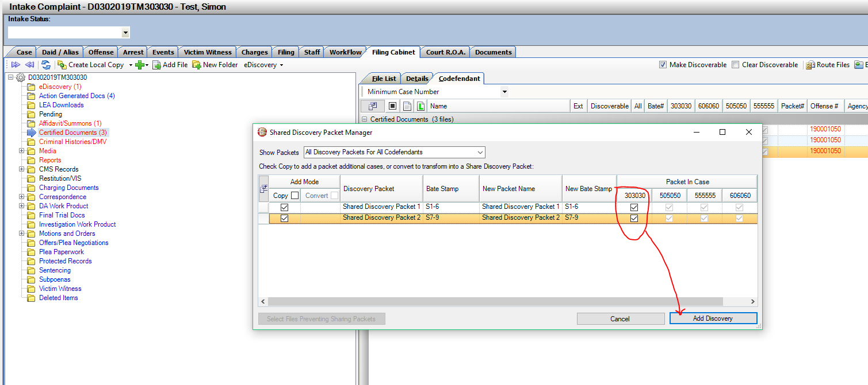

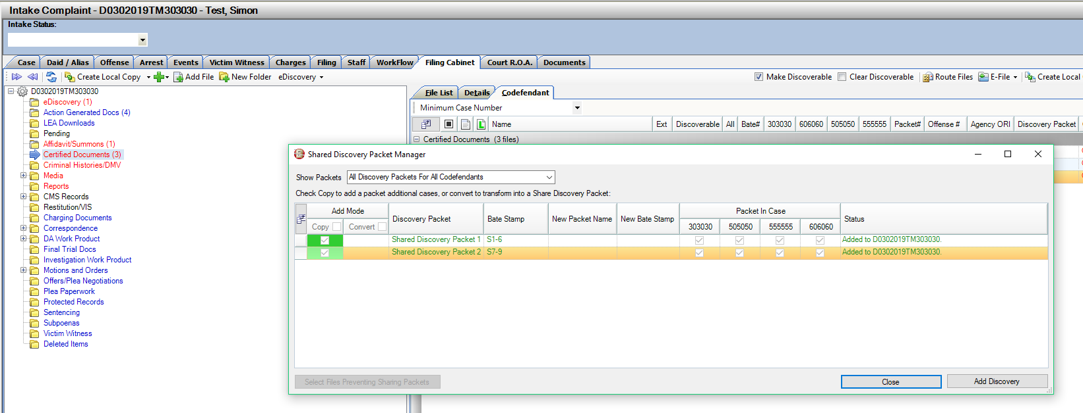
Successful Copy shows in Green and Status updated as shown below- Added.

Discovery Packets are now copied into your new Co-Def linked Case. In this example both Shared Discovery Packets 1 and 2 were copied to this new case. As these packets were created, bate-stamped and uploaded when this Copy function completed it notified defense (if entered onto this case) that discovery is now available.
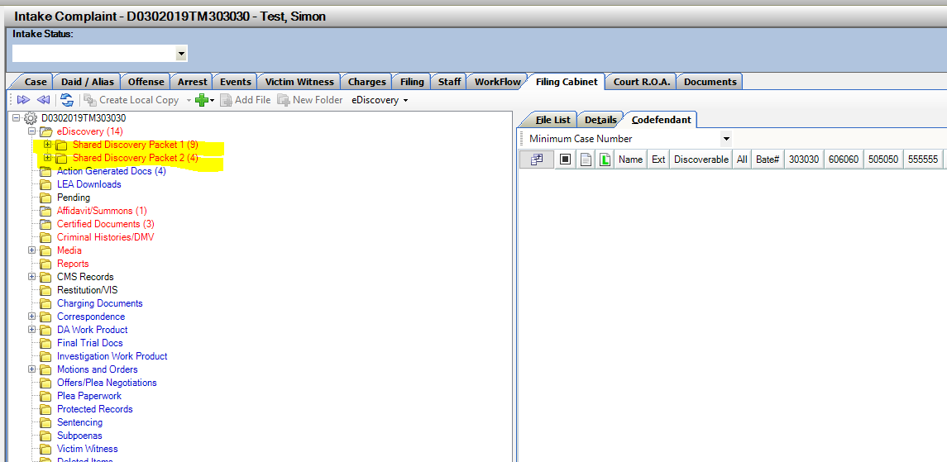

Convert Discovery Packet to a Shared Discovery Packet

Functionality: Convert a Single Discovery Packet into a Shared Discovery Packet.
Setting: Setting per user to use Convert in File Cabinet.
When to Use: When Single Discovery Packets were generated in a case, and now a new co-defendant has been added and linked in the File Cabinet. Selecting when to use this “Convert a Single to a Shared Discovery Packet” option will be determined by your district discovery practices.
This will impact Defense attorney’s if they had already received the Single Discovery Packets, it can impact your DA’s if they have started prepping for Trial for example using current bate-stamps. Best practice would be use if packets had been generated, but defense has not entered yet, or you can notify defense early on the case you will be re-processing discovery now as Shared Discovery as they will re-received on the eDiscovery website and will need to re-download.
If converting multiple linked cases that all have separate single Discovery Packets, there is potential to have duplicated files in each case. Please contact CDAC with any processing questions on these instances to ensure you will have the outcome desired with your discovery.
Example Case Scenario– Single Case- with processed Single Discovery Packets. New Co-Def is then added to Action.

- Link the new co-defendant in the File Cabinet with the Link Co-Def button.
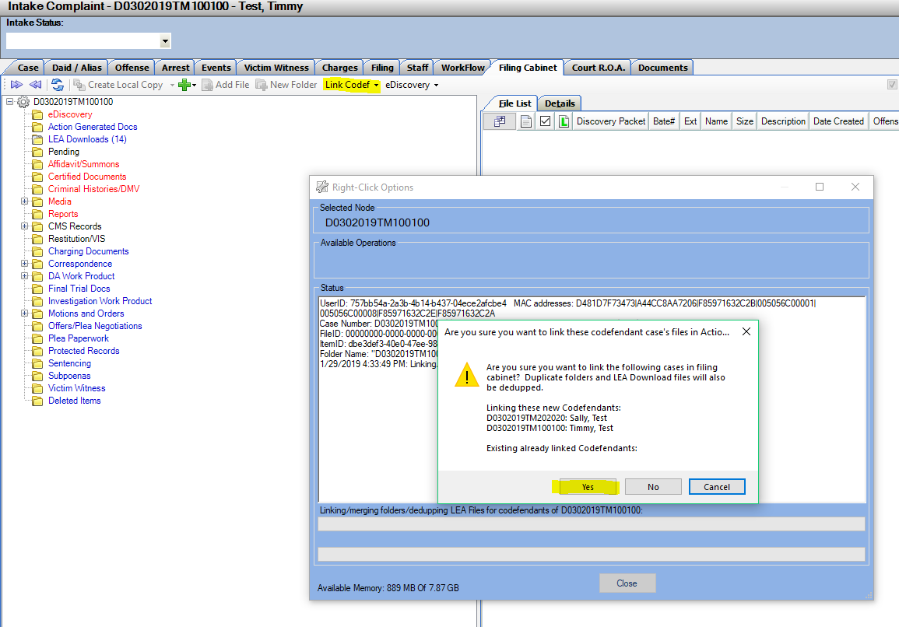

- Existing Discovery Detected

The system see’s there are discovery packets on the linked cases in the file cabinet.
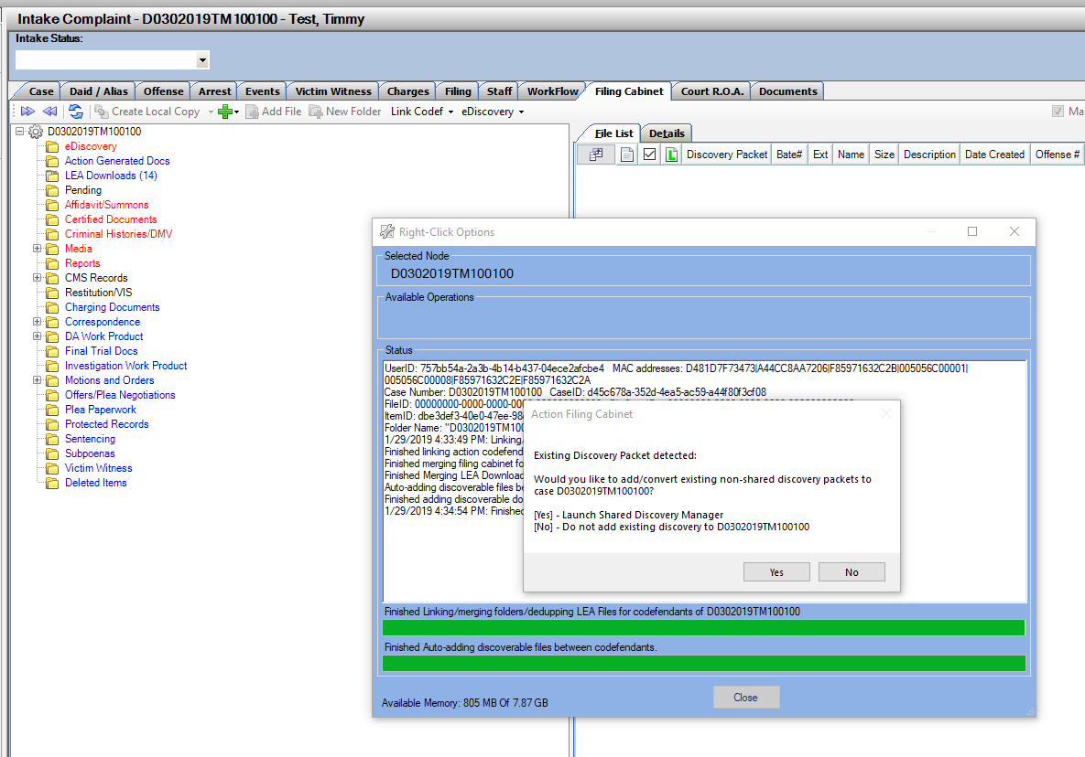
Select Yes to Launch the Shared Discovery Manager or No to not share Discovery to this new linked case. This option can be re-selected from the case (Right Click menu option) if you click no at this time.

- Convert Selected Packets

Select Covert Checkbox- Choosing to Convert Single Packets to a Shared Discovery Packet.
Bate Stamps will change from 1-21 to S1-S21 and the bate-stamp footer will change and include both case numbers linked. When selected you will see a preview of what the packet will be after converted and the preview of the New Bate-Stamp Number before commiting the change. There is currently not a way to un-convert a discovery packet back to a Single Packet.

Packet Manger Opens
Initial View:
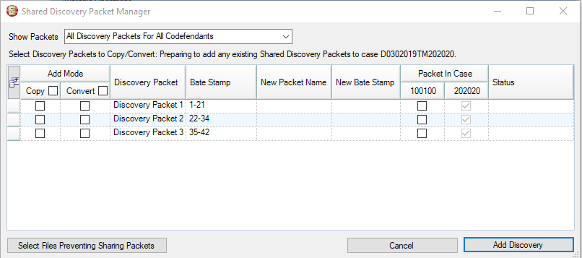
Clicking Convert Option:
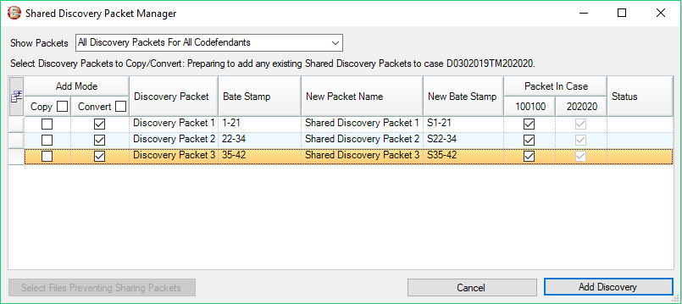

Ensure your selections and Click – Add Discovery Button.
- Note Same Error and Warnings apply to convert if files have not been added to the case you are wanting to convert and share with. Use of the Select File Preventing Sharing Packets can be used to quickly identify the files.

The packets are then converted, give this time to re-fresh in the file cabinet view. It processes 1 packet at a time so if there are multiple packets it needs to re-fresh as it’s converting each one.
If Defense is entered onto either case, notificaiton is provided through email of the new discovery. They will need to re-download this discovery as the bate-stamp numbers have changed.
Converted View in both linked Co-Def Cases:
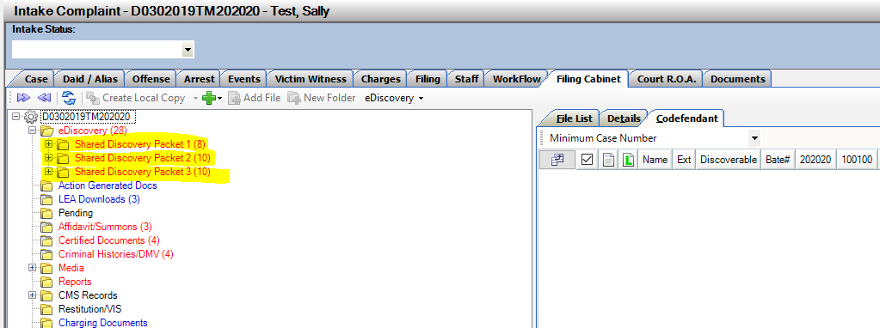
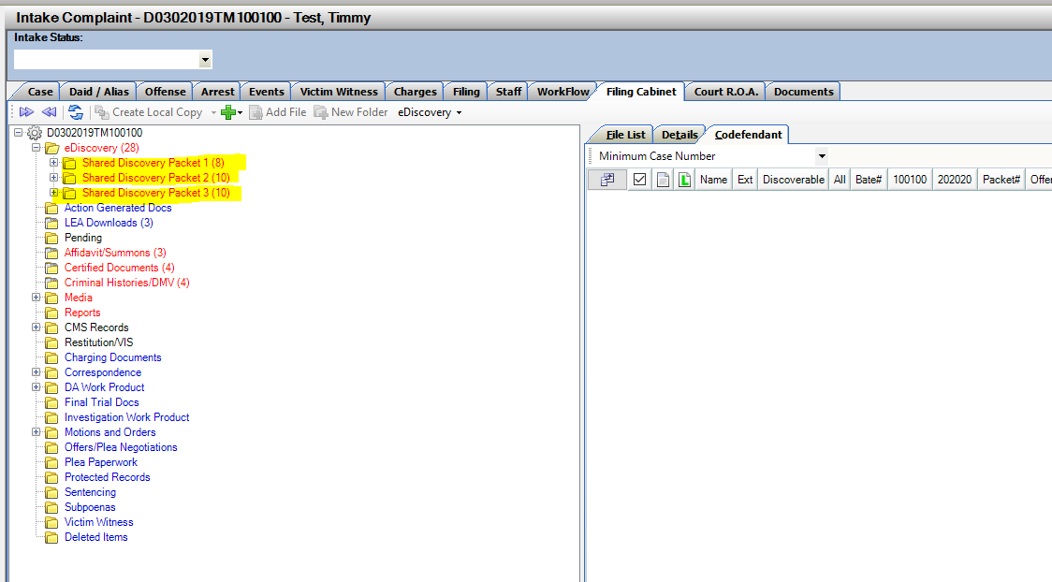

Tracking Converted Discovery Packets
Under the Case that the Discovery Packet was converted, if you click on Summary under eDiscovery it will show you the history of the packets on this case including Converted Packets, Deleted Packets and Current Active Packets all in one place. This is not sent to defense, this only for Internal use.

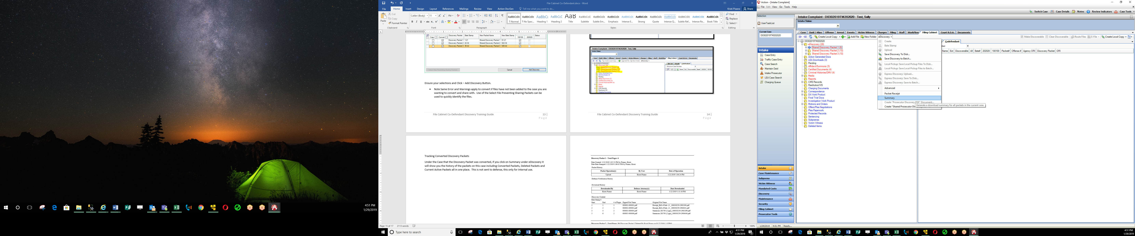

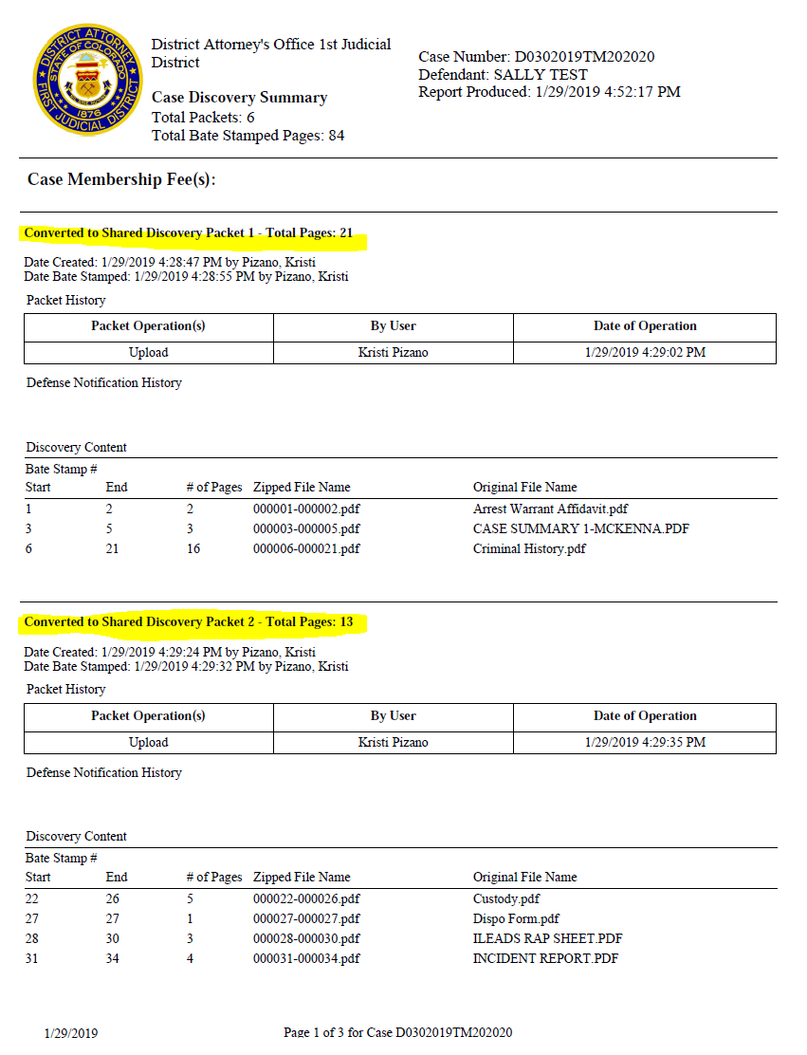
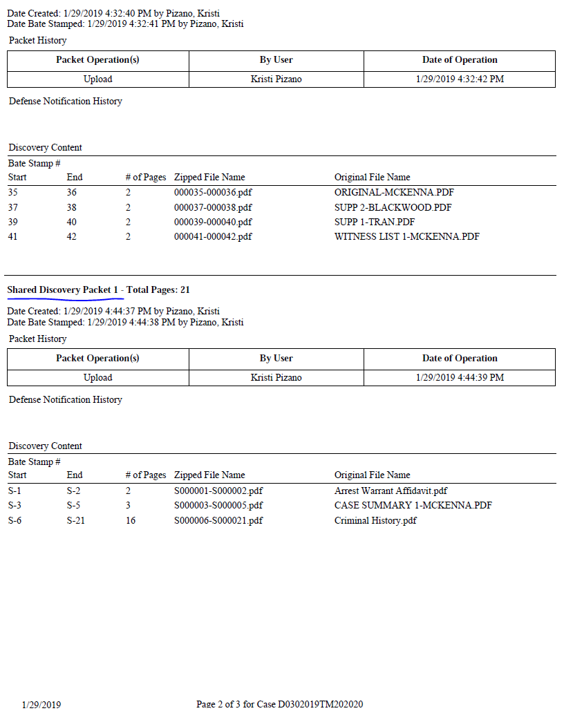

Deleted Packet also appearing on Case Summary for reference of what was initially generated:
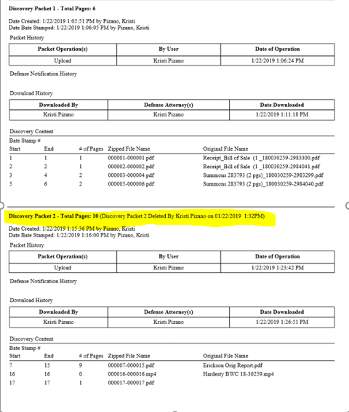

Shared Discovery Prosecutor PDF
Functionality: Shared Discovery Prosecutor PDF Option
Setting: Setting with current Prosecutor PDF option of Manual or Automatic creation.
When to Use: When Shared Discovery Packets have been produced on a case, this new option will allow you to create a Shared Discovery Prosecutor PDF in addition to any Single Discovery on the case for your internal use. Option is located on the Right Click Menu Option in the File Cabinet- by highlighting a folder and Right clicking- New Option - Create Shared Prosecutor PDF
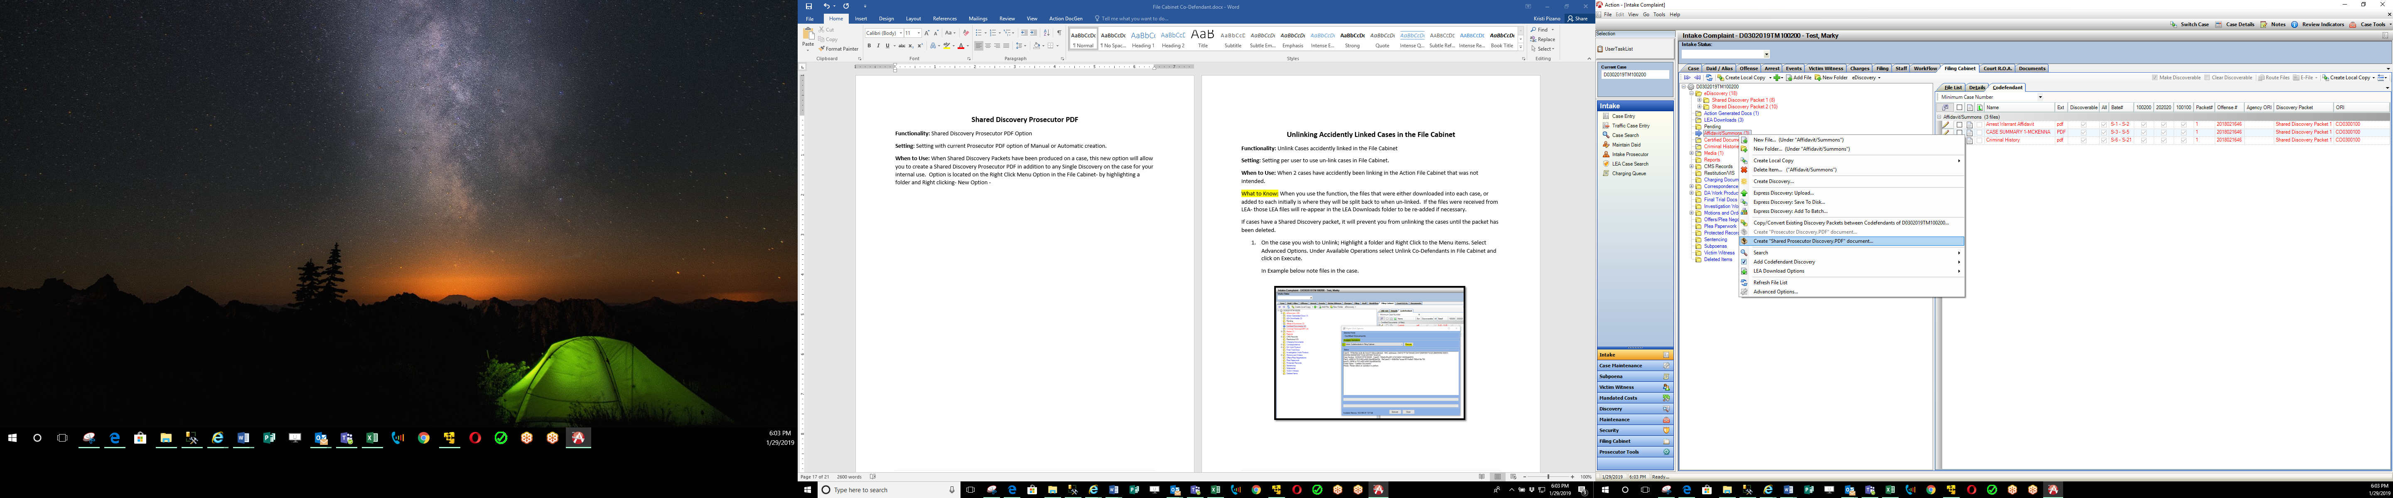
This generated document is still saved under the main eDiscovery folder- name is Shared Prosecutor Discovery. When additional Shared Discovery Packets are produced you can update this which appends the new discovery to this pdf for internal use.
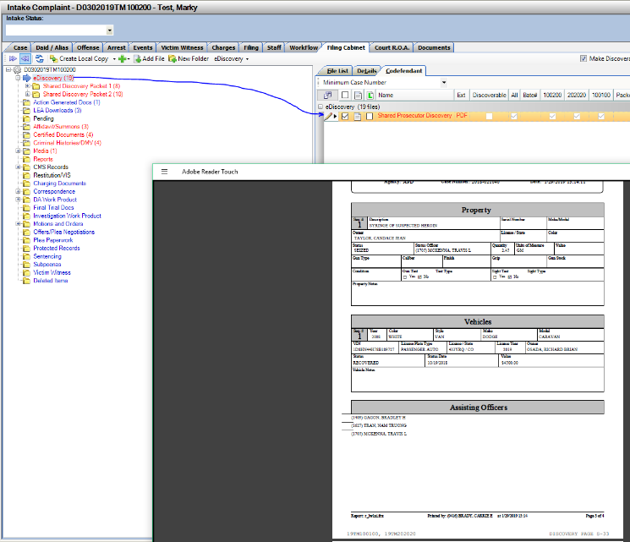

Unlinking Accidently Linked Cases in the File Cabinet
Functionality: Unlink Cases accidently linked in the File Cabinet
Setting: Setting per user to use un-link cases in File Cabinet.
When to Use: When 2 cases have accidently been linking in the Action File Cabinet that was not intended.
What to Know: When you use the function, the files that were either downloaded into each case, or added to each initially is where they will be split back to when un-linked. If the files were received from LEA- those LEA files will re-appear in the LEA Downloads folder to be re-added if necessary.
If cases have a Shared Discovery packet, it will prevent you from unlinking the cases until the packet has been deleted.
- On the case you wish to Unlink; Highlight a folder and Right Click to the Menu items. Select Advanced Options. Under Available Operations select Unlink Co-Defendants in File Cabinet and click on Execute.
In Example below note files in the case.
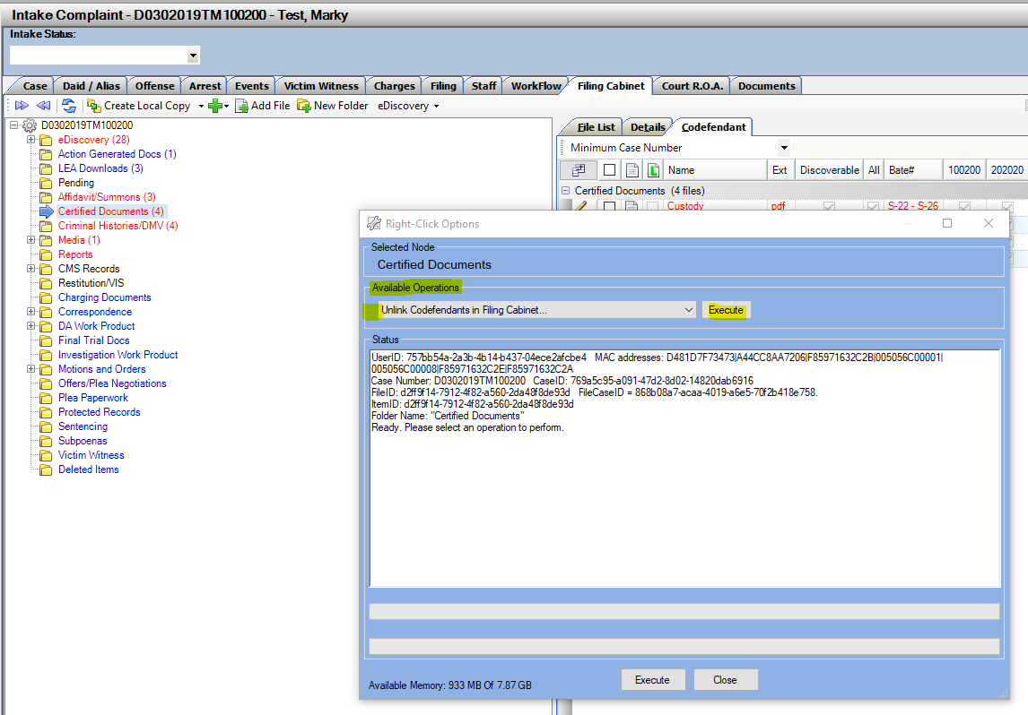

- Pop-up Window appears confirming you wish to Unlink the cases. Enter the reason for unlinking the cases (for tracking purposes).
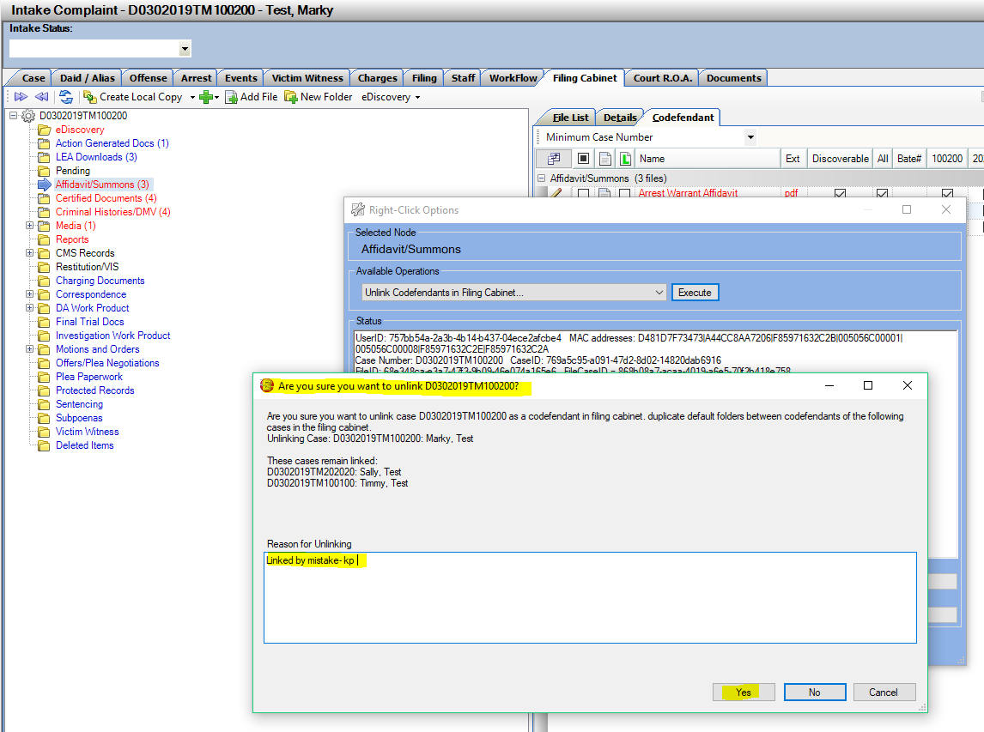

- Process runs and unlinks this case. Note files are back in LEA Downloads on this example and the document I originally added to this case. Co-Defendant Tab in File Cabinet is removed.

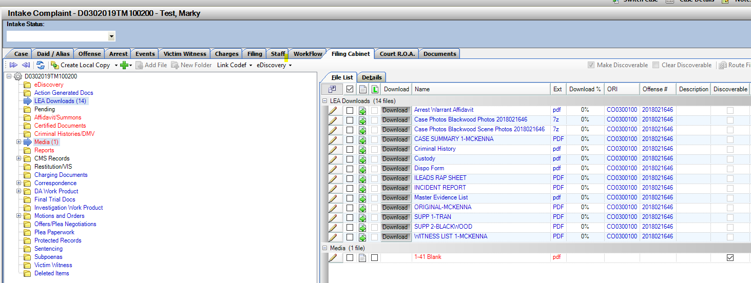
Deleting Discovery Packet Warning
Warning to recognize when deleting a Discovery Packet or a Shared Discovery Packet from a case. Remember these packets are associated to multiple cases, if you delete from one case, you are deleting from ALL linked cases that packet is shared with. Removing access to any defense attorney that may have been previously notified.
Any users that have been given Delete permissions in the File Cabinet need to be extra cautious when deleting Discovery Packets, Files both Discoverable and Work Product.
