1. **Register an account on the Secure Email Portal** by clicking this link <https://web1.zixmail.net/s/e?b=stateofcolorado>  
   Follow the prompts. A confirmation email will be sent to you.

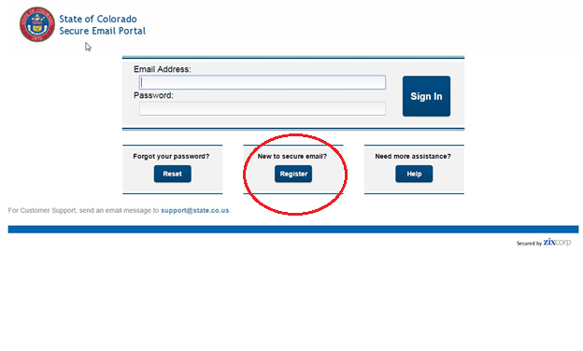

1. **Activate your password (red emphasis added)**

**From:** [stateofcolorado.notification@zixmessagecenter.com](mailto:stateofcolorado.notification@zixmessagecenter.com)  
**Date:** July 21, 2015 at 11:16:30 AM MDT  
**Subject:** **State of Colorado Notification**

Your State of Colorado password is pending.

**To ACTIVATE your new password, click the link below:**

[**https://web1.zixmail.net/s/a?b=stateofcolorado&cmd=ABB3V0Oek6EZRc9rnuNX3Sox**](https://web1.zixmail.net/s/a?b=stateofcolorado&cmd=ABB3V0Oek6EZRc9rnuNX3Sox)

**This is the last step in this one-time process.**

To DECLINE your new password, click the link below:

<https://web1.zixmail.net/s/d?b=stateofcolorado&cmd=ABB3V0Oek6EZRc9rnuNX3Sox>

If the link above is disabled, copy and paste it into your Internet browser address bar.

1. **Sign in**

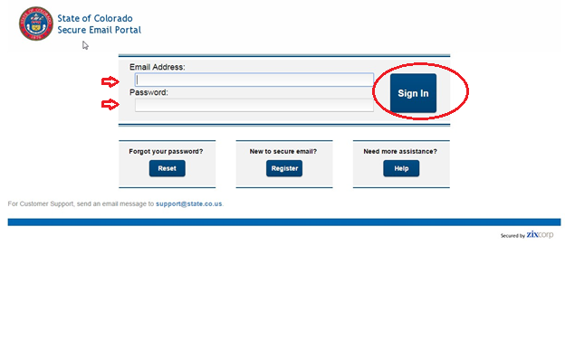

1. **Prepare your email. Click on “Compose.”**

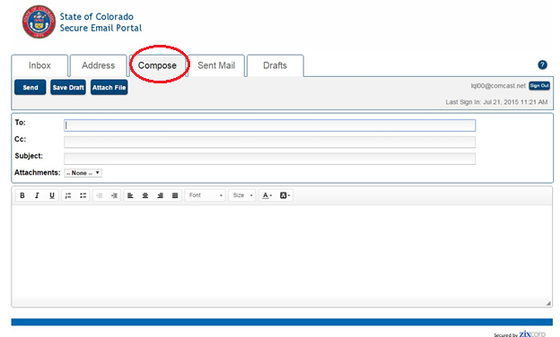

1. **Insert the address below and click on “Attach File.”**

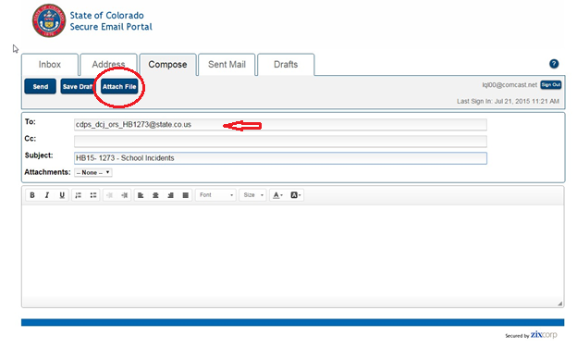

cdps_dcj_ors_hb1273@state.co.us

1. **Follow the prompts below to attach your data file.**

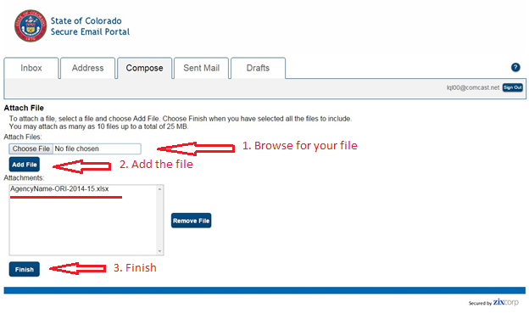

Note: Naming convention of the file should be:   
AgencyName-AgencyORI-SchoolYear.csv (or .xls, .xlsx)

1. **Please insert the information below into the body of your email message (Name, Agency, Telephone, & Email). Complete the submission by clicking, “Send.”**

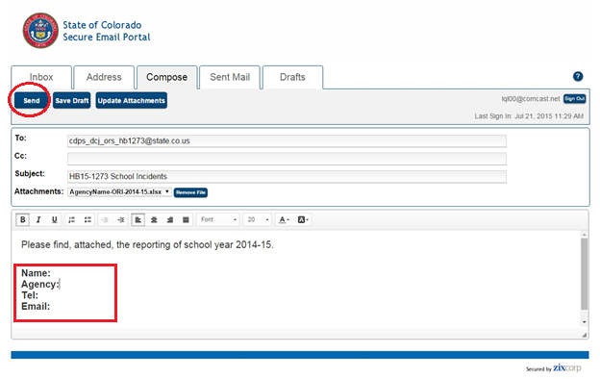

1. **Log out of your Secure Email Portal account.**